

**ParTech, Inc.**

8383 Seneca Turnpike, New Hartford, NY 13413 | p. 800.458.6898 | [www.partech.com](http://www.partech.com/)



Administrator Portal

Configuration Guide

*for Brink POS version 5.0g*

*(5.0g+)*

**partech.com | 800.448.6505 October 2021- REV 1**

# Publication Details

## Copyright

Copyright © 2021 by PAR Technology Corporation, Inc. All Rights Reserved. This product and related documentation are protected by copyright and are distributed under licenses restricting their use, copying, distribution, and decompilation. No part of this product or related documentation may be reproduced in any form by any means without prior written authorization of PAR and any requisite licensors.

## Trademarks, Patents, etc.

Brink, Brink POS, PAR, ParTech, and all of their respective logos are trademarks or registered trademarks of PAR Technology Corporation, Inc.

PAR holds the following patents in the United States that pertain to the Brink POS software suite: 6,382,850; 6,871,325; 8,146,077. PAR may have other patents, patent applications, trademarks, copyrights, or other intellectual property rights covering subject matter in this document.

Except as expressly provided in any written license agreement from PAR, the furnishing of this document does not convey any license to these patents, trademarks, copyright, or other intellectual property.

Microsoft® and Windows® are registered trademarks of Microsoft Corporation in the United States and other countries. Other product names may be trademarks or registered trademarks of their respective companies and are hereby acknowledged.

## Disclaimer

This document is provided for informational purposes only. PAR makes no warranties, either expressed or implied, in this document. Information in this document is subject to change without notice. Risk of use and responsibility for the results of use of this docdument lie with the user.

# Revision History

**17 November 2021, Revision 1**: Initial release.

# Table of Contents

Publication Details ii

Copyright ii

Trademarks, Patents, etc ii

Disclaimer ii

Revision History ii

Table of Contents iii

Introduction 1

Organization 1

Text Conventions 1

Section 1: Administrator Portal 2

Logging In 2

My Account 2

*Change Password 3*

*Contact Information Preferences 3*

*Alert Subscriptions 3*

Home 4

*Dashboard 4*

*Devices 11*

Reports 12

*Accounting 14*

*Audits 16*

*Comparative 17*

*Configuration 17*

*Employees 18*

*Future Orders 19*

*Kitchen 19*

*Labor 20*

*Loyalty 21*

*Marketing 22*

*Orders 23*

*Product Mix 23*

*Sales by Day Part 24*

*Sales Details 24*

*Sales Summaries 25*

Configuration 26

*Changeset Publisher 27*

*Changeset Packages 30*

*Alerts 33*

*Scheduled Reports 38*

*Tokenization 41*

*Processor Settings 41*

*Location Groups 42*

*Roles 44*

*Users 45*

*Promo Codes 48*

*General Settings 51*

Orders 52

*Open Orders 52*

*Pending Orders 53*

*Search Orders 54*

Labor 55

*Scheduler 55*

*Edit Pay Periods 56*

*Edit Shifts 57*

Guests 59

*Customers 59*

*House Accounts 62*

*Bulk Adjust 65*

Accounting 67

*Budgets 67*

*Deposits 68*

*Royalties 69*

Export 70

*Customers 70*

*Sales 71*

*Labor 72*

*Settings 72*

*Surveys 73*

Tools 73

*Run End of Day 73*

*Send Email Template 74*

Section 2: Settings Editor 75

Brands 76

Cash Drawers 76

Charities 79

Customer Attributes 80

Day Parts 81

Deposit Types 81

Destinations 82

Discount Groups 86

Discounts 86

Email Templates 91

Employees 92

Gift Card Filters 97

Images 98

Item Groups 99

Item Size Groups 100

Items 101

Jobs 114

Key Ingredients 123

Keyboard Shortcuts 125

Kitchen Displays 126

Kitchen Key Ingredient Summaries 127

Kitchen Keypads 130

Kitchen Queues 131

Kitchen Views 136

Labels 140

*Formatting tags 142*

*Replaceable Parameters 142*

Labor Groups 144

Lanes 145

Layout 148

*Panel Browser 148*

*Layout Toolbar 150*

Loyalty Adjustment Reasons 172

Loyalty Events 172

Loyalty Cards 176

Loyalty Plans 179

Loyalty Rewards 184

Marketing Campaigns 186

Menus 187

Menu Categories 188

Menu Items 189

Modifier Codes 190

Modifier Groups 191

Modifier Tiers 192

Options 193

*System 193*

*Location 197*

*Ordering 199*

*Payment 204*

*Printing 211*

*SMS 218*

*Accounting 219*

*Labor 223*

*Loyalty 226*

*Kitchen 237*

*Customer Portal 239*

*Online Ordering 240*

*Future Orders 244*

*Customer Display 248*

*Customer 249*

*Prepaid Item 249*

*Promotion 250*

*Comp Card 250*

Payment Devices 250

Permissions 259

Petty Accounts 260

Price Changes 260

Price Levels 262

Printer Groups 263

Printer Messages 264

Printers 268

Promotions 271

Refund Reasons 280

Registers 281

Revenue Centers 284

Scales 285

Scheduled Events 286

Screens 287

Script Functions 288

Sections 288

Security Levels 289

Shift End Reasons 292

Smart Groups 292

Sounds 293

Surcharges 293

Survey Question Groups 297

Survey Questions 297

Survey Rating Scales 300

Surveys 301

Tables 303

Tares 303

Taxes 304

Tenders 307

Video Groups 310

Void Reasons 312

# Introduction

This document provides setup and usage information for the Brink POS Administrator Portal and Settings Editor.

## Organization

This document is organized into two major sections: one of the Administrator Portal proper and one for Settings Editor. Within each section, functions and settings are organized in the order in which they are presented in the user interface.

## Text Conventions

References to other documents, links to other parts of this document, and references to parts of the user interface are represented with different text styles.

* User interface items that are directly selectable or interactive (such as named buttons, navigational items, form elements, or hyperlinks) are shown in **Bold**.
* User interface items that are not selectable or interactive (such as dialog titles, webpage or UI section names, and form names), cross-references to other documents, and figure captions, are shown in *Italic*.
* Unnamed buttons/screens or buttons/screens with configurable names are shown in ‘single quotes’.
* Status, error, and warning messages are shown in “double quotes”.
* File names, folder names, Windows directory paths, and code examples are shown in

Monospace.

* Text that must be entered into a form field or other UI element is shown in **Monospace Bold**.
* Variables are shown in [brackets].
* Internal cross-references are shown in blue.

# Section 1: Administrator Portal

This section of this document covers all of the features and functions of the main Administrator Portal user interface.

## Logging In

When the system administrator creates your Administrator Portal user account, you will receive an email with a link to the Administrator Portal and your login credentials.

**NOTE**: The Administrator Portal URL you receive may be unique to you. Be sure to bookmark it for future use.

*Administrator Portal Login screen*

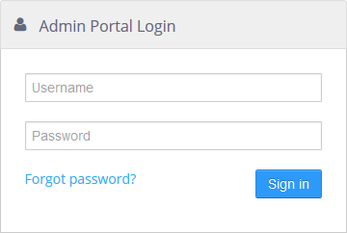

When you log in for the first time, you may be required to change your password before being able to continue. Also, you may be required to change your password on a regular basis.

**NOTE**: If you forget your password, you can click the **Forgot password?** link on the login page to request an email containing instructions on how to reset your password.

## My Account

Select the **My Account** link at the top of the navigation panel to get to the account options.

***My Account*** *link*

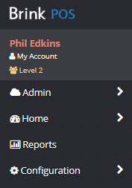

### Change Password

Allows the current Admin Portal user to change the password on their account.

##### *Change Password tool*

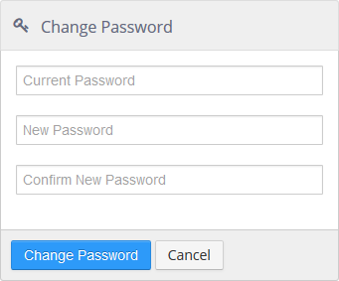

### Contact Information Preferences

This includes your email address and the email address that you would like alert notifications to be sent to. These can be the same.

##### *Alert Preferences tool*

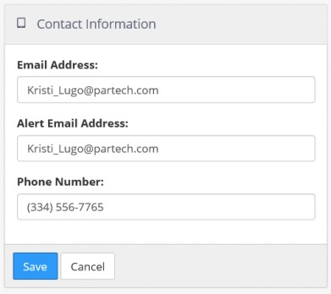

### Alert Subscriptions

Lists all the alerts defined in the current group and allows the current Admin Portal user to subscribe to receive alert notifications by checking the box beside the alert name. Alerts that the user subscribes to via their assigned roles are checked and cannot be unchecked.

##### *Alert Subscriptions tool*

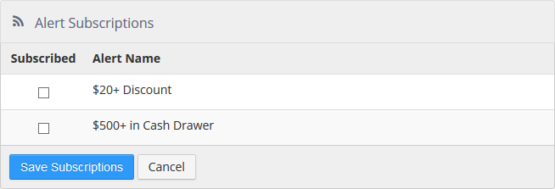

## Home

When you log in as a non-Admin user, you are taken to the **Home > Dashboard** screen.

*Dashboard (example)*

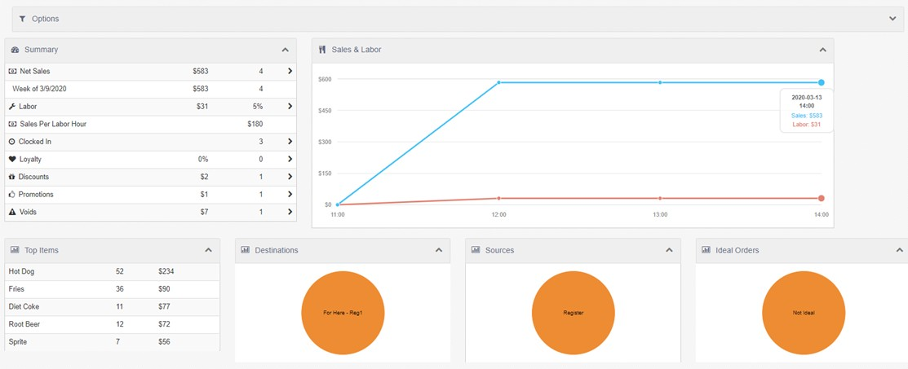

### Dashboard

The *Dashboard* page displays data elements in widget format for the selected locations and date range. You can use the dashboard controls in *Options* on the top of the page to change the locations, date and widgets that are displayed on the dashboard.

*Options*



*Dashboard controls*



The controls, from left to right, are:

* ‘Locations’: Clicking the control opens the *Locations* dialog. Using the drop-down list, you can select **All Locations**, **Select Locations**, **All Groups**, or **Select Groups**.

**NOTE**: **All Groups** and **Select Groups** will only appear if you have Location Groups configured. See Location Groups.

* ‘Date’: Clicking the control opens the *Date* dialog. Using the drop-down list, you can select **Date Range**, **Day**, **Week**, **Month**, or **Pay Period**.
* ‘Ownership Type’: Clicking the control opens the *Ownership Type* dialog. Using the drop-down list, you can select **All Ownership Types, Corporate,** or **Franchisee.**
* ‘Widgets’: Clicking the control opens the *Widget Configuration* dialog. See Widget Configuration for details.

**NOTE**: The default dashboard widgets are **Summary**, **Sales & Labor**, **Top Items**, **Destinations**, **Sources**, and **Ideal Orders**.

Individual widgets on the dashboard can be collapsed and expanded by clicking their title bars.

*Collapsed* ***Top Items*** *widget*

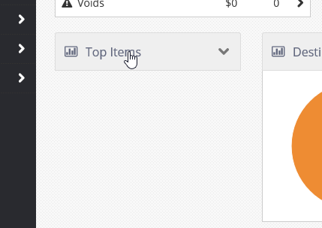

*Widget Configuration*

Clicking the ‘Widgets’ button in the upper right corner opens the *Widget Configuration* dialog.

*Widget Configuration dialog*

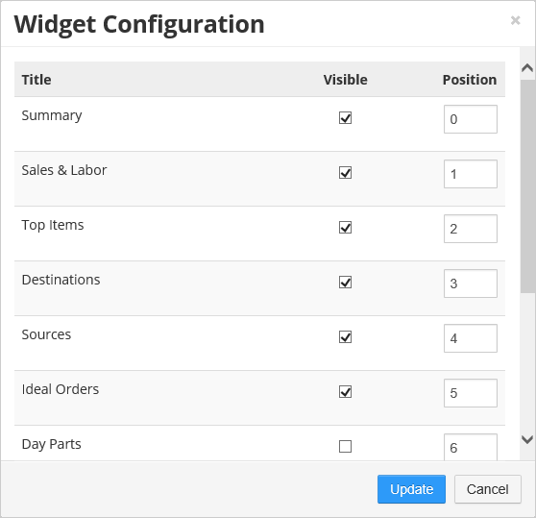

All available data widgets are shown in the list. Those with their **Visible** check boxes checked are displayed on the dashboard. The order in which they are displayed is controlled by the value of their **Position** field, from lowest (**0**) to highest (up to **10**).

The available widgets are:

* **Summary**: Displays key metrics in list format, including *Net Sales*, *Labor* cost, *Sales Per Labor Hour*, the number of employees *Clocked In*, *Loyalty* program statistics, and the number and amounts of *Discounts*, *Promotions*, and *Voids*.

***Summary*** *widget*

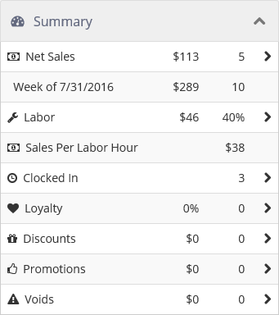

Each item that has an arrow next to it can be clicked to go to a details page that displays additional information organized by location.

*Sales summary, accessed by clicking* ***Net Sales*** *in the* ***Summary*** *widget*

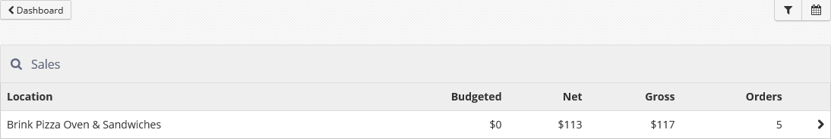

A location can in turn be clicked to access even more detailed information.

*Location sales details, accessed by clicking the location in the sales summary*

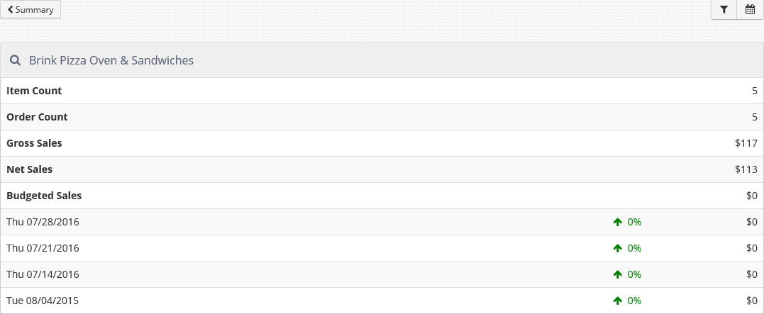

* **Sales & Labor**: Displays a line graph with the net sales and total labor cost for the selected date range plotted. If the dashboard is displaying data for a single day, the graph is delineated by hour; if the dashboard is displaying data for more than one day, the graph is delineated by date.

***Sales & Labor*** *widget*

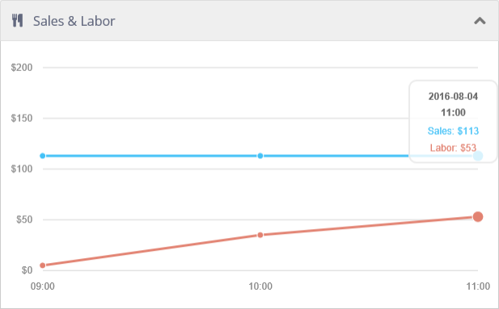

* **Top Items**: Displays the five items that have generated the highest total sales for the selected date range. In addition, a count of items sold for each is shown.

***Top Items*** *widget*

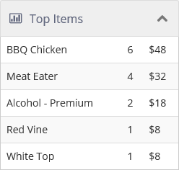

* **Destinations**: Displays a pie chart of the distribution of sales by destination. Moving the cursor over any part of the pie chart displays net sales and percent of total net sales for that destination.

***Destinations*** *widget*

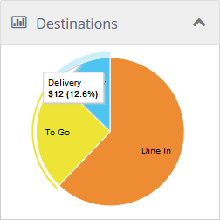

* **Sources**: Displays a pie chart of the distribution of sales by the order source: *Register*, *Customer Portal*, or *Mobile*. Moving the cursor over any part of the pie chart displays net sales and percent of total net sales for that source.

***Sources*** *widget*

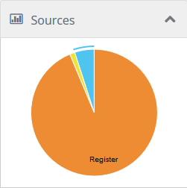

* **Ideal Orders**: Displays a pie chart of the distribution of orders that match the ideal order definition. Ideal orders are defined on the **Options > Ordering > Ideal Order** tab in Settings Editor (see Ideal Order). Moving the cursor over any part of the pie chart displays net sales and percent of total net sales for that part.

***Ideal Orders*** *widget*

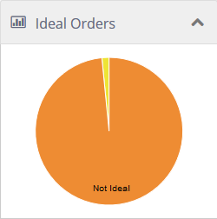

* **Day Parts**: Displays **Net Sales**, **Gross Sales**, or **Labor Cost** by day part for each of the selected locations. Click the buttons to display the corresponding data. Click the ‘Refresh’ button to refresh the data.

***Day Parts*** *widget*

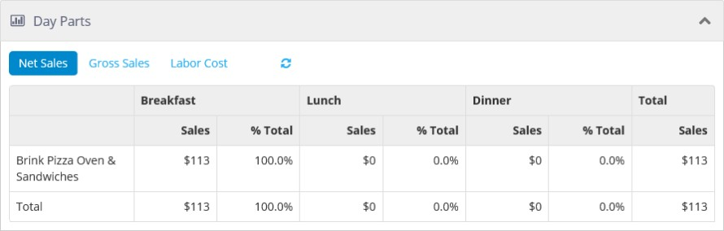

* **Sales**: Displays **Net Sales** or **Gross Sales** for each of the selected locations. Also displays the number of transactions and the average amount spent per transaction. Click the buttons to display the corresponding data. Click the ‘Refresh’ button to refresh the data.

***Sales*** *widget*

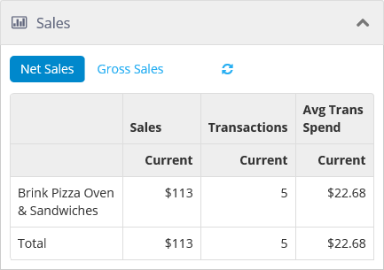

* **Labor**: Displays labor statistics and how they relate to sales by day part for each of the selected locations. Click **Net Sales** or **Gross Sales** to display the corresponding data. Click the ‘Refresh’ button to refresh the data.

***Labor*** *widget*

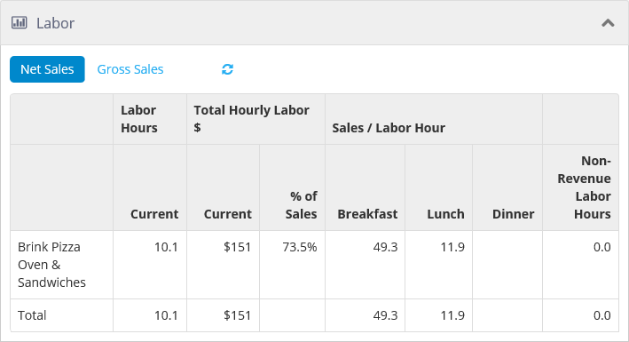

* **Transactions**: Displays the average number of orders per hour by day part for each of the selected locations. Click **Net Sales** or **Gross Sales** to display the corresponding data. Click the ‘Refresh’ button to refresh the data.

***Transactions*** *widget*

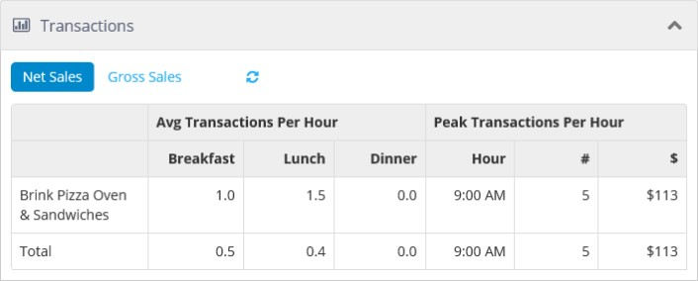

* **Daily Performance Trends**: Displays line graphs of sales and labor values by the day of the week. Click **Net Sales** or **Gross Sales** to display the corresponding data. Click the ‘Refresh’ button to refresh the data. Select or deselect the check boxes to display the corresponding current or historical data.

##### *Daily Performance Trends widget*

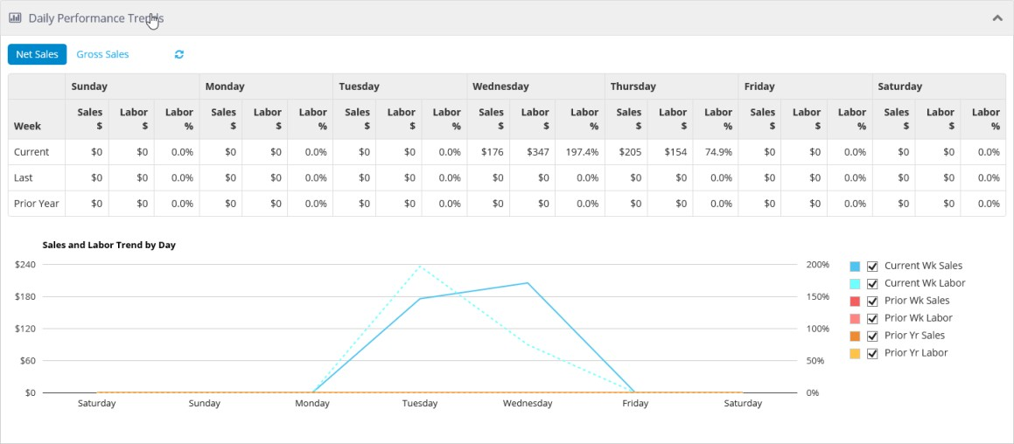

### Devices

The *Devices* page displays the connection status for all *Kitchen Displays* and *Registers* for the selected

location. The location’s current business date is shown at the top of the *Registers* section. Along with the

*Terminal Topology*, which is the configuration of the terminal e.g. IP Address, Machine ID

The status of the Maintenance Service for each Register and Kichen Display is reported in the *Maint. Svc. Status* column. Please reference to the Brink Maintenance Service documentation for more details on BMS.

The page also displays all *Cash Drawers*, to whom they are checked out, and the amount of cash in each. The total amount of cash in all drawers is displays at the top of this section.

Also, the ability to change a locations environment for lab\demo\staging purposes. The *Change Environment Type to: No Registers* is shown at the upper right top of the page

*Devices page (example)*

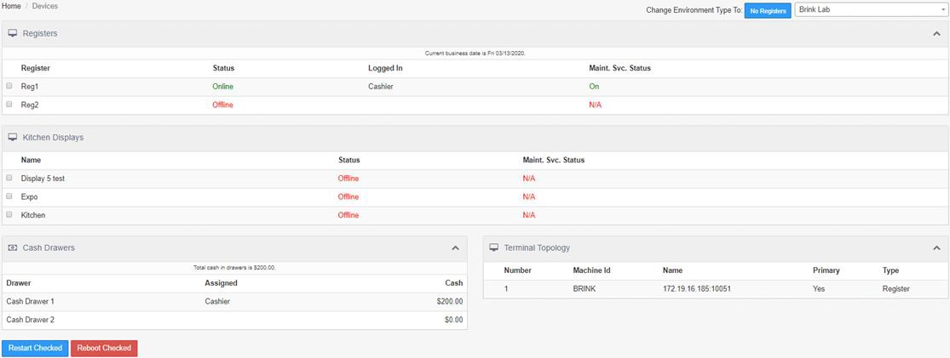

Registers and kitchen displays can be restarted (the software closed and reopened) or rebooted (the hardware powered off briefly and then back on) by checking the device’s check box and clicking the appropriate button: **Restart Checked** or **Reboot Checked**.

## Reports

Reports are organized into categories.

*Reports page*

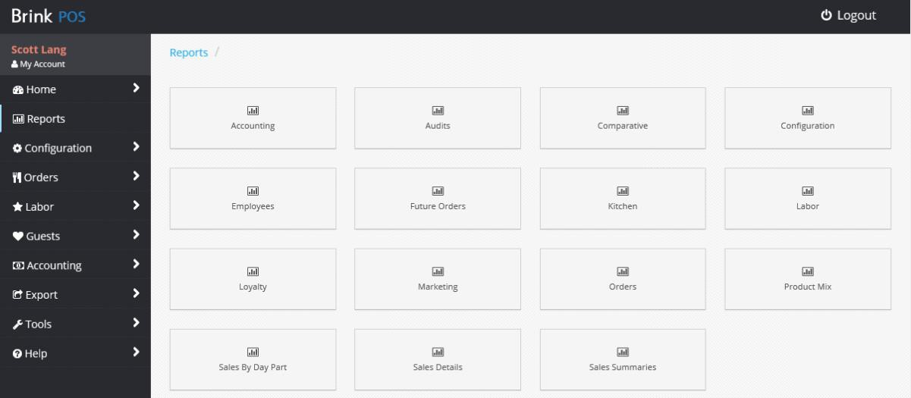

#### To run a report:

1. Click **Reports** in the left navigation bar to open the *Reports* page.
2. Click a category to open the page listing its available reports (for example, **Sales Summaries**).

*Sales Summaries Reports page*

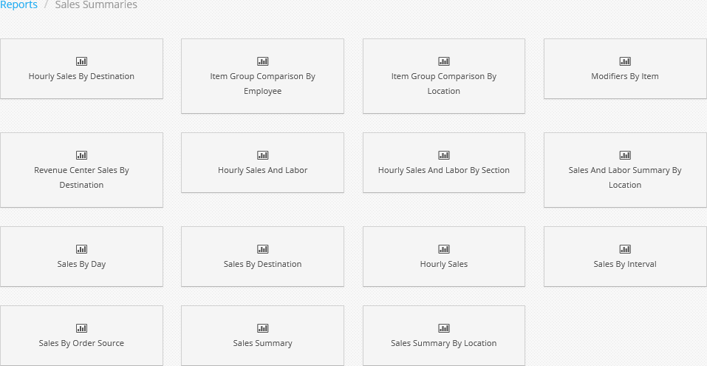

1. Click a report to open its page (for example, **Sales Summary by Location**).

*Sales Summary by Location page*

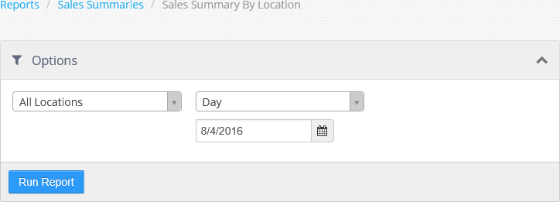

1. Configure the *Options* as you desire.

**NOTE**: The available *Options* almost always include location and date, and others may be present as well depending on the type of report being run.

1. Click **View Report**. Some reports also have the option to download via a Download Report button.

**NOTE**: The report may take a few seconds to display.

### Accounting

|  |  |
| --- | --- |
| Report | Description |
| Add On Purchases By Discount | Shows each discount and lists the items ordered on orders that the discount was applied to. You can sort by discount. It can be run for one or more locations and for a given date range. |
| Add On Purchases By Item | Presents each item, lists the other items ordered on the same order, sorted by item. It can be run for one or more locations, and for a given date range. |
| Add On Purchases by Promotion | Shows each promotion, lists the items ordered on orders that the promotion where it was applied. You can sort by promotion. It can be run for one or more locations, and for a given date range. |
| Credit Card Detail | Presents approved credit card transaction details, sorted by location and then transaction time. It can be run for one or more locations, for a given date range and can be filtered by section. |
| Credit Card Summary by Merchant Account | Lists total approved credit card transactions by Brick & Mortar verses E-Commence merchant accounts. It can be run for one or more locations, and for a given date range. |
| Discount Detail | Shows order discount details, which are grouped and sorted by discount. It can be run for one or more locations, for a given date range and can be filtered by discount. |
| Discount Group Summary | Presents total order discounts, which are grouped and sorted by discount group. It can be run for one or more locations, and for a given date range. |
| Discount Summary | Lists total order discounts, grouped and sorted by discount. It can be run for one or more locations, and for a given date range. |
| Donation Summary | Shows total order donations, grouped and sorted by charity. It can be run for one or more locations, and for a given date range. |
| Gift Card Items By Employee | Provides gift card issue and reload transactions. They are grouped and ordered by location name, and then employee. It can be run for one or more locations, and for a given date range. |
| Gift Card Payment | Lists approved gift card tender transaction details which are sorted by location and then transaction time. It can be run for one or more locations, and for a given date range. |
| Gift Card Sales Summary | Shows totals for each gift card transaction type, a cumulative  total for all selected locations. It can be run for one or more locations, and for a given date range. |

|  |  |
| --- | --- |
| Report | Description |
| Gift Card Sales Summary By Store | Presents totals for each gift card transaction type, which are grouped and sorted by location. It can be run for one or more locations, and for a given date range. |
| Gift Card Summary By Employee | Lists totals for each gift card transaction type, which are grouped by employee and sorted by Total Amount. It can be run for one or more locations, and for a given date range. |
| House Account Detail | Shows house account transaction details, which are sorted by transaction time. It can be run for one or more locations, for a given date range, and filtered by account number. |
| House Account Summary | Presents house accounts and the current status including balance due for a single location. |
| Ideal Food Cost By Item | Lists all items sold along with cost relative to sales, both on an average per item and cumulative bases, which is sorted by item name. It can be run for one or more locations, and for a given date range. |
| Open Order Deposit | Shows order deposits on future orders created on the current business date, or due on the current business date, which are ordered by deposit transaction time. It can be run for a single location. |
| Open Till | Lists all cash drawers and self-banking tills that are currently open/assigned and have not been checked out which are sorted by Till Number. It can be run for one or more locations. |
| Petty Account Detail | Lists cash in/out transaction details sorted by transaction time. Can be run for a single location, for a given date range. |
| Promotion Detail | Lists order promotion details grouped and sorted by promotion. Can be run for one or more locations, for a given date range. |
| Promotion Summary | Lists total order promotions, grouped and sorted by promotion. Can be run for one or more locations, for a given date range. |
| Refund Detail | Lists refund order details sorted by transaction time. Can be run for a single location, for a given date range. |
| Royalties By Location  Skim Detail Report | Lists selected locations, their royalty collection details, and the total calculated royalties for the selected date range. Can be run for one or more locations, for a given date range.  List of triggered warning messages and Skim events. Can be run for one location, for a given date range. |

|  |  |
| --- | --- |
| Report | Description |
| Surcharge Summary | Lists total order surcharges, grouped and sorted by surcharge. Can be run for one or more locations, for a given date range. |
| Taxes by Location | Lists all taxes for each location. Can be run for one or more locations. |
| Tax Exempt Sales | Lists details of orders set as tax exempt, sorted by transaction time. Can be run for a single location, for a given date range. |
| Tax Summary | Lists tax collected, grouped by tax, and sorted by percent or total tax collected. Can be run for one or more locations, for a given date range. |
| Tender Detail | Lists order details, grouped by tender applied, and sorted by tender then transaction time. Can be run for one or more locations, for a given date range, and filtered by tender. |
| Tender Summary | Lists all tenders and totals collected, sorted by tender name. Can be run for one or more locations, for a given date range. |
| Till History | Lists till details for all checked out cash drawers and self-banking tills, sorted by checkout time. Can be run for a single location, for a given date range. |
| Void Details | Lists voided item details, grouped by employee and sorted by void time. Can be run for a single location, for a given date range. |
| Void Summary | Lists void totals for all void reasons, grouped by void reason and sorted by total amount voided. Can be run for one or more locations, for a given date range. |

### Audits

|  |  |
| --- | --- |
| Report | Description |
| Business Date Audit | Lists all system events for a single business date. Can be run for a single location, for a given business date. |
| Credit Card Audit | Lists details of all attempted credit card transactions (including EMV activity), batch transactions, and audit access. Can be run for a single location, for a given date range. |
| Gift Card Audit | Lists details of all attempted gift card transactions. Can be run for a single location and date. |
| Notifications | Lists details of triggered alerts. Can be run for a single location, for a given date range. |

|  |  |
| --- | --- |
| Report | Description |
| Location Security Audit | Lists details of each time an Admin Portal user accessed Settings Editor and published settings changes. Can be run for a single location, for a given date range. |
| Group Security Audit | List details of each time an Admin Portal user accessed any portion of the Admin Portal that controls any form of system access. Can be run for a given date range. |
| Reopened Order | Lists order details of any orders that were reopened, grouped by location, and sorted by location, then Reopen Time. |
| Tax Audit Report | Lists changes to taxes for a given date range, sorted by user, with the location, tax name, old tax value, new tax value, and the date and time of the change. Can be run for one or more locations. |

### Comparative

|  |  |
| --- | --- |
| Report | Description |
| Hourly Sales | Lists sales totals for two groups of locations by hour, along with comparative value between the two groups of locations. Can be run for one or more locations, for a given date range. |
| Product Mix | Lists sales totals for two groups of locations by item, along with comparative value between the two groups of locations, sorted by item name. Can be run for one or more locations, for a given date range. |
| Sales By Day Part | Lists sales totals for two groups of locations by day part, along with comparative value between the two groups of locations, sorted by day part start time. Can be run for one or more locations, for a given date range. |
| Sales Summary | Lists sales summary date for two groups of locations by hour, along with comparative value between the two groups of locations. Can be run for one or more locations, for a given date range. |

### Configuration

|  |  |
| --- | --- |
| Report | Description |
| Items By Revenue Center | Lists all items in a single location and the item’s revenue center,  sorted by revenue center and then item name. Can be run for a  single location. |

|  |  |
| --- | --- |
| Report | Description |
| Menu Comparison | Displays items that have any different values set between two locations. Must be run with two, and only two locations selected. |
| Modifier Group Detail | List all the modifier groups, along with the items in the modifier group, sorted by modifier group name. Can be run for a single location. |
| Tax By Item | Lists all items, along with the taxes assigned to the item either  directly or via the revenue center, sorted by item name. Can be run for a single location. |

### Employees

|  |  |
| --- | --- |
| Report | Description |
| Declared Tips | Lists all employees with shifts during the selected date range and their tips relative to their sales by business date, sorted by employee name then business date. Can be run for a single location, for a given date range. |
| Cash Accuracy | Lists all employees that had tills during the selected date range and their cash accuracy as a function of declared cash variance divided by calculated cash, sorted by cash accuracy. Can be run for one or more locations, for a given date range. |
| Employee Directory | Lists all non-terminated employees in a single location, along with their contact and personal information. Can be run for a single location. |
| Employee Productivity | Lists all employees with sales in the selected date range, along with total sales values. Eligible sales are items sold from the selected item group, and Eligible Sales % is calculated as Eligible Sales divided by Total Sales. Report is sorted by Eligible % Sales. Can be run for one of more locations, for a given date range, and for a single item group. |
| Sales Comparison By Item | List items sold by employee, relative to other employees, sorted by location, item, business date, and then employee name. Can be run for one of more locations, for a given date range. |
| Sales Comparison By Revenue Center | Revenue center sales by employee, relative to other employees, sorted by location, revenue center, business date, and then employee name. Can be run for one of more locations, for a given  date range. |

|  |  |
| --- | --- |
| Report | Description |
| Employee Sales Summary | Lists all employees with sales within the selected date range, along with key performance metrics for each employee. Can be run for a single location, for a given date range. |
| Item Sales By Employee | Lists all items, and then items sold by employee, sorted by item name and then total sales per employee. Can be run for a single location, for a given date range. |

### Future Orders

|  |  |
| --- | --- |
| Report | Description |
| Future Order Detail | Lists order details for future orders that have a request time within the selected date range, which not been sent to the kitchen. Can be run for one of more locations, for a given date range. |
| Future Order Summary | Lists a count per item sold on future orders that have a request time within the selected date range, which not been sent to the kitchen. Can be run for one of more locations, for a given date  range. |

### Kitchen

|  |  |
| --- | --- |
| Report | Description |
| Kitchen Performance | Lists total orders bumped prior to each threshold time defined on each kitchen queue, and orders bumped beyond the last threshold are reported as Extended. Can be run for a single location, for a given date range. |
| Performance By Day Part And Hour | Lists total orders bumped prior to each threshold time defined on each kitchen queue by hour and day part, and orders bumped beyond the last threshold are reported as Extended. Can be run for a single location, for a given date range. |
| Performance By Day Part | Lists total orders bumped prior to each threshold time defined on each kitchen queue by day part, and orders bumped beyond the last threshold are reported as Extended. Can be run for a single location, for a given date range. |
| Performance By Hour | Lists total orders bumped prior to each threshold time defined on each kitchen queue by hour, and orders bumped beyond the last threshold are reported as Extended. Can be run for a single  location, for a given date range. |

|  |  |
| --- | --- |
| Report | Description |
| Speed Of Service By Day Part | Lists average order bump time per kitchen queue by day part. Can be run for a single location, for a given date range. |
| Speed Of Service By Hour | Lists average order bump time per kitchen queue by hour. Can be run for a single location, for a given date range. |

### Labor

|  |  |
| --- | --- |
| Report | Description |
| Clocked In | Lists all employees that are currently clocked in, sorted by employee name. Can be run for a single location. |
| Edited Shifts | Lists shifts with a business date that is within the selected date range that were edited, grouped by employee and sorted by employee name then shift business date. Can be run for a single location, for a given date range. |
| Employee Breaks | Lists all employee breaks taken, sorted by employee name then date. Can be run for a single location, for a given date range. |
| Employee Summary By Job | Lists total shift hours per employee by job, grouped and sorted by job. Can be run for a single location, for a given date range. |
| Employee Summary By Job With Salary | Lists total shift hours and total pay per employee by job, grouped and sorted by job. Can be run for a single location, for a given date range. |
| Employee Timecard | Lists shift details by employee, sorted by employee name. Can be run for a single location, for a given date range, and can be filtered by employee and/or job. |
| Job Summary By Employee | Lists job totals, including hours and pay, by employee, sorted by employee name. Can be run for a single location, for a given date range. |
| Labor Cost By Job | Lists total hours and pay by job, sorted by job name. Can be run for a single location, for a given date range. |
| Hourly Labor By Labor Group | Lists total hours by labor group, sorted by labor group name. Can be run for a single location, for a given date range. |
| Weekly Labor Schedule | Displays the labor schedule by week as defined via the Labor Scheduler or submitted by a third-party via the API. |

### Loyalty

|  |  |
| --- | --- |
| Report | Description |
| Adjustment Detail | Lists loyalty activity that is the result of a manual adjustment, sorted by transaction time. Can be run for a single location, for a given date range, and can exclude bulk adjustments. |
| Earned Reward Detail | Displays loyalty rewards that were issued or redeemed within the selected date range, sorted by reward issue date. Can be run for one or more locations, for a given date range. |
| Inactive Customer Detail | Lists customer details for those customers whose last order was prior to the selected date. Can be run for a single date. |
| Member Count Summary | Lists high level customer metrics. Can be run for one or more locations, for a given date range. |
| Member Items | Lists customer visit count, most purchased item, and most visited location, per customer, grouped by Loyalty Card. Can be run for one or more locations, for a given date range. |
| Member Sales | Lists loyalty totals for customers with any activity between the selected date ranges, grouped by Loyalty Plan. Can be run for one or more locations, for a given date range. |
| Member Sales By Day Part | Lists sales metrics for orders with a customer assigned, versus those orders without a customer assigned, by location, by day part. Can be run for one or more locations, for a given date range. |
| Member Sales By Revenue Center | Lists sales metrics for orders with a customer assigned, versus those orders without a customer assigned, by location, by revenue center. Can be run for one or more locations, for a given date range. |
| Member Visit Detail | Lists order totals by customer for the selected date range, grouped by Loyalty Card. Can be run for one or more locations, for a given date range. |
| PreTax Sales | Lists order pre-tax totals by customer for the selected date range, grouped by Loyalty Card. Can be run for one or more locations, for a given date range. |
| Reward Summary By Plan | Lists a count of rewards awarded and redeemed, grouped and sorted by Loyalty Plan. Can be run for one or more locations, for a given date range. |
| Visits By Employee | Lists customer order count by employee, ordered by employee and then order count. Can be run for one or more locations, for a given date range, and filtered by visit count. |

|  |  |
| --- | --- |
| Report | Description |
| Member Sales Summary | Lists visit count and total pend by customer, sorted by total spend. Can be run for one or more locations, for a given date range. |
| New Customers By Employee | Lists all employees and their new customer signup metrics, sorted by signup rate. Can be run for one or more locations, for a given date range. Orders with employee discounts applied can be excluded. |
| New Customers By Location | Lists all selected locations and their new customer signup metrics, sorted by signup rate. Can be run for one or more locations, for a given date range. Orders with employee discounts applied can be excluded. |
| New Customers By Location for Year | Lists all selected locations and their new customer count by month. Can be run for one or more locations, for a given year. |

### Marketing

|  |  |
| --- | --- |
| Report | Description |
| Marketing Campaign Summary | Lists all marketing campaigns and totals used to calculate ROI, sorted by marketing campaign name. Can be run for one or more locations, for a given date range. |
| Marketing Campaign Detail | List order details for all orders associated with a marketing campaign. Can be run for one or more locations, for a given date range, and filtered by marketing campaign. |
| Survey Summary | Lists all questions on the selected survey, and a summary of responses for each. Sorted by the sort order in which the question appears on the survey. Can be run for one or more locations, for a given date range, and can be filtered by survey and completeness. |
| Survey Detail | Lists individual survey response details for a given survey, sorted by response time. Can be run for one or more locations, for a given date range, and can be filtered by survey and completeness. |
| Survey Question Summary | Lists all survey questions and a summary of responses for each, sorted by survey question name. Can be run for one or more locations, for a given date range, and can be filtered by survey  and completeness. |

### Orders

|  |  |
| --- | --- |
| Report | Description |
| Order List by Destination | Lists order details grouped by destination, sorted by destination name then order time. Can be run for a single location, for a given date range. |

### Product Mix

|  |  |
| --- | --- |
| Report | Description |
| All Items | Lists all items and their sales totals, sorted by percent of total sales. Can be run for one or more locations, for a given date range, and can exclude items with a price of zero. |
| Forecasted | Lists sold count per item, per week. For weeks in the past the actual sold count is displayed, for weeks in the future forecasted sold count is displayed, based on historical sales. Can be run for a single location, for a given date range. |
| By Brand | Lists all items and their sales totals, grouped by brand, and sorted by percent of total sales. Can be run for one or more locations, for a given date range, and can exclude items with a price of zero. |
| By Day Part | Lists all items and their sales totals, grouped by day part, and sorted by percent of total sales. Can be run for one or more locations, for a given date range, and can exclude items with a price of zero. |
| By Destination | Lists all items and their sales totals, grouped by destination, and sorted by percent of total sales. Can be run for one or more locations, for a given date range, and can exclude items with a price of zero. |
| By Interval | Lists all items and their sales totals, grouped by the selected time interval, and sorted by percent of total sales. Can be run for one or more locations, for a given date range. |
| By Item Group | Lists all items and their sales totals, grouped by item group, and sorted by percent of total sales. Can be run for one or more locations, for a given date range, can filter by item group, and can exclude items with a price of zero. |
| By Revenue Center | Lists all items and their sales totals, grouped by revenue center, and sorted by percent of total sales. Can be run for one or more locations, for a given date range, and can exclude items with a  price of zero. |

|  |  |
| --- | --- |
| Report | Description |
| By Section | Lists all items and their sales totals, grouped by section, and sorted by percent of total sales. Can be run for one or more locations, for a given date range, and can exclude items with a  price of zero. |

### Sales by Day Part

|  |  |
| --- | --- |
| Report | Description |
| Sales Summary By Day Part | Lists sales summary metrics by day part. Can be run for a single location, for a given date range. |
| Revenue Centers Sales By Day Part | Lists all revenue centers and the net sales by day part for each, sorted by revenue center. Can be run for one or more locations, for a given date range. |
| Employee Sales By Day Part | Lists all employees with sales data for the selected date range, and the net sales by day part for each, sorted by employee name. Can be run for one or more locations, for a given date range. |
| Payments By Day Part | Lists all tenders and the total collected by day part for each, sorted by tender name. Can be run for one or more locations, for a given date range. |
| Discounts By Day Part | Lists all discounts and the total dollar amount applied by day part for each, sorted by discount name. Can be run for one or more locations, for a given date range. |
| Taxes By Day Part | Lists all taxes and the total collected by day part for each, sorted by tax name. Can be run for one or more locations, for a given date range. |

### Sales Details

|  |  |
| --- | --- |
| Report | Description |
| Item Sales | Lists all items, and the orders on which the item was sold. Can be run for a single location, for a given date range. |
| Sales By Section | Lists order totals by section for multiple differentiators. Can be run for a single location, for a given date range. |

### Sales Summaries

|  |  |
| --- | --- |
| Report | Description |
| Hourly Sales By Destination | Lists sales by hour, by destination. Can be run for one or more locations, for a given date range, and can be filtered by employee and/or item group. |
| Item Group Comparison By Employee | Lists all employees, and item count sold for each, for two selected item groups. Sorted by the percent of items sold from the first item group relative to the second. Can be run for one or more locations, for a given date range. |
| Item Group Comparison By Location | Lists all selected locations, and item count sold for each, for two selected item groups. Sorted by the percent of items sold from the first item group relative to the second. Can be run for one or more locations, for a given date range. |
| Modifiers By Item | Lists modifiers sold, grouped by item. Can be run for one or more locations, for a given date range, and can be filtered by item group. |
| Revenue Center Sales By Destination | Lists all revenue centers and the net sales by destination for each, sorted by revenue center. Can be run for one or more locations, for a given date range. |
| Hourly Sales And Labor | Lists sales and labor key metrics by hour. Can be run for one or more locations, for a given date range. |
| Hourly Sales And Labor By Section | Lists all sections, and for each section lists sales and labor key metrics by hour. Can be run for one or more locations, for a given date range. |
| Sales And Labor Summary By Location | Lists all selected locations, and for each location lists sales and labor key metrics. Can be run for one or more locations, for a given date range. |
| Sales By Day | Lists all business dates within the selected date range, and sales totals for each business date. Can be run for a single location, for a given date range. |
| Sales By Destination | Lists sales totals by destination, sorted by destination name. Can be run for one or more locations, for a given date range. |
| Hourly Sales | Lists sales totals by hour. Can be run for one or more locations, for a given date range. |
| Sales By Interval | Lists sales totals by the selected time interval. Can be run for one or more locations, for a given date range, and can be filtered by order source. |

|  |  |
| --- | --- |
| Report | Description |
| Sales By Order Source | Lists all registers and order sources, and the sales totals for each, sorted by net sales. Can be run for one or more locations, for a given date range. |
| Sales Summary | Lists high level key metrics, including sales, labor, and cash. Can be run for a single location, for a given date range. |
| Sales Summary by Location | Lists sales specifics including sales, tender, discounts, and tills. Can be run for all, multiple, or single location. |

## Configuration

The *Configuration* section contains several tools for configuring Administrator Portal.

**NOTE**: Settings Editor is covered in its own section of this document, Section 2: Settings Editor.

### Changeset Publisher

Changeset Publisher is a tool that allows you to package a group of changesets and publish that package to selected locations on a scheduled date. This tool is comprised of three steps, including selecting which existing changesets you want to package on the **Changeset Publisher** page, then selecting which locations will receive that package, and when the package should be published to those locations on the **Configure Changeset Package** page.

The Changeset Publisher page is made up of a Filtering tool, to help find existing changesets by date, name or location, and the Changeset Publisher grid to select and view all the details of a changeset.

*Filtering tool*

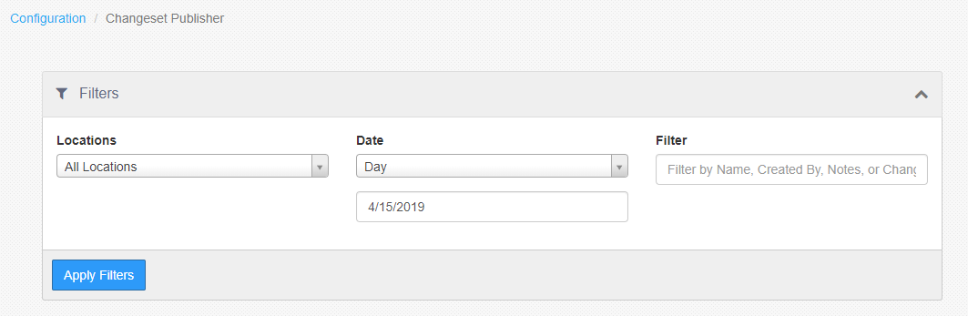

*Changeset Publisher grid*

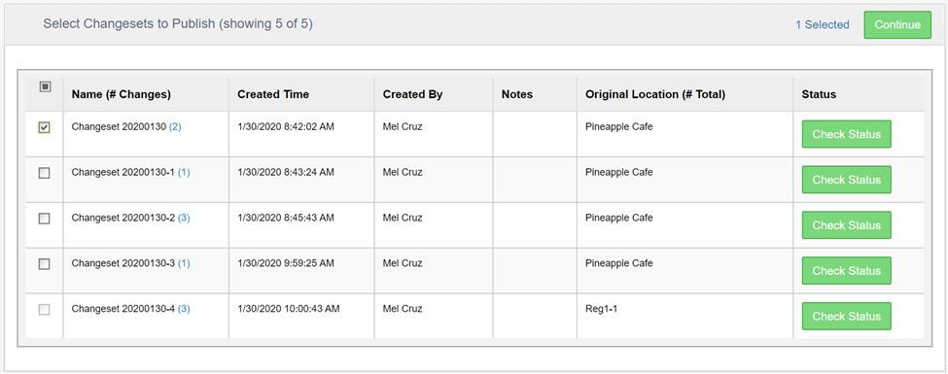

* **Name (# Changesets)**: Name of Changeset with the total count of changes. You can click on the count to view all changes made to which entities.
* **Created Time**: Date and time that the changeset was first published. Time displayed matches

the user’s time zone.

* **Created By**: Full name of the user who first published the changeset. Changesets published by an external API call will not have a creator displayed.
* **Notes**: Any notes added to the changeset when it was created. If the note text runs longer than the width of the Notes column, the note text will be cut off with ellipsis and the user can hover over to display the complete view of all notes for that changeset.
* **Original Location (# Total)**: Name of the original location at which the changeset was first published. The count of other locations to which the changeset has been published will be displayed where you can click and open a dialog that lists all of the locations to which the changeset has been published. This will include any pending scheduled publishes as well.
* **Status**: Clicking the “Check Status” button brings up a popup that allows you to view the

detailed status of the specific changeset.

*Changeset Status Popup*

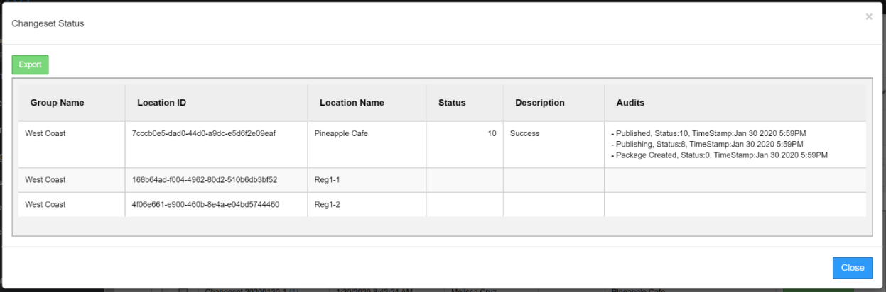

This popup displays all locations and sorts the ones with statuses to the top of the table. You are also

able to use the “Export” button at the top left corner to download the table to a .csv file

*Export of Changeset Status*

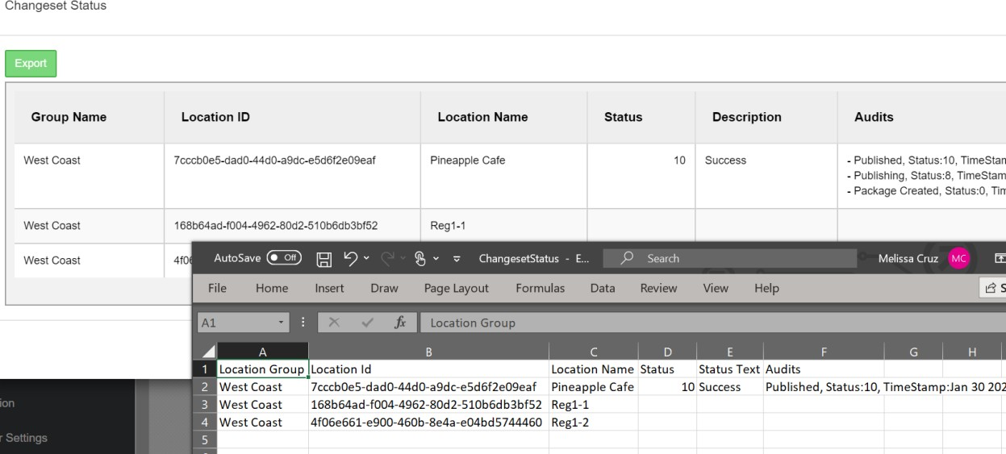

*Status Codes*

|  |  |  |
| --- | --- | --- |
| **Value** | **Status** | **Description** |
| **0** | Unprocessed | Changeset Created |
| **4** | Validating | Validating Changeset |
| **6** | Scheduled | Changeset Scheduled for Publishing |
| **8** | Publishing | Currently Publishing |
| **10** | Published | Changeset Published |
| **12** | Cancelling | Cancelling Changeset |
| **14** | Cancelled | Changeset Cancelled |
| **200** | Failed | Changeset Failed – Cannot Retry |
| **210** | TransientFault | Changeset Failed – Can Retry |
| **220** | HardFault | Changeset resulted in Error |

After clicking “Close” on the Changeset Status popup, selecting a changeset and clicking the Continue button from the Changeset Publisher page, you will be brought to the Configure Changeset Package page. This page can only be accessed via the Changeset Publisher.

On the Configure Changeset Package page, you can **name** the package, select the **target locations** that you want to publish to, and determine the **publish time** of when you want the package to be published.

*Configure Changeset Package page*

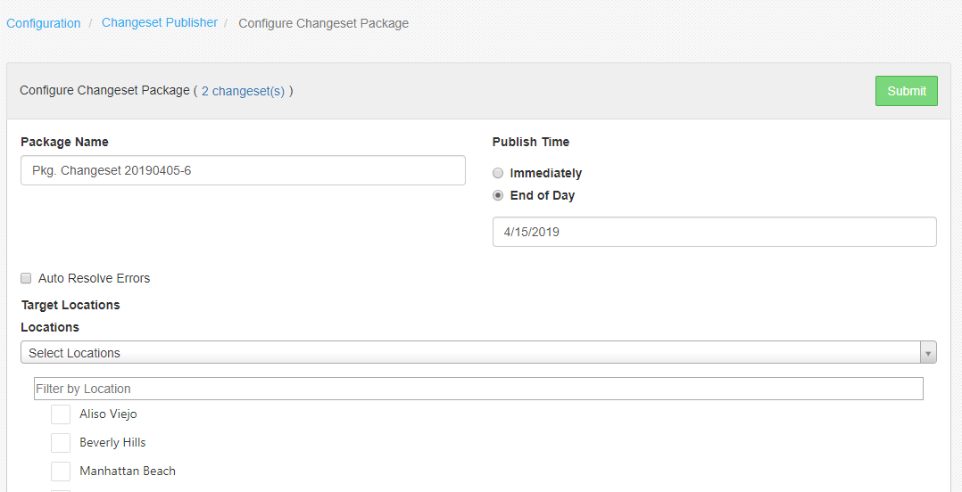

* **Package Name**: Name your package in the Package Name text field. Any text is allowed in the name, including special characters and spaces.
* **Auto Resolve Errors**: Unchecked by default. When checked, the publishing process will delete what it can to successfully publish.
* **Target Locations**: Select the locations that the package will be published to.

#### Locations:

* + **All Locations**: Select every location in the grid.
  + **Select Locations**: Select individual target locations or select each location's group checkbox (if applicable) which will select all the locations in that group at once.

#### Publish Time:

* + **Immediately**: The package will be published to target locations immediately.
  + **End of Day**: The package will be published to target locations upon completion of the selected date's End of Day process. The limit to scheduling a future date is two (2) weeks into the future.
* **Submit**: The package will undergo a simple pre-validation to try and catch any errors before it is completely submitted for publishing.

### Changeset Packages

The Changeset Packages page is the most informative part of the Changeset Publisher tool. Every package, created from either from Settings Editor or in Changeset Publisher, can be viewed and in some cases, modified, from the Changeset Packages page.

You can access the Changeset Packages page using the navigation panel in Admin Portal or as the final page in the process of creating a changeset package. This page is made up of a Filtering tool, to help find published changeset packages by date, name or location, and the Changeset Packages grid to view all the details of a changeset package.

*Filtering tool*

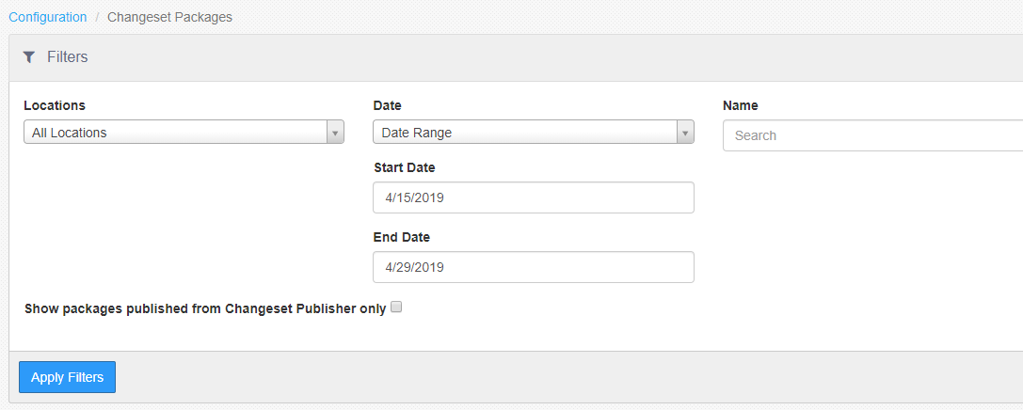

* **Show packages published from Changeset Publisher only**: Unchecked by default. Filters for packages only created from Changeset Publisher.

*Changeset Packages grid*

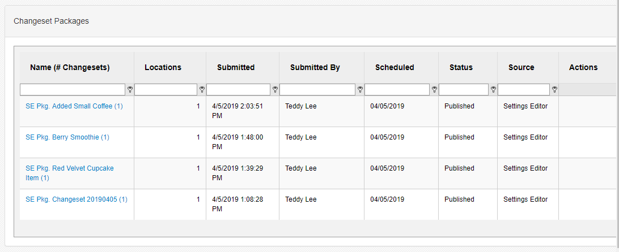

* **Name (#Changesets)**: Package's name with the number of changesets in the package in parentheses. Selecting the package name hyperlink allows you to view the details of the package, including the changeset details and target locations.
* **Locations**: The number of locations selected for the package. For scheduled packages, the count does not include locations that have been cancelled.
* **Submitted By and Submitted**: User who submitted the package and when the package was submitted.
* **Scheduled**: The scheduled date that the package will be published. Immediate publishes will have a scheduled date of the current business date at time of submission.
* **Status:** The package's publish status.
* **Source:** Where the package was created. This will be from Changeset Publisher or Settings Editor

#### Actions:

* + **Edit**: Brings you back to the Changeset Publisher page to make edits to the package. This action is only available if the package has not attempted to publish yet.
  + **Cancel**: Cancels your package to all target locations. This action is only available if the package has not attempted to publish yet.
  + **Retry**: Immediately retries publishing the package to failed locations only; locations that were already successfully publish will be ignored.

Selecting the Package's name from the Changeset Packages page will bring you to the Changeset Package detail page. The purpose of this page is to give you insight into every target location's publish status at the time as well as all the changesets in the changeset package.

The Changeset Package detail page will include two tabs; the Locations tab and the Changeset tab. The Locations tab will give you a view of all the target locations in your package and their respective publish status. The Changesets tab will give you a view all the changesets included in the package.

*Detail page; Locations tab*

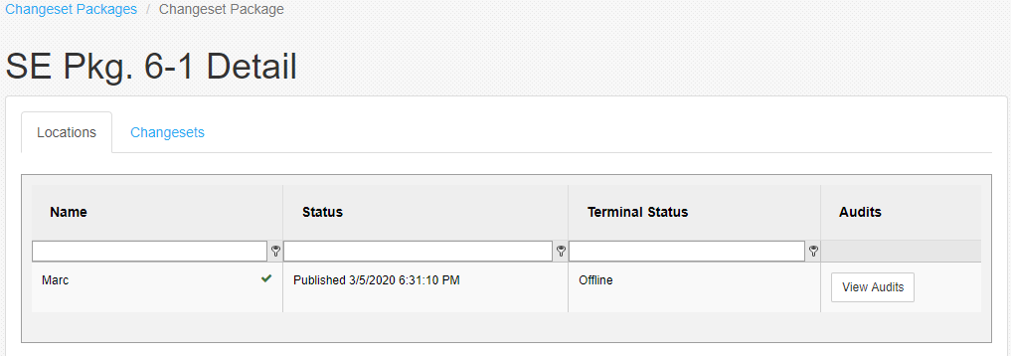

* **Name:** Name of the location receiving the package's changesets.
* **Status:** Location's publish status and the day/time that status was last received.
* **Terminal Status:** The connectivity status of the location's primary terminal (register). The status can be either Online or Offline.
  + The terminal status can be immensely helpful when trying to trouble shoot for a location that has been retrying for a while. Because the successful publish of a package requires the location's primary register to be online at the time, if you see that your location has a terminal status of offline, bringing that primary register online would most likely resolve that location's publish wait time.
* **Audits:** Clicking the “View Audits” button brings up a popup to display a summary of the logs

and statuses associated to the changeset package.

*Audits popup*

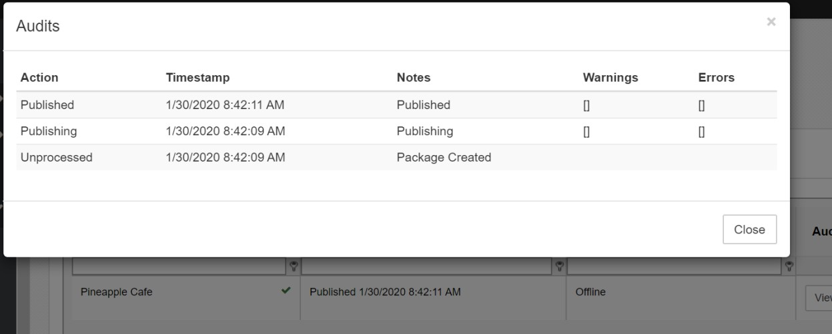

*Detail page; Changesets tab*

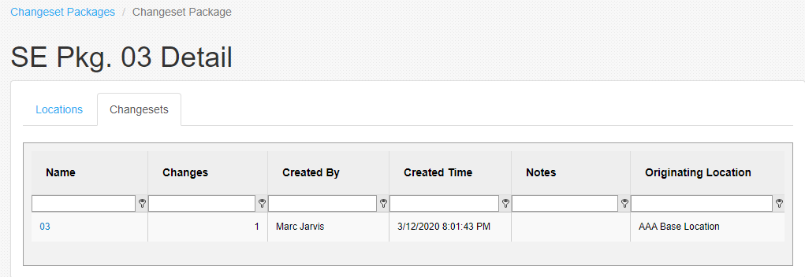

* **Name:** Name of the Changeset. You can click on the changeset name to view all changes made in XML format.
* **Changes:** Number of changes made in the changeset.
* **Created By:** Name of the person who created the changeset.
* **Created Time:** Day and time that the changeset was created. The created time is defined as the time the changeset was published.
* **Notes:** Any notes included in the changeset when it was published. Notes are typically included to help remind the user what changes they made in the changeset.
* **Originating Location:** The original location that the changeset was created from.

### Alerts

Alerts are notifications that are sent via email which are triggered by system events that match certain conditions. New alerts are configured by clicking the **+New Alert** button in the upper right to open the *Alert* configuration page. Existing alerts can be edited by clicking the alert’s name in the list.

*Alerts list*

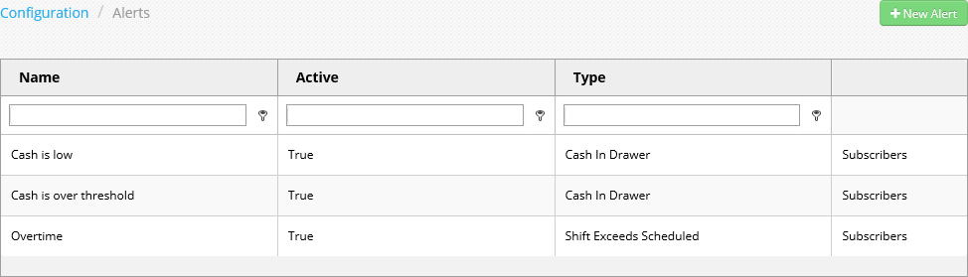

*Alert configuration page*

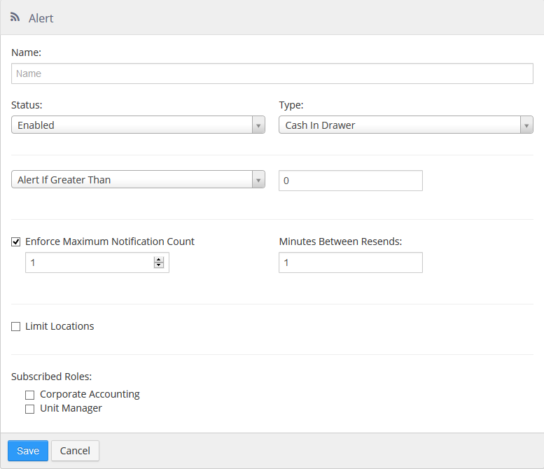

* **Name**: Name of the alert.

#### Status:

* + **Enabled**: Alert will be sent when conditions are met.
  + **Disabled**: Alert will not be sent.

#### Type:

* + **Auto Clock Out**: Send alert when shift is ended by the end of day process.

 **Limit By Job**: Only send the alert for the selected jobs.

* + **Cash In Drawer**: Send alert when calculated cash in a cash drawer is over or under a specific amount.

 **Condition:**

* + - **Alert If Greater Than**: Sent alert when cash exceeds dollar amount.
    - **Alert If Less Than**: Sent alert when cash is under dollar amount.
  + **Customer Assigned**: Send alert when a customer is assigned to an order.

 **Generate alert for reopened orders only**: Only send the alert when the customer is assigned to an order that was previously closed.

* + **Discount Amount** - Send alert when discount applied to an order is over or under a specific amount.

 **Condition:**

* + - **Alert If Greater Than**: Sent alert when discount exceeds dollar amount.
    - **Alert If Less Than**: Sent alert when discount is under dollar amount.

 **Generate alert for reopened orders only**: Only send the alert when the discount is applied to an order that was previously closed.

 **Exclude approved discounts**: Do not sent alert when discount was authorized by another employee.

 **Exclude employee discounts**: Do not sent when the ‘Employee Discount’ button behavior is used.

 **Exclude loyalty discounts:** Do not send when discount is applied via loyalty reward redemption.

* + **Overtime**: Send alert when an employee goes from regular time to overtime.

 **Limit By Job**: Only send for shifts clock in under the selected jobs.

* + **Paid In/Out**: Send alert when paid in or paid out transaction is over or under a specific amount.

 **Condition:**

* + - **Alert If Greater Than**: Sent alert when cash exceeds dollar amount.
    - **Alert If Less Than**: Sent alert when cash is under dollar amount.
  + **Promotion Amount** - Send alert when promotion applied to an order is over or under a specific amount.

 **Condition:**

* + - **Alert If Greater Than**: Sent alert when promotion exceeds dollar amount.
    - **Alert If Less Than**: Sent alert when promotion is under dollar amount.

 **Generate alert for reopened orders only**: Only send the alert when the promotion is applied to an order that was previously closed.

 **Exclude approved promotions**: Do not sent alert when promotion was authorized by another employee.

 **Exclude auto-applied promotion**: Do not send when the promotion is automatically applied.

* + **Shift Exceeds Scheduled**: Send alert when shift time exceeds the time scheduled.

 **Condition:**

* + - **Alert If Greater Than Schedule By**: Sent alert when shift exceeds scheduled time by specified number of minutes.
    - **Alert If Less Than Schedule By**: Sent alert when shift exceeds scheduled time less the specified number of minutes.

 **Limit By Job**: Only send for shifts clocked in under the selected jobs.

* + **Void Amount** - Send alert when items voided on an order are over or under a specific amount.

 **Condition:**

* + - **Alert If Greater Than**: Sent alert when voided amount exceeds dollar amount.
    - **Alert If Less Than**: Sent alert when voided amount is under dollar amount.

 **Generate alert for reopened orders only**: Only send the alert when items are voided on an order that was previously closed.

* **Enforce Maximum Notification Count**: Number of times to send the alert for each occurrence.
* **Minutes Between Resends**: Number of minutes to wait before sending the alert again for the same occurrence.
* **Limit Locations**: Only send the alert for the selected locations.
* **Subscribed Roles**: User roles that are to automatically subscribe to the alert.

### Scheduled Reports

Scheduled reports define reports that are automatically generated and sent via email at a particular time or system event. New scheduled reports are configured by clicking the **+New Scheduled Report** button in the upper right to open the *Scheduled Report* configuration page. Existing scheduled reports can be edited by clicking the scheduled report’s name in the list. Note that viewing and editing is only available to users that have access to all locations within the scheduled report.

*Scheduled Reports list*

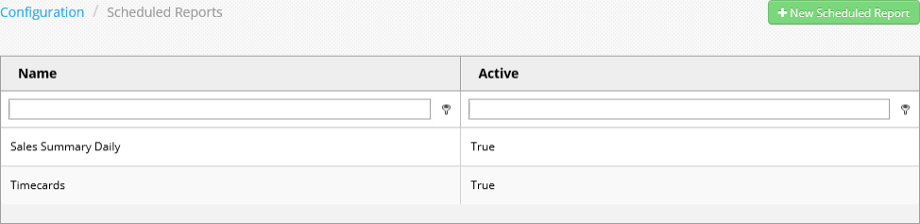

*Scheduled Report configuration page*

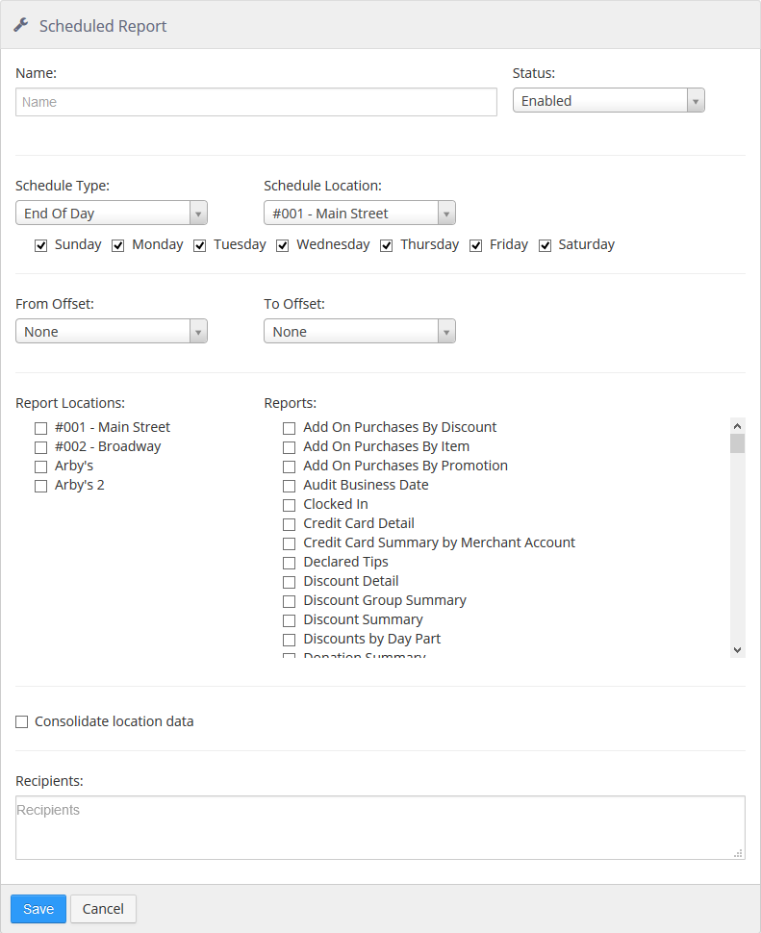

* **Name**: Name of the scheduled report.

#### Status:

* + **Enabled**: Reports will be sent.
  + **Disabled**: Reports will not be sent.

#### Schedule Type:

* + **End of Day**: Reports are sent when the end of day process runs at the schedule location.
  + **Specific Time**: Reports are sent at a specific time at the schedule location.
* **Schedule Location**: Location that determines when the reports are sent, either by EOD or time zone.
* **Days of Week**: Reports are sent on the checked days of the week.
* **From Offset**: Number of days to go back when deterring the start of the date range for the report.
* **To Offset**: Number of days to go back when deterring the end of the date range for the report.
* **Report Locations**: Locations for which reports are to be generated.

**NOTE**: The **Report Locations** list does not show locations in the Location Groups hierarchy (see Location Groups). Locations are simply listed in alphabetical order.

* **Reports**: Reports that are to be generated and attached as PDFs to the email.
* **Consolidate Location data**: Generate one report for all locations that includes aggregate data.
* **Recipients**: Email addresses to send the reports to.

### Tokenization

The *Tokenization* page is where the third-party tokenization provider settings for the group are configured for storing credit cards. These values are provided by Brink Software Support.

Tokenization page

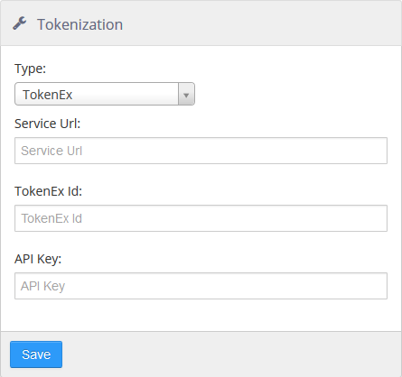

### Processor Settings

The Processor Settings section is where you input processor level settings for gift card processors. Currently, there is only one processor that requires these settings, The Customer Connection.

*The Customer Connection Client ID entry screen*

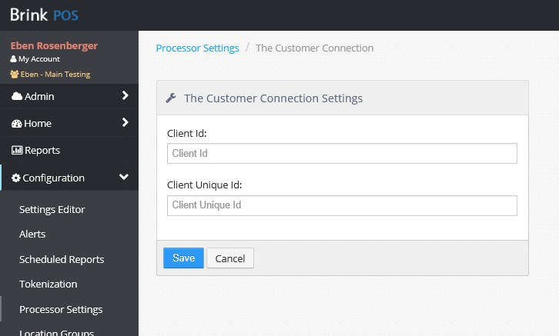

* **Client Id**: Enter the two-digit number given to you by The Customer Connection.
* **Client Unique Id**: Enter the alphanumeric code given to you by The Customer Connection. This code comes in the following format: **XXXXXXXX-XXXX-XXXX-XXXX-XXXXXXXXXXXX.**

### Location Groups

Location groups allow you to arrange locations in a hierarchical fashion. Location groups can be nested to create subgroups, and locations can belong to more than one location group. Location names and numbers (which appear on reports and in Settings Editor) can also be edited here. This feature replaces both **Locations** and **Report Groups** from previous versions of Brink POS.

*Location Groups page*

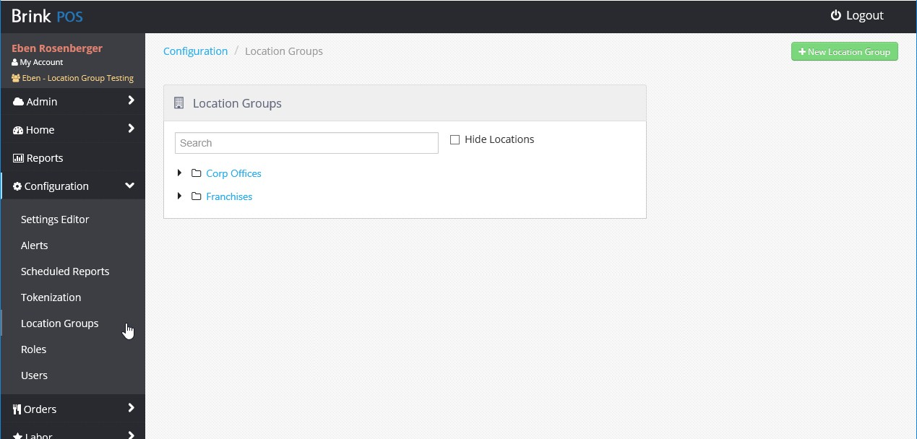

Top level location groups are displayed by default. They are expanded by clicking the arrows beside them. Locations that are not part of a location group are also listed on this page.

*Location Groups expanded to show subgroups and locations*

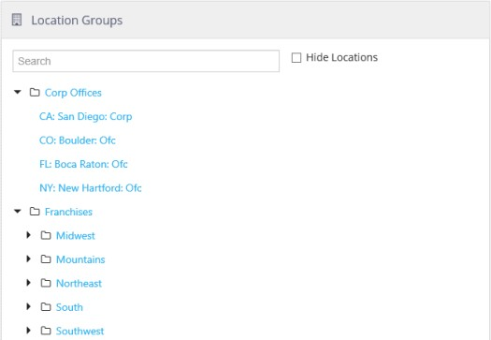

A location group is created by clicking the **+ New Location Group** button in the upper right to open the *Location Group* configuration page. Existing location groups can be edited by clicking the location group’s name in the list.

*Location Group configuration page*

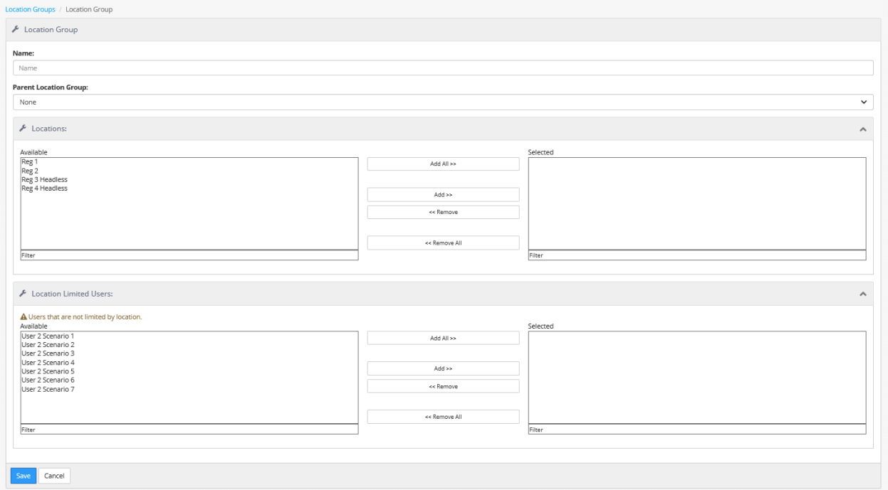

* **Name**: The name of the location group.
* **Parent Location Group**: The location group that this location group is nested under. To make a top-level location group, select None.

#### Locations:

* + **Available**: The list of locations that can be added to this location group.
  + **Selected**: The locations that are included in this location group.

#### Location Limited Users:

* + **Available**: The list of Administrator Portal users who can be assigned to this location group.
  + **Selected**: The users who are assigned to this location group.

**NOTE**: Assigning a user to a location group limits that user’s access to the location group only. This is the same as using the **Limit Locations** check box on the *User* configuration page (see Users).

### Roles

Roles control the areas and functions of the Admin Portal and Settings Editor that a user (see Users) can access. Ranks can be assigned to roles to limit which other users a given user can view or edit. Roles are created by clicking the **+ New Role** button in the upper right to open the *Role* configuration page.

Existing roles can be edited by clicking the role’s name in the list.

*Roles list*

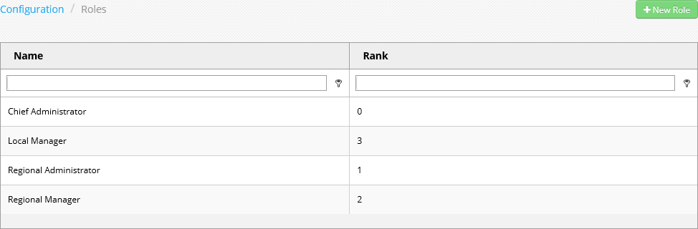

*Role configuration page*

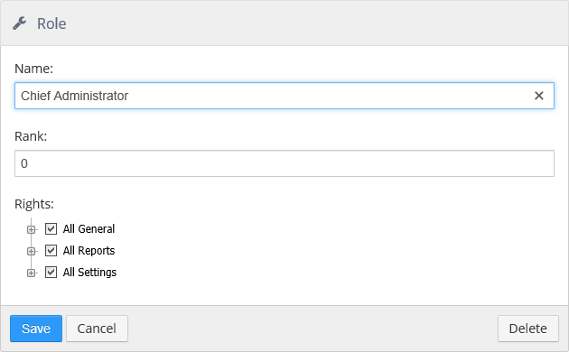

* **Name**: The name of the role.
* **Rank**: The rank of the role. Rank **0** is always the highest rank.

Users of Rank **0** can view and edit all other users. Users of Rank **1** or lower can only view or edit users below their level. For example, a Rank **2** user cannot view or edit other Rank **2** users or any user with a higher rank, but can view and edit users of Rank **3** or lower.

* **Rights**: Functions that are visible and allowed.

### Users

Users are people that can login and access the Admin Portal. Access limitation is controlled by assigning Roles to the user (see Roles). New users are added by clicking the **+ New User** button in the upper right to open the user configuration page. Existing users can be edited by clicking the user’s name in the list.

*Users list*

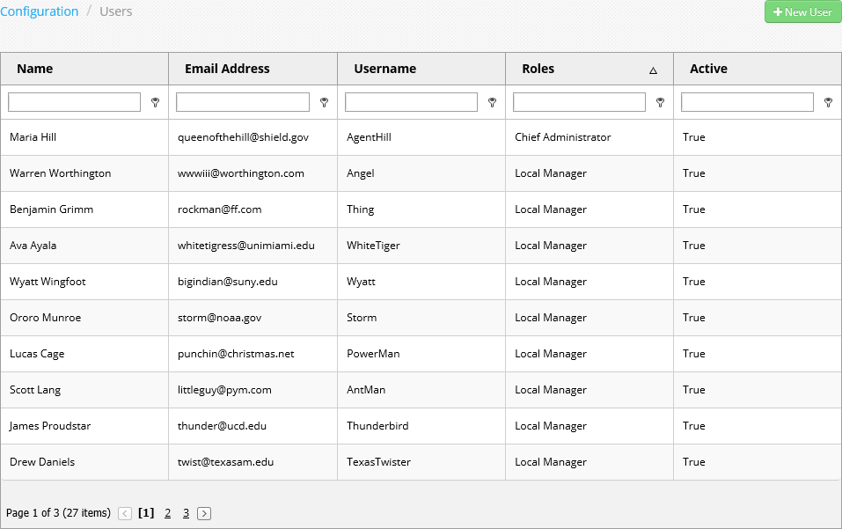

*User configuration page*

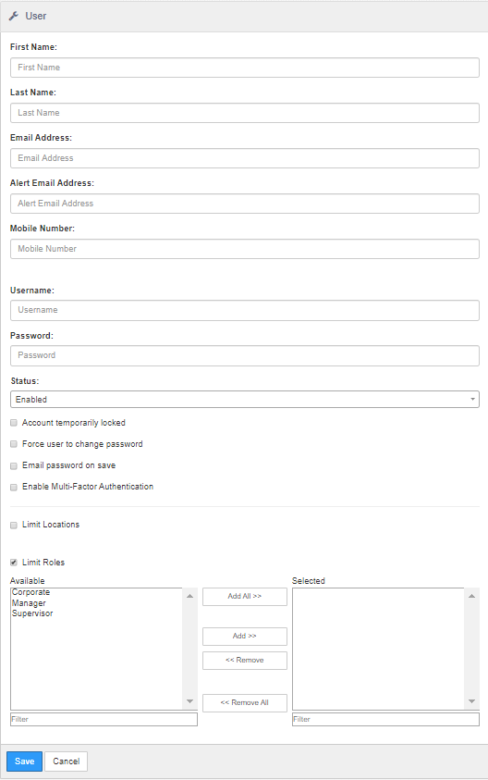

* **First Name**: First name of the user.
* **Last Name**: Last name of the user.
* **Email Address**: Email address of the user for account notifications.
* **Alert Email Address**: Email address to which alerts are sent.
* **Mobile Number**: Used for Multi-Factor Authentication (if applicable)
* **Username**: Username used for logging into the Admin Portal.
* **Password**: Password used to log into the Admin Portal.

#### Status:

* + **Enabled**: User can login to the Admin Portal.
  + **Disabled**: User cannot login to the Admin Portal.
* **Account temporarily locked**: User is not allowed to login due to excessive failed login attempts, automatically resets after 30 minutes.
* **Force user to change password**: User is required to create a new password the next time they login.
* **Email password on save**: Generate an email to the user’s email address that contains Admin Portal URL, username, and password.
* **Enable Multi-Factor Authentication**: Place Holder for future development (MFA)
* **Limit Locations**: User only have access to the selected locations.
* **Limit Roles**: User only has access to functions allowed by the selected roles.

When **Limit Locations** is checked, the location selector is expanded. Locations are displayed in the Location Groups hierarchy (see Location Groups).

*Limit Locations section of the User configuration page*

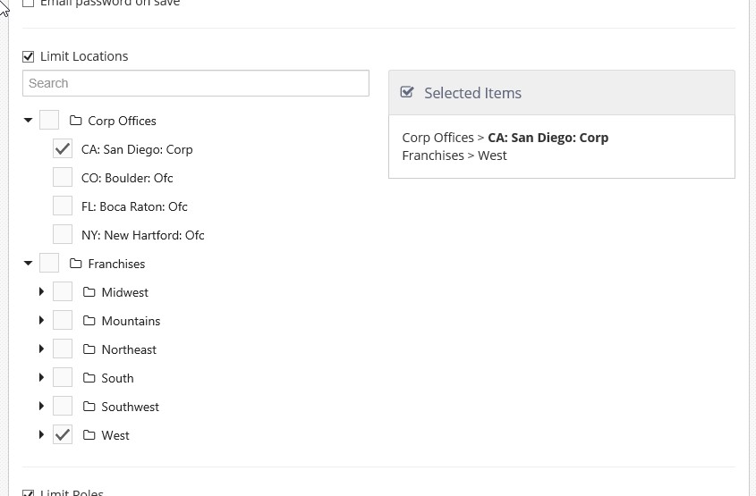

### Promo Codes

Promo codes are single-use codes tied to specific promotions (as set up in Settings Editor; see Promotions). The Promo Codes page allows you to view, create, and manage single-use promotion codes.

*Promo Codes page in Administrator Portal*

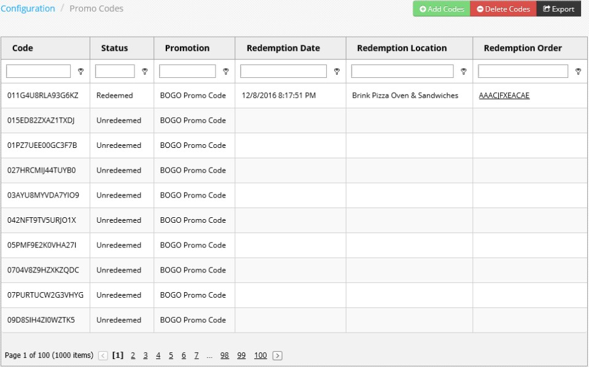

* **Code**: Displays the single-use code.
* **Status**: Shows whether the code is redeemed or unredeemed.
* **Promotion**: Shows the promotion associated with the code.
* **Redemption Date**: Shows the date and time that the code was redeemed. If the code has not been redeemed, this is blank.
* **Redemption Location**: Shows the location where the code was redeemed. If the code has not been redeemed, this is blank.
* **Redemption Order**: Displays the order ID for the order that the code was used for. The order ID is a link to the Order Detail page (see Open Orders and Pending Orders). If the code has not been redeemed, this is blank.

To add codes for a particular promotion, click the **Add Codes** button to open the Add Single Use Promotion Codes page.

*Add Single Use Promotion Codes page, manual entry (left) and auto-generation (right)*

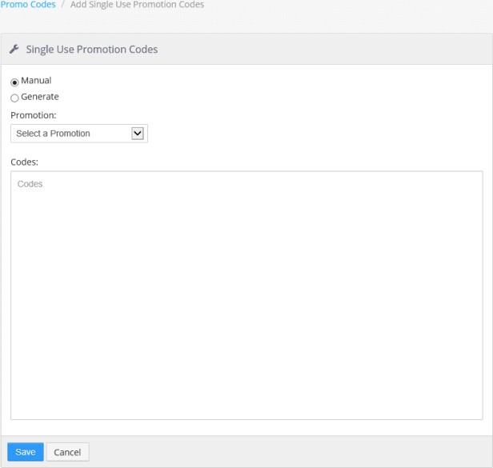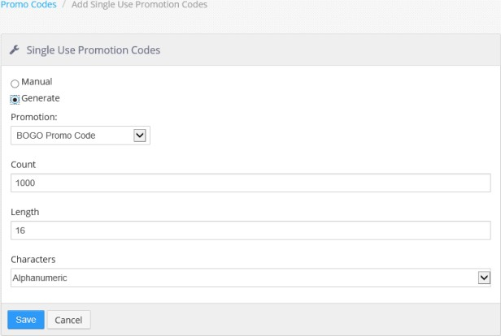

* **Manual**: Select this option to create codes manually. When **Manual** is selected, the **Codes** text area is displayed.
* **Generate**: Select this option to have Administrator Portal generate a set of codes based on a set of parameters. When **Generate** is selected, the **Count** field, **Length** field, and **Characters** drop- down list are displayed.
* **Promotion**: Use the drop-down list to select the promotion for which the codes will be created.
* **Codes** (only displayed if **Manual** is selected): Enter each code on a new line.
* **Count** (only displayed if **Generate** is selected): Enter the number of codes you wish to create.
* **Length** (only displayed if **Generate** is selected): Enter the number of characters that you wish the generated codes to have.
* **Characters** (only displayed if **Generate** is selected): Use the drop-down list to select one of the options:
  + **Alpha**: The code will consist of letters.
  + **Numeric**: The code will consist of numbers.
  + **Alphanumeric**: The code will consist of a mixture of numbers and letters.

**NOTE**: When Save is clicked, the system creates a .zip file called SingleUsePromotionCodeResults.zip which contains a .csv file of all the promotion codes. It is strongly recommended that you save this file so that you can use it later as an aid to distributing the codes to customers.

Click the **Delete Codes** button to open the Delete Single Use Promotion Codes page.

*Delete Single Use Promotion Codes page, by code (left) and by promotion (right)*

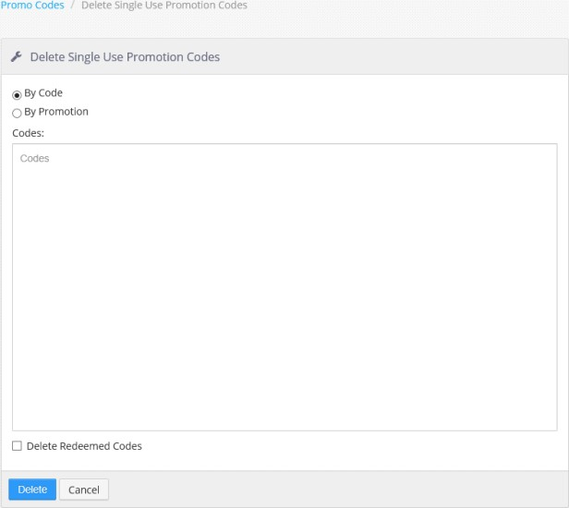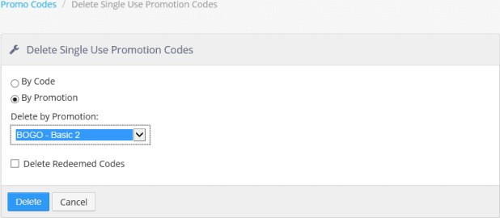

* **By Code**: Select this option to delete codes by entering them manually. When **By Code** is selected, the **Codes** text area is displayed.
* **By Promotions**: Select this option to delete all codes associated with a particular promotion. When **By Promotion** is selected, the **Delete by Promotion** drop-down list is displayed.
* **Codes** (only displayed if **By Code** is selected): Enter the codes you wish to delete, each code on a new line.
* **Delete by Promotion** (only displayed if **By Promotion** is selected): Select the promotion associated with the codes you wish to delete.
* **Delete Redeemed Codes**: Check this box if you wish to delete redeemed codes as well as unredeemed codes.

Click the **Export** button to export all current codes as a .csv file.

### General Settings

The General Settings page contains the *Notification Recipients* list control. Email addresses entered into this list will be notified of Brink POS system upgrades and notifications. There is no limit to the number of email addresses that can be entered, but each email address must be entered on its own line.

*General Settings page*

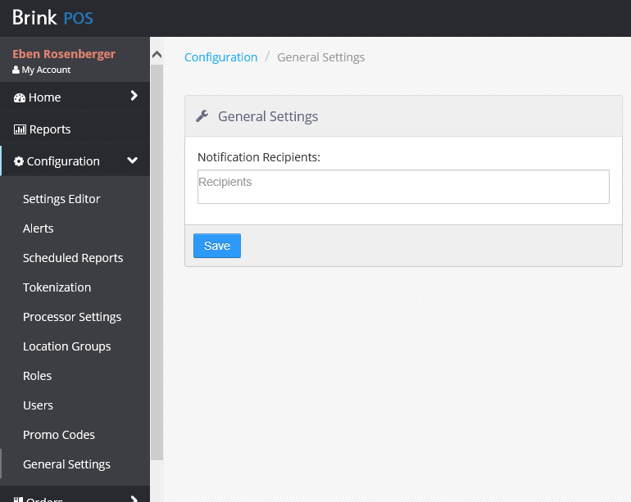

## Orders

The *Orders* section allows you to view open and pending orders and also to search orders.

### Open Orders

The *Open Orders* page displays all orders that are currently open at the selected location.

*Open Orders list*

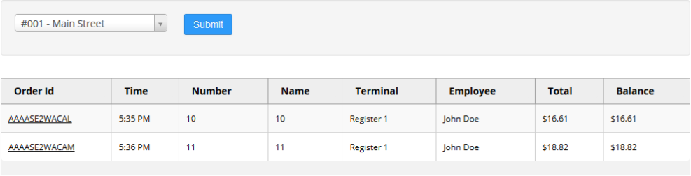

You can use the drop-down list to select the location you wish to view orders for. Clicking the **Order Id** opens an order detail page.

*Order detail page*

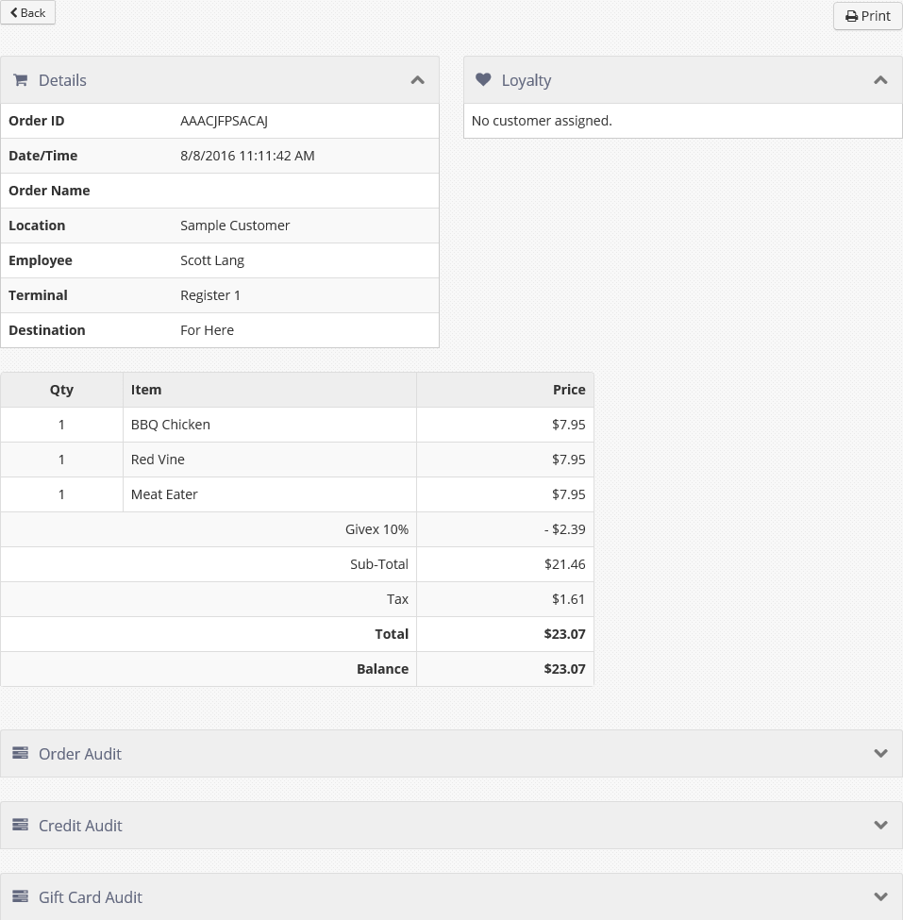

### Pending Orders

The *Pending Orders* page lists all future orders for the selected location which have not been sent to the kitchen.

*Pending Orders page*

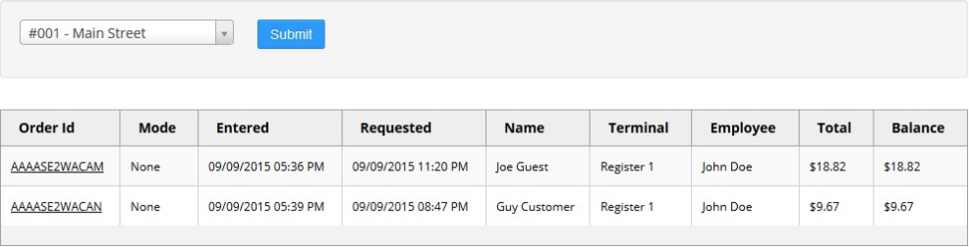

You can use the drop-down list to select the location you wish to view pending orders for. Clicking the **Order Id** opens a pending order detail page.

*Pending order detail page*

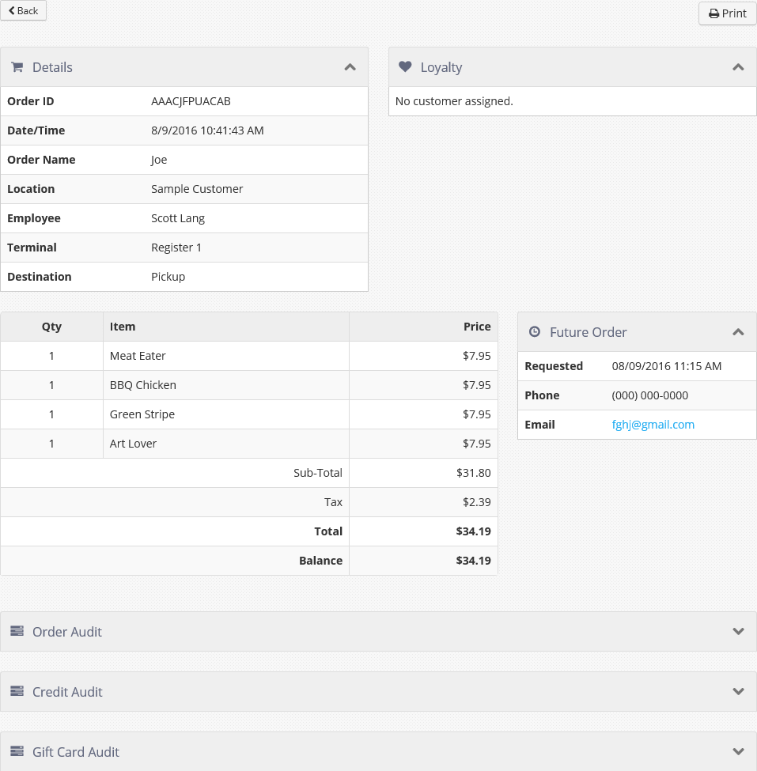

### Search Orders

The Search Orders page allows you to search both open and closed orders, for all locations or only selected locations, for the selected date range. Select the locations you wish to search and set the date range with the appropriate controls, then click **Submit**. The results are displayed in the list below.

*Search Orders page after search has been run*

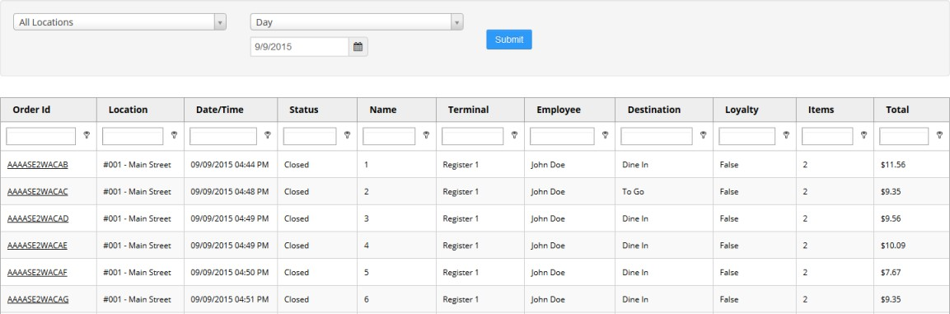

The data can be filtered using the filter row directly below the column header row.

*Filtering options*

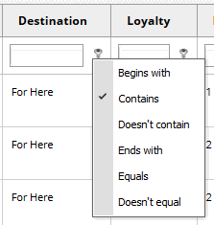

Clicking an Order Id opens the order detail page (see Open Orders and Pending Orders).

## Labor

The Labor section contains tools related to employee shifts and schedules.

### Scheduler

The labor scheduler application allows for scheduling of shifts for punctuality enforcement or schedule distribution. Start by selecting a location from the drop-down list in the top right corner, then select the pay period and date.

*Scheduler page*

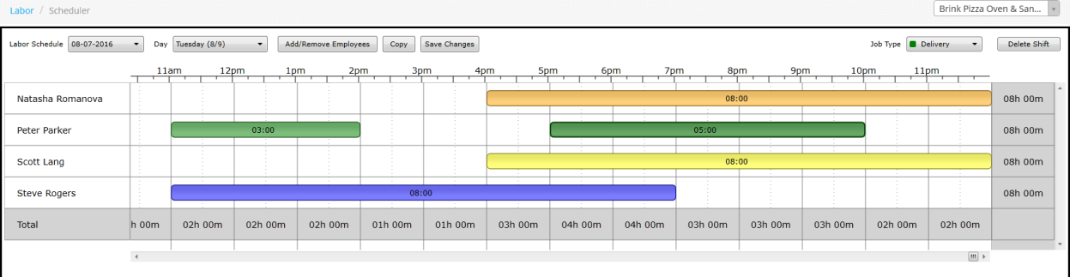

All employees in the selected location are listed on the left. To add a shift, click and drag the shift on the employee’s row, starting at the shift’s start time column and releasing at the end time. The shift will be created using the first job associated with the employee record, but you can change shift’s job by clicking on the shift to highlight it, then use the **Job Type** dropdown to change the shift’s job. To delete a shift, click on the shift to highlight it and then click the **Delete Shift** button.

Use the **Copy** button to copy shifts from prior days or weeks when the schedule has little or no change from day to day or week to week.

The shift for a deleted employee can be seen on the schedule by scrolling to the bottom under 'Unknown'. The shift for a deleted employee can be successfully deleted from the schedule while adding new shifts to the schedule.

Prior to navigating away from the scheduler, closing your browser, or selecting another location, be sure to click the **Save Changes** button to save the schedule.

### Edit Pay Periods

Pay periods are automatically created based on the settings found in the Settings Editor at **Options > Labor > General** (see Labor in Section 2: Settings Editor). The *Edit Pay Periods* page is only used to mark pay periods as either open or closed. When a pay period’s status is set to Closed, no further shift edits will be allowed.

*Pay Period configuration page*

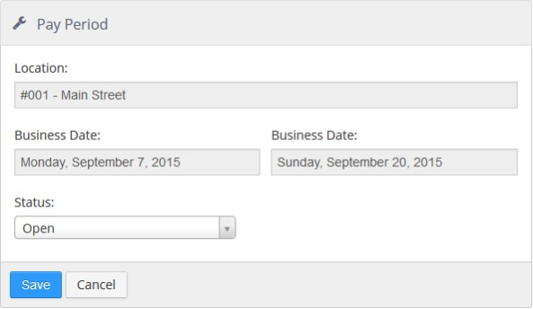

* **Location**: Location to which the pay period applies.
* **Business Date** (start): First business date of the pay period.
* **Business Date** (end): Last date of the pay period.

#### Status:

* + **Open**: Pay period is open and shift edits are allowed
  + **Closed**: Pay period is closed and shift edits are not allowed.

### Edit Shifts

The *Edit Shifts* page displays employee shifts that can be edited for the selected date range. To display shifts that can be edited, set the date range, location, employees, and jobs using the drop-down lists and click **Submit**.

**NOTE**: Only shifts that begin within the date range are shown. For example, if someone works an overnight shift that ends on August 5th, but started on August 4th, then a date range that starts on August 5th will not show that shift.

New shifts can be created by clicking the **+New Shift** button. Existing shifts can be edited by clicking the

employee’s name.

*Shift edit page*

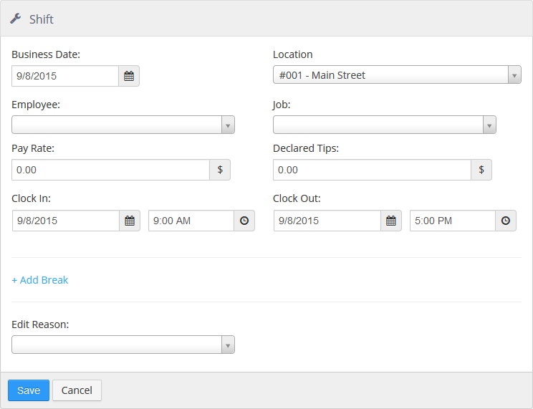

* **Business Date**: Date on which the shift is to be reported as a labor cost.
* **Location**: Location at which the employee worked.
* **Employee**: Employee that worked the shift, only employees in the selected location are displayed.
* **Job**: Job worked, only jobs associated with the employee are displayed.
* **Pay Rate**: Hourly rate of pay for the shift.
* **Declared Tips**: Reported tips earned during the shift.
* **Clock In**: Date and time that the shift started.
* **Clock Out**: Date and time that the shift ended.
* **Edit Reason**: Reason for manually editing or creating the shift. Lists Shift Edit reasons defined in Settings Editor for the selected location.

Breaks can be added to shifts by clicking the **+ Add Break** link.

Break section of the Shift edit page

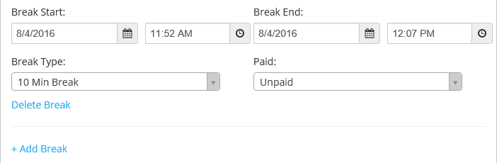

* **Break Start**: Date and time the break started.
* **Break End**: Date and time the break ended.
* **Break Type**: Lists the Break Types defined in Settings Editor at **Options > Labor > Breaks**.

#### Paid:

* + **Paid**: Employee is paid for the time on this break.
  + **Unpaid**: Employee is not paid for the time on this break.

## Guests

The *Guests* section contains tools for looking up or adding customers, configuring house accounts, and performing bulk loyalty adjustments.

**NOTE**: This section only applies to the Brink Loyalty program. If you have another provider for your loyalty program, then these tools do not apply to you.

### Customers

The Customers page contains a search form. You can search on a customer name or any other piece of customer data that is stored in the customer database. Enter the search string and click **Search**.

*Customers page after performing a search*

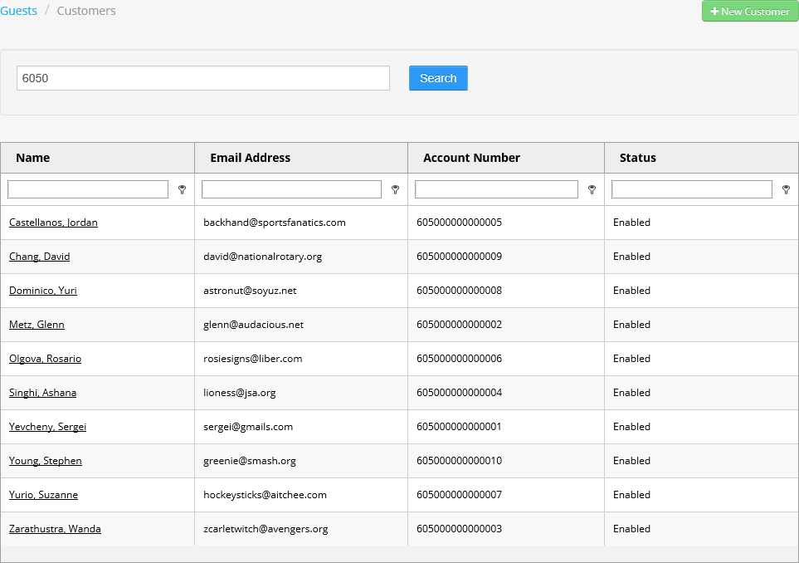

Clicking a name in the customer list displays a customer detail page.

*Customer detail page*

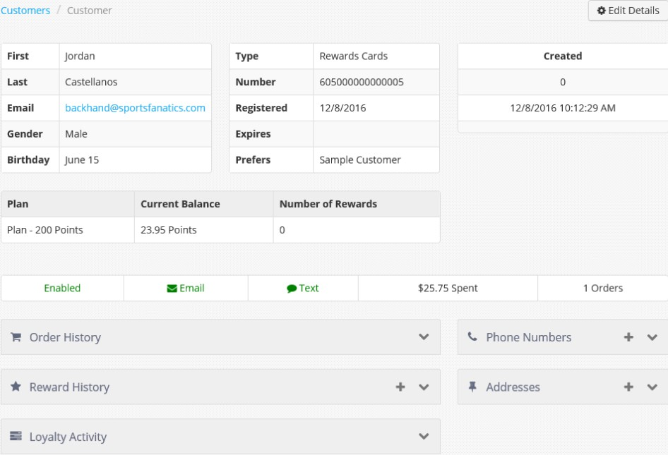

Click the down arrow in any of the title bars to expand the section and see more details. Click the plus sign in any of the title bars to add an entry to that section.

To create a new customer, click the **+New Customer** button in the upper right of the *Customers* page. To edit a customer, click the **Edit Details** button in the upper right of the *Customer* detail page.

*Customer entry/edit page*

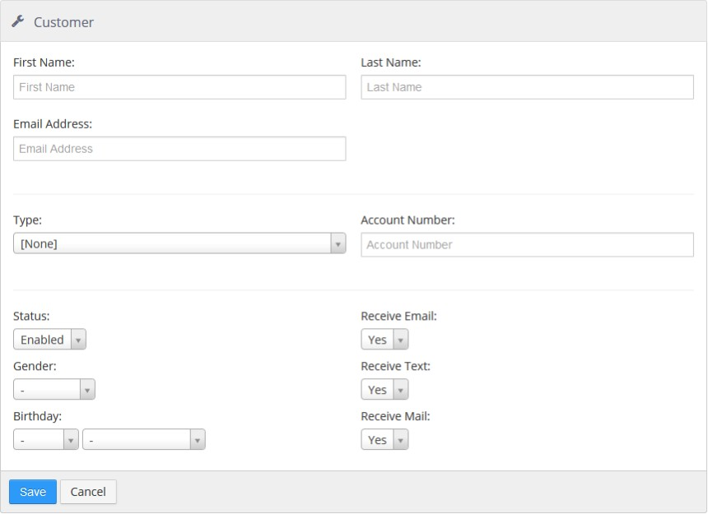

* **First Name**: Customer’s first name.
* **Last Name**: Customer’s last name.
* **Email Address**: Customer’s email address.
* **Type**: Loyalty Card associated with the customer record.
* **Account Number**: Loyalty or gift card number associated with the customer record.

#### Status:

* + **Enabled**: Customer can be assigned to orders and can login to Customer Portal.
  + **Disabled**: Customer cannot be assigned to orders or login to Customer Portal.
* **Gender**: Gender of the customer.
* **Birthday**: Month and day of the customer’s date of birth.
* **Receive Email**: Send the customer system generated emails, and used for filtering customer export.
* **Receive Text**: Used only for filtering customer export.
* **Receive Mail**: Used only for filtering customer export.

### House Accounts

The *House Accounts* page allows you to create new house accounts, edit existing house accounts, and view or edit payment information for house accounts.

*House Accounts page*

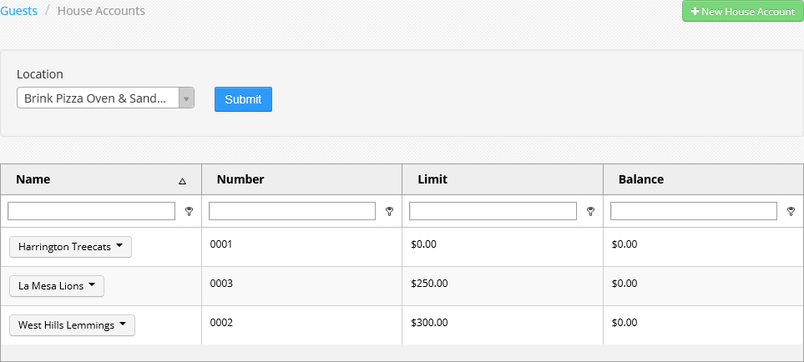

Each house account’s name is a drop-down list with three selections.

*House account drop-down list*

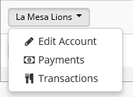

To create a new house account, click the **+New House Account** button in the upper right of the *House Accounts* page. To edit an existing house account, select **Edit Account** from the account’s drop-down list.

*House Account configuration page*

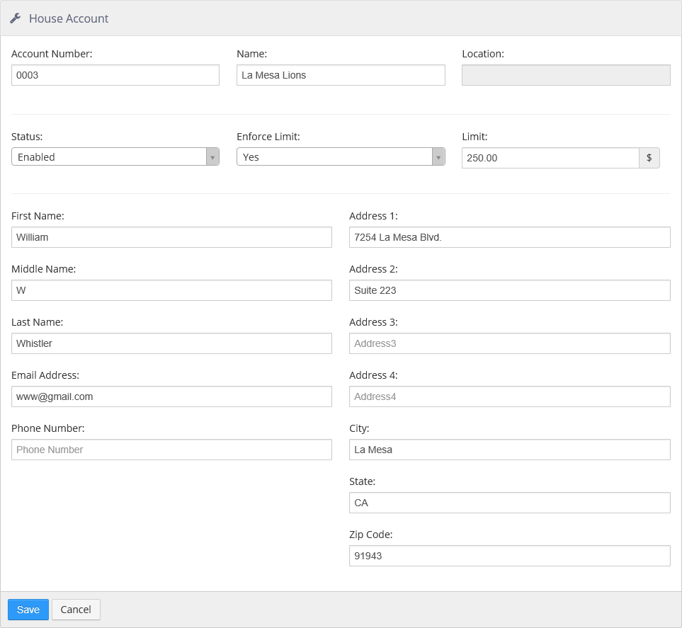

* **Account Number**: number used to lookup house account when tendering
* **Name**: name displayed on house account related reports and when tendering
* **Location**: location at which the house account is valid

#### Status:

* + **Enabled**: house can be tendered to account
  + **Disabled**: house account cannot be tendered to account
* **Enforce Limit**: drop-down to select **No** or **Yes**. If **Yes**, the **Limit** field can be used
* **Limit**: allows entry of a limit amount
* **First Name**: allows entry of first name
* **Middle Name**: allows entry of middle name
* **Last Name**: allows entry of last name
* **Email Address**: allows entry of an email address
* **Phone Number**: allows entry of a phone number
* **Address 1 to 4**: provides four lines to enter an address
* **City**: allows entry of a city name
* **State**: allows entry of a state
* **Zip Code**: allows entry of a zip code

Selecting **Payments** in a house account’s drop-down list opens the *Payments* page.

Payments page

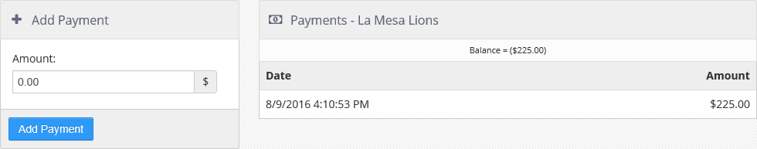

The *Payments* section shows payments made to the account recently, plus a balance at the top. The *Add Payment* section allows you to add a payment to the house account, which is then displayed in the *Payments* section.

Selecting **Transactions** in a house account’s drop-down list takes you to the configuration page for the

*House Account Detail* report. See Accounting under Reports for more information.

### Bulk Adjust

Clicking **Bulk Adjust** takes you to the *Loyalty Adjustment* page, which allows you to make bulk adjustments to loyalty program participants.

*Loyalty Adjustment page*

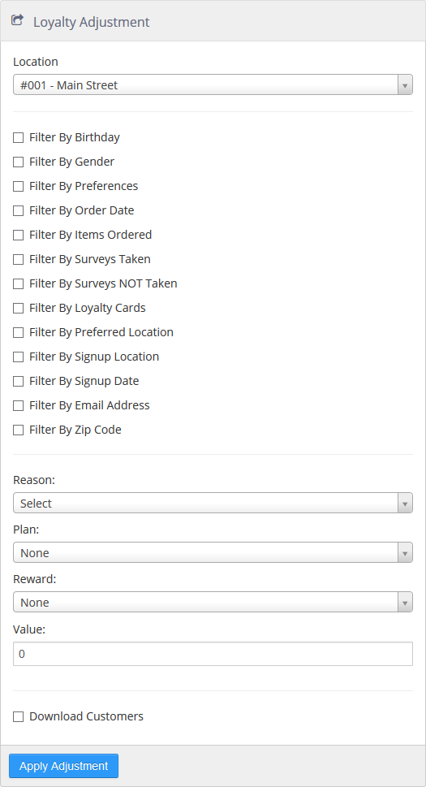

* **Location**: The location which the loyalty activity will be issued from.

#### Filters:

* + **Filter By Birthday**: Filter customer to those whose birthday is within a given date range.
  + **Filter By Gender**: Filter the customers by one or more gender options.
  + **Filter By Preferences**: Filter the customers by one or more communication preferences.
  + **Filter By Order Date**: Filter the customers to those who ordered within a given date range.
  + **Filter By Items Ordered**: Filter customer to those who have ordered one or more particular items.
  + **Filter By Surveys Taken**: Filter customers to those who have completed one or more particular surveys.
  + **Filter By Surveys NOT Taken**: Filter customers to those who have not completed one or more particular surveys.
  + **Filter By Loyalty Cards**: Filter customers to those associated with a particular loyalty card.
  + **Filter By Preferred Location**: Filter customers to those who prefer a particular location.
  + **Filter By Signup Location**: Filter customer to those whose account was created at a particular location.
  + **Filter By Signup Date**: Filter customer to those that were created within a given date range.
  + **Filter By Email Address**: Filter customer to those whose email address is in a given list of email addresses.
  + **Filter By Zip Code**: Filter customer to those that have an address with a zip code is in a given list of zip codes.
* **Reason**: Reason for making the adjustment. Lists the **Loyalty Adjustment Reasons** defined in Settings Editor. See Loyalty Adjustment Reasons
* P**lan**: Loyalty plan that any value/points are to be associated with.
* **Reward**: Reward to add to the customer account.
* **Value**: Loyalty value or points to be added to the customer account.
* **Discount**: Maximum dollar value of the reward, when the selected reward is of type Discount.
* **Download Customers**: Generate a CSV file containing all of the customer records affected by the adjustment for download.

## Accounting

Accounting allows you to access budgets, deposits and royalties.

### Budgets

Sales and labor budgets can be defined on a per day and per location basis for the purpose of reporting sales and labor as a percent of budget on the Admin Portal Dashboard.

*Budget page*

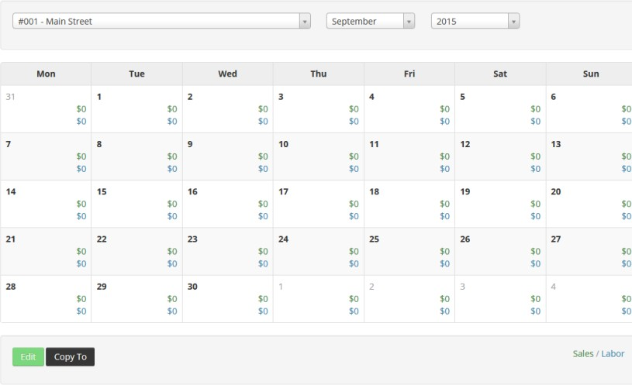

Use the **Edit** button at the bottom of the page to enable edit mode on the calendar.

*Budget page edit mode*

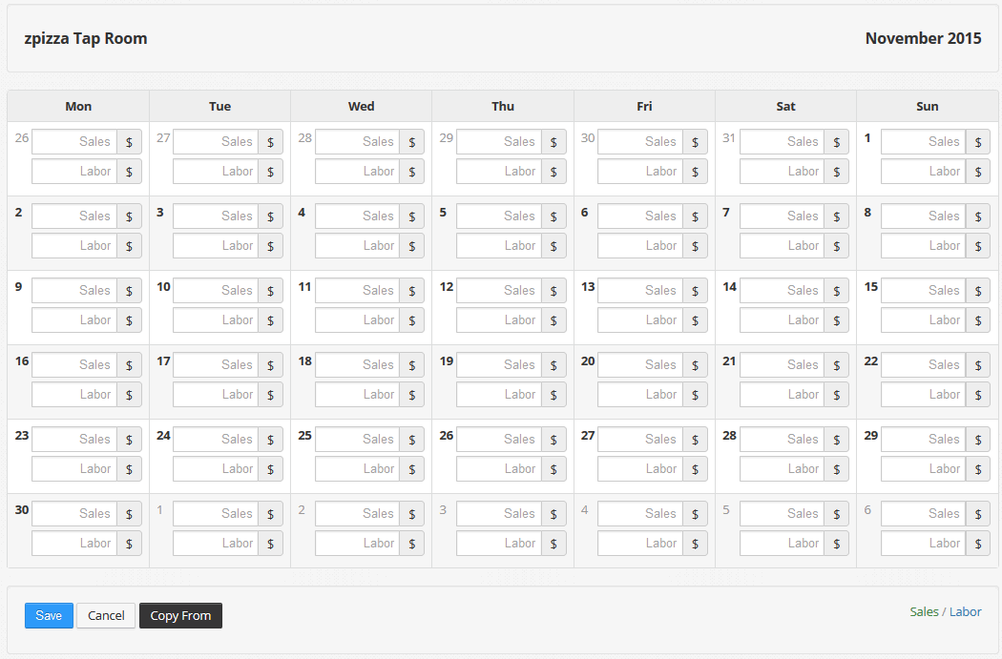

Once in edit mode, you can enter daily budget amounts or use the **Copy From** button to copy budget values for other months/locations.

You can also use the **Copy To** button to copy the visible month to another month and/or location.

### Deposits

Bank deposits are used to report cash variances on the Daily Sales Summary report in the Admin Portal, and any variance is also included in any GL account exports.

*Deposits page*

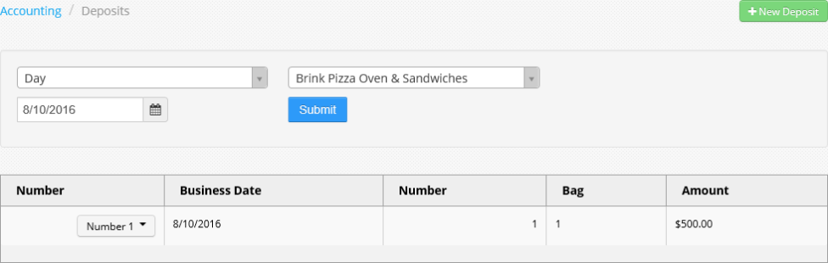

New deposits are created by clicking the **+New Deposit** button to open the *Deposit* entry screen. Existing deposits can be edited by selecting **Edit** in the deposit’s drop-down list.

*Deposit entry screen*

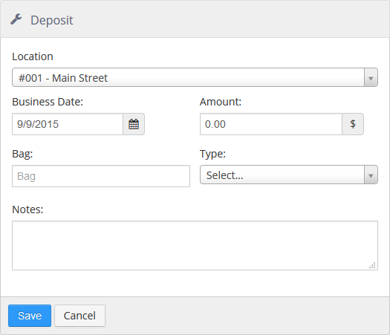

* **Location**: Location of the bank deposit. This can be selected using the drop-down list for a new deposit, but cannot be edited.
* **Business Date**: Business date on which to report the bank deposit. This can be changed when creating a new deposit, but cannot be edited.
* **Amount**: Dollar amount of the bank deposit.
* **Bag**: Name or number on the physical bag, for auditing purposes.
* **Type**: Type of bank deposit, lists the Deposit Types defined in Settings Editor for the selected location.
* **Number**: The number of the deposit. This is only displayed when editing a deposit, not when creating a new one.
* **Notes**: Any pertinent notes for auditing purposes.

Selecting **History** in the deposit’s drop-down list shows the history of the deposit.

*History dialog*

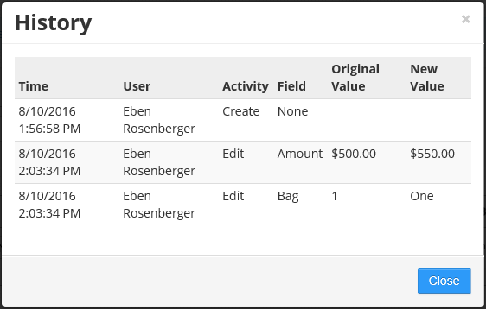

### Royalties

Royalties can be defined for the calculation of royalties reported on the Royalties by Location report.

*Royalty entry dialog*

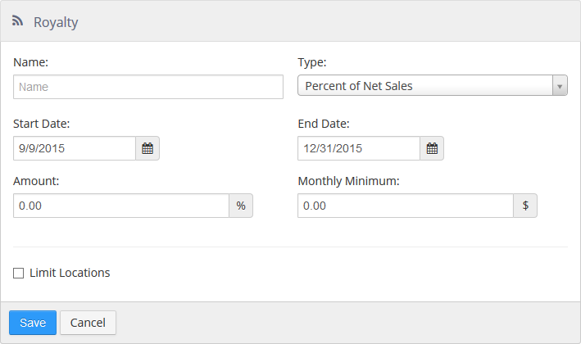

* **Name**: Name of the royalty.

#### Type:

#### Percent of Net Sales:

 **Amount**: Percent of the net sales that is due as a royalty.

 **Monthly Minimum**: Minimum amount due per month, regardless of percent of net sales.

#### Fixed Per Month:

 **Amount**: Dollar amount of the royalty per month.

* **Start Date**: First business date the royalty is effective.
* **End Date**: Last business date the royalty is effective.
* **Limit Location**: Royalty is only to be paid by the selected locations.

## Export

The Export section provides tools for exporting customers, sales, labor, settings, and surveys.

### Customers

The *Export Customers* tool produces a CSV file for download which contains customer records that match the selected filters.

*Export Customers tool*

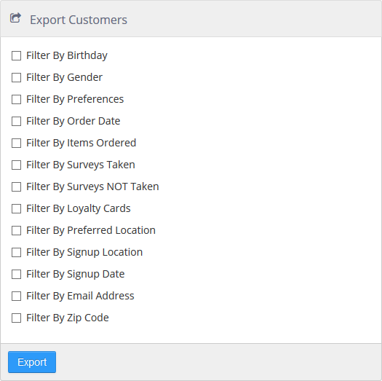

* **Filter By Birthday**: Filter customer to those whose birthday is within a given date range.
* **Filter By Gender**: Filter the customers by one or more gender options.
* **Filter By Preferences**: Filter the customers by one or more communication preferences.
* **Filter By Order Date**: Filter the customers to those who ordered within a given date range.
* **Filter By Items Ordered**: Filter customer to those who have ordered one or more particular items.
* **Filter By Surveys Taken**: Filter customers to those who have completed one or more particular surveys.
* **Filter By Surveys NOT Taken**: Filter customers to those who have not completed one or more particular surveys.
* **Filter By Loyalty Cards**: Filter customers to those associated with a particular loyalty card.
* **Filter By Preferred Location**: Filter customers to those who prefer a particular location.
* **Filter By Signup Location**: Filter customer to those whose account was created at a particular location.
* **Filter By Signup Date**: Filter customer to those that were created within a given date range.
* **Filter By Email Address**: Filter customer to those whose email address is in a given list of email addresses.
* **Filter By Zip Code**: Filter customer to those that have an address with a zip code is in a given list of zip codes.

### Sales

The *Export Sales* tool produces a file that can be imported into a third-party accounting or inventory system. The format and file type of the export is dependent on the export type that is selected. For example, the file format for QuickBooks is IIF.

*Export Sales tool*

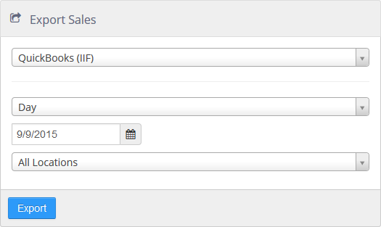

Data formatting is based on the general ledger account mapping defined in Settings Editor at **Options > Accounting > GL Export**. Contact your third-party software provider for details on how to import the exported file.

### Labor

The Export Labor tool produces a file that can be imported into a third-party payroll system. The format and file type of the export is dependent on the export type that is selected.

Export Labor tool

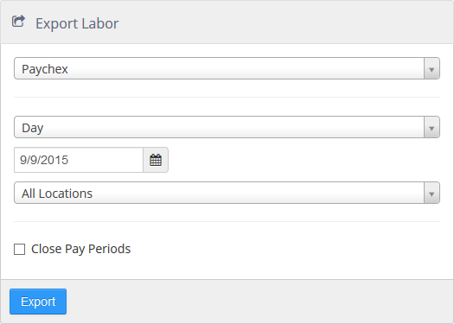

Data formatting and file name is based on the settings defined in Settings Editor at **Options > Labor > General**.

When **Close Pay Periods** is checked, the status any pay periods included in the export will be set to Closed.

Contact your third-party software provider for details on how to import this file.

### Settings

The Export Settings tool produces a CSV file containing records of the selected settings type from the selected location. Currently, only items can be exported.

*Export Settings tool*

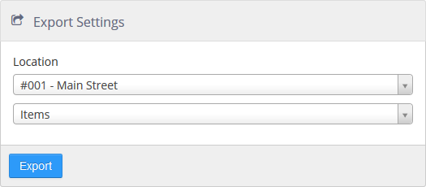

### Surveys

The Export Survey Results tool produces a CSV file containing survey responses for the selected survey completed within the selected date range.

Export Survey Results tool

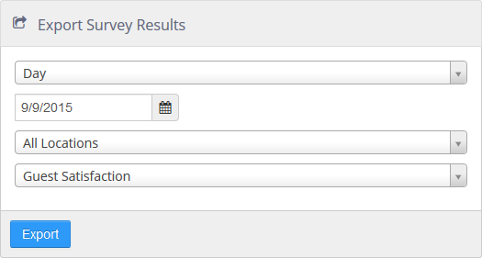

## Tools

The Tools section gives you access to the End of Day tool and the Email Template tool.

### Run End of Day

This tool lets an Admin Portal user initiate the end of day process at a location remotely.

*Run End of Day tool*

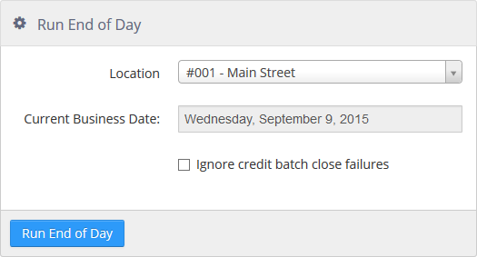

* **Location**: drop-down to select location where end of day is run.
* **Current Business Day**: shows the current business day.
* **Ignore credit batch close failures**: when checked, batch close failures are ignored.

**NOTE**: At least one Register must be online in order to initiate the end of day process via the Admin Portal. This is to ensure that an offline store does not have transactions that need to be synchronized to the Brink data center.

### Send Email Template

With this tool, an Admin Portal user can send an email template for testing purposes or to resend an email to a particular customer.

*Send Email Template tool*

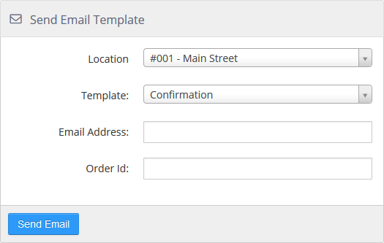

* **Location**: Location from which the email is to be send.
* **Template**: Email template defined in Settings Editor to send.
* **Email Address**: Email address of the recipient.
* **Order Id**: Order ID of the order to use when the email template includes order details.

# Section 2: Settings Editor

The Settings Editor is used for the configuration of all location specific settings; this includes hardware, peripherals, employees, and menus.

*Settings Editor toolbar*



The Settings Editor toolbar contains the following controls:

* **Location drop-down list**: Lists all locations available to the current user, configuration for the selected location is visible in the Settings Editor.
* **Refresh button**: Reverts all changes made to the selected location since the last Save or Publish.
* **Save button**: Saves all changes, for the selected location, since the last time a save or publish was performed.
* **Publish button**: Saves and publishes all changes, for the selected location, since the last time a publish was performed.
* **Delete Changeset button**: Permanently deletes the currently saved changeset for the selected location.
* **Changeset Publisher button**: Opens the Changeset Publisher window.
* **Close Settings Editor button**: Exits Settings Editor and returns you to Administrator Portal.

*Changeset Publisher dialog*

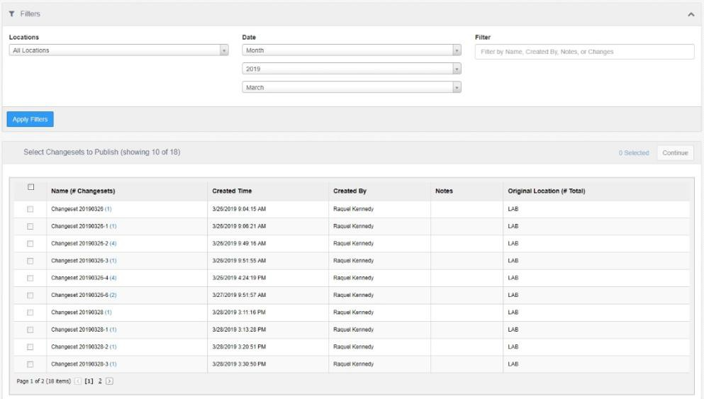

The *Changeset Publisher* displays published changes, optionally filtered by date range, location, and detail text. Selecting a changeset row, then selecting the **Show Changeset Locations** link near the bottom of the screen will expand a windowpane listing the locations that the changes have been

published to. To publish a changeset to another location, or multiple locations, select the changeset row, check the target locations in the pane to the right, then click the **Publish** button at the bottom.

## Brands

Item sales can be allocated to multiple concepts, allowing reporting sales of common items across brands.

*Edit Brand dialog*

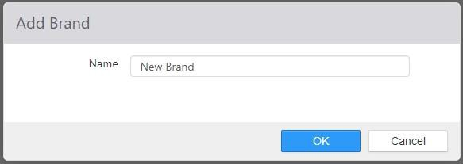

The brands set here can be used in **Items**, **Brand Allocations** tab. In addition, your Product Mix report shows items grouped by brand.

## Cash Drawers

The Cash Drawers page lists the physical cash drawers at the location.

*Edit Cash Drawer dialog*

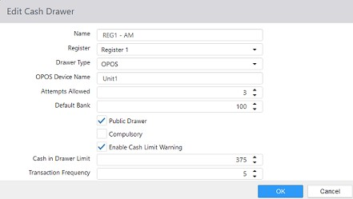

* **Name**: Name of the cash drawer.
* **Register**: Terminal that the cash drawer is associated with.
* **Drawer Type**: Interface type of the cash drawer.

#### None

#### OPOS

 **OPOS Device Name**: Logical device name in the OPOS driver.

#### POS for .Net

#### Printer Interface

 **Printer**: Printer the cash drawer is physically connected to.

**NOTE**: This cannot be an OPOS printer.

#### Serial Interface

 **Serial Port**: COM port the cash drawer is physically connected to.

* **Attempts Allowed**: Number of times the system will allow an invalid declared cash amount when cash drawer is checked out.
* **Default Bank**: Default starting bank amount when cash drawer is assigned.
* **Public Drawer**: Allows cash drawer to be assigned as public, allowing any employee to utilize the cash drawer.
* **Compulsory**: Requires the cash drawer to be closed before any further functions can be performed.

#### Open Status Phase:

***Open Status Phase*** *drop-down list*

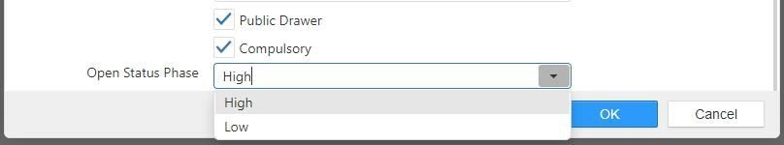

* **Enable Cash Limit Warning:** Enables Cash Skims which allows configurable excess cash warnings. The cashier will be notified and a clear visual signal for the manager will also be displayed. This feature will reduce the risk of cash handling errors and help prevent the risk of robbery due to known high levels of cash on hand.
  + A Skim Detail Report has also been added for restaurant management/operators. It provides the insight needed to ensure the cash skim is completed in a timely manner.
* **Cash in Drawer Limit:** Set to the maximum dollar amount the drawer can hold before warning a skim must be performed.
  + It is required to include the default bank when using the skim feature. All cash taken from the drawer in a drawer skim will include the starting bank, no way around this.
  + Red border on the Register will persist until the amount of cash in the drawer is below the limit
* **Transaction Frequency:** Once the drawer limit has been reached, this setting determines the number of orders that can be taken before the cashier is given another warning.
  + Default is 5
  + A Transaction is completed when an order is closed
  + Auto-Close Destination excluded from calculation

## Charities

Charities can be assigned to orders and financially accounted for as donations on the Sales Summary reports and Donation summary report. Donations are not included in reported sales.

*Edit Charity dialog*

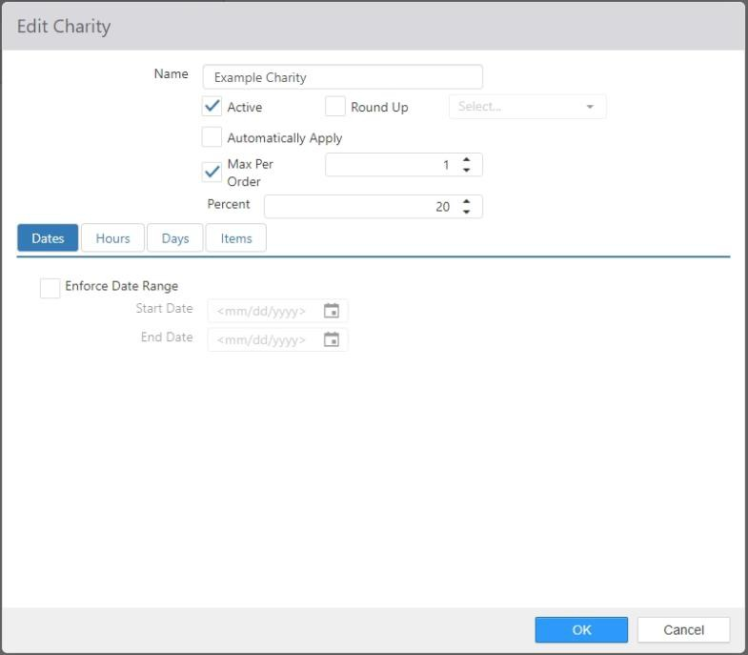

* **Name**: Name of the charity.
* **Active**: Charity can be assigned to orders.
* **Round Up**: Activate the “round up for charity” feature. Use the drop-down list to select the non- revenue, zero-priced item associated with the round up feature. See Items.
* **Automatically Apply**: Automatically apply the charity to all orders that qualify.
* **Max Per Order**: Limits the number of times the charity can be assigned to an order.
* **Percent**: Charity amount to be applied as a percent of the order sub-total.
* **Date**: Limits the date(s) on which the charity can be applied.
* **Time**: Limits the time of day during which the charity can be assigned.
* **Days**: Limits the day(s) of the week on which the charity can be assigned.
* **Items**: Items in the *Selected Items* list will have their sales counted towards the charity.

**NOTE**: It is recommended that any items sold for charity be non-revenue items. See Items.

## Customer Attributes

Customer attributes are custom data fields associated with customer records. For example: Company Name. They are visible in the Register, Customer Portal, and Admin Portal.

*Edit Customer Attribute dialog*

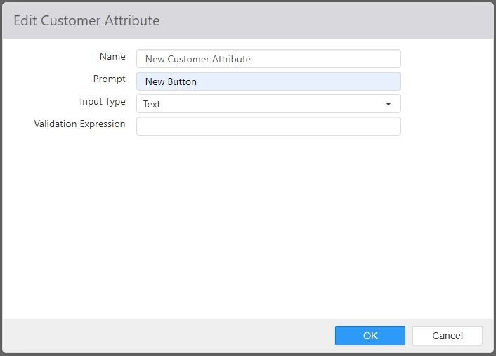

* **Name**: Name of the customer attribute.
* **Prompt**: Label that appears next to the value input on the Register, Customer Portal, and Admin Portal.
* **Input Type**: Type of data expected.
  + **Text**: Single line text box.

 **Validation Expression**: Regular expression for validating input as valid.

* + **Date**: Date control is displayed.
  + **Select Multiple**: List of choices with multiple selections allowed.
  + **Select Single**: List of choices with single selection allowed.

## Day Parts

Day parts are used to report sales and labor for specific time periods during the day. There are various day part related reports both on the Register and in the Admin Portal.

*Edit Day Part dialog*

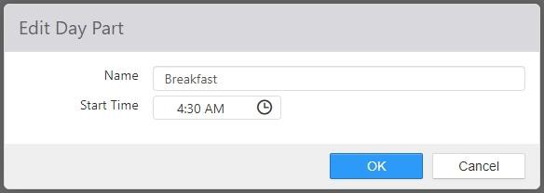

* **Name**: Name of the day part.
* **Start Time**: Time that the day part starts, and the time the prior sequential date part ends.

## Deposit Types

The deposit types created here are listed in the **Type** field of the *Deposit* entry dialog under **Accounting**

**> Deposits** in Administrator Portal (see Deposits), and in the **Type** field of the *New Bank Deposit* dialog in the Bank Deposit button functionality in Register (see Layouts > Button behaviors > Bank Deposits).

Note: In order to create bank deposits in either Administrator Portal or Register, it is **required** to set up deposit types here in Settings Editor.

*Edit Deposit Type dialog*

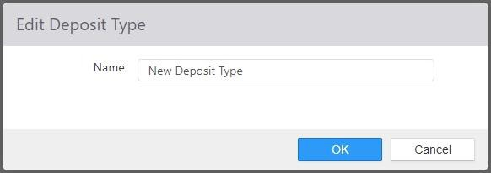

## Destinations

Destinations are used to communicate to the kitchen how to package the order, and also determine how items are routed to the kitchen via printer groups and video groups.

***Details*** *tab on Edit Destination dialog*

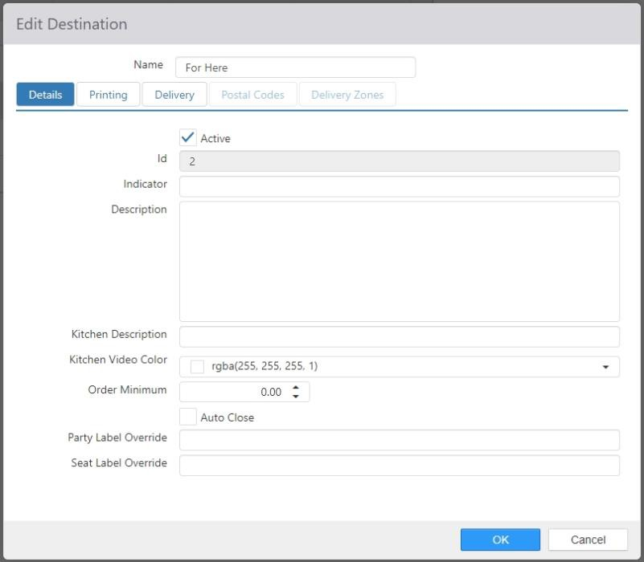

* **Name**: Name of the destination.

#### Details tab:

* + **Active**: Destination can be assigned to orders.
  + **Id**: Auto generated destination ID.
  + **Indicator**: Prints in front of the item name on the kitchen chit.
  + **Description**: When entered, replaces the destination name in Customer Portal.
  + ***Reminder Message****: NO LONGER USED*
  + **Kitchen Description**: When entered, replaces the destination name displayed on kitchen chit and kitchen video display.
  + **Kitchen Video Color**: Color of the destination name displayed on kitchen video display.
  + **Order Minimum**: Order sub-total minimum required.
  + **Auto Close**: Auto close order when order is sent to the kitchen and there is no balance due.
  + **Party Label Override**: When entered, changes the Table caption to the entered text in the Pivot Seat control, on the Order list, and on the kitchen chit.
  + **Seat Label Override**: When entered, changes the Seat caption to the entered text in the Pivot Seat control, on the Order list, and on the kitchen chit.

#### Printing > Receipt tab:

***Printing > Receipt*** *tab on Edit Destination dialog*

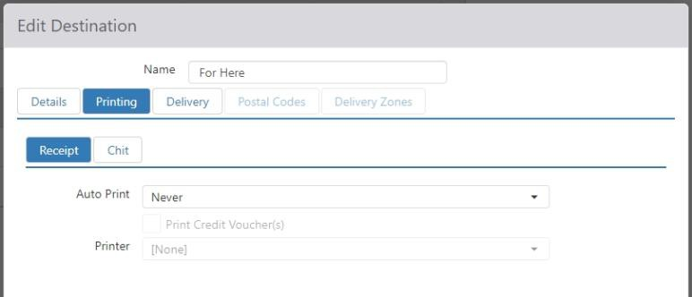

* + **Auto Print**: Automatically print order receipt.

 **Never**: Do not auto print.

 **Immediate**: Print when future order is received.

 **On Send to Kitchen**: Print when order is sent to kitchen.

* + - **Print Credit Voucher(s)**: And includes credit drafts when auto print is enabled.
  + **Printer**: Printer to print to when auto print is enabled.

#### Printing > Chit tab:

***Printing > Chit*** *tab on Edit Destination dialog*

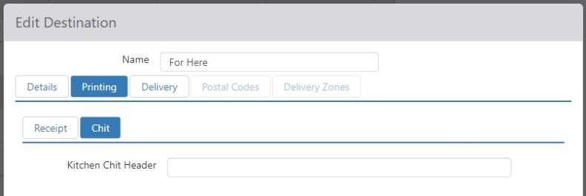

* + **Kitchen Chit Header**: The header that is printed at the top of each kitchen chit.

#### Delivery tab:

***Delivery*** *tab on Edit Destination dialog*

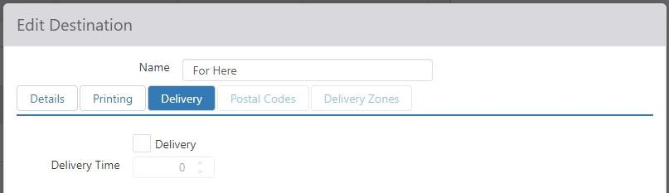

* + **Delivery**: Destination is delivery specific and delivery address will be required.
  + **Delivery Time**: Average delivery time in minutes, used to calculate approximate delivery driver arrival time.

#### Postal Codes tab:

***Postal Codes*** *tab on Edit Destination dialog*

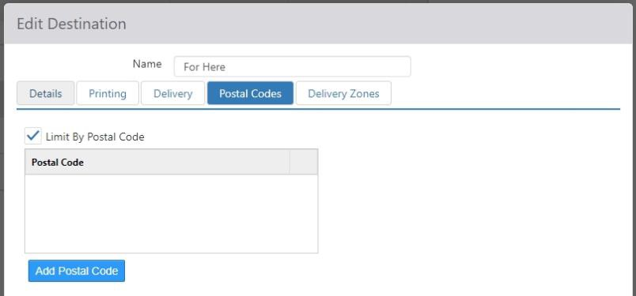

**NOTE**: The **Postal Codes** tab is only available if the **Delivery** check box on the **Delivery** tab is checked.

* + **Limit by Postal Codes**: Limit delivery address to specific postal codes.
  + **Postal Code List**: Valid postal codes.

#### Delivery Zones tab:

***Delivery Zones*** *tab on Edit Destination dialog*

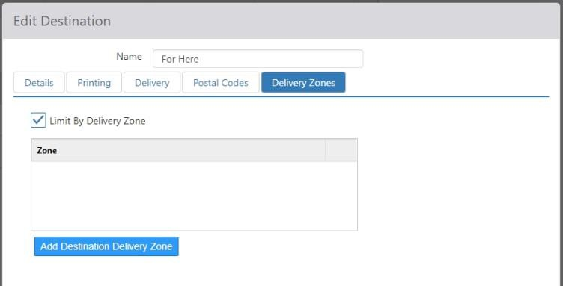

**NOTE**: The **Delivery Zones** tab is only available if the **Delivery** check box on the **Delivery** tab is checked.

* + **Limit by Delivery Zones**: Limit delivery address to specific delivery zones.
  + **Delivery Zone List**: Valid geographical areas.

Clicking the ‘Add Destination Delivery Zone’ button at the bottom of the list opens the *Add*

dialog, where you can specify the **Name**, **Surcharge**, and area of a delivery zone.

*Add dialog*

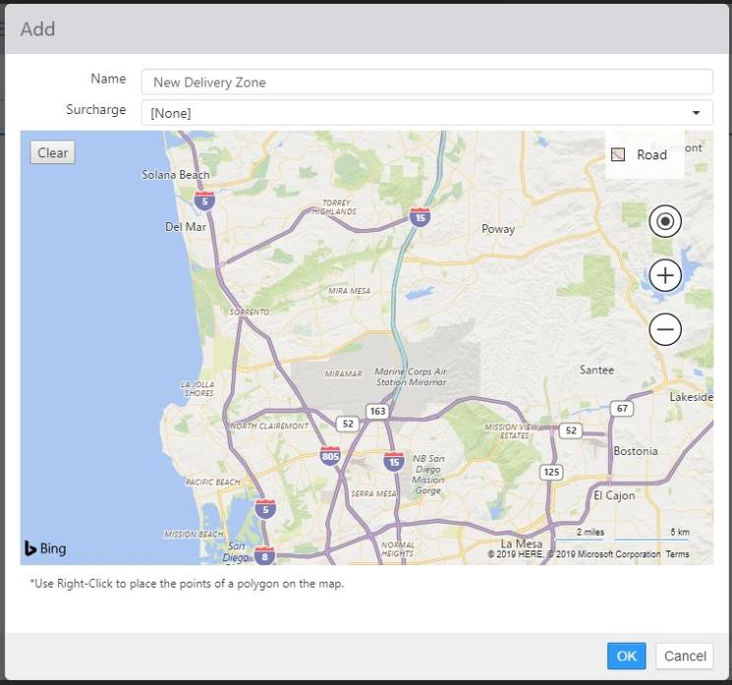

## Discount Groups

Discount groups are used to report cumulative totals for discounts (see Discounts) of similar types on the Discount Group report.

*Edit Discount Group dialog*

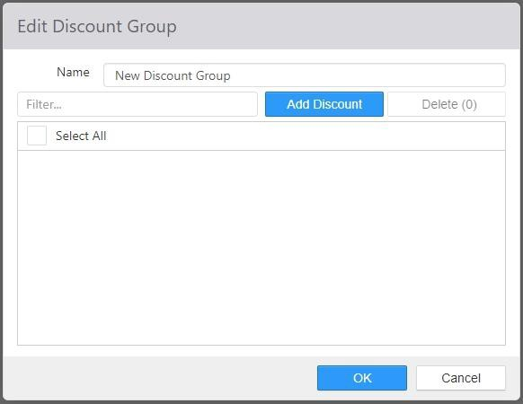

* **Name**: Name of the discount group.
* **Selected**: Selected discounts, which appear on the right, are included in the discount group.

## Discounts

A discount can be applied to an order to reduce the price of order items or modifiers.

*Discounts list*

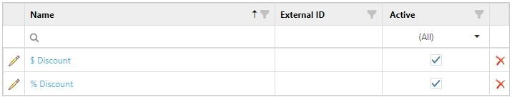

New discounts are created by clicking the **Add** button. Existing discounts can be edited by clicking their name in the list.

*Edit Discount dialog,* ***Options*** *tab*

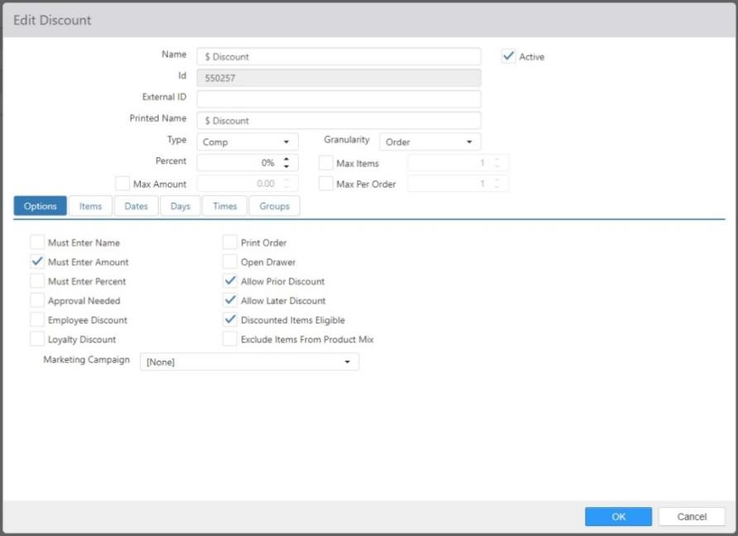

* **Name**: Name of the discount.
* **External ID**: External identifier for mapping to loyalty rewards in external loyalty providers.
* **Printed Name**: Name to be displayed on the receipt when discount is applied to an order.
* **Active**: Discount can be applied to orders.

#### Type:

* + **Comp**: Reduces order item price by percentage of the current order item price.
  + **New Price**: Reduces order item price to a specific amount.

#### Granularity:

* + **Items**: Order items or modifiers to which the discount will be applied must be selected prior to applying the discount.
  + **Order**: Discount will be applied to all qualifying order items or modifiers.

**NOTE**: This drop-down list only appears if **Type** is set to **Comp**.

* **Percent/New Price**: The percentage of the current price to be reduced (if **Type** is **Comp**) or the new price to which the item will be set (if **Type** is **New Price**).
* **Max Items**: Maximum number of items or modifiers to which the discount can be applied.
* **Max Amount**: Maximum total dollar amount of the discount across all order items and modifiers to which it is applied.

**NOTE**: This control only appears if **Type** is set to **Comp**.

* **Max Per Order**: Maximum number of times the discount can be applied to an order.

#### Options tab:

* + **Must Enter Name**: Employee will be prompted to enter a name to be attached to the discount.
  + **Must Enter Amount**: Employee will be prompted to enter a total dollar amount for the discount.
  + **Must Enter Percent**: Employee will be prompted to enter a percent for the discount.
  + **Approval Needed**: Discount can only be applied/authorized by an employee with

#### Security Level > Approve Discount enabled.

* + **Employee Discount**: Discount can only be applied by the ‘Employee Discount’ button behavior.
  + **Loyalty Discount**: Discount can only be applied via the redemption of a loyalty reward. This also identifies a Discount associated with a Comp Card (see Item dialog > Options tab).
  + **Print Order**: Print order receipt when the discount is applied.
  + **Open Drawer**: Open the employee’s cash drawer when the discount is applied.
  + **Allow Prior Discounts**: Discount can be applied to order items or modifiers that previously had another discount applied.

**NOTE**: When this option is unchecked, the discount cannot be applied to an order that has another discount already applied to it, regardless of the items or modifiers the discount is applied to.

* + **Allow Later Discounts**: Additional discounts can be applied to order items or modifiers reduced by this discount.
  + **Discounted Items Eligible**: Discount can be applied to order items and modifiers that previously had another discount applied.

**NOTE**: When this option is unchecked, the discount cannot be applied to order items or modifiers that already have another discount applied.

* + **Exclude Items from Product Mix**: Order items and modifiers to which the discount is applied are to be excluded from all product mix reports.
  + **Marketing Campaign**: Marketing campaign to assign to the order when discount is applied.

#### Item tab:

*Edit Discount dialog,* ***Item*** *tab*

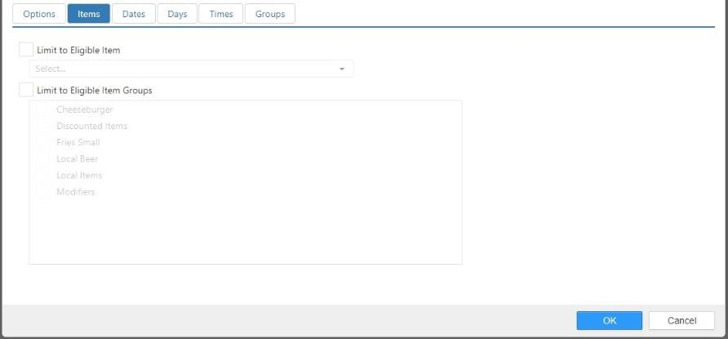

* + **Limit to Eligible Item**: Only the selected item or modifier qualifies for the discount.
  + **Limit to Eligible Item Group**: Only items or modifiers contained within the selected item groups qualify for the discount.

#### Dates tab:

*Edit Discount dialog,* ***Dates*** *tab*

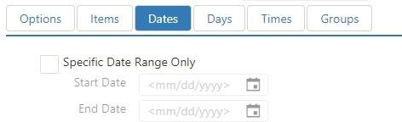

* + **Specific Date Range Only**: Discount can only be applied during the specified date range.
  + **Start Date**: The first day of the discount’s date range.
  + **End Date**: The last day of the discount’s date range.

#### Days tab:

*Edit Destination dialog,* ***Days*** *tab*

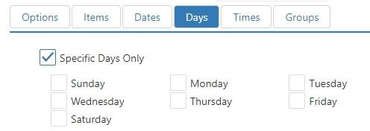

* + **Specific Days Only**: Discount can only be applied on the selected days of week.

#### Times tab:

*Edit Destination dialog,* ***Times*** *tab*

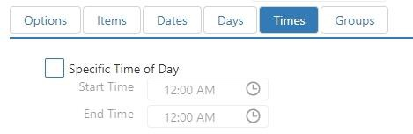

* + **Specific Times of Day Only**: Discount can only be applied during the specific time period.
* **Groups tab**: Discount is reported in the selected discount groups.

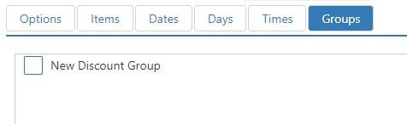

## Email Templates

Email templates define common elements of various email that are generated by the system, such as order confirmations or loyalty related emails.

*Edit Email Template dialog*

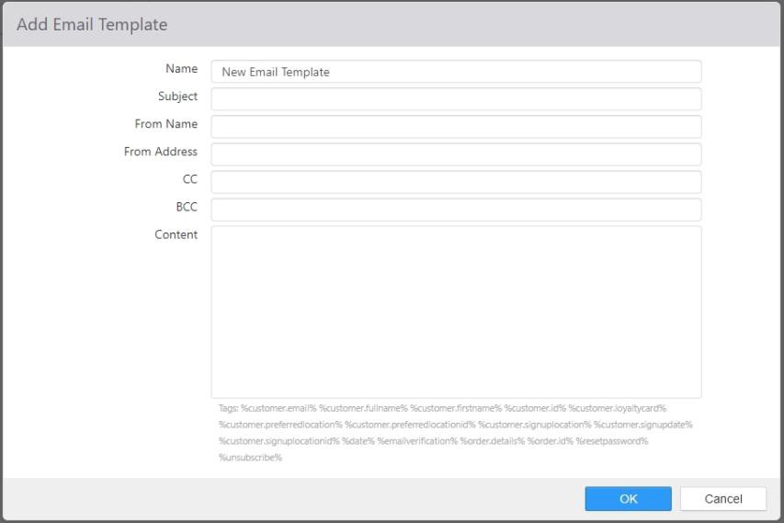

* **Name**: Name of the email template.
* **Subject**: Subject line of emails sent.
* **From Name**: Name displayed in the *From* field when email is received.
* **From Address**: Email address displayed in the *From* field when email is received.
* **CC**: Email addresses to be CC’d when email is sent, separated by semicolon.
* **BCC**: Email addresses to be blind CC’d when email is sent, separated by semicolon.
* **Body**: Body of the email to be sent.
* **Tags**: List of replaceable parameters that can be entered in the body.

## Employees

Employees have access to the Register application for order entry or simply for time and attendance tracking.

*Edit Employee dialog,* ***Access*** *tab*

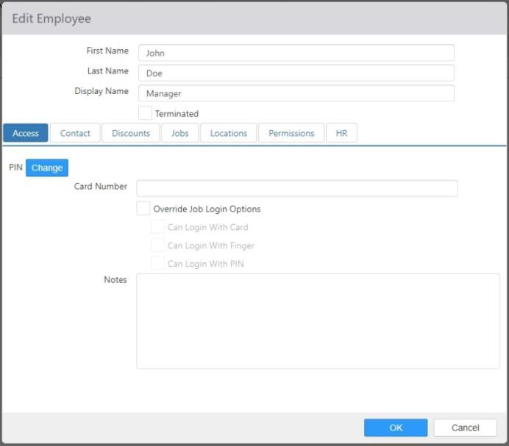

* **First Name**: Employee’s first name.
* **Last Name**: Employee’s last name.
* **Display Name**: Name that appears on the receipt, kitchen chit, register, and kitchen display.

**NOTE**: **Display Name** can accept values that are duplicated in other employee records.

* **Employee Type**: NO LONGER USED.
* **Terminated**: Employee is not allowed to clock-in or be scheduled for shifts.
  + **NOTE**: To terminate an employee, check the “Terminate” box and select the OK button.

#### Access tab:

* + **PIN**: Four-digit number the employee uses to clock in and login to the Register application. Click the **Change** button to change the PIN.
  + **Card Number**: Account number encoded on the employee’s magnetic card, used to

clock in and login to the Register application.

* + **Override Job Login Options**: This option indicates that employee login options should be used rather than the login options setup on job

 **Can Login with Card**: Clock In, Login, and permission authorization via magnetic card is allowed.

 **Can Login with Finger**: Clock In, Login, and permission authorization via finger scan is allowed.

* + - **NOTE:** If the “can login with finger” option is checked, the employee will

be prompted to provide their consent prior to using this login option.

* + - **NOTE**: Using this feature either within an employee record or at the job level will cause Brink POS to keep a hexadecimal string of data in conjunction with an employee record once the employee has enrolled their finger using a configured finger scanner peripheral.
    - **NOTE**: This hexadecimal string of data is kept until either:
      * The “can login with finger” option is unchecked for the

employee within the employee record or the job description, or

* + - * The “Terminate” box is checked for the employee within the

employee record, or

* + - * The individual employee is deleted by clicking on the red “X” associated with the employee in the “Employees” section of Settings Editor, and
      * The changes are published, and the End of Day process runs.
    - **NOTE:** Brink POS does not store an employee’s fingerprint or

information based on the employee’s fingerprint, only a hexadecimal string of data in conjunction with an employee record if Brink POS is configured to allow an employee to Login with Finger.

 **Can Login with PIN**: Clock In, Login, and permission authorization via a 4-digit PIN is allowed.

* + **Notes**: Any notes associated with the employee should be entered here.
* **Contact**: Address, phone numbers, and email address that appears on the Employee Directory report.

*Edit Employee dialog,* ***Contact*** *tab*

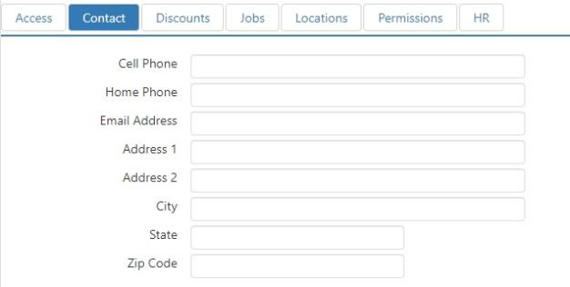

#### Discounts tab:

*Edit Employee dialog,* ***Discounts*** *tab*

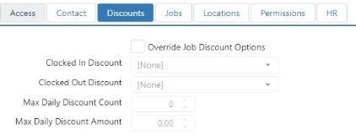

* + **Override Job Discount Options**: This option indicates that employee discount options should be used rather than the discount options setup on the employee’s job.

 **Clocked In Discount**: Discount to be applied to the current order when ‘Employee Discount’ button behavior is executed and the selected employee is clocked in.

 **Clocked Out Discount**: Discount to be applied to the current order when ‘Employee Discount’ button behavior is executed and the selected employee is not clocked in.

 **Max Daily Discount Count**: Maximum number of times an employee can be associated with an employee discount for single business day. Can be overridden be an employee with **Security Level > Allow Excess Employee Card Usage** enabled.

 **Max Daily Discount Amount**: Maximum total employee discount amount for an employee for single business day. Can be overridden be an employee with **Security Level > Allow Excess Employee Card Usage** enabled.

* **Jobs tab**: Jobs available to the employee when clocking in. Jobs are configured on the **Jobs** page in Settings Editor (see Jobs). To add a new job, click the ‘Add’ button to open the *Edit Job* dialog.

*Edit Employee dialog,* ***Jobs*** *tab*

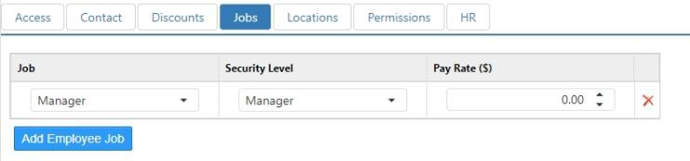

* + **Job**: Job assigned to employee.
  + **Security Level**: Security level while clocked in under the job.
  + **Pay Rate**: Hourly rate of pay paid to the employee while clocked in under the job.

#### Locations tab:

*Edit Employee dialog,* ***Locations*** *tab*

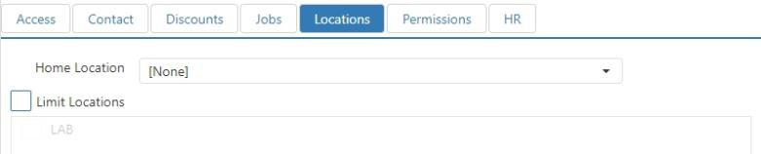

* + **Home Location**: Primary location at which the employee can be scheduled for shifts.
  + **Limit Location**: Limit locations at which the employee can be scheduled for shifts.

 **Valid Locations**: Locations at which the employee can be scheduled for shifts.

* **Permissions tab**: Permissions are defined in **Permissions** in Settings Editor. You can assign the permissions to employees either here or in **Permissions**. Changing it in one place automatically changes it in the other

*Edit Employee dialog,* ***Permission*** *tab*

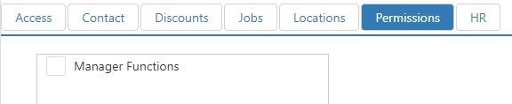

#### HR tab:

*Edit Employee dialog,* ***HR*** *tab*

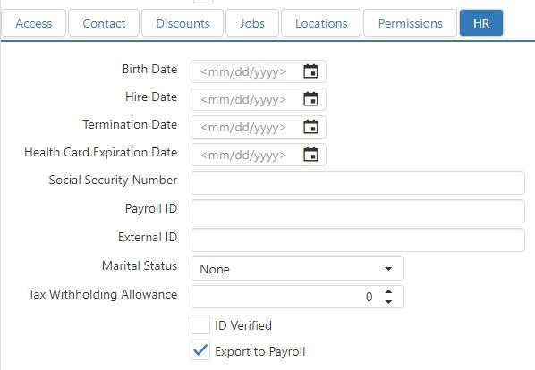

* + **Birth Date**: Displays on the Employee Directory report.
  + **Hire Date**: Displays on the Employee Directory report.
  + **Termination Date**: Displays on the Employee Directory report.
  + **Health Card Expiration Date**: Date the employee’s health card expires.
  + **Social Security Number**: Masked value displays on the Employee Directory report.
  + **Payroll ID**: Employee identifier included on labor exports and various labor reports.
  + **External ID**: External identifier to be used by third party integrators.
  + **Marital Status**: NO LONGER USED.
  + **Tax Withholding Allowance**: NO LONGER USED.
  + **Identification Verified**: NO LONGER USED.
  + **Export to Payroll**: Employee’s shifts are included in labor exports.

## Gift Card Filters

Gift card filters are defined to restrict the locations at which gift cards can be redeemed or applied as tenders. This is commonly used to restrict redemption of promotional gift cards.

*Edit Gift Card Filter dialog,* ***Valid Locations*** *tab*

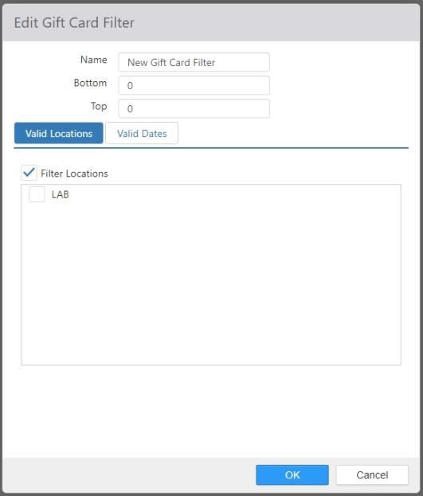

* **Name**: Name of the gift card filter.
* **Bottom**: First number in the matching gift card account number range.
* **Top**: Last number in the matching gift card account number range.

#### Valid Locations tab:

* + **Filter Locations**: Limit gift card tendering by location.

 **Locations list**: Check the check boxes of the locations where the gift cards will be valid.

#### Valid Dates tab:

*Edit Gift Card Filter dialog,* ***Valid Dates*** *tab*

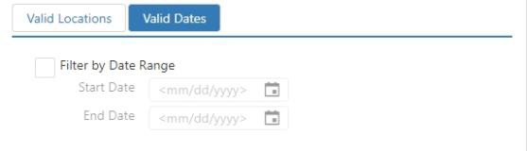

* + **Filter by Date Range**: Limit gift card tendering date range.

 **Start Date**: The first day that the gift cards will be valid.

 **End Date**: The last day that the gift cards will be valid.

## Images

Images can be uploaded to show in image controls on the register or assigned to menu items to show in the Customer Portal.

***Images*** *page, partial*

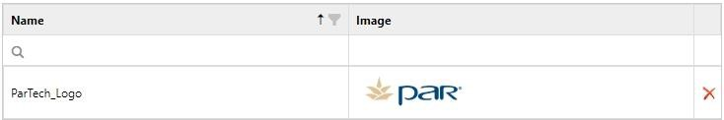

* **Filter**: Enter text in this field to only show images whose names contain that text. Use the **Clear**

button to erase all text from this field.

* **Add**: Click the **Add** button to open the *Add Image* dialog.
* **Delete**: Select an image and click **Delete** to remove it from the system.

*Add Image dialog*

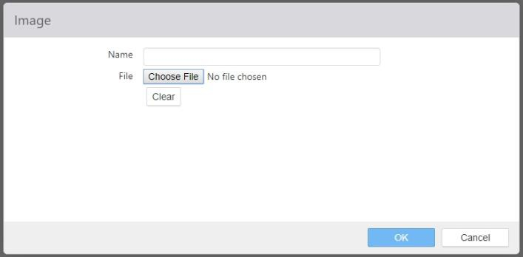

* **Name**: The name of the image. This should be descriptive so that it’s easy to find later.
* **Select an Image**: Click this button to open a Windows selection screen. When you’ve selected an

image, it appears in the frame next to the button.

## Item Groups

Item groups are collections of items with common characteristics, used for item validation or qualifications in various areas of the system. There are also various item group related reports available in both the Register and the Admin Portal.

*Edit Item Group dialog*

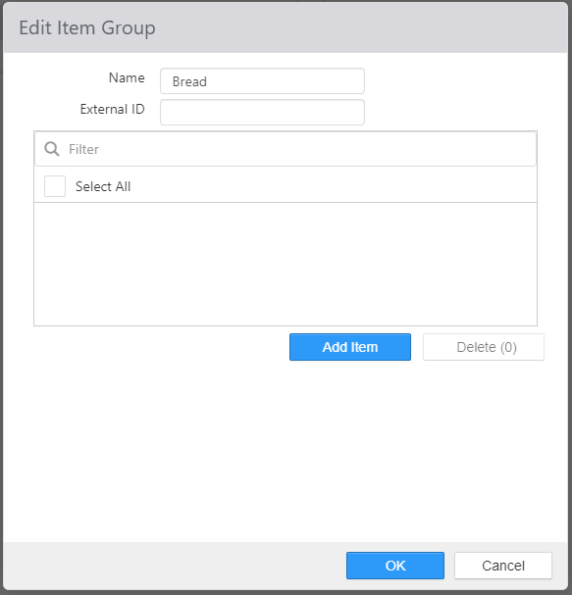

* **Name**: Name of the item group.
* **External ID**: External identifier to be used by third party integrators.
* **Selected Items**: To select items either check ‘Select All’ or select ‘Add Item’ button and choose which items apply to this group within the Add Item dialog box below. Item Description is now displayed in addition to Item Name.

*Add Item dialog*

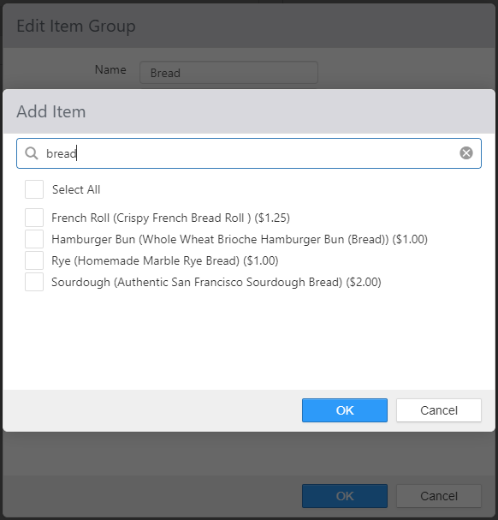

## Item Size Groups

Item size groups are a way to organize items by size (for example, “Small Beverage” 0, “Medium

Beverage” 1, “Large Beverage” 2). Item Size Groups are used in conjunction with the ‘Change Item Size’ button behavior, which allows the user to change the size of the selected item up or down.

*Edit Item Size Group dialog*

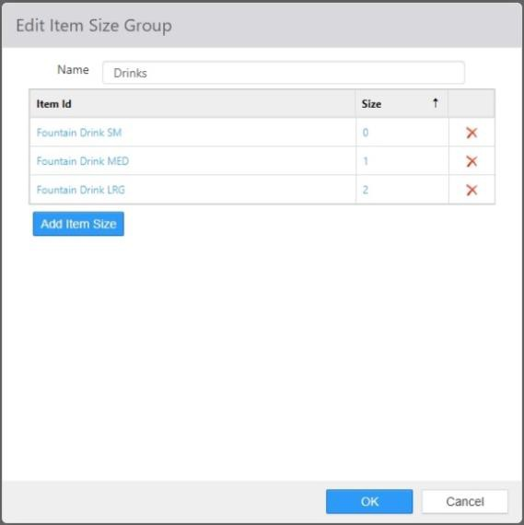

* **Name**: Name of the item size group.
* **Item Sizes list**: The items that make up the sizes of the item group.

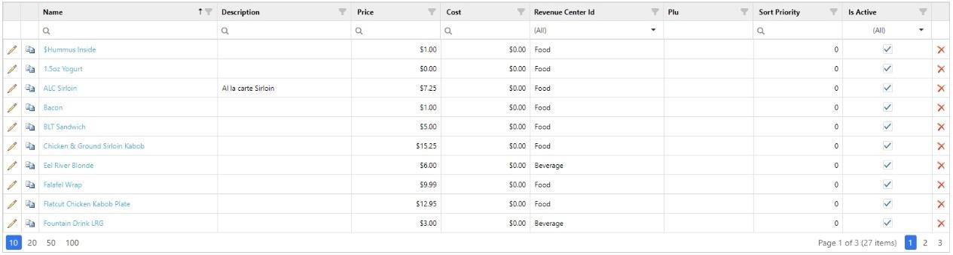

* + **Item**: Items included in the group.
  + **Size**: The size of the item in the group, from **0** to **n**. **NOTE**: The smallest size is always zero (**0**).
  + **Edit link**: Click to open the *Edit* dialog.
* **[Add] link**: Click to open the *Add* dialog.
* **[Delete] link**: Select an item and click to delete the item from the item group.

*Add/Edit item dialog*

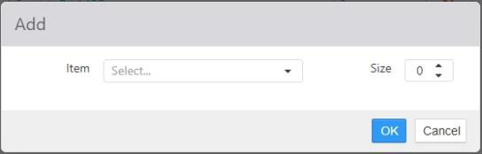

**NOTE**: The *Add* and *Edit* dialogs operate in exactly the same way.

* **Item**: Select the item using the drop-down list.
* **Size**: Set the size. Zero (**0**) is always smallest.

## Items

The **Items** page is where you define items available for order and most of the settings that affect how the item is tracked and counted. The list can be sorted by clicking any of the column headers.

*Items page (example)*

* **Filter**: Enter text in this field to only show items that contain that text.
* **Revenue Center Filter**: Enter text in this field to only show items assigned to revenue centers that contain the entered text.
* **Add**: Click to open the *Edit Item* dialog.
* **Active check box**: When checked, the item is active and can be ordered normally. When unchecked, the item is not active and cannot be ordered.

*Edit Item dialog,* ***Options*** *tab*

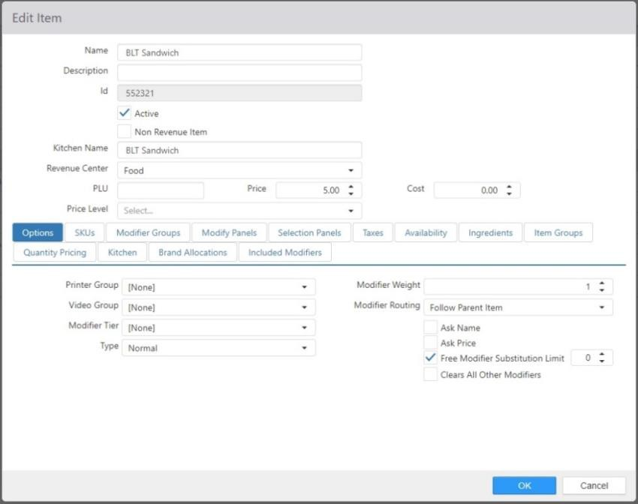

* **Name**: Name of the item.
* **Description**: If desired, a longer description of the item can be entered here. This description is only displayed on the Items page, not on the Register application. Items can be sorted by **Description**.
* **Id**: The ID number of the item. This is automatically assigned and cannot be changed.
* **Active**: The item can be ordered. When this box is unchecked, any associated buttons are not displayed on the Register.
* **Non-Revenue Item**: Sales of this item are not included in gross sales or net sales calculations.
* **Kitchen Name**: Alternate name to be displayed on kitchen chits and kitchen displays.
* **Revenue Center**: Revenue center under which sales of the item and its modifiers are to be reported.
* **PLU**: Identifier used by external systems.
* **Price**: Price of the item. This can be negative.
* **Cost**: Cost of the item.
* **Price Level**: Price level that is to override the item price.

#### Options tab:

* + **Printer Group**: Printer group the item is to be routed to when sent to the kitchen.
  + **Video Group**: Video group the item is to be routed to when sent to the kitchen.
  + **Modifier Tier**: Modifier tier to be used to calculate price when item is a substitution modifier.

#### Type:

 **Normal**: Regular item.

 **Chicken**: NO LONGER USED.

 **Gift Card**: Transaction that request authorization be gift card provider.

 **Loyalty Item**: Item that activates a third-party loyalty account.

 **Pizza**: NO LONGER USED.

 **Combo**: Item is comprised of one or more other items.

 **Prepaid**: Item that requires authorization/activate through the Prepaid Processor defined in Options.

 **Comp Card**: Specifies that this Item is a Comp Card configured for Paytronix (examples of Item Name: Guest Relations, Charitable Donations). See Options > Comp Card tab.

* + - **Discount**: Drop-down appears when Type of Comp Card is selected. Choose from a list of Discounts having an External ID and is a Loyalty Discount.

#### Gift Card Type:

**NOTE**: This drop-down list only appears if **Type** is set to **Gift Card**.

 **Cash Out**: Deducts stored value from a gift card.

 **Issue**: Adds stored value to a new gift card.

 **Reload**: Adds stored value to a previously issued gift card.

#### Prepaid Item Type:

**NOTE**: This drop-down list only appears if **Type** is set to **Prepaid**.  **Code**: Employee enters code to activate at time of sale.

 **Code on Receipt**: Code required for activation is printed on receipt.

 **PIN on Receipt**: PIN required for activation is printed on order receipt.

* + **Automatically Apply Combo**: Automatically create a combo if a complete set of combo components is ordered individually.

**NOTE**: This check box only appears if **Type** is set to **Combo**.

* + **Modifier Weight**: Count towards the modifier group’s min/max/free settings, when

ordered as a modifier.

#### Modifier Routing:

 **Follow Parent Item** (the default): The modifier displays on the kitchen display and prints on the printer group for the parent item only.

*Example*: A sandwich is ordered with extra cheese. The order is displayed and printed at the sandwich station normally.

 **Route Separately**: The modifier and the parent item are displayed and printed separately on their own kitchen displays and printer groups.

*Example*: A ham sandwich is ordered with hot ham instead of cold. The ham part of the order displays and prints at the grill station, while the rest of the sandwich order (without the ham) displays and prints at the sandwich station.

 **Parent item also follows modifier**: The parent item and modifier are displayed and printed on both the parent item’s and the modifier’s kitchen display and printer group.

*Example*: A pepperoni pizza is ordered. The entire order is displayed and printed at the dough station, the sauce and cheese station, and the toppings station.

 **Parent item only follows modifier**: The parent item and modifier are only displayed and printed on the modifier’s kitchen display and printer group. *Example*: A ham sandwich is ordered with hot ham instead of cold. However, in this case, the grill has the ability to finish the entire sandwich order, so the entire order displays and prints at the grill.

* + **Ask Name**: When ordered, employee is prompted to enter item name.
  + **Ask Price**: When ordered, employee is prompted to enter item price.
  + **Exception Mod**: NO LONGER USED.
  + **Free Modifier Substitution Limit**: Limits the number of modifiers that can be substituted without charge.
  + **Clears All Other Modifiers**: For modifiers only, adding this modifier clears all other modifiers except required or deferred modifiers.
* **SKUs tab**: Product barcode identifiers used to order item via barcode scanner or ‘Lookup Item’ screen.

*Edit Item dialog,* ***SKUs*** *tab*

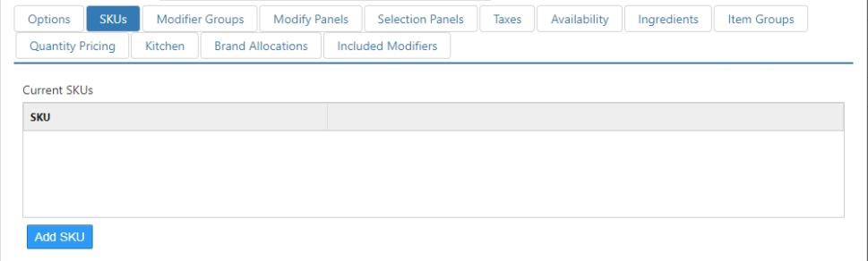

* + **Current SKUs**: A list of barcode numbers currently associated with the item.
  + **New SKU**: Enter a new SKU in the field and click the ‘Add’ button to add it to the *Current SKUs* list.
* **Modifier Groups tab**: Modifier groups that are to be available when the item is ordered or modified.

*Edit Item dialog,* ***Modifier Groups*** *tab*

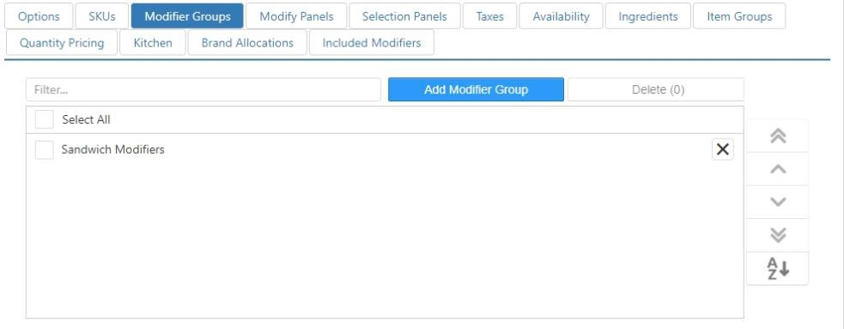

**NOTE**: Modifier groups are configured on the **Modifier Groups** page in Settings Editor (see Modifier Groups).

* **Combo Components tab**: A list of components that belong to the combo.

**NOTE**: This tab only appears if **Type** (on the **Options** tab) is set to **Combo**.

*Edit Item dialog,* ***Combo Components*** *tab*

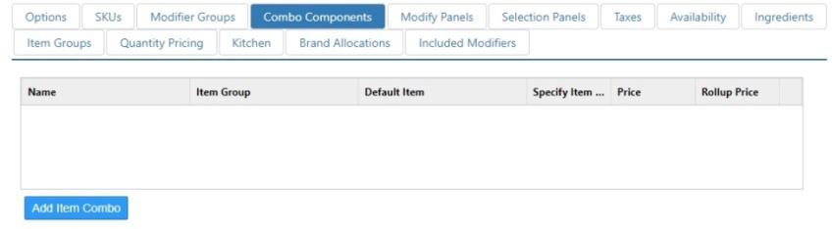

* + **Edit**: Click on the item name to edit an existing combo component.
  + **Add Item**: Click to open the *Add* dialog.
  + **Delete**: Select the red ‘X’ correlated to a component in the list to remove it.

*Add/Edit component dialog*

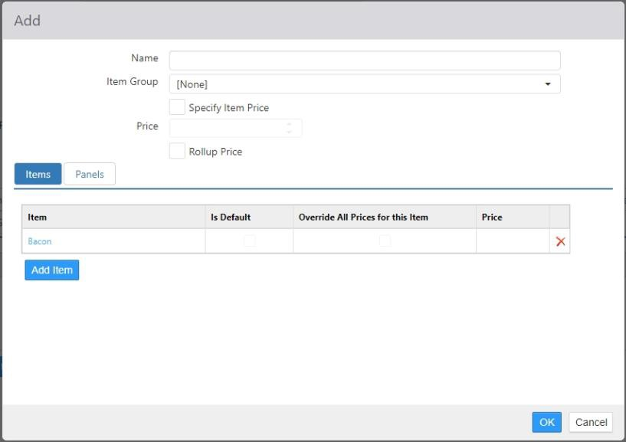

Use the *Add* or *Edit* component dialog to specify what items are eligible to be part of the combo component. Both dialogs work the same.

 **Name**: The name of the combo component. For example, “Entrée,” “Drink,” or “Side Dish.”

 **Item Group**: The item group to which the component is assigned.

 **Specify Item Price**: When checked, the price entered here overrides the item’s

normal price.

 **Price**: The price of this component.

 **Rollup Price**: When checked, the price isn’t displayed separately on the ‘Order List’ screen on the Register, but is included in the total price of the combo.

 **Items list**: The items that are eligible to be this component of the combo.

* + - **Edit**: Click on the item name to edit an existing combo component.
    - **Add Item**: Click to open the *Add* combo item dialog. The Item drop- down list now displays Item Description in addition to Item Name.
    - **Delete**: Select an item in the list and click **Delete** to remove it.

*Add/Edit combo item dialog*

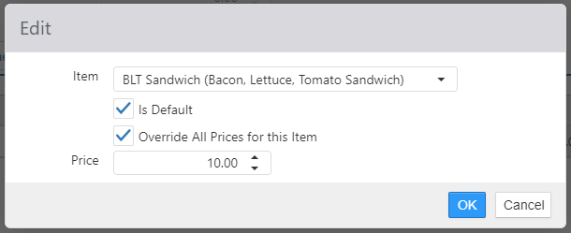

Use the *Add/Edit* combo item dialog to define an item that can be made a part of this combo. Both dialogs work the same.

* **Item**: Use the drop-down list to select the item.
* **Is Default**: When checked, this item is used as the default item for this combo component.

**NOTE**: If no item is set as a default, and if the combo has a selection panel configured, the panel can still be dismissed and the combo added to the order without all of its components being defined. See the section on the **Selection Panels** tab, below.

* **Override All Prices for this Item**: When checked, the price specified in this dialog overrides all other prices for this item when it is in a combo.
* **Price**: Enter the price of the item.
* **Modify Panels** tab: Panels that are to be displayed in place of the ‘Modify’ system screen.

*Edit Item dialog,* ***Modify Panels*** *tab*

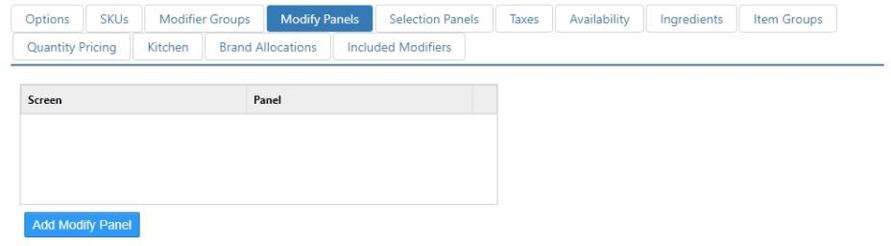

* + **Screen**: Current screen that triggers the selected panel.
  + **Panel**: The panel to be shown, when screen matches.
* **Selection Panels tab**: Panels that are to be displayed when the item is ordered or selected.

*Edit Item dialog,* ***Selection Panels*** *tab*

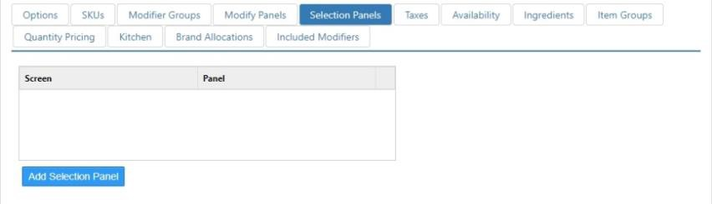

* + **Screen**: Current screen that triggers the selected panel. Configured on the Screens page.
  + **Panel**: The panel to be shown, when screen matches. Configured in Layout.
  + **Add**: Click this button to open the *Add* dialog, then select the **Screen** and **Panel** using the drop-down lists.

*Add dialog for adding selection panels to a combo*

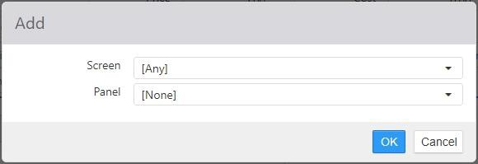

**NOTE**: If a combo has a selection panel configured, and if at least one component does not have a default item specified, then the system enters “out-of-sequence” mode. This means that the component selection panel can be dismissed and the combo added to the order without all of its components being defined. This allows cashiers to take orders as they are spoken by the customer without having to interrupt them to ask for the combo components they want.

The Register application will not allow the order to be closed before all components of the combo are selected. To select missing components, select the combo on the Order List to display the selection panel again.

* **Taxes tab**: Taxes that are to be applied to the item, in addition to those inherited via the revenue center.

*Edit Item dialog,* ***Taxes*** *tab*

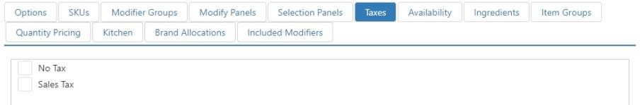

#### Availability tab:

*Edit Item dialog,* ***Availability*** *tab*

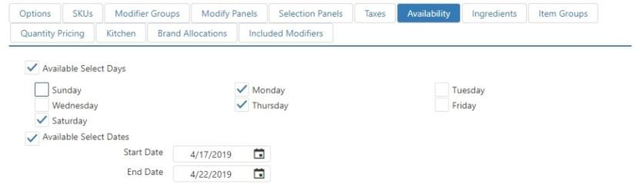

* + **Available Select Days**: Item can only be ordered on the checked days of the week.
  + **Available Select Dates**: Item can only be ordered within the defined date range.
* **Ingredients tab**: Items that are considered ingredients when calculating modifier prices, and when determining valid modifier codes on Customer Portal.

*Edit Item dialog,* ***Ingredients*** *tab*

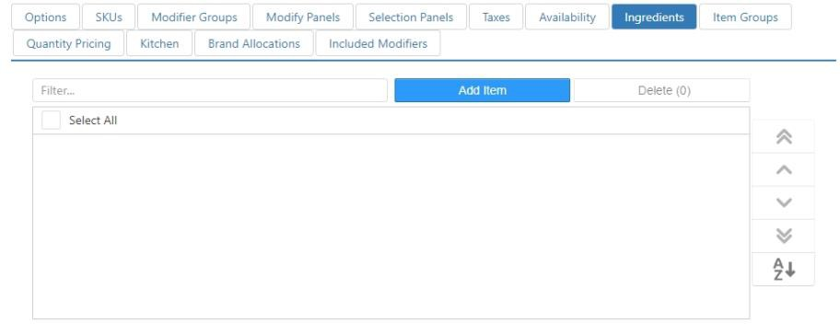

* **Item Groups**: Item groups that the item belongs to.

*Edit Item dialog,* ***Item Groups*** *tab*

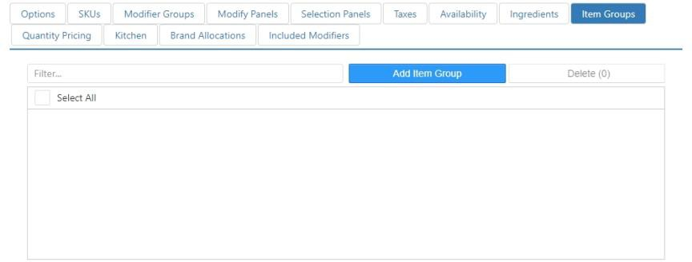

* + **Select All**: Select this in order to select all available Item Groups.
  + **Add Item Group**: To select an Item Group select this button.

*Add Dialog for adding an Item Group*

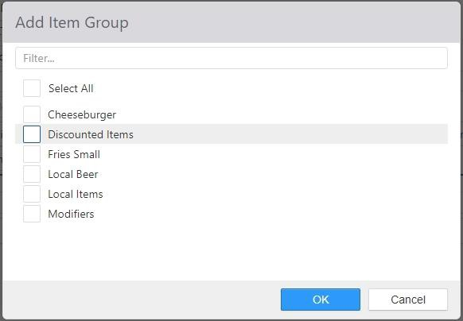

**NOTE**: Changes made on this tab are also made in the appropriate item group on the **Item Groups** page, and vice versa.

#### Quantity Pricing tab:

*Edit Item dialog,* ***Quantity Pricing*** *tab*

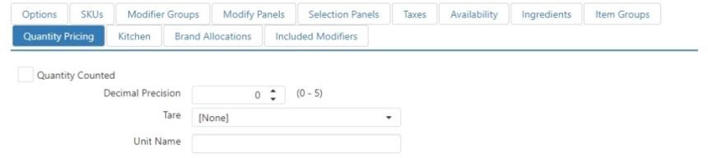

* + **Quantity Counted**: Item is ordered by weight.
  + **Decimal Precision**: Number of decimal places of weight.
  + **Tare**: Tare that the item is packaged in.
  + **Unit Name**: Name of the unit of measure.

#### Kitchen tab:

*Edit Item dialog,* ***Kitchen*** *tab*

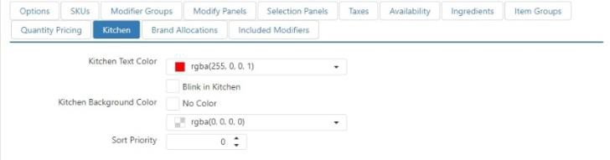

* + **Kitchen Text Color**: Color of the item text when displayed on kitchen display.
  + **Blink in Kitchen**: Item name flashes on kitchen display.
  + **Kitchen Background Color**: Color of the item background when displayed on the kitchen display.

#### CAUTION: Be careful when setting background colors and text colors. Setting colors that are too similar to each other can result in items being illegible on the kitchen display.

* + **Sort Priority**: Position on the kitchen chit and kitchen display relative to other items. Order items and modifiers appear sorted by **Sort Priority** (ascending) and then by time ordered (ascending).
* **Brand Allocation tab**: Distribute sales of the item across more than one brand. Click the ‘Add’

button to open the *Edit Brand Choice* dialog, wherein you can select a brand and set its weight.

*Edit Item,* ***Brand Allocation*** *tab*

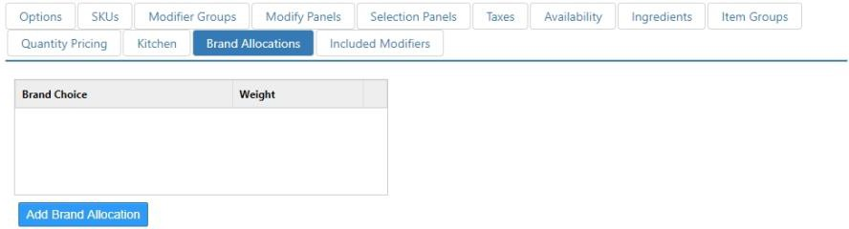

* + **Brand Choice**: Brand to allocate sales to.
  + **Weight**: Percent of the net sales to allocate to the selected brand.
* **Included Modifiers tab**: Modifiers that are implied as being included in/on the item by default.

*Edit Item dialog,* ***Included Modifiers*** *tab*

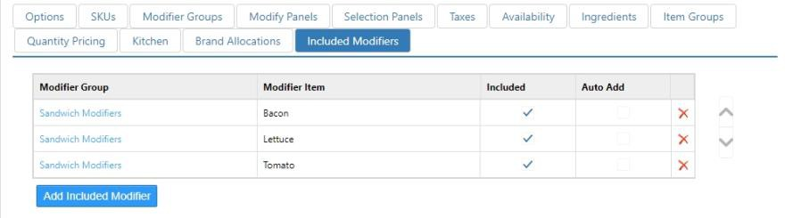

Click the **Add** button to create a new included modifier. Select a modifier and click the **Edit**

button to edit an existing modifier.

*Edit Item Included Modifier dialog*

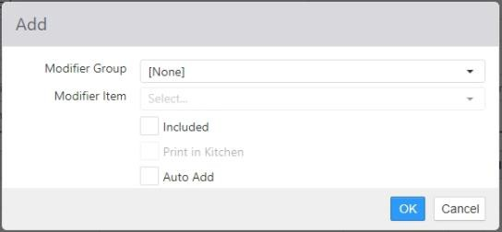

* **Modifier Group**: Modifier group the included modifier belongs to.
* **Modifier Item**: Modifier that is included.
* **Included**: Modifier is included in/on the item.
* **Print in Kitchen**: Always print the modifier in the kitchen, even when not selected.
* **Auto Add**: Automatically add the modifier when the item is ordered.

## Jobs

Jobs define the behavior of the Register application for the employee.

*Jobs list*

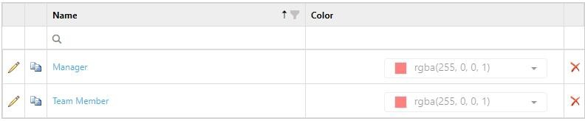

Click the **Add** button to create a new job. Click the name of a job to edit it.

*Edit Job dialog,* ***General*** *tab*

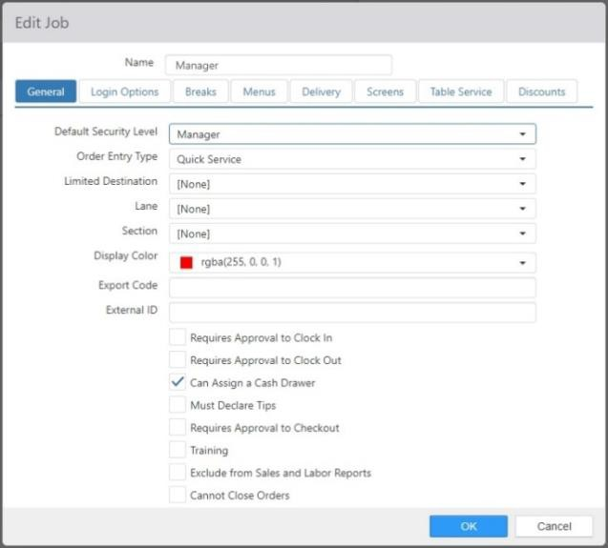

* **Name**: The name of the job.

#### General tab:

* + **Default Security Level**: The default security that is selected when adding the job to an employee.
  + **Order Entry Type**: Controls access to functions that are Table Service specific.
  + **Limited Destination**: Limits the destination that can be assigned to an order employee is clocked in under job.
  + **Lane**: Default lane for orders created when employee is clocked in under job. Overrides Registers **Lane**.
  + **Section**: Section associated to order created when employee is clocked in under job.
  + **Display Color**: Color of shifts in **Labor >** **Scheduler** in Administrator Portal.
  + **Export Code**: Included in labor data exports, commonly referred to by payroll providers as Department.
  + **External ID**: External identifier to be used by third party integrators.
  + **Requires Approval to Clock In**: Requires approval by an employee with **Security Level > Approve Clock In** enabled.
  + **Requires Approval to Clock Out**: Requires approval by an employee with **Security Level**

**> Approve Clock Out** enabled.

 Approval will only be required if the employee has checked in. If an employee clocks in and then clocks out, no approval is required.

* + **Can Assign Cash Drawer**: Allow employee to execute the ‘Assign Cash Drawer’ button behavior.
  + **Must Declare Tips**: Prompts employee for declared tips amount at clock out.
  + **Requires Approval to Checkout**: Requires approval by an employee with **Security Level**

**> Approve Checkout** enabled in order to execute the ‘Checkout’ button behavior.

* + **Training**: Job is for training purposes only, orders do not appear on kitchen chits or kitchen videos, sales are not reported, and only cash tender is allowed.
  + **Exclude from Sales and Labor Reports**: Labor cost is not reported in any reports in the Register or Admin Portal.
  + **Cannot Close Orders**: Employee cannot close orders on the Register.
  + **Self-Banking:** Employee cannot be assigned a cash drawer, but instead a personal till is automatically created for the employee.
  + **Exempt from Labor Schedule:** Job is excluded from punctuality enforcement approval.
  + **Clock In Automatically:** Automatically start a shift when the employee signs in to Register, skipping the clock-in screen.

 NOTE: The clock-in screen is always displayed for employees that have more than one Job assigned to them, even if this check box is checked for all Jobs assigned to that employee.

* + **Can apply discounts/promotions without cash drawer assignment:** Employee can apply discounts and promotions without having to have a cash drawer assigned.
  + **Can apply payments on behalf of self-banking employees:** When applying a payment to an order on party that is owned by a self-banking employee, the payment will be recorded against the till of the party owner.
  + **Can Approve Without Being Clocked In:** Employee can approve manager permissions on a register without having to clock in.
* **Login Options**: Determines how an employee clocked in under the job can access the Register; can be overridden at the Employees level.

*Edit Job dialog,* ***Login Options*** *tab*

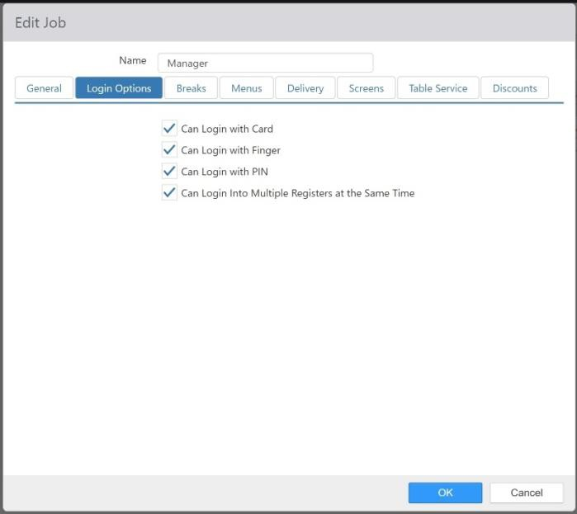

* + **Can Login with Card**: Clock In, Login, and permission authorization via magnetic card is allowed. Can be overridden at the Employees level.
  + **Can Login with Finger**: Clock In, Login, and permission authorization via finger scan is allowed. Can be overridden at the Employees level.

 **NOTE:** Brink POS does not store an employee’s fingerprint or information based on the employee’s fingerprint, only a hexadecimal string of data in conjunction with an employee record if Brink POS is configured to allow an employee to Login with Finger.

* + **Can Login with PIN**: Clock In, Login, and permission authorization via a 4-digit PIN is allowed. Can be overridden at the Employees level.
  + **Can Log Into Multiple Registers at the Same Time**: Employees with this job can log in to multiple registers simultaneously. Only one till is allowed per employee.

#### Breaks tab:

*Edit Job dialog,* ***Breaks*** *tab*

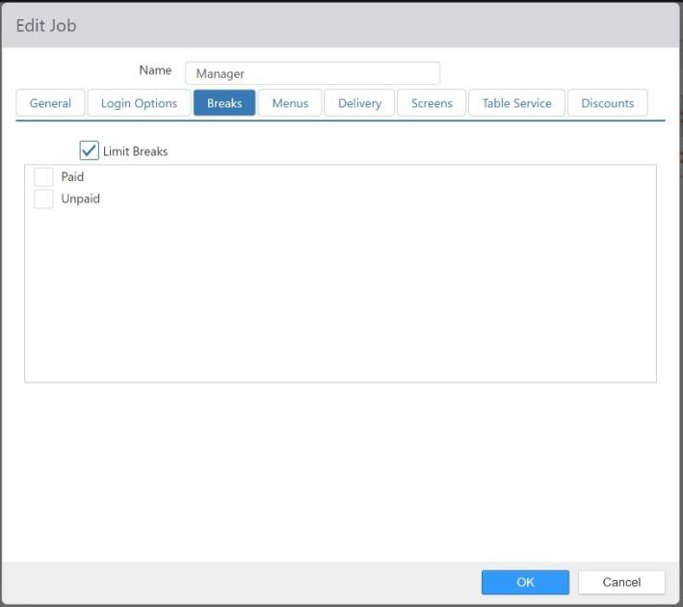

* + **Limit Breaks**: Limits the break type options available when the ‘Start Break’ button behavior is executed.
  + **Select Breaks**: Valid break types (as configured on the **Labor >** **Breaks** tab of the Options page).
* **Menus tab**: Default Menu to display; overrides **Register > Menu** and **Options > Ordering > General > Default Server Menu**.

*Edit Job dialog,* ***Menus*** *tab*

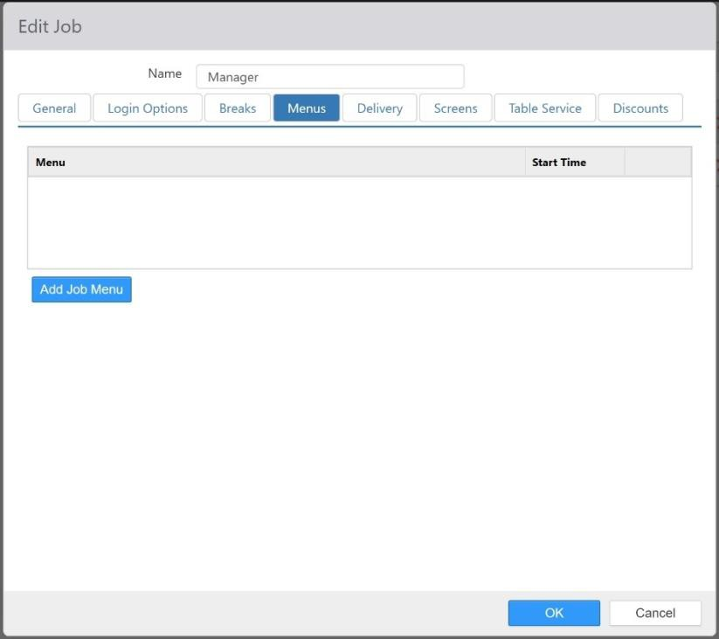

Click the ‘Add’ button to add a new menu.

*Add menu dialog*

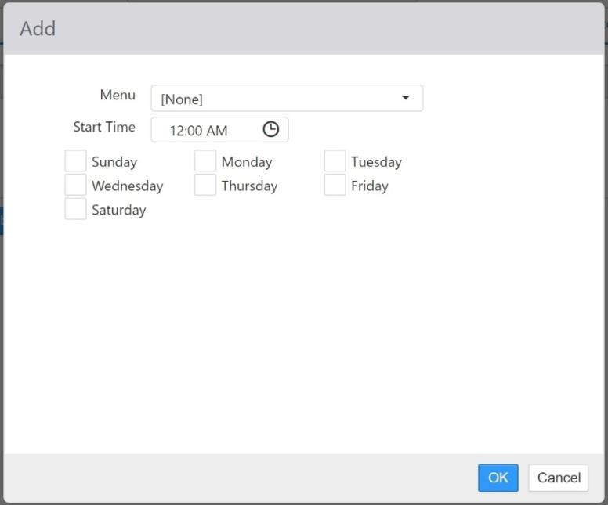

* **Menu**: Menu to display.
* **Start Time**: Time that the menu becomes valid, and the time the prior sequential menu ends.
* **Days**: Valid days of the week.

#### Delivery tab:

*Edit Job dialog,* ***Delivery*** *tab*

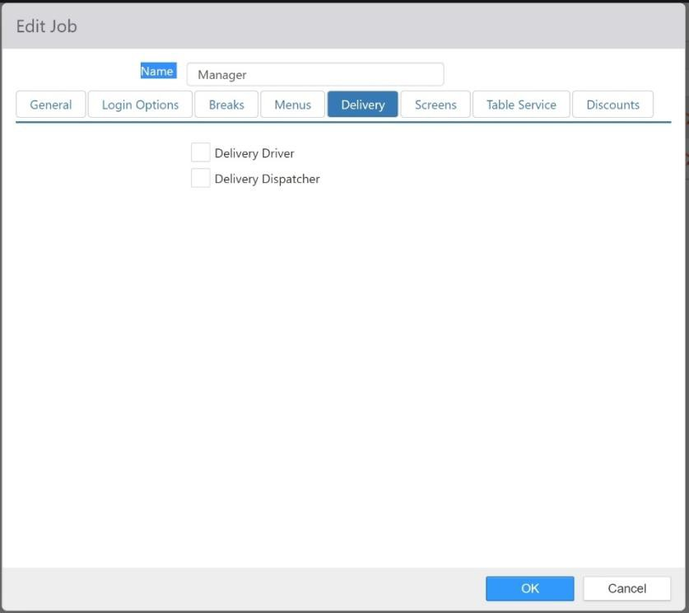

* + **Delivery Driver**: Display employees as order recipients in the *Assign Delivery Order*

screen.

* + **Delivery Dispatcher**: Allow employee to execute the ‘Assign Delivery Order’ button

behavior.

#### Screens tab:

*Edit Job dialog,* ***Screens*** *tab*

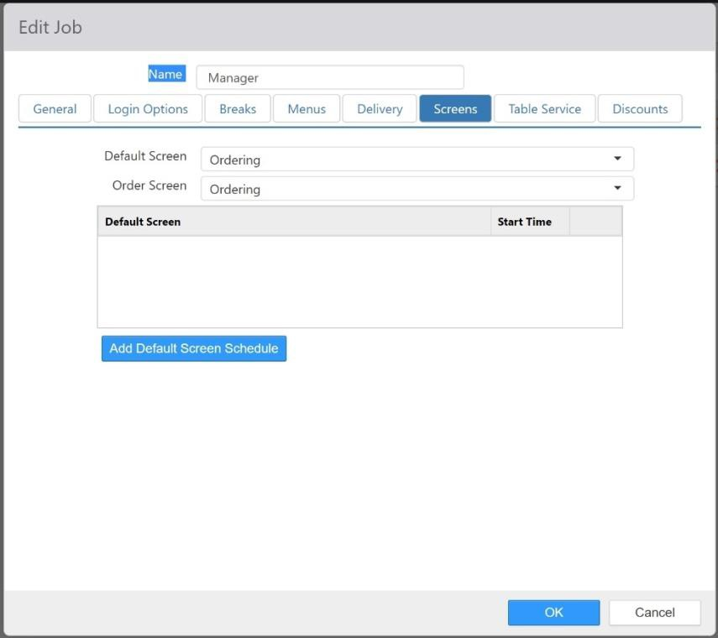

* + **Default Screen**: Screen that is displayed when the user logs in, closes a table, or closes a tab. Overrides the **Screen** setting on the current Registers.
  + **Order Screen**: Screen that is displayed. When set to **None**, the **Default Screen** is displayed instead.
  + **Order Screen list**: Displays screens that are configured to be displayed starting at certain times of day (for example, a breakfast screen starting at 6:00 a.m. or a dinner screen starting at 4:00 p.m.). Click the **Add** button to add a screen override setting.

*Add order screen override dialog*

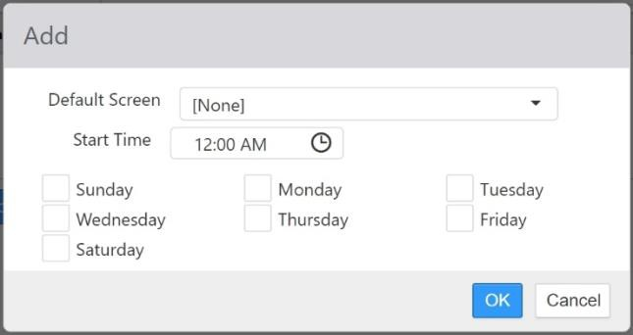

 **Default Screen:** Use the drop-down list to select the screen to be displayed.

Screens are configured on the Screens page.

 **Start Time:** The time of day to begin displaying the selected **Order Screen**.

 **Days:** The days of the week to display the selected **Order Screen** at the indicated **Start Time**.

#### Table Service tab:

*Edit Job dialog,* ***Table Service*** *tab*

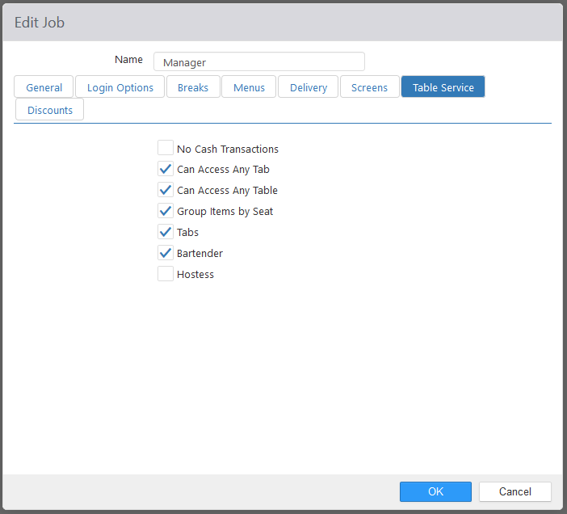

* + **No Cash Transactions**: Disallows payments where the tender type is Cash.
  + **Can Access Any Tab**: Allows employee to access tabs owned by other employees.
  + **Can Access Any Table:** Allows employee to access tables owned by other employees.
  + **Group Items by Seat**: Order items displayed on the Order List control are grouped by Seat Number. Pressing the **Next Person** button on the register advances to the next seat.

**NOTE**: This setting also applies to quick service.

* + **Tabs**: Allows employee to open Tabs.
  + **Bartender**: Allows employee to execute the ‘Fast Cash’ button behavior.
  + **Hostess**: Not implemented.

#### Discounts tab:

*Edit Job dialog,* ***Discounts*** *tab*

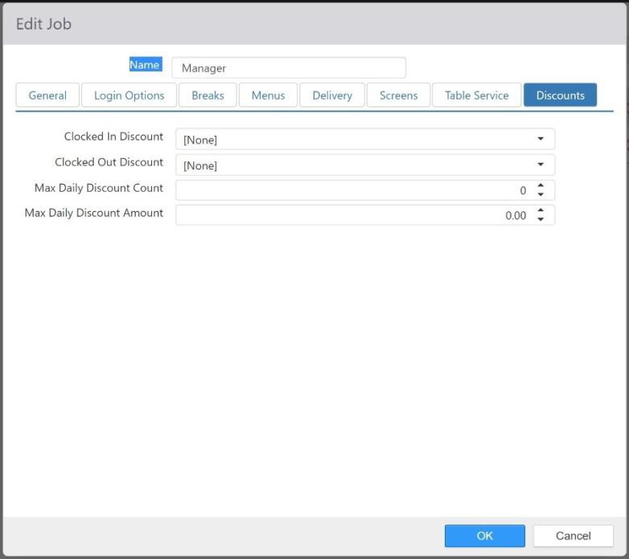

* + **Clocked In Discount**: Discount to be applied to the current order when ‘Employee Discount’ button behavior is executed and the selected employee is clocked in. Can be overridden at the Employees level.
  + **Clocked Out Discount**: Discount to be applied to the current order when ‘Employee Discount’ button behavior is executed and the selected employee is not clocked in. Can be overridden at the Employees level.
  + **Max Daily Discount Count**: Maximum number of times an employee can be associated with an employee discount for single business day. Can be overridden be an employee with **Security Level > Allow Excess Employee Card Usage** enabled. Can be overridden at the Employees level.
  + **Max Daily Discount Amount**: Maximum total employee discount amount for an employee for single business day. Can be overridden be an employee with **Security Level > Allow Excess Employee Card Usage** enabled. Can be overridden at the Employees level.

## Key Ingredients

Key ingredients print on the kitchen chit or display on Key Ingredient Summary control and are intended to communicate common prep items or ingredients for different order items.

*Key Ingredients list*

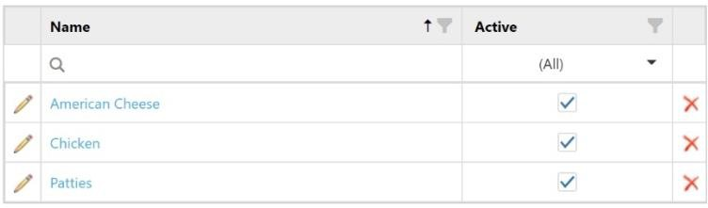

Click the **Add New Key Ingredient** button to add a new key ingredient. Click the name of an existing key ingredient to edit it.

*Edit Key Ingredient dialog*

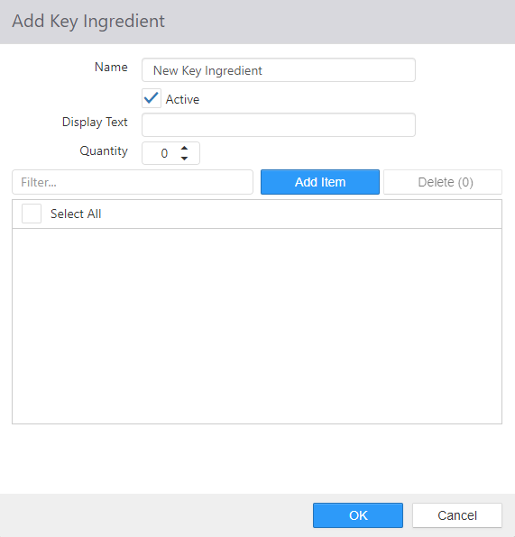

* **Name**: Name of the Key Ingredient.
* **Active**: Check Active if this Key Ingredient should be displayed.
* **Display Text**: Text that is to be displayed on kitchen chit.
* **Quantity**: Number of times each qualifying item counts towards the quantity displayed.
* **Add Item**: This will open a dialog box to allow you to select relevant items.
* **Delete**: Select the food item you want to remove from the Key Ingredient list.
* **Select All**: A way for the user to select and delete all of the key ingredients currently in the list.

*Add order screen override dialog*

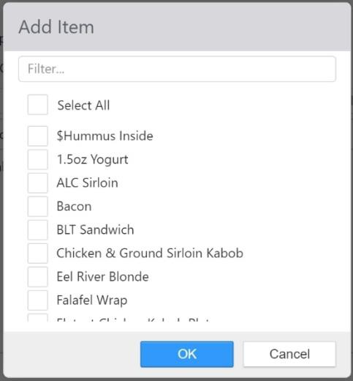

**Note:** To select items you can type the name into the Filter section or scroll through the list.

## Keyboard Shortcuts

Keyboard shortcuts are used to create shortcut buttons for common input values on the keyboard that displays on the Register and a text field is selected.

*Keyboard Shortcuts list*

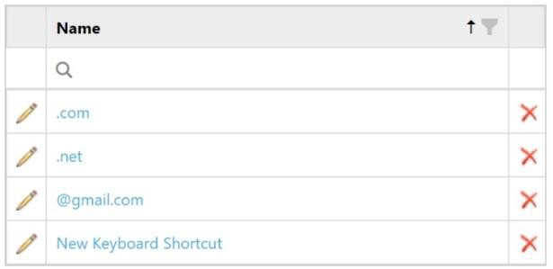

The shortcuts are available by selecting the gears button.

*Keyboard shortcuts on the register*

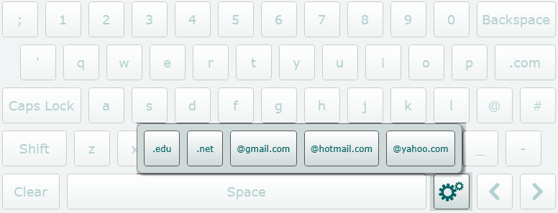

Click **Add** to create a new keyboard shortcut. Click the name of a keyboard shortcut in the list to edit it.

*Edit Keyboard Shortcut dialog*

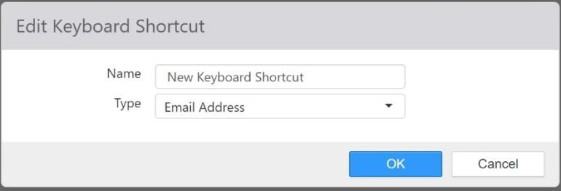

* **Name**: Name of the Keyboard Shortcut
* **Type**: Data type for which the shortcut applies.

## Kitchen Displays

Kitchen displays are terminals running the Kitchen application for displaying order items in the kitchen. A single kitchen display can display two different kitchen views in a split screen setup. Whether it displays one view or two views is setup in the Kitchen Display dialog.

The split screen functionality is provided to allow the user to make use of one terminal for two functions. For instance if you have a grill and a fryer right next to each other, you can have one terminal that is setup to split screen so that half of the kitchen display is the grill and the other half is the fryer.

To create a new kitchen display, click **Add New Kitchen Display**. To edit an existing kitchen display, click its name.

*Add Kitchen Display dialog, Options tab*

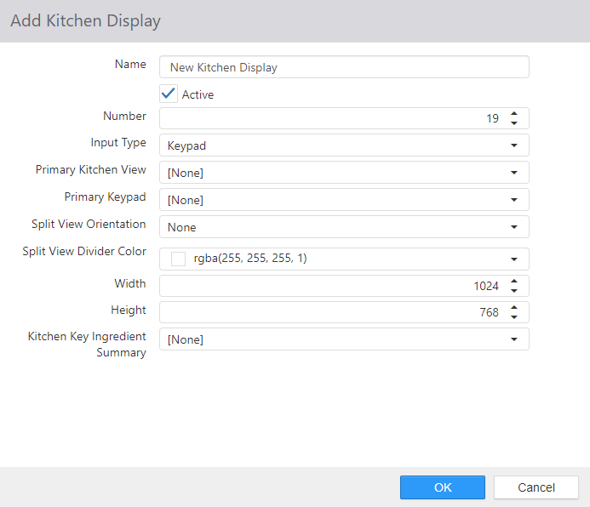

* **Name**: Name of the Kitchen Display
* **Active**: Kitchen application can run on kitchen display.
* **Number**: Terminal number to be used in the Kitchen.cfg file.

#### Input Type:

* + **Keypad**: Use keypad or bump bar to manipulate the kitchen display.
  + **Touchscreen**: Use touchscreen buttons to manipulate the kitchen display.
* **Primary Kitchen View**: The 1st view that will display on the kitchen display.
* **Primary Keypad**: Bumpbar connected to the primary kitchen view.
  + If Input Type = Touchscreen, this field will be hidden on the dialog.

#### Split View Orientation:

* + **None**: The kitchen display is not using split screen (default).
  + **Horizontal**: The kitchen display will be split into two kitchen views horizontally.
  + **Vertical**: The kitchen display will be split into two kitchen views vertically.
* **Secondary Kitchen View**: The 2nd view that will display on the kitchen display.
  + If Split View Orientation = None, this field will be hidden on the dialog.
* **Secondary Keypad**: Bumpbar connected to the secondary kitchen view.
  + If Split View Orientation = None, this field will be hidden on the dialog.
  + If Input Type = Touchscreen, this field will be hidden on the dialog.
* **Split View Divider Color**: Select the color of the visible split view divider on the kitchen display
* **Width**: Width in pixels of the Kitchen application window.
* **Height**: Height in pixels of the Kitchen application window.
* Kitchen Key Ingredient Summary: Select which Kitchen Key Ingredient Summary will display on the kitchen display.
  + None is a valid option (default)

## Kitchen Key Ingredient Summaries

Kitchen Key Ingredient Summaries allows you to configure how the key ingredients will display on the kitchen display. Key ingredients are created in the Key Ingredients entity.

To create a new kitchen key ingredient summary, click **Add New Kitchen Key Ingredient Summary**. To edit an existing kitchen display, click its name.

*Add Kitchen Key Ingredient Summary dialog*

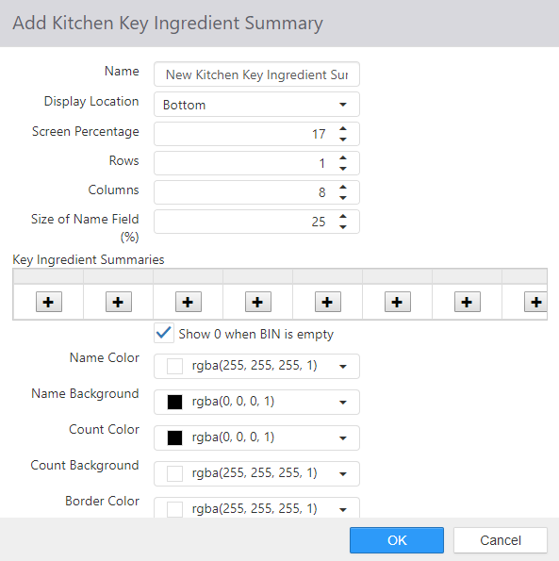

* **Name**: Name of the Kitchen Key Ingredient Summary
* **Display Location**: Use the drop-down list to set the location of the key ingredient summaries:
  + **None** (the default), **Top**, **Bottom**, **Left**, or **Right**.
  + Note that the remainder of settings below will only be visible if the Display Location is set to other than None.
* **Screen Percentage**: How much of the screen the key ingredient summaries area takes up.
* **Rows**: How many rows of key ingredient summaries there are.
* **Columns**: How many columns of key ingredient summaries there are.
* **Size of Name Field (%)**: How much of the key ingredient summary area is taken up by the name of the ingredient.
* **Key Ingredient Summaries**: The list of key ingredient summaries to be displayed (see Key Ingredients).

#### Show 0 when BIN is empty:

* + When a key ingredient is defined but there are currently none of the key ingredients ordered, this setting defines what to display on the Kitchen Display.

 When checked (Default), the key ingredient will display on the Kitchen Display with a value of 0

 When unchecked, the key ingredient will not display on the Kitchen Display

* Click the **‘+’** button to add a new key ingredient summary.

*Edit dialog*

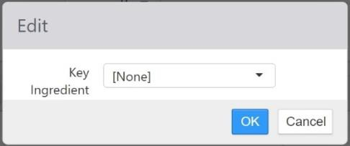

* **“Show 0 when BIN is empty” checkbox:** When the number of key ingredients gets to 0, the cell will display the number 0. If the checkbox is disabled, the whole key ingredient cell will be removed from the grid when the number of key ingredients gets to 0.
* **Name Color**: The color that the key ingredient summary name is displayed in.
* **Name Background**: The color of the background behind the name of the key ingredient summary.
* **Count Color**: The color of the digit that shows the ingredient count.
* **Count Background**: The color of the background behind the digit that shows the ingredient count.
* **Border Color**: The color of the border around the key ingredient summary.

## Kitchen Keypads

Kitchen keypads define the mapping of key characters to behaviors in the Kitchen application. To create a new kitchen keypad, click the **Add New Kitchen Keypad** button. To edit an existing kitchen keypad, click its name in the list.

*Edit Kitchen Keypad dialog*

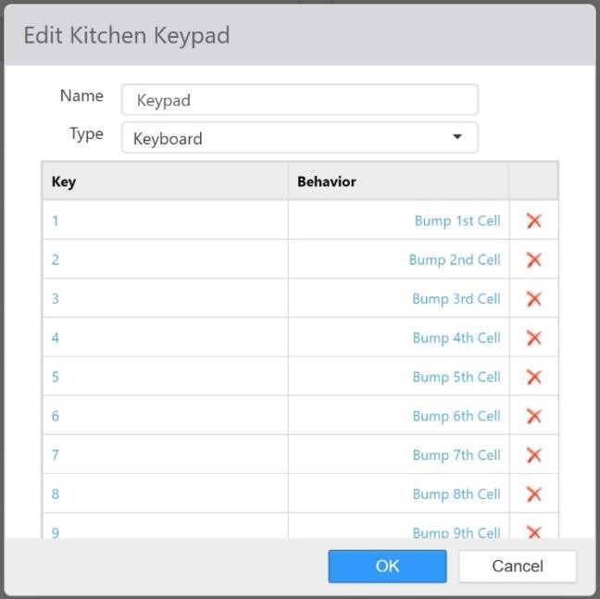

* **Name**: Name of the Kitchen Keypad
* **Type**: Type of keypad or bump bar.
  + **Keyboard**: Is a keyboard, or emulates a keyboard.
  + **Serial**: Connected via a serial COM port.

 **Parity**: Parity setting of the device.

 **COM Port**: COM port the device is physically connected to.

#### Keys:

 **Baud Rate**: Baud rate setting of the device.

*Edit Kitchen Keypad dialog*

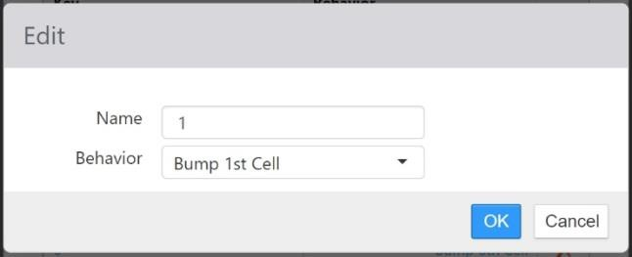

* + **Key**: Key character to be mapped
  + **Behavior**: Kitchen behavior to execute when key character received by Kitchen application.

## Kitchen Queues

A kitchen queue is a collection of order items that are to be displayed on one or more kitchen views. Order items are routed to kitchen queues by video groups. To create a new kitchen queue, click the **Add New Kitchen Queue** button. To edit a kitchen queue, click its name in the list.

*Edit Kitchen Queue dialog,* ***General*** *tab*

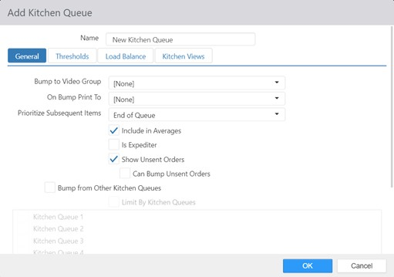

* **Name**: Name of the kitchen queue.

#### General tab:

* + **Bump to Video Group**: Video Group to add order items to when they are bumped from this kitchen queue.
  + **On Bump Print To**: Printer to print a kitchen chit to when the order is bumped from this kitchen queue.
  + **Prioritize Subsequent Sends**: Subsequent sends of an order will be displayed next to the original order on kitchen views, even if new orders have been sent prior to the subsequent send.

 If the order is sent to only one kitchen queue **and t**he kitchen queue is an expediter **and** the kitchen view mode is order mode, **then t**he order should be moved ahead of orders that do not meet the criteria above (but behind other orders that do meet the criteria).

 NOTE: Prior to version 5.0b of the software, this setting was in Options > Kitchen.

* + **Include in Averages**: Include kitchen bump times in kitchen performance reports.
  + **Is Expediter**: Displays check marks beside order items that have been bumped from all kitchen queues that do not have **Is Expediter** enabled.
  + **Show Unsent Orders**: Order items are displayed immediately on the kitchen display, prior to being sent.

 **Note:** Prior to version 5.0g of the software, this setting is in Options > Kitchen.

 **Can Bump Unsent Orders**: Order can be bumped as it is completed whether sent or unsent.

* + **Bump From Other Kitchen Queues**: Bumping from this queue bumps from all other queues.

 **Limit By Kitchen Queues**: Enables the list of queues. Only checked queues will have items bumped from them when they are bumped from this queue.

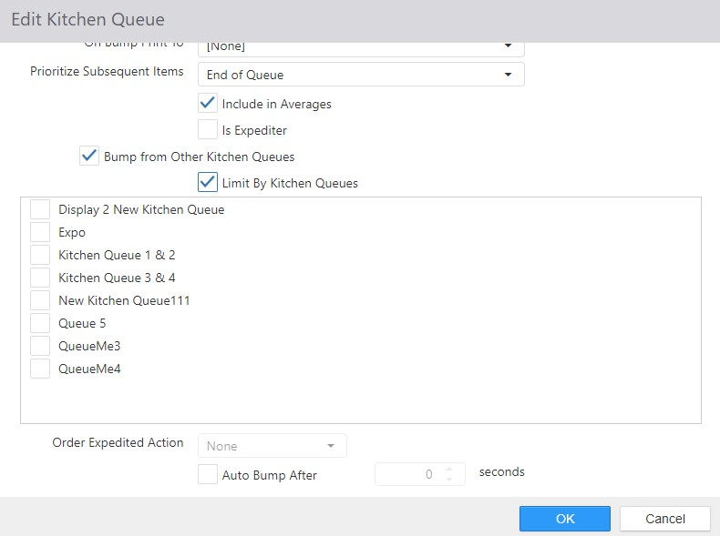

* + **Order Expediter Action**: Action to perform when order is bumped from queue when Is Expediter is enabled.

 **None** (default) is a valid options.

 **Send Email**

*Email Template dialog with* ***Send Email*** *selected*

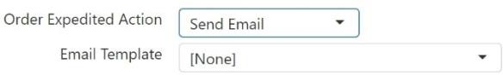

* + - **Email Template**: Email template to be sent. Email Templates setup in the Email Templates entity in Settings Editor.

 **Send Page**

 **Send SMS**

* + - **Message**: Content of the text message to be sent.
  + **Auto Bump After**: The number of seconds before items not yet bumped from this queue will be automatically bumped.



#### Thresholds tab:

If not selected, items/orders will not be automatically bumped from this queue

*Edit Kitchen Queue dialog,* ***Thresholds*** *tab*

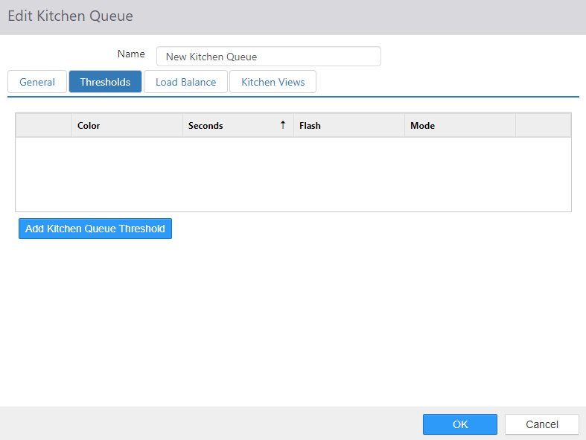

* + **Color**: Color of the order card border.
  + **Seconds**: Number of seconds after the order appears in the queue to apply the threshold style.
  + **Flash**: Flash the order card timer.

#### Mode:

 **Animate**: Change order card border color with animation effect.

 **Switch**: Change order card border color without any affects.

* + **Add Kitchen Queue Threshold** button: Select to add a new threshold.

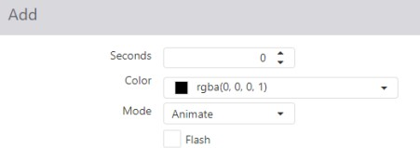

* **Load Balance tab**: Controls designed to help evenly distribute incoming orders in the queue to multiple Kitchen Displays.

*Edit Kitchen Queue dialog,* ***Load Balancing*** *tab*

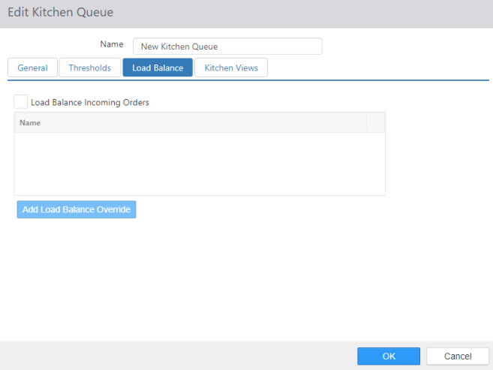

* + **Load Balance Incoming Orders**: Distribute incoming orders to multiple Kitchen Views based on the rules set in one or more *Overrides*.
  + **Overrides**: List of rules for distributing orders to multiple Kitchen Views. The current load balance *Override* is displayed on the bottom of all kitchen views that this kitchen queue is disbursing orders to.

 Enabled when Load Balance Incoming Orders selected.

* + To add an override, click the **Add Load Balance Override** button.

*Add dialog for load balance override*

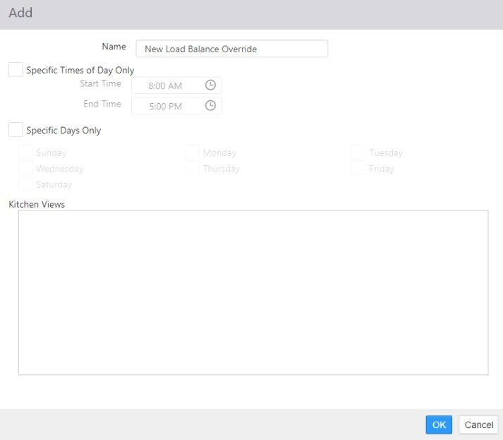

 **Name**: The name of the override.

 **Specific Time Only**: The override is automatically activated between the configured **Start Time** and **End Time**.

 **Specific Days Only**: If **Specific Time Only** is enabled, the override is only activated on the selected days of the week.

 **Kitchen Views**: The views to which the orders in the queue are evenly distributed.

* **Kitchen Views tab**: List of Kitchen Views that can be assigned to this kitchen queue.

*Edit Kitchen Queue dialog,* ***Kitchen Displays*** *tab*

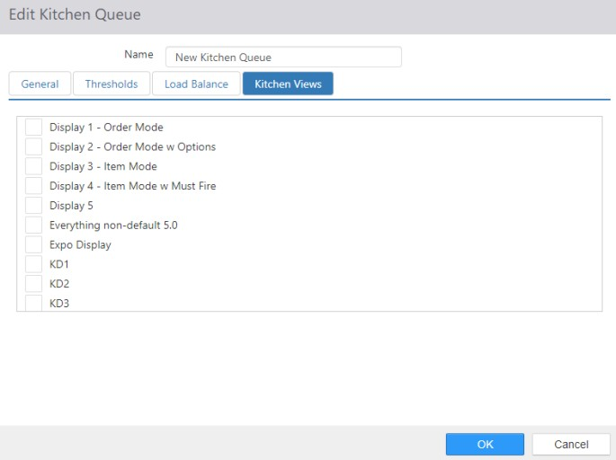

## Kitchen Views

Kitchen views are a way to allow two different kitchen stations to display on one kitchen display terminal. A kitchen display can have one or two kitchen views displaying. If two display, they can be configured to display horizontally (one on top of the other) or vertically (side by side). This sharing of the kitchen display is referred to as “Split Screen.”

To create a new kitchen view, click **Add New Kitchen View**. To edit an existing kitchen view, click its name.

*Add Kitchen View dialog, Options tab*

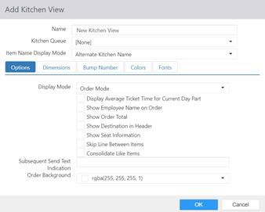

#### Options tab:

* + **Name**: Name of the Kitchen View
  + **Kitchen Queue**: The kitchen queue from which to display and bump order items.
  + **Item Name Display Mode:** Can select how you want the item name to display.

 **Alternate Kitchen Name:** The ‘Kitchen Name’ of the item, found in **Items**.  **Full Item Name:** The ‘Name’ of the item, found in **Items**.

#### Display Mode:

 **Order Mode:** Displays order items grouped by order in grid format.

 **Item Mode:** Displays order items in list format.

* + **Display Average Ticket Time for Current Day Part:** Displays the average amount of time between an order being sent to the kitchen and being bumped from the kitchen queue for the current day part (as configured on the Day Parts page) at the bottom of the current kitchen view.
  + The following options are available only when Display Mode set to Order Mode:

 **Show Employee Name on Order:** Displays the name of the employee who owns the order at the bottom of the order card.

 **Show Order Total:** Displays the total order amount at the bottom of the order card.

 **Show Destination in Header:** Displays the order destination at the top of the order card.

 **Show Seat Information:** Displays table and seat numbers

* + - **NOTE:** Group Items by Seat must be checked on the **Table Service** tab of the *Edit Job* dialog for this setting to work. See Jobs.
    - **NOTE:** This setting uses the **Seat Label Override** and **Party Label Override** values found on the Details tab of the *Edit Destination* dialog, if any. See Destinations.

 **Skip Lines Between Items:** Adds an extra space between order items.

* + - **NOTE:** This does not affect the spacing between modifiers.

 **Consolidate Like Items**: Order items of the same item, with the same modifiers, are displayed as a single item on the kitchen display with a quantity to the left.

* + - **NOTE:** Prior to version 5.0g of the software, this setting was in Options > Kitchen.
  + **Subsequent Send Text Indication**: Text to be displayed in the header of subsequent sends of an order on kitchen views. This text can be up to 25 characters in length.
  + **Order Background:** Sets the background color of the order display area.

#### Dimensions tab:

*Add Kitchen View dialog, Dimensions tab*

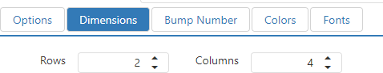

* + **Rows**: Number of rows to display when **Display Mode** is set to **Order Mode.**
  + **Columns:** Number of columns to display when **Display Mode** is set to **Order Mode.**

#### Bump Number tab:

*Add Kitchen View dialog, Bump Number tab*

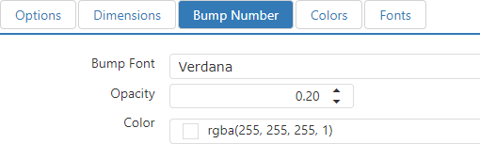

* + **Bump Font**: Font of the bump number that appears in the background of the order card.
  + **Opacity:** Transparency of the bump number that appears in the background of the order card.
  + **Color:** Color of the bump number that appears in the background of the order card.

#### Colors tab:

*Add Kitchen View dialog, Colors tab*

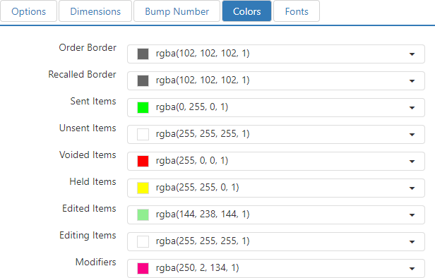

* + **Order Border:** Color of the border surrounding the order card.
  + **Recalled Border:** Color of the border surrounding orders that have been recalled.
  + **Sent Items:** Color of order items that have been sent to the kitchen.
  + **Unsent Items:** Color of order items that have not been sent to the kitchen.
  + **Voided Items:** Color of order items that have been voided.
  + **Held Items:** Color of order items that are currently being held.
  + **Edited Items:** Color of order items that have been edited after being sent to the kitchen.
  + **Editing Items:** Color of order items that are in the process of being edited after being sent to the kitchen.
  + **Modifiers:** Color of modifiers attached to order items.

#### Fonts tab:

*Add Kitchen View dialog, Fonts tab*

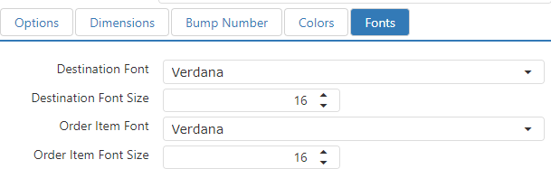

* + **Destination Font:** Font face of the destination displayed at the top of the order card.
  + **Destination Font Size:** Font size of the destination displayed at the top of the order card.
  + **Order Item Font:** Font face of the order items.
  + **Order Item Font Size:** Font size of the order items.

## Labels

The Labels page is where you configure labels for the Epson TM-L90 label printer. Create a new label by clicking the **Add** button, or edit an existing one by clicking its name in the list.

*Edit Label dialog*

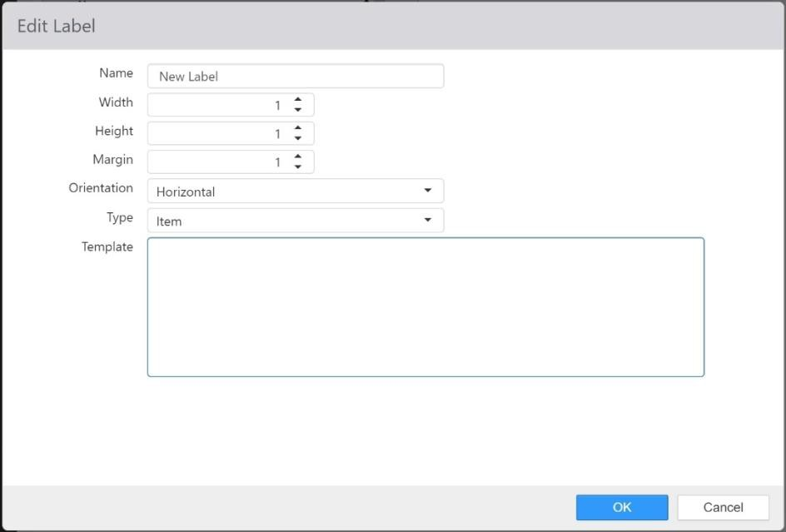

* **Name**: The name of the label.
* **Width**: The width of the label in inches.
* **Height**: The height of the label in inches.
* **Margin**: The distance between labels on the label roll, in inches.
* **Orientation**: Vertical or Horizontal.

#### Type:

* + **Item**: Label is for an individual item.
  + **Summary**: Label is an order summary.
* **Template**: The tags and parameters that define how the label will print.

### Formatting tags

The Epson TM-L90 label printer recognizes the following formatting tags. All tags must have accompanying closing tags (for example, **<Bold>** . . . **</Bold>**) and be nested properly. Tags are case- sensitive.

|  |  |
| --- | --- |
| Tag | Description |
| <Invert> | Prints white text on a black background. The black background bleeds off the edge of the label to the left and right and either the top or bottom if appropriate. |
| <Right> | Aligns the text on the right margin. |
| <Center> | Aligns the text in the center of the line. |
| <Bold> | Prints the text in boldface. |
| <FontB> | Prints the text in a smaller typeface. |
| <DoubleHeight> | Prints the text twice as tall as the default. |
| <DoubleWidth> | Prints the text twice as wide as the default. |
| <Bottom> | Prints the text at the bottom of the label. |
| <Wrap> | Wraps the contents of the line if it would otherwise extend off the edge of the label. |

### Replaceable Parameters

Brink POS recognizes and appropriately replaces the following replaceable parameters on labels printed to an Epson TM-L90 label printer. All replaceable parameters must be enclosed in percentage signs

(**%** . . . **%**) and are case-sensitive.

|  |  |
| --- | --- |
| Parameter | Description |
| Destination | The destination of the item or order (as configured on the  **Destinations** page in Settings Editor). |
| FutureOrderDate | Prints the date that the future order is due. |
| FutureOrderPhoneNumber | Prints the phone number entered for a future order. |
| FutureOrderTime | Prints the time that the future order is due. |
| ItemCount | The total number of items ordered. |

|  |  |
| --- | --- |
| ItemList | **NOTE**: Must be used with a label **Type** of **Summary**.  Prints a list of all items (but not modifiers) with each item’s price. Item prices reflect the price of any modifiers applied to them. |
| ItemModifiers | Displays a list of all item modifiers with their modifier code abbreviations, if any, as they would be printed on a kitchen chit. If a note was entered for the item, the note is displayed at the top of the modifier list. |
| ItemModifiersRemoveAddHorizontal | **NOTE**: Must be used with a label **Orientation** of **Horizontal**.  Displays a list of all item modifiers with their modifier code abbreviations, if any, grouped under two headings:  “REMOVE” and “ADD”. The REMOVE section is printed on the left, and the ADD section is printed on the right. If a note was entered for the item, the note is displayed at the top of the ADD list.  **NOTE**: Modifiers with a modifier code of type NO, SUB, or FOR appear under the REMOVE heading; all others appear under the ADD heading. |
| ItemModifiersRemoveAddVertical | **NOTE**: Must be used with a label **Orientation** of **Vertical**.  Displays a list of all item modifiers with their modifier code abbreviations, if any, grouped under two headings:  “REMOVE” and “ADD”. The REMOVE section is printed first, with the ADD section below it. If a note was entered for the item, the note is displayed at the top of the ADD list.  **NOTE**: Modifiers with a modifier code of type NO, SUB, or FOR appear under the REMOVE heading; all others appear under the ADD heading. |
| ItemName | Inserts the kitchen name of the ordered item. |
| ItemNumber | Inserts the number assigned to the item by the auto- numbering function. |
| ItemXofY | Displays the item number (in sequence as ordered) and the  total number of items ordered in this format: “Item 2 of 3” |
| OrderId | The identification code for the order. |
| OrderName | Prints the order name. If there is no order name, it prints the customer name. If there is no customer name, it prints the Lane prefix and the order number. |

|  |  |
| --- | --- |
| SKU | The SKUs of the items on the label, separated by commas. |
| Totals | Prints an order total section with each of the following lines:   * Sub-Total $0.00 * Discounts $0.00 * Promotions $0.00 * Surcharges $0.00 * Tax $0.00 * Total $0.00 * Paid $0.00 * Balance $0.00   Discounts, Promotions, and Surcharges only appear if their value does not equal zero. |

**NOTE**: For more information on configuring labels for the Epson TM-L90 label printer, see the *Epson TM- L90 Label Printer Label Formatting Guide*.

## Labor Groups

Labor groups are defined for reporting of hours on the Hourly Labor By Labor Group report. To create a new labor group, click the **Add** button. To edit a labor group, click its name in the list.

*Edit Labor Group dialog*

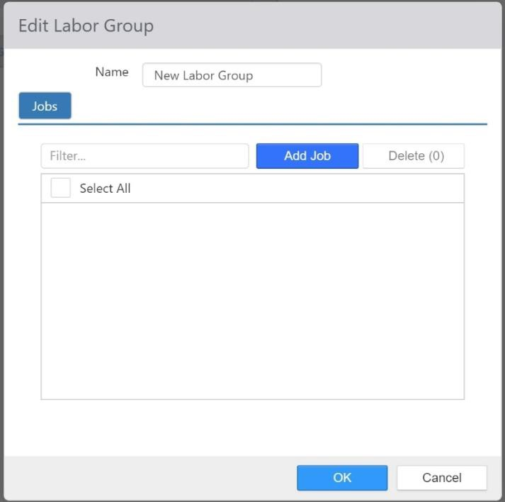

* **Name**: Name of the Labor Group
* **Selected Jobs**: Jobs included in the Labor Group

## Lanes

A lane is a collection of open orders in a quick serve environment, and determines how numbers are automatically numbered. To create a new lane, click the **Add** button. To edit a lane, click its name in the list.

*Edit Lane dialog,* ***Options*** *tab*

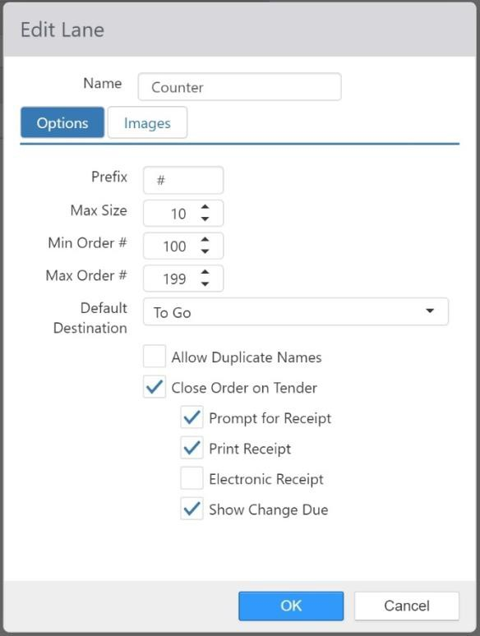

* **Name**: Name of the Lane

#### Options tab:

* + **Prefix**: String to display before the order name/number in the lane.
  + **Max Size**: Maximum number of open orders allowed in the lane.
  + **Min Order Number**: Number assigned to the first order opened in the lane.
  + **Max Order Number**: Last number assigned to an order opened in the lane, next number assigned will be the **Min Order Number**.
  + **Default Destination**: Default destination of new orders opened in the lane.
  + **Allow Duplicate Name**: Allow more than one open order of the same name in the lane.
  + **Close Order on Tender**: When checked, orders in this lane are automatically closed when the tender is processed.

 **Prompt for Receipt**: Prompt employee to select one of these options when order is closed: *No Receipt, Print, Email,* or *Both*

* + - If Tip and Signature has been enabled and set to *Customer Display* mode in *Options*, this prompt will be displayed on the customer-facing screen for the guest.







#### Images tab:

**Print Receipt**: Print receipt when order is closed.

**Electronic Receipt**: Prompt for email address for delivery of electronic receipt when order is closed.

**Show Change Due**: Display the change due dialog when order is closed.

*Edit Lane dialog,* ***Images*** *tab*

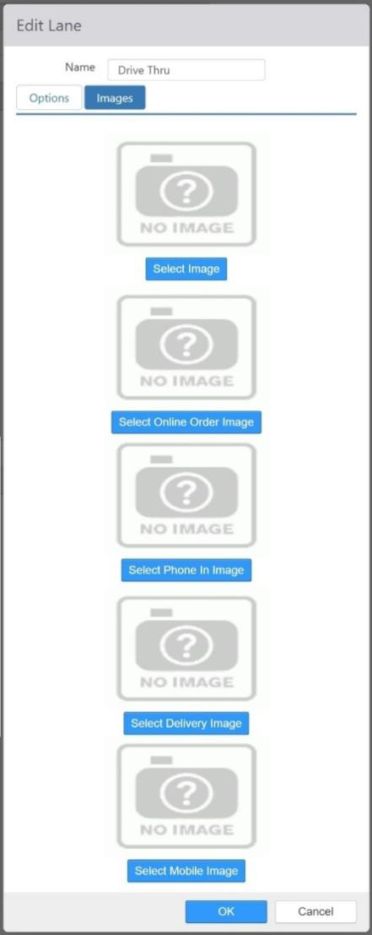

* **Image**: Default image to display for each order in the lane.
* **Online Order Image**: Image to display for orders with an order source of Customer Portal or API.
* **Phone In Image**: Image to display for future orders entered into the Register.
* **Delivery Image**: Image to display for orders with a destination that has Delivery enabled.
* **Kiosk Image**: Not implemented.
* **Mobile Image**: Image to display for orders with an order source of Customer Portal Mobile.

## Layout

The Layout section allows for editing panels used in the Register application, along with the controls on these panels. The controls define the functionality available to the employee and how the employee interacts with the application.

*Layout page*

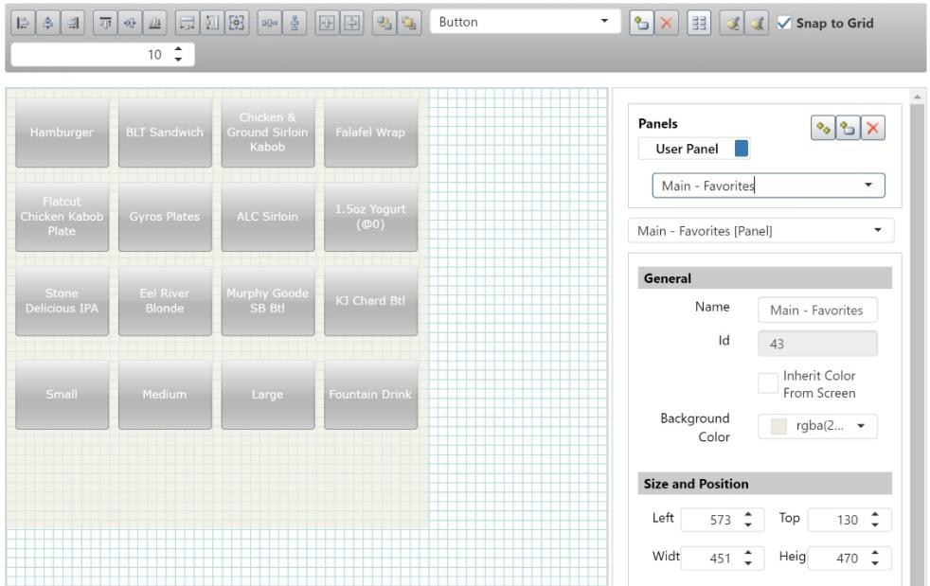

### Panel Browser

In the upper right area of the Layout page is the panel browser. Selecting a panel in this list displays it in the editing area on the left, below the layout toolbar.

*Panel browser*

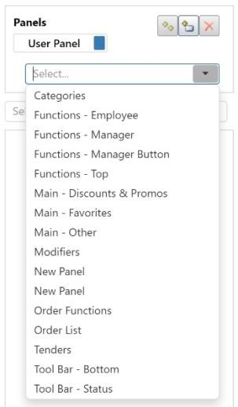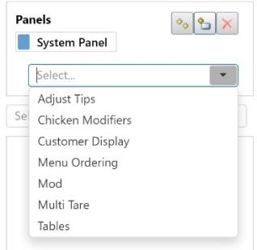

* **User Panels button**: Displays the user-defined panels. User panels can be added, edited, and deleted as needed.
* **System Panels button**: Displays the system-defined panels. System panels can be modified, but they cannot be deleted because the system expects these panels to exist for certain actions.
* **‘Copy the Selected Panel’ button**: Makes a copy of the selected panel.
* **‘Add a New Panel’ button**: Adds a new, blank panel to the list.
* **‘Delete the Selected Panel’ button**: Deletes the selected panel.

When a panel is selected in the panel browser, the properties area in the lower right displays the panel’s properties. The **Left** and **Top** property determine where on the screen of the Register application the panel appears, relative to the top/left corner of the screen.

*Properties area, showing panel properties*

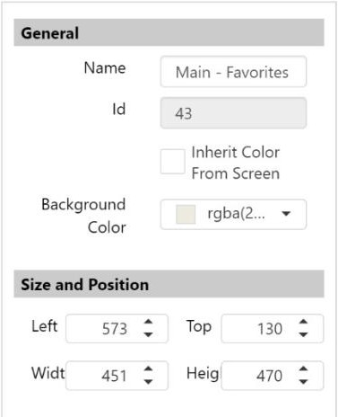

The information displayed in the properties area changes depending on what is selected.

### Layout Toolbar

The layout toolbar is use for adding controls to the current panel and for manipulating the controls’ size,

position, and style.

*Layout toolbar*



The buttons on the toolbar are arranged in groups of related functions:

|  |  |
| --- | --- |
| Buttons | Functions |
|  | Vertical alignment: align left edges, align centers, align right edges |
| Horizontal alignment: align tops, align middles, align bottoms |
| Size: make same width, make same height, make same size |
| Spacing: make horizontal spacing equal, make vertical spacing equal |
| Page alignment: center horizontally, center vertically |
| Arrangement: send to back, bring to front |
| Adding/removing: control drop-down list, add new control, delete selected control, add order items. See |

|  |  |
| --- | --- |
| Buttons | Functions |
|  | Adding New Controls for more information. |
|  | Style: copy style, apply style |
|  | Grid: Check the check box to have controls snap to the grid in the editing area. Use the number field to control how large  the grid is. |

*Adding New Controls*

Use the drop-down list to select the type of control you want to add, then click the ‘Add New Control’

button.

*Adding a new control to a panel*

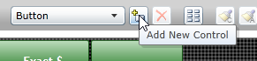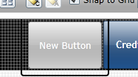

The types of controls that can be added are as follows:

|  |  |  |
| --- | --- | --- |
| Control | Description | Key Properties (in properties area) |
| Button | When selected, executes a particular button behavior. | **Text**: Text that appears on the button.  **Behavior**: Button behavior that executes when the button is selected. If the selected behavior had configuration options, a **Configure** button appears directly to the right.  **Permission**: Permission needed by the current employee to access the button. |

|  |  |  |
| --- | --- | --- |
| Control | Description | Key Properties (in properties area) |
|  |  | **Allow Override**: When enabled and the current employee does not have selected permission, PIN pad will appear to allow authorization by another employee. |
| Clock  Edit Sent Items | Displays the current local time.  Allows a sent item to be edited | None  None |
| Image | Displays a single image. | **Image**: Image to display. |
| Item Group Navigator | Dynamically generates buttons with the **Order Item** button behavior. Buttons are sorted alphabetically by item name. | **Item Group**: Item group containing items to display. |
| Key Ingredient Summary | Displays key ingredient summaries for the current order. | None |
| Label | Displays text. | **Text**: Text to be displayed. |
| Lane |  | **Lane**: Default lane to display. |
| Menu Category Navigator | Dynamically generates buttons for each menu category in the current menu. Used in conjunction with the **Menu Item Navigator** control. | None |
| Menu Item Navigator | Dynamically generates buttons for each of the menu items in the currently menu category. Used in conjunction with the **Menu Category Navigator** control. | None |
| Order List | Displays the current order details. | **Consolidate Like Items**: Group order items of the same item and modifiers as a single entry with a quantity count to the left.  **Show Offline Indicator**: Displays “Offline” at the top of the panel on the Register when the connection status of the current register is  offline. |

|  |  |  |
| --- | --- | --- |
| Control | Description | Key Properties (in properties area) |
|  |  | **Highlight Entire Combo**: Highlights the entire combo when it is first added to the order, whenever any of its components is selected, or whenever an item is made into a combo using the ‘Make Combo’ button behavior. To differentiate between the highlighted combo and the selected item, set the **Selected Item Color** and the **Selected Combo Color** to different values using the drop-down lists in the *Size and Style* section of the configuration panel.  **Show Scroll Bars**: Display buttons for scrolling the order list up or down.  **Show Sub-Total by Seat**: When employee’s current job has “Group Items by Seat” enabled, shows sub-total of the items per seat.  **Hide Totals When Unsent**: When the current order has unsent items, the bottom portion of the order list control, which displays Subtotal, Tax, Total, and Balance Due, is not visible.  **Allow Modifier Selection**: Allows direct selection of modifiers without selecting the parent item.  **Allow Multi Selection Mode**: Multiple items can be selected, and touching a selected item deselects it.  **Auto Select Combo Item Component**: Either the first or last item in a combo is selected when the combo is first added to the order or when an  item is made into a combo using the ‘Make |

|  |  |  |
| --- | --- | --- |
| Control | Description | Key Properties (in properties area) |
|  |  | Combo’ button behavior. Select either **First** or  **Last** using the drop-down list.  **Appearance**: Add or change the colors on a selected button. |
| Pivot Seat | Dynamically displays buttons for each guest/seat on the current order. Also includes a **Table** button for ordering items that are common to the entire order. | None |
| Party List | Displays a list of open orders as selectable buttons. Each button shows the order name and total. | **Show Arrow Keys**: Display buttons for scroll the list of orders when there are more orders than can be displayed based on the size of the control.  **Show Future Orders**: Include future orders in the list.  **Show Tables**: Include tables in the list of orders.  **Show Tabs**: Include tabs in the list of orders. |
| Separator | Used to separate and label groups of controls. | **Text**: Text to appear adjacent to the separator line. |
| Table | Represents a table and shows  the table’s current status. | **Table**: Table assigned to the control. |

If the control added is a **Button**, then the properties area shows a **Behavior** drop-down list. Some behaviors must be configured; if one of these is selected, a **Configure** button is displayed. The possible button behaviors are as follows:

|  |  |  |
| --- | --- | --- |
| Behavior | Description | Configuration Parameters |
| Add Order | Adds a new order to the current party, buttons automatically appear at the bottom of the Order List control for toggling between  orders on the party. | None |

|  |  |  |
| --- | --- | --- |
| Behavior | Description | Configuration Parameters |
| Add Panels to Screen | Displays the selected panels, and any overlapping panels previously visible will be hidden. | List of panels. |
| Adjust Payment | Opens tender dialog to allow adjustment of the amount of the selected payment.  Adjustments are not supported by all payment processors. | None |
| Adjust Tips | Opens system screen that allows input of tips on credit card payments applied against the current employees till. | None |
| Assign Cash Drawer | Assigns the cash drawer on the current register to the current employee. If more than one cash drawer is available a prompt to choose a cash drawer will appear.  Current employee must be logged in under a  job with “Can Assign Cash Drawer” enabled. | None |
| Assign Delivery Order | Opens ‘Assign Delivery Order’ screen, which allows for assigning delivery orders to delivery drivers. Only orders with a destination marked as delivery will appear, and only employees clocked in under a job marked as delivery driver will appear.  Current employee must be logged in under a  job with “Delivery Dispatcher” enabled.  Assigning an order to a delivery driver transfers ownership of non-cash payments to the driver. | None |
| Bank Deposit | Opens a *Bank Deposit* dialog which allows employee to enter **Amount**, **Bag**, **Type**, and **Notes**. This functions exactly like the Bank Deposit function in Admin Portal. | None |

|  |  |  |
| --- | --- | --- |
| Behavior | Description | Configuration Parameters |
| Break Combo | Breaks up an item combo, leaving all the components of the combo as individual items in the order list. | None |
| Cancel | Dismisses a model panel without making a combo component selection. | None |
| Change Item Size | Changes the size of the selected item up or down, depending on configuration. Used in conjunction with defined Item Size Group. | **Up** or **Down**. |
| Change Kitchen Load Balancing | Changes the kitchen load balancing setting either automatically or via prompt. | **Prompt** to select a kitchen queue and override setting or set the **Kitchen Queue** and **Override** to be automatically set. |
| Change Lane | Changes the currently visible lane for the current employee’s session. Lane reverts back after employee logs out. | **Prompt User** to select or set to a specific lane. |
| Change Menu | Changes the currently visible menu the current employee’s session. Menu reverts back after employee logs out. | Select **Menu** |
| Change Seat | Changes the seat of the select items in the order list. Items must be unsent in order to change seats. | None |
| Charity | Assigns a select charity to the current order. | Select charity |
| Check Gift Card Balance | Opens the gift card dialog and allows the retrieval of the stored value balance via an integrated gift card processor. | **Type**: **Print**, **Display**, or **Both** |
| Checkout | Checks out the till assigned to the current employee. | **Type**: Self-baking **Employee** or cash **Drawer**.  *Optional:*  **Confirm Checkout**  **Print Report** (checkout report)  **Open Cash Drawer** |

|  |  |  |
| --- | --- | --- |
| Behavior | Description | Configuration Parameters |
| Claim Order Confirmation Display | Claim a pre-configured Order Confirmation Display. | Select Order Confirmation Display |
| Clear | Removes all unsent order items from the current order. | None |
| Clear Current Party | Clears the current party, leaving no current order. | None |
| Clear Customer | Un-assigns the customer from the current order. | None |
| Clear Note | Removes the note from the select order item. | None |
| Clear Selected Items | Removes selected unsent order items from the current order. | None |
| Clock In | NO LONGER USED | None |
| Clock Out | Clocks out the current employees, and forces checkout if a till is assigned to the employee. | None |
| Close Order | Closes the current order.  Current employee must be logged in under a  job with “Cannot Close Orders” disabled. | *Optional:*  **Show Change Due** dialog **Prompt For Receipt** Automatically **Print Receipt**  Send **Electronic Receipt** via email. |
| Close Table | Closes the current table. Table cannot have any open orders.  Only allowed when the current mode is Table Service. | None |
| Combine Orders | Prompt to select another open order, which is to be combined with the current order.  The selected order is closed after the items  are moved to the current order. | None |

|  |  |  |
| --- | --- | --- |
| Behavior | Description | Configuration Parameters |
| Combo | NO LONGER SUPPORT ED | NO LONGER SUPPORTED |
| Comp Card | To trigger a comp Card integration, button behavior must exist | None |
| Credit Card | Opens credit card dialog of card swipe or manual entry. Tender applied is the first active tender of the matching card type. | None |
| Delete | Removes unsent order items, or voids sent order items. | None |
| Delete All | Removes all unsent order items and voids all sent order items. | None |
| Deposit | Obsolete | None |
| Destination | Sets the destination of the order and all unsent order items. | **Prompt User** – prompts the user with a list of available destinations  **Prompt User Only When Unsent Items** – the list of available destinations will only display if there are unsent items in the order list  Select a destination from the list |
| Discount | Applies a discount to the current order. | **Prompt User** to select or set to a specific discount. |
| Done | Closes a system panel. | None |
| Dynamic Included Modifier | Configures to a position rather than a specific modifier. | Numbered **Position** |
| Edit Checkout | Prompts employee to select a previously checked out till to re-enter the declared cash. | None |
| Edit Customer | Opens the ‘Edit Customer’ screen for the customer assigned to the current order. | None |

|  |  |  |
| --- | --- | --- |
| Behavior | Description | Configuration Parameters |
| Electronic Receipt | Prompts for an email address and then sends an electronic receipt via email. Email is prepopulated with the email address of the customer assigned to the current order. | None |
| Edit Shifts | Opens the ‘Edit Shifts’ screen which allows for shift maintenance for the current business day. | None |
| Employee Discount | Applies a discount that has the Employee Discount option selected. | **Prompt Type**: **Select Employee**  or **Swipe Employee Card**  **Discount Source**: **All Employee Discounts** or **Employee Specific** |
| End Break | Obsolete | None |
| End of Day | Runs the end of day process and advances the business date by one day. | None |
| Ensure Items Selected | Validates that at least one order item is selected on the current order. | None |
| Equal Payments | Prompts the employee for the number of payments to apply, then prompts for the tender type for each payment. Payments are applied at equal amounts based on the balance due. | None |
| Execute Macro | Executes a series of button behaviors. | List of button behaviors to execute |
| Execute Payment Device Action | Instructs an attached payment device to capture information from the customer. | **Type**: **Get Customer Email Address**, **Get Customer Phone Number**, or **Get Gift Card Tender** |
| Execute Script | Executes a VB script or VB script function. | Script |
| Exit | Shuts down the Register application. | None |
| Fast Cash | Applies a cash payment to the current order for the balance due, opens the cash drawer, and displays the payment amount.  Current employee must be logged in under a  job with “Bartender” enabled. | None |

|  |  |  |
| --- | --- | --- |
| Behavior | Description | Configuration Parameters |
| Hold | Places selected order items on hold, to be sent at a later time. | **Clusivity**: **Inclusive** of the order items selected, or **Exclusive** of the order items selected.  **Release Type**:  **Manual**: Order items will be held until employee explicitly releases.  **Prompt**: Employee must enter hold minutes.  **Specific**: Predefined hold minutes.  *Optional:*  Default/predefined **Minutes** to be held. |
| Ingredients | Opens ‘Ingredients’ screen, which displays the ingredients for all of the selected order items. | None |
| Item Availability | Opens ‘Item Availability’ screen, which allows for setting availability of all items. | None |
| Logout | Logs the current employee out of the Register, returning to the login screen. | None |
| Lookup Customer | Opens the ‘Customer Lookup’ screen, which allows for searching the customer database and assigning a customer to the current order. | None |
| Lookup Item | Opens the ‘Lookup Item’ screen, which allows searching items by name and adding items to the current order. | None |
| Make Combo | With an item in the order list selected, allows the user to create a combo, based on existing  item combos. | None |

|  |  |  |
| --- | --- | --- |
| Behavior | Description | Configuration Parameters |
| Manage Drawers | Opens the ‘Manage Cash Drawer’ screen, which allows for assigning cash drawers, checking out cash drawers, and performing paid ins/outs.  Current employee must be logged in under a security level with “Manage cash Drawers” enabled. | None |
| Manage Future Orders | Opens the ‘Manage Future Orders’ screen, which allows for viewing, editing, cancelling, and sending future orders that are unsent. | None |
| Manage Payment Device | Opens a dialog listing options to download or reset payment device related data, depending on the configured payment device. | None |
| Modifier Code | Sets the modifier code to be applied to the next modifier ordered. | Select modifier code |
| Modify | Opens the ‘Modify’ screen, which allows for ordering and removing modifiers. | None |
| Move Party | Opens a dialog listing all open tables, the current party is moved to the selected table and the current table is closed. | None |
| Name Order | Prompts to enter a name for the current order. | None |
| Name Party | Prompts to enter a name for the current party. | *Optional:*  **Use Numeric Keypad**  Or enter default text |
| New Customer | Opens the ‘New Customer’ screen for entry of a new customer record. After created, the new customer is assigned to the current order. | None |
| New Order | Creates a new party with a single new order. | *Optional:*  **Suppress “Already On New Order” Error Message** |

|  |  |  |
| --- | --- | --- |
| Behavior | Description | Configuration Parameters |
| New Tab | Creates a new party as a tab. | *Optional:*  **Prompt for Name** |
| New Table | Prompts use to select from a list of open tables, selected table is opened with a single new order. | None |
| Next Person | Advances to the next seat number. | None |
| Note | Adds a note to the select order item. | Optional predefined note value |
| Open Cash Drawer | Opens a specific cash drawer on the current register. | Select cash drawer number |
| Open Panels | Hides all currently visible panels and displays select panels. | Select panels |
| Open Panels with Saved Return | Saves the currently visible panels, then hides all currently visible panels, and displays select panels. To be used with the ‘Restore Panels’ behavior. | Select panels |
| Order Confirmation Display Configuration | Select multiple claimable Order Confirmation Displays for a single register | None |
| Order Item | Adds select item to current order. | **Price Method**:  **Item Price**: The price used is the price set in the *Edit Item* dialog  **Button Price**: Set the price of the item in the Price field  Select item |
| Order Item by SKU | Prompts employee to enter item SKU. If only one matching item is found the item is added to the current order, but if more than one matching item is found the employees receives a prompt to select the correct item. | None |
| Order Modifier | Adds select modifier to the currently selected order item. | Select item |

|  |  |  |
| --- | --- | --- |
| Behavior | Description | Configuration Parameters |
| Order Weighted Items | Opens ‘Order Weighted Items’ screen for ordering items with **Quantity Counted** enabled. | Select items |
| Override Order Confirmation Display | Overrides the previous register sending orders to the Order Confirmation Display. The current register will now send orders to the Order Confirmation Display. | None |
| Payment Device | Initiates payment from payment device associated with the current register for the balance due on the current order. | *Prompt Employee for Payment Method*:  **Do Not Prompt** or **Prompt Employee for Payment Method** (**Gift Card**, **Credit Card**, **Debit Card**, **Manual Credit Card**)  **NOTE**: **Manual Credit Card** only functions when the Payment Device **Model** is **Tender Retail** or **VeriFone Point**. |
| Print Member Summary | Prints loyalty plan summary for the customer assigned to the current order. | None |
| Print Label | Opens ‘Print Label’ screen, which allows for printing Item SKU barcode labels on the label printer assigned to the current register. | None |
| Print Last Order | Prints a receipt for the last order viewed on the current register. | None |
| Print Last Order Credit Drafts | Reprints all credit drafts for the last order viewed on the current register. | None |
| Print Order | Prints a receipt for the current order. | None |
| Promotion | Applies select promotion to the current order. | Select promotion |
| Promotion Code | Prompts for code of promotion to be applied to the current order. | Select promotion code processor |
| Quantity | Sets the quantity of the next item or modifier ordered or gift card issued. | *Optional:*  Specify a **Quantity**  **Append to Current Quantity** |

|  |  |  |
| --- | --- | --- |
| Behavior | Description | Configuration Parameters |
| Recall Next | Sets the current order to the next order in the current lane created after the current order. | None |
| Recall Order | Opens the ‘Recall Order’ screen, which allows for reprinting and reopening orders. | **Recall Type**: **Open**, **Closed**, or  **Both** |
| Recall Previous | Sets the current order to the previous order in the current lane created before the current order. | None |
| Redeem Rewards | When a loyalty customer is assigned to the order, brings up a dialog with available rewards.  **NOTE**: This is only available with certain non-  Brink loyalty providers. Will display the  message “This button behavior is not valid with the configured loyalty provider” if not allowed. | None |
| Refund | Converts the current order to a refund. | None |
| Release | Releases selected items that are currently being held so that they can be manually sent to the kitchen. | None |
| Reopen Order | Reopens the current order.  Current employee must be logged in under a  security level with “Reopen Orders” enabled. | None |
| Repeat | Repeats the last item or modifier ordered. | *Optional:*  **Prompt for Quantity** (number of times to repeat) |
| Replace Customer Card | Prompts employee to swipe new loyalty card for the customer assigned to the current order. Customer account number is updated with the new card number.  Only valid when loyalty provider is set to Brink. | None |

|  |  |  |
| --- | --- | --- |
| Behavior | Description | Configuration Parameters |
| Report | Opens a selected report. | Select report |
| Reprint Checkout | Prompts employee to select a previously checked out till to reprint checkout slip. | None |
| Reprint All Credit Drafts | Reprints all credit drafts for the current order. | None |
| Reprint Credit Draft | Reprints the selected credit drafts on the current order. | None |
| Reprioritize Kitchen Order | Reprioritizes an order that has been sent to the kitchen. | **New Position:** The priority number to assign to the reprioritized order. |
| Reroute Kitchen Display | Reroutes kitchen video display from one display to another. | **Prompt** for kitchen displays or select from/to **Kitchen Display**.  *Optional:*  **Persist at End of Day**: **Yes**, **No**, or **Prompt** |
| Reroute Kitchen Queue | Reroutes kitchen video queues from one queue to another. | **Prompt** for kitchen queues or select origin **Kitchen Display** and destination **Kitchen Queue**.  *Optional:*  **Persist at End of Day**: **Yes**, **No**, or **Prompt** |
| Reroute Printers | Opens the ‘Reroute Printers’ screen, which allows for rerouting specific printers or resetting the routing. | None |
| Restore Panels | Opens panels that were last saved by the Open Panels with ‘Saved Return’ behavior. | None |

|  |  |  |
| --- | --- | --- |
| Behavior | Description | Configuration Parameters |
| Reward History | Opens ‘Reward History’ screen, which displays loyalty reward history for the customer assigned to the current order.  Only valid when loyalty provider is set to Brink. | None |
| Save Card to Party | Opens credit card dialog, which tokenizes a credit card and stores token on the current party for future use.  Requires that credit card tokenization be enabled. | None |
| Save Tab | Prompts for party name if no name previously entered. | None |
| Select Order | Obsolete | None |
| Send Order | Sends to the kitchen all unsent order items, which are not being held, on the current order. | *Optional:*  **Suppress Error Messages** |
| Send Order Items | Sends to the kitchen selected unsent order items, which are not being held, on the current order. | None |
| Send Party | Sends to the kitchen all unsent order items, which are not being held, on all orders on the current party. | *Optional:*  **Suppress Error Messages** |
| Send with Destination | Sets the order destination, then sends to the kitchen all unsent order items, which are not being held, on the current order. | Select destination |
| Set Future Order | Opens the ‘Future Order’ screen, which allows for selecting order date/time, assigning customer, and selecting  destination. | None |

|  |  |  |
| --- | --- | --- |
| Behavior | Description | Configuration Parameters |
| Set Future Order Parameters | Sets future order lead time minimum and enables/disables online ordering.  These are reset by the end of day process. | **Future Order Lead Time in Minutes (0 to Prompt)**  *Optional:*  **Online Ordering Unavailable** |
| Set Guest Count | Prompts employee to enter guest count for the current party. If party is assigned to a table, this also updates the seat count. | None |
| Set Login | Prompts to select employee to update, only employees with the selected login type enabled are displayed. After selecting an employee, the appropriate dialog for updating the selected login type is displayed.   * If **Finger Scan** is selected AND any employees eligible for finger scan login have a home location (**Employees > Locations**), you have the option to ‘Show employees for this location only’ * **NOTE:** Brink POS does not store an   employee’s fingerprint or  information based on the employee’s fingerprint, only a hexadecimal string of data in conjunction with an employee record if Brink POS is configured to allow an employee to Login with Finger. | Login type: **Prompt** for type,  **Card**, **Finger Scan**, or **PIN** |
| Set Party Contact Data | Opens a dialog where the pager # can be entered for the current order. | **Contact Method**: **None**, **Pager**, or **SMS** |
| Set Section | Changes the section that the current register is assigned to. | Select section, or **Prompt User**  to choose |

|  |  |  |
| --- | --- | --- |
| Behavior | Description | Configuration Parameters |
| Set Tax Exempt | Toggles the current order to tax exempt or not. When setting to tax exempt, prompt to enter Tax ID is presented.  Example: Start a new order and select this button. The order is now tax exempt (no tax applied). Select the button again and the order is no longer tax exempt. No matter what tax-exempt state the previous order is in, selecting a new order sets the Set Tax Exempt status for the new order to not tax exempt. | None |
| Show Default Screen | Opens panels assigned to the current  employee’s default screen as defined on their current Job. If no default screen is set on the current job, then the default screen on the current register is used. | None |
| Show Order Screen | Opens panels assigned to the current  employee’s order screen as defined on their current Job. If no order screen is set, then the default screen is used. | None |
| Show Screen | Opens panels assigned to a select screen. | Select screen |
| Smart Item | Adds item to the current order based on the active smart element for a given smart group. If no active smart element is set, then the default item is added.  Use in conjunction with ‘Smart Select’ behavior. | **Smart Group**: Select smart group  **Default Item**: Select a default item, or **None**  **Smart Element**: Element number  **Item**: Item name |
| Smart Select | Sets the active smart element for a specific smart group.  Use in conjunction with ‘Smart Item’ behavior. | **Smart Group**: Select smart group  **Smart Element**: Element number |

|  |  |  |
| --- | --- | --- |
| Behavior | Description | Configuration Parameters |
| Split Order | Opens ‘Split Order’ screen, which allows for adding new orders to the current party, moving items between the orders, splitting individual items, and combining (un-splitting) split items.  Current employee must be logged in under a  security level with “Split Check” enabled. | None |
| Start Bank | Assigns a new self-banking till to the current employee.  Current employee must be logged in under a  job with “Self-Banking” enabled. | None |
| Substitute | Adds panels to the screen for the selected combo component on the current order. | None |
| Surcharge | Applies a select surcharge to the current order. | Select surcharge, or **Prompt User** to select |
| Tables Screen | Hides all currently visible panels and displays the ‘Tables’ system panel.  Only allowed when the current mode is Table Service. | None |
| Transfer | Opens the Transfer Party window that allows the current employee to select tables or tabs to transfer to another employee. | None |
| Transfer Items | Prompts employee to select an open order to move the selected sent items to from the current order. | None |
| Tender | Applies a payment of a select tender type. | Select tender |
| Toggle Order List Selection | Switches between multi-selection mode and single-selection mode. After the current employee logs off, the setting returns to the default as set in the Order List control. | None |
| Toggle Show Employee Names | Toggles the visibility of the employee name on table controls. | None |

|  |  |  |
| --- | --- | --- |
| Behavior | Description | Configuration Parameters |
| Unassigned | Button does not perform any function. | None |
| Undo Checkout | Prompts employee to select a previously checked out till undo and return to the cash drawer or employee. | None |
| Update Table Status | Updates the current status of the selected tables. | **Table Status**: **Closed**, **Clean**, **Seated**, **Dirty**, **Preassigned**, **CheckDown**, or **Reserved** |
| Validate Combos | Checks all combo items on the current order to make sure that all component requirements have been satisfied. | None |

*Adding Multiple ‘Order Item’ Buttons*

You can use the ‘Add Order Items’ button to add multiple buttons to the panel which are all set to the ‘Order Item’ behavior. When you click the ‘Add Order Items’ button, the *Select Order Items* dialog is displayed.

*Select order items dialog*

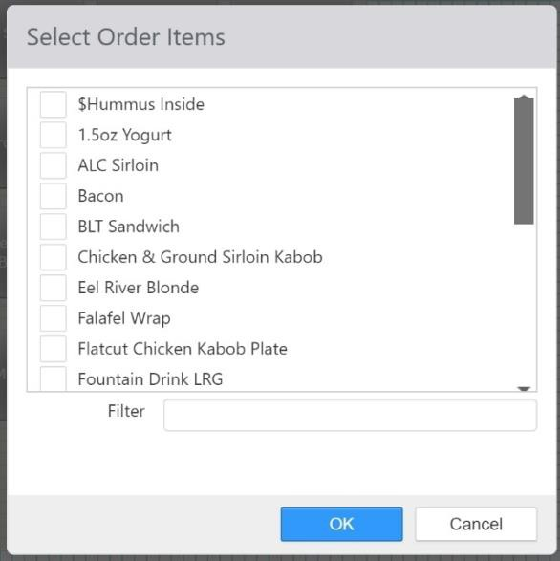

When you click the **OK** button, new buttons will be added for each item in the *Selected* list.

## Loyalty Adjustment Reasons

Loyalty adjustment reasons are listed on the Reason dropdown list when performing a loyalty adjustment on a specific customer record, or when performing a bulk loyalty adjustment. To add a new loyalty adjustment reason, click **Add**. To edit an existing one, click its name in the list.

*Edit Loyalty Adjustment Reason dialog*

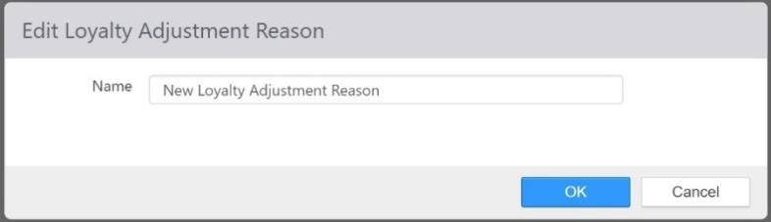

* **Name**: The name of the loyalty adjustment reason. This is what is displayed in the **Reason** drop- down list.

## Loyalty Events

Loyalty events are used to automate customer engagement based on customer transactions. Loyalty events can send emails, issue rewards, and/or issue loyalty value.

*Loyalty Events list*

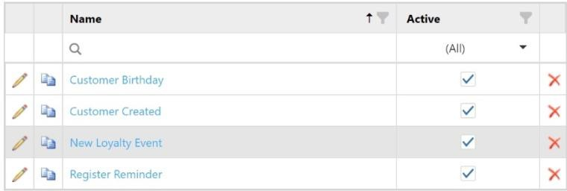

To create a new loyalty event, click **Add**. To edit an existing loyalty event, click its name in the list.

*Edit Loyalty Event dialog,* ***Details*** *tab*

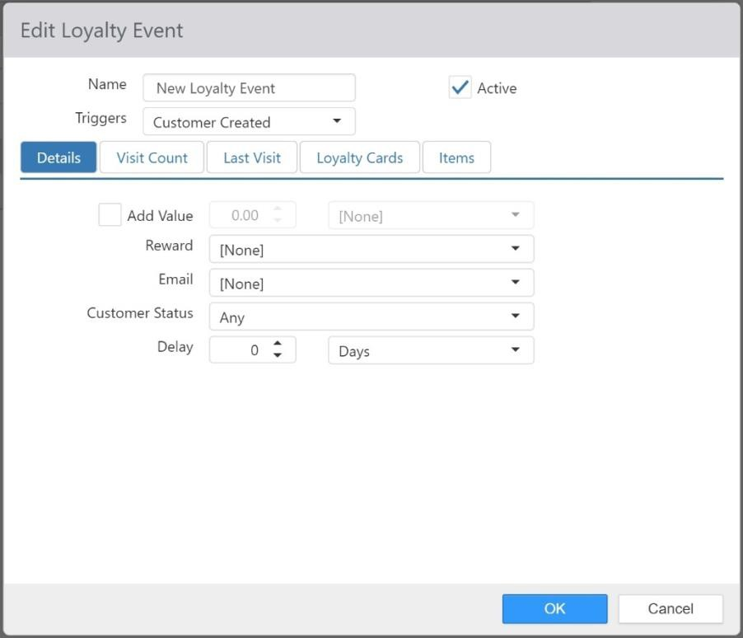

* **Name**: Name of the Loyalty Event.
* **Active**: When checked, this loyalty event is active.
* **Trigger**: Action or date that initiates the event occurring.
  + **Customer Birthday**: This event occurs on the customer’s birthday if the customer

entered it into his or her online profile.

* + **Customer Registered**: This event occurs when the customer registers on the online ordering portal for the first time.
  + **Customer Created**: This event occurs when the customer’s loyalty account is created. This can be the same as **Customer Registered**, above, if the customer both signs up and registers their account at the same time.
  + **Customer Ordered**: This even occurs when the customer places an order.

#### Details tab:

* + **Add Value**: Adds value to the customer account when event fires.

 **Value**: Loyalty value to add to the customer account.

 **Loyalty Plan**: Loyalty Plan the value is to be associated with.

* + **Reward**: Reward to be added to the customer account.
  + **Email**: Email template to be send to the customer.

#### Customer Status:

 **Any**: Trigger for all customers, regardless of registration status.

 **Registered**: Only trigger for customer that have completed their online profile.

 **Un-Registered**: Only trigger for customers that have not completed their profile online.

* + **Delay**: Delay event from triggering, relative to the action that triggers the loyalty event. Can be negative or positive.

 **Delay Type**: **Days** or **Minutes**

* + **Check for Duplicates:** When this check box is checked, the system checks to see if multiple customers have the same birthday and last name and only triggers the event for the first one to initiate a transaction.
* **Visit Count**: Only activate for customers that have a total order count between the given count range.

*Edit Loyalty Event dialog,* ***Visit Count*** *tab*

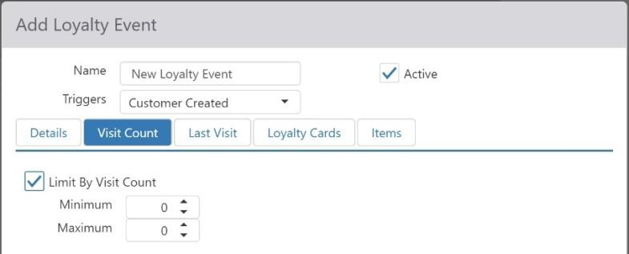

* **Last Visit**: Only activate for customers where the number of days since their last visit is within the given day count range.

*Edit Loyalty Event dialog,* ***Last Visit*** *tab*

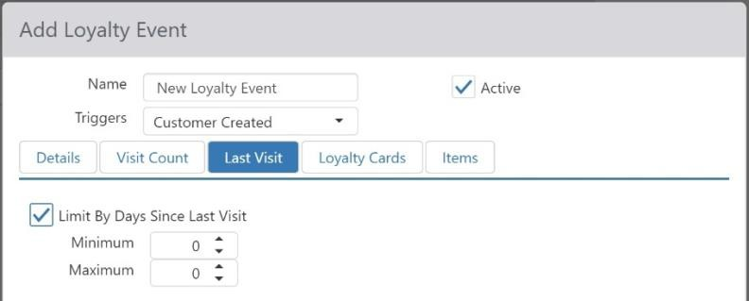

* **Loyalty Cards**: Only activate for customers that have the selected Loyalty Cards.

*Edit Loyalty Event dialog,* ***Loyalty Cards*** *tab*

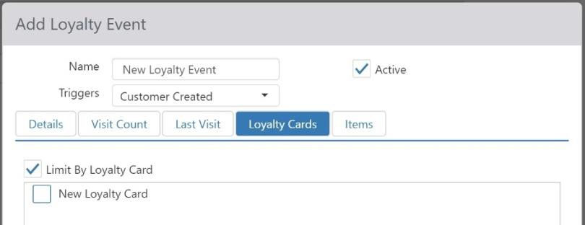

* **Items**: Only activate when the **Trigger** is **Customer Ordered** and the order contains any of the selected items.

*Edit Loyalty Event dialog,* ***Items*** *tab*

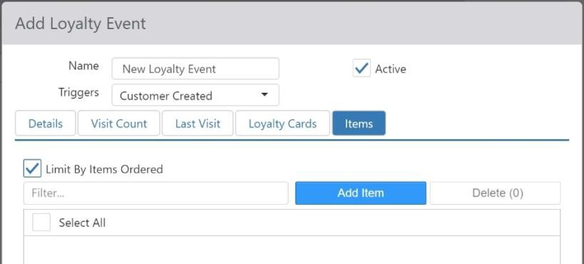

## Loyalty Cards

Loyalty cards identify the loyalty plans that customers participate in. A customer record can only be associated with one loyalty card. To create a new loyalty card, click Add. To edit an existing loyalty card, click its name in the list.

*Edit Loyalty Card dialog,* ***Plans*** *tab*

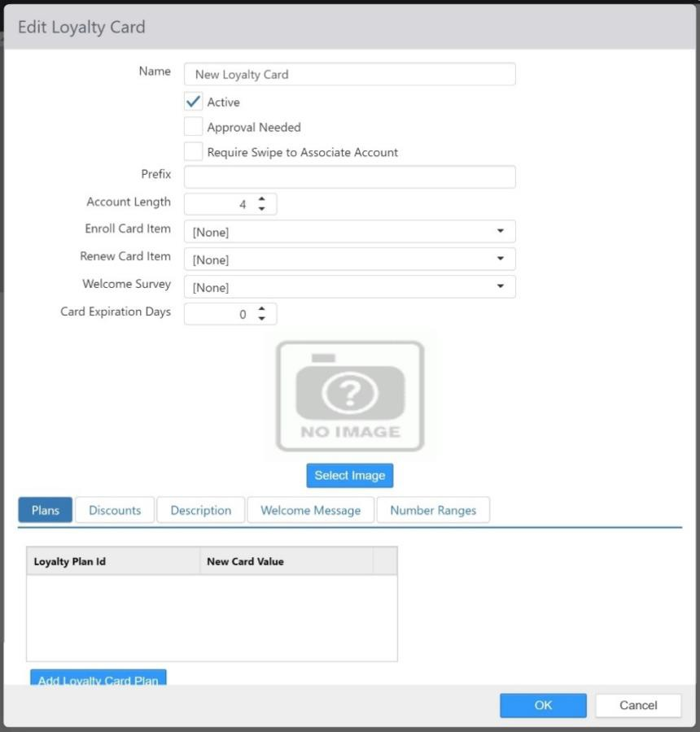

* **Name**: Name of the loyalty card.
* **Active**: Customers can be assigned to orders.
* **Approval Needed**: Customer with this loyalty card can only be assigned to order with authorization be an employee with **Security Level > Approve Loyalty Cards** enabled.
* **Require Swipe to Associate Account**: Assigning customer to orders can only be done by swiping or scanning the customer’s physical loyalty card.
* **Prefix**: Common numeric prefix of the account/card numbers.
* **Account Length**: Account number length, including the Prefix.
* **Enroll Card Item**: Item automatically added to customer’s first order upon signup.
* **Renew Card Item**: Item automatically added to the customer’s first order after the account has

expired.

* **Welcome Survey**: Survey that is presented to the customer after completing their online profile.
* **Card Expiration Days**: Number of days after the customer is created that the account expires.
* **Image**: Image to be displayed in the My Account section of the Customer Portal.
* **Plans tab**: Loyalty Plans associated with the loyalty card.
  + **Plan**: Loyalty Plan to accumulate value for the customer’s orders.
  + **New Card Value**: Initial value to be associated with the plan when the customer is created.

#### Discounts tab:

*Edit Loyalty Card dialog,* ***Discounts*** *tab*

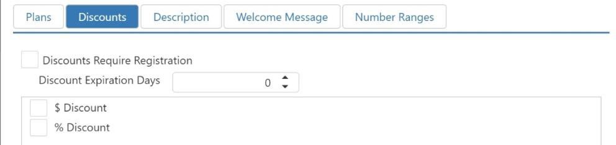

* + **Discounts Require Registration**: Customer must have completed their online profile before discounts will be automatically applied.
  + **Discount Expiration Days**: Number of days after the customer is created that the selected discounts are no longer automatically applied.
  + **Selected Discounts**: Discounts to automatically be applied to customer
* **Description**: Description of the loyalty card to be displayed in My Account section of the Customer Portal.

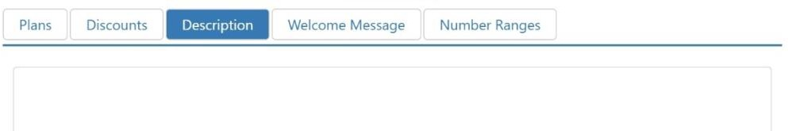

* **Welcome Message**: Text to be printed on receipt of the customer’s first order.

*Edit Loyalty Card dialog,* ***Welcome Message*** *tab*

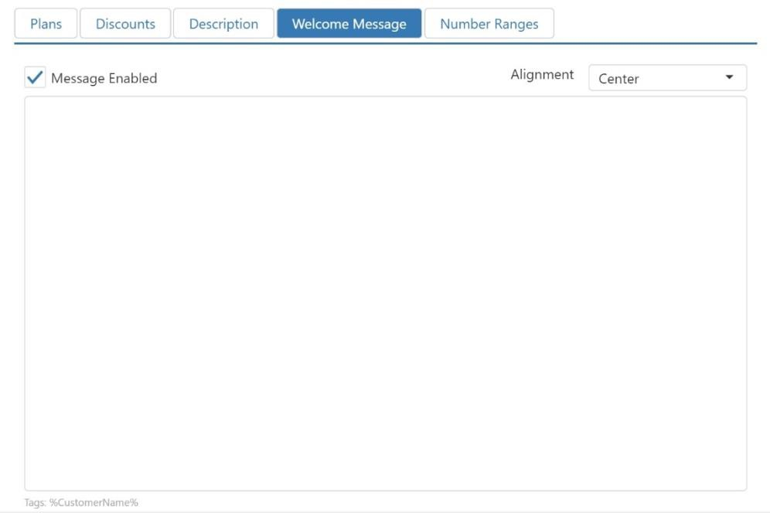

* **Number Range**: Valid account number ranges, excluding prefix.

*Edit Loyalty Card dialog,* ***Number Range*** *tab*

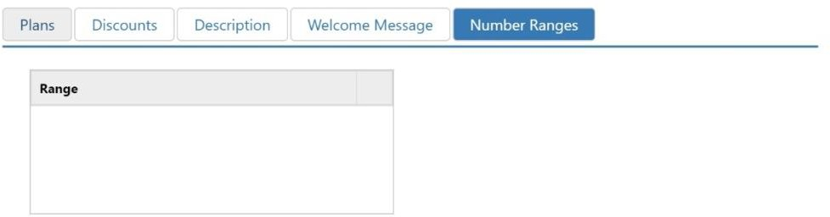

## Loyalty Plans

Loyalty plans determine how loyalty rewards are to be issued to customers participating in a loyalty program. To create a new loyalty plan, click **Add**. To edit an existing loyalty plan, click its name in the list.

*Edit Loyalty Plan dialog,* ***Rewards*** *tab*

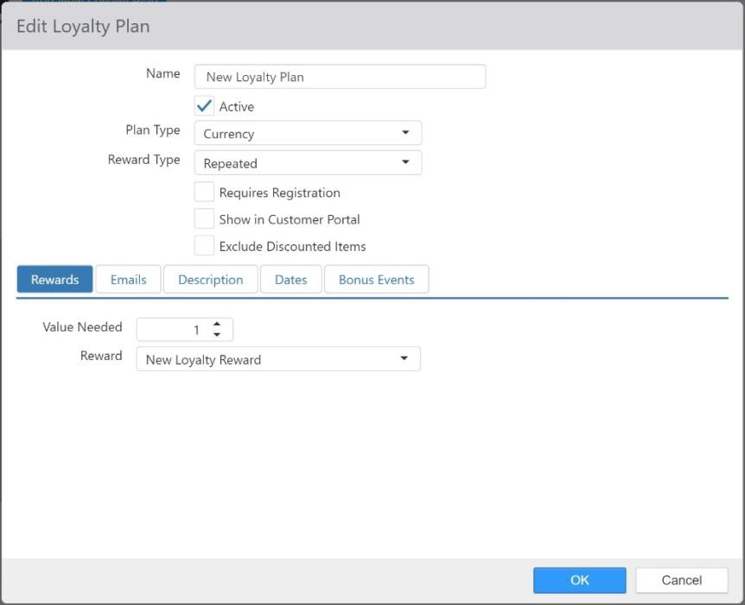

* **Name**: Name of the Loyalty Plan
* **Active**: Loyalty plan will accumulate value.

#### Plan Type:

* + **Currency**: Value equates to total item sales.
  + **Frequency**: Value equates to order count.
  + **Item**: Value equates to number of orders that have satisfied the item requirements.
  + **Point**: Value equates to points as calculated by item sales multiplied by a Factor.

#### Reward Type:

* + **Lottery**: Reward is given based on a set percentage change when the required total value is met.
  + **One-Time**: Reward is given once when the net value exceeds a given threshold.
  + **Repeated**: Reward is issued each time the net value exceeds a given threshold.
  + **Tiered**: Allows you to set up ranked rewards based on total value.
* **Requires Registration**: Customer must complete online profile before any rewards issued.
* **Show in Customer Portal**: Display the loyalty plan in the My Account section of the Admin Portal.
* **Exclude Discounted Items**: Discounted order items are to be excluded when calculating value accumulated.
* **Rewards tab for Plan Type of One-Time and Repeating**: Only one reward can be configured for

#### Plan Types of One-Time or Repeating.

* + **Value Needed**: Net value threshold required for earning reward.
  + **Reward**: Reward to be issued.
* **Rewards tab for Plan Type of Lottery and Tiered**: Multiple rewards can be configured for **Plan Types** of **Lottery** or **Tiered**.

*Edit Loyalty Plan,* ***Rewards*** *tab (****Lottery****)*

* + **Reward**: Reward to be issued.
  + **Value Needed**: Total value threshold required for earning reward.
  + **Odds** (**Lottery** only): Chances of receiving reward once **Value Needed** has been met.

#### Emails tab:

*Edit Loyalty Plan,* ***Emails*** *tab*

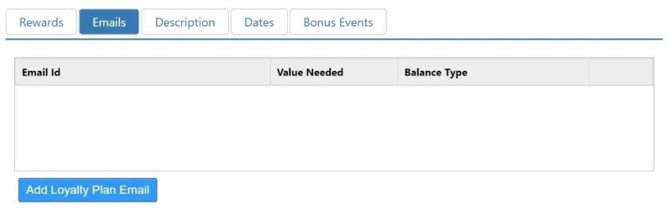

* + **Email**: Email templates to be sent to the customer
  + **Value Needed**: Value needed to trigger the email

#### Balance Type:

 **Net Value**: Email is triggered by net value; email is to be repeated.

 **Total Value**: Email is triggered by total value; email is only sent once.

* **Item Options tab** (**Plan Type** of **Item** only):

*Edit Loyalty Plan dialog,* ***Item Options*** *tab*

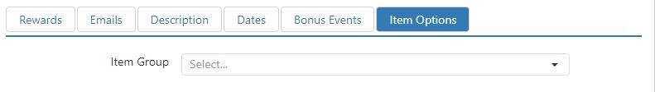

* + **Item Group**: Item group containing qualifying items.

#### Requirement:

 **All Items in Group**: All items in the group must exist on the order for value of one to be earned.

 **Quantity from Group**: Specific number of items from the group must exist on the order, one value earned for each quantity requirement satisfied.

* + **Quantity Required**: Number of items required when Requirement set to Quantity from Group.
* **Point Options tab** (**Plan Type** of **Point** only):

*Edit Loyalty Plan dialog,* ***Point Options*** *tab*

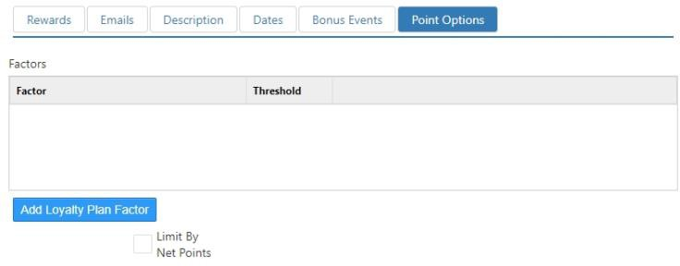

* + **Factor**: Multiplier applied to order sub-total to calculate value earned.
  + **Threshold**: The maximum amount of value that can be earned per transaction. If this is set to **0** (zero), then no maximum is enforced.
  + **Limit by Net Points**: Reward can only be earned when the total points earned is within a given range.

 **Minimum Net Points**: The minimum number of points necessary to qualify for reward.

**Maximum Net Points**: The maximum number of points necessary to quality for reward.

* **Description tab**: Description of the loyalty plan that is to be displayed in the My Account section of the Customer Portal.

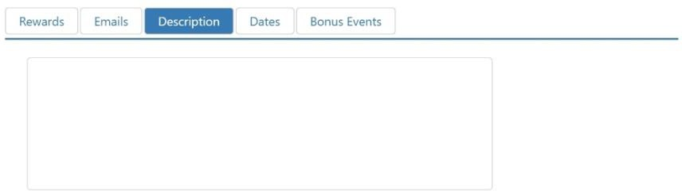

#### Dates tab:

*Edit Loyalty Plan dialog,* ***Dates*** *tab*

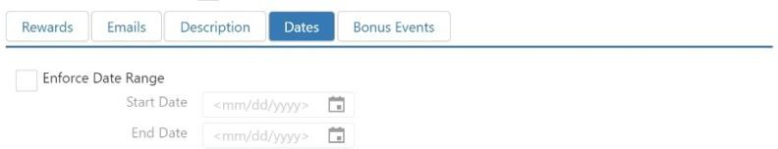

* + **Enforce Date Range**: Limit value accumulation by date range.
  + **Start Date**: First valid date the loyalty plan can accumulate value.
  + **End Date**: Last valid date the loyalty can accumulate value.

#### Bonus Events tab:

*Edit Loyalty Plan dialog,* ***Bonus Events*** *tab*

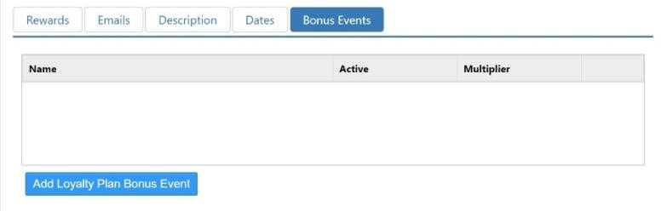

Click the ‘Add’ button to create a new bonus event, or click on a bonus event in the list to edit it.

*Add bonus event dialog,* ***Items*** *tab*

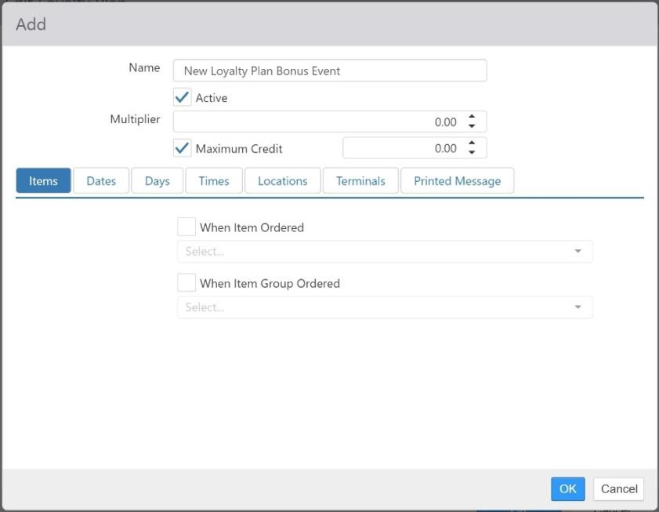

* **Name**: Name of the bonus event.
* **Active**: Bonus event is valid and will automatically apply when all requirements are met.
* **Multiplier**: Applied to base value calculated on the order.
* **Maximum Credit**: Maximum total value to be earned per order when bonus event applies.
* **Items tab**: Items or Item Groups that must be on the order for it to qualify.
* **Dates tab**: Valid date range.
* **Days tab**: Valid days of the week.
* **Times tab**: Valid time of days.
* **Locations**: Valid locations.
* **Terminals**: Valid order source terminals.
* **Printed Message**: Message that is to be printed on the receipt.

## Loyalty Rewards

Loyalty rewards are issued to customers through the loyalty plans they participate in and offer some form of benefit to the customer, such as a discount or voucher.

*Edit Loyalty Reward dialog*

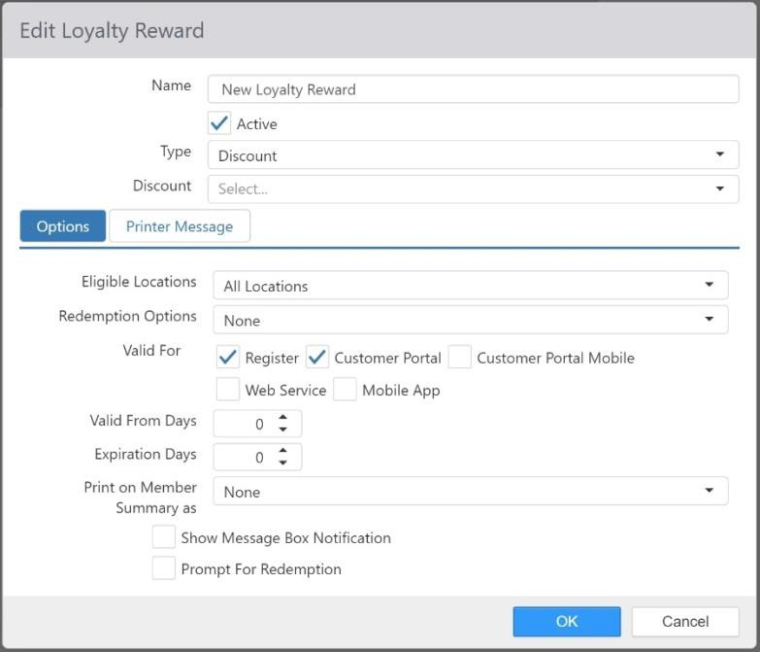

* **Name**: Name of the loyalty reward.
* **Active**: Reward is redeemable.

#### Type:

* + **Discount**: Reward is associated with a discount.

 **Discount drop-down list**: Discount that is applied to the order when the reward is redeemed. This only appears if **Type** is set to **Discount**.

* + **Gift Card**: Stored value gets added to the gift card number in the **Customer > Account Number** field.

 **Amount**: Amount to be added to the gift card. This only appears if **Type** is set to

#### Gift Card.

* + **Voucher**: Simply prints message on the receipt when earned.

#### Options tab:

* + **Eligible Locations**: Locations at which the reward can be redeemed.

#### Redemption Options:

 **None**: Reward is only automatically applied when the order contains qualifying items.

 **Multiple**: Reward is automatically applied to the customer’s first order during the redemption period, and partially redeemed for the discount value applied to the order. Any remaining value is carried forward for use on the next order during the redemption period.

 **Required**: Reward is automatically applied to the customer’s first order during

the redemption period, and redeemed regardless of any qualifying items.

* + **Valid For**: Terminals types on which the reward can be redeemed.
  + **Valid From Days**: Number of day from issuance until the reward is redeemable.
  + **Expiration Days**: Number of days from issuance that the reward expires.
  + **Show Message Box Notification**: Display notification to employee on the Register when reward is automatically applied to order for redemption.
  + **Print On Member Summary**: Print earned rewards, which have not expired, on the member summary that appears at the bottom of the receipt.
  + **Prompt For Redemption**: Prompt employee to apply unredeemed rewards when customer is assigned on the Register.
* **Printed Message tab**: Message to be printed on the receipt when order is earned.

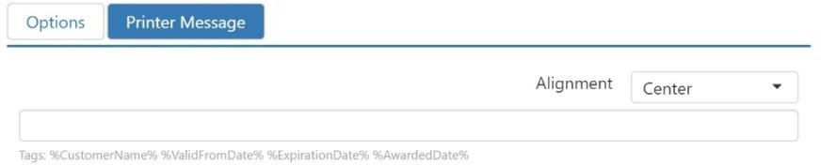

## Marketing Campaigns

Marketing campaigns are a mechanism to track total sales relative to a specific marking initiative. Orders can become associated with a marketing campaign through a discount applied, promotion applied, or query string parameter passed to the Customer Portal. To create a new marketing campaign, click Add. To edit an existing one, click its name in the list.

*Edit Marketing Campaign dialog*

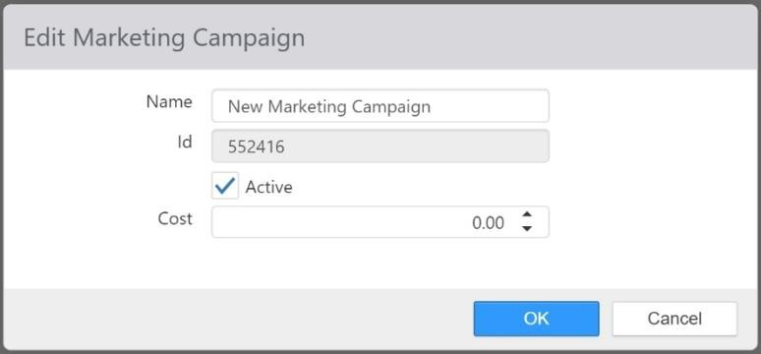

* **Name**: Name of the marketing campaign.
* **Id**: System generated identifier that can be used in the Customer Portal URL for associating online orders with the marketing campaign.
* **Active**: Marketing campaign can be associated with orders.
* **Cost**: Total cost of the marketing campaign, used for calculating ROI in related reports.

## Menus

Menus are used to present categorized menu items to the employee on the Register, or to the customer on the Customer Portal.

*Edit Menu dialog*

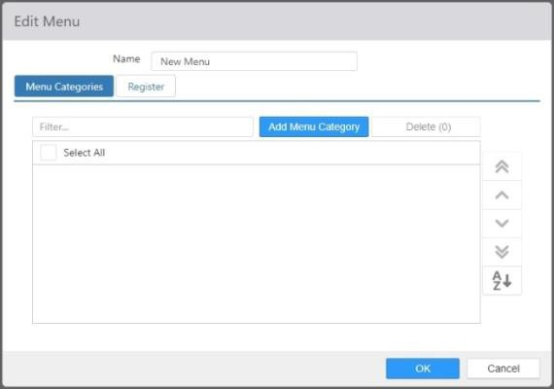

* **Name**: Name of the menu.
* **Menu Categories**: Menu categories included on the menu, sorted in the order the categories are to be displayed.

#### Register tab:

*Edit Menu dialog,* ***Register*** *tab*

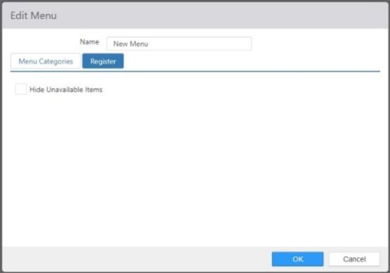

* + **Hide Unavailable Items**: Check this box to have the register hide ordering controls for items that are not currently available.

## Menu Categories

Menu categories are used to group menu item within one or more menus.

*Edit Menu Category dialog*

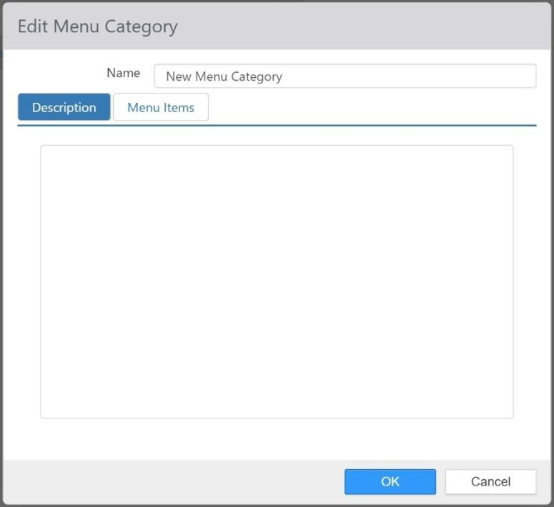

* **Name**: Name of the menu category.
* **Description tab**: Description that appears above the menu items in Customer Portal.
* **Menu Items tab**: Menu items in the menu category, sorted in the order in which they are to be displayed.

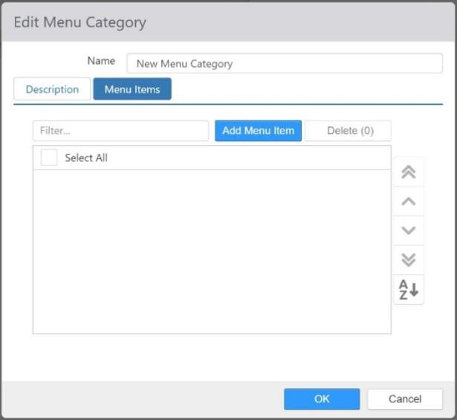

## Menu Items

Menu items are used in menu based ordering, and allow for offering alternate price and modifier groups.

*Edit Menu Item dialog*

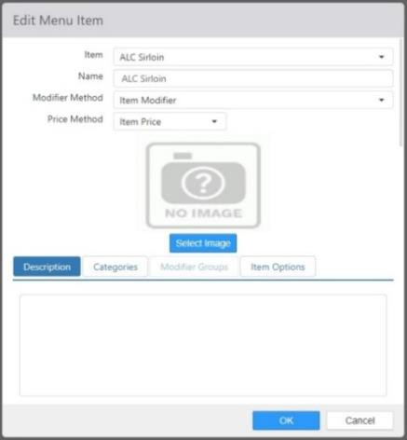

* **Item**: Item to be ordered when menu item is selected.
* **Name**: Name of the menu item.

#### Modifier Method:

* + **Menu Modifiers**: Use the modifier groups defined on the Menu Item.
  + **Item Modifiers**: Use the modifier groups defined on the Item.

#### Price Method:

* + **Menu Price**: Use the price defined on the Menu Item.
  + **Item Price**: Use the price defined on the Item.
* **Image**: Image that is displayed in Customer Portal.
* **Description tab**: Description that is displayed in Customer Portal below the name.
* **Categories tab**: Menu categories that the menu item belongs to.
* **Modifier Groups tab**: Modifier groups to be used when the Modifier Method is set to Menu Modifiers.
* **Item Options tab**: Provides the ability to select from a list of items to order in Customer Portal.
  + **Item**: Item to be ordered.
  + **Display Name**: Label to be displayed beside the radio button.
  + **Position**: Sort position of the item option.

## Modifier Codes

Modifier codes are used to communicate to the kitchen how to handle modifiers, such as adding or removing particular items. The modifier code can also determine if the is a charge associated with the modifier. To create a new modifier code, click Add. To edit an existing modifier code, click its name in the list.

*Edit Modifier Code dialog*

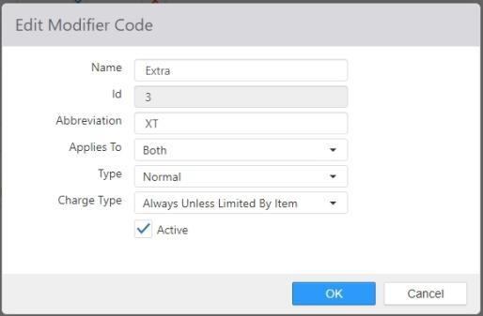

* **Name**: Name of the modifier code.
* **Abbreviation**: Text to be added to the beginning or end of the modifier name.

#### Applies To:

* + **Ingredients**: Available in Customer Portal only for modifiers that are listed in the parent

item’s list of ingredients.

* + **Non Ingredients**: Available in Customer Portal only for modifiers that are not listed in

the parent item’s list of ingredients.

* + **Both**: Available in Customer Portal for all modifiers.

#### Type:

* + **Normal**: Modifier is considered to be added to the parent item.
  + **No**: Modifier is considered to be removed from the parent item.
  + **Sub**: Modifier is considered to be added to the parent item, must be used in conjunction with a modifier that has a **For** modifier code.
  + **For**: Modifier is considered to be removed from the parent item, must be used in conjunction with a modifier that has a **Sub** modifier code.
  + **On Side**: Modifier is considered to be already included in the parent item, and not removed.

#### Charge Type:

* + **Always**: Price of the modifier is determined by the price of its associated item.
  + **Never**: Price of the modifier is always set to zero.
  + **Charge for Non-Ingredients**: Price of the modifier is determined by the price of its

associated item, only when not listed in the parent item’s list of ingredients.

* **Active**: Modifier code can be used with the ‘Order Modifier’ button behavior.

## Modifier Groups

Modifier groups are a group of modifier choices available when ordering a particular item. To create a new modifier group, click Add. To edit an existing modifier group, click its name in the list. Item Description is now displayed in addition to Item Name.

*Edit Modifier Group dialog*

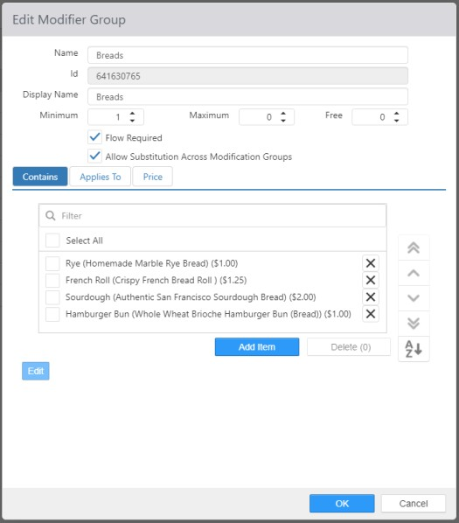

* **Name**: Name of the modifier group.
* **Display Name**: Alternate name to be displayed in Register and Customer Portal.
* **Minimum**: Minimum number of required selections.
* **Maximum**: Maximum number selections allowed.
* **Free**: Number of selections that are allowed free of charge.
* **Flow Required**: Forces the ‘Modify’ screen to appear when item that the group is applied to is ordered.
  + **NOTE**: If Flow Required is not set but there is a Minimum that is not met, the Modify screen will automatically appear.
* **Allow Substitution Across Modification Groups**: Allows modifiers from other modifier groups to be substituted for modifiers in this group. Also allows modifiers in this group to be substituted for modifiers in other groups.
* **Contains** tab: Items that are available as selections.
  + **Add Item**: Clicking **Add Item** will open a dialog box allowing you to select relevant items. Item Description is now displayed in addition to Item Name.

*Add Item dialog*

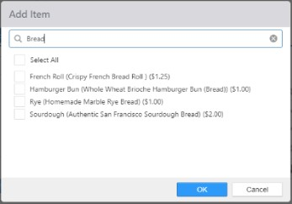

* **Applies To** tab: Items to which the modifier group is associated.
* **Price** tab:
  + **Use Tiered Pricing**: Modifier price is determined by the number of modifiers selected from the group.

## Modifier Tiers

Modifier tiers are used to determine if a substituted item should carry a charge. Substituting a modifier for another of equal or lesser modifier tier level does not carry a charge, whereas substituting for a modifier with a high tier does. See Items.

*Edit Modifier Tier dialog*

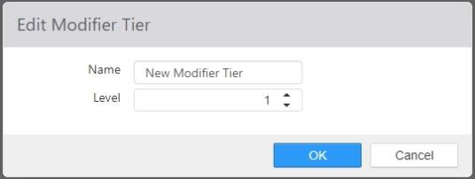

* **Name**: Name of the modifier tier
* **Level**: Level of the modifier tier, relative to other tiers.

## Options

The Options page is where options for a number of areas of Brink POS are grouped. The page is organized into tabs, and many tabs are organized into sub-tabs.

### System

The system tab contains sub-tabs that deal with system-wide settings.

*General*

General settings related to overall system functions.

##### *Options > System > General tab*

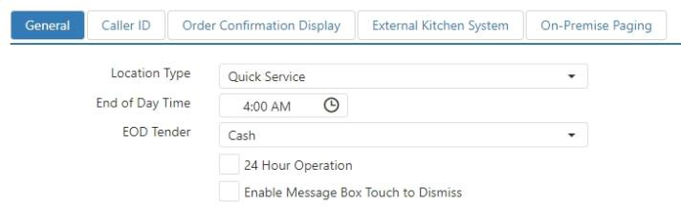

* **Location Type**: Controls access to functions that are Table Service specific; overridden by **Job > Order Entry Type**.
* **End of Day Time**: Time of day when the end of day process is expected to run, used to determine valid times for future orders and start time of the first day part.
* **24 Hour Operation**: Employees are not automatically clocked out by the end of day process.

#### Enable Message Box Touch to Dismiss:

* + Checked: Dialog windows, such as the ‘Change Due’ dialog, are dismissed simply by touching anywhere on the screen.
  + Unchecked: Dialog windows include an **OK** button that must be selected in order to dismiss the dialog.

*Caller ID*

Configuration settings for caller ID device, which communicates caller name and number to the POS when an incoming call is received. When enabled, displays caller name and phone number at the top of the ‘Future Order’ screen.

##### *Options > System > Caller ID tab*

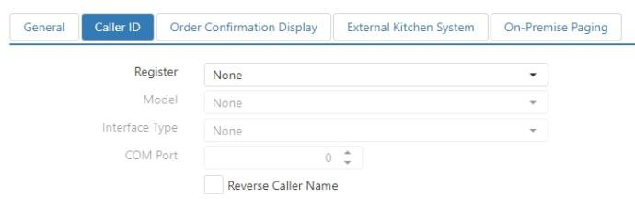

* **Register**: Register that is caller ID device is physically connected to.
* **Model**: Make and model number of the caller ID device.
* **Interface**: Interface type of the caller ID device.
* **COM Port**: COM port that the device is connected to.
* **Reverse Caller Name**: Displays the caller name as “Last Name, First Name”, rather than “First Name Last Name”.

*Order Confirmation Display*

Configuration settings for Order Confirmation Display (OCD) that is used to display order details to the customer, typically used in a single or multi lane drive thru operation.

##### *Options > System > Order Confirmation Display tab*

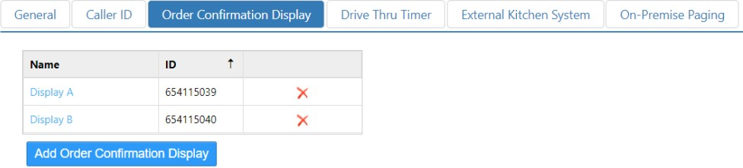

Order Confirmation Display: Single or Multiple

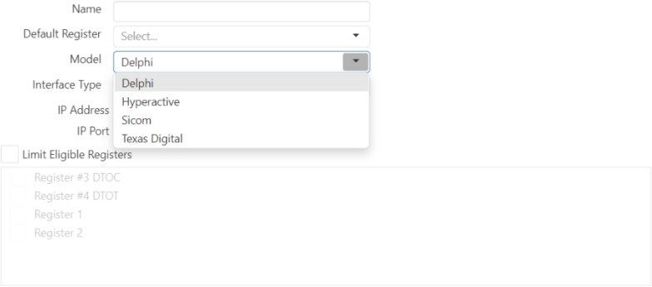

* **Name:** Name of the Order Confirmation Display.
* **Default Register**: Register that the Order Confirmation Display is connected to by default. This register is responsible for the communication to the device over the network.
* **Model:** Select the Order Confirmation Display model in the drop-down list.
* **Interface Type**: Interface type of the OCD. The available options are **Ethernet** and **Serial**.
  + **Ethernet**: OCD is connected via an ethernet connection.

 **IP Address**: IP address provided by the Order Confirmation Display manufacturer.

 **IP Port**: Port number for the OCD Ethernet port. This is a configurable field, with a default value based on model.

* + - **Delphi:** 48501
    - **Hyperactive**: 29000
    - **Sicom**: 3742
    - **Texas Digital:** 5557
  + **Serial**: OCD is connected via a serial connection.

 **COM Port**: COM port that the device is connected to the on the selected Register, provided by the Order Confirmation Display manufacturer.

 **Baud Rate**: Baud rate setting provided by the Order Confirmation Display manufacturer.

* **Limit Eligible Registers**: Limit the eligible register terminals that can be set as claimable for a specific Order Confirmation Display.

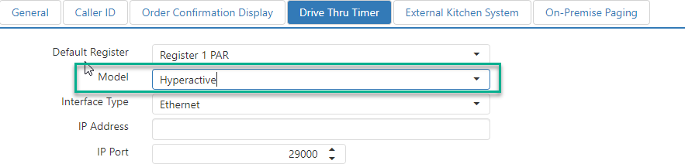*Drive Thru Timer*

* **Default Register**: Register that the Hyperactive device is connected to by default. This register is responsible for the communication to the device over the network.
* **Interface Type**: Interface type of the Hyperactive device. **Ethernet** is the only available option for Hyperactive.
  + **Ethernet**: Hyperactive device is connected to the POS network.
  + **IP Address**: IP address provided by Hyperactive.
  + **IP Port**: Port number for the Hyperactive device’s Ethernet port. This is a configurable

field, with a default value of 29000.

*External Kitchen System*

Configuration settings for a third-party kitchen video system connected to the POS network. When using an external kitchen video system, all Items should route to a single Video Group in Settings Editor to ensure that all items are sent to the kitchen video system’s controller.

##### *Options > System > External Kitchen System tab*

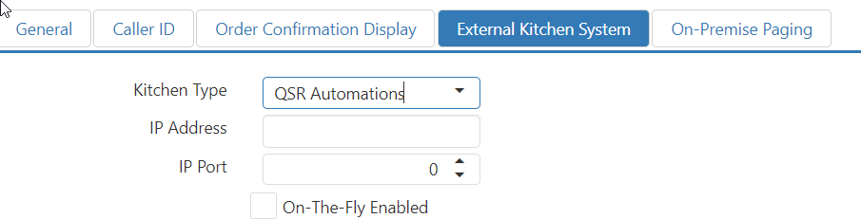

* **Kitchen Type**: Brand of the kitchen video system.
* **IP Address**: IP address of the kitchen video system controller connected to the POS network.
* **IP Port**: Port number that the kitchen video system controller listens on.
* On-The-Fly- Enabled: In order to enable on the fly, this checkbox must be checked. When not checked, it will default to the On Total Interface.

*On-Premise Paging*

Configuration settings for pager systems.

##### *Options > System > On-Premise Paging tab*

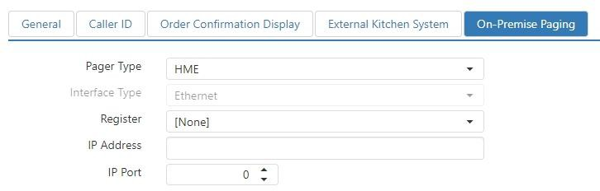

#### Pager Type:

* + **HME**: HME brand paging

 **Interface Type**: Set to **Ethernet**

 **IP Address**: IP address of the pager device.

 **Port**: Port that the pager device listens on.

 **Register**: Register that is responsible for communicating with the pager device.

* + **LRS**: LRS brand paging

 **Interface Type**: Set to **Serial ** **Parity**: Choose **Odd** or **Even**.

 **Handshake**: Set to **XOnXOff** or **DTR/DSR**.

 **Com Port**: Enter the com port number in the field.

 **Baud Rate**: Select the baud rate.

 **Register**: Register the pager device is physically connected to.

### Location

The Location tab contains sub-tabs that pertain to the specific location.

*General*

General settings related to the physical location and how information about the location is displayed throughout the POS system.

##### *Options > Location > General tab*

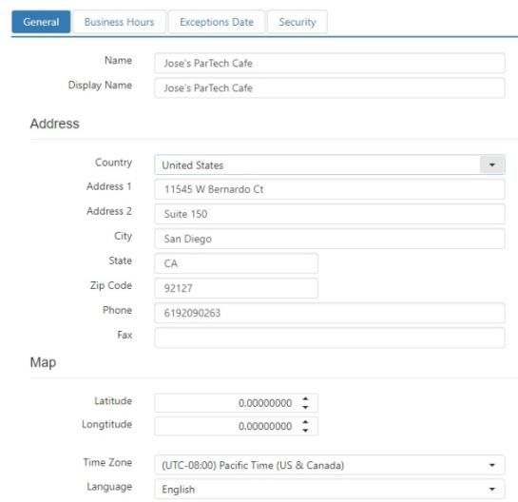

* **Name**: Printed at the top of the order receipt when no logo image is printed.
* **Display Name**: Name of the location as it appears on the reports and in Customer Portal.
* **Address**: Address and phone number to be displayed on the order receipt and on the Customer Portal.
* **Map**: Coordinates are used to plot the location on a map in Customer Portal, and used for the directions link included in order confirmation emails.
* **Time Zone**: Local time zone of the location’s physical address.

*Business Hours*

Standard hours of operation of the location, used to validate future order request times.

##### *Options > Location > Business Hours tab*

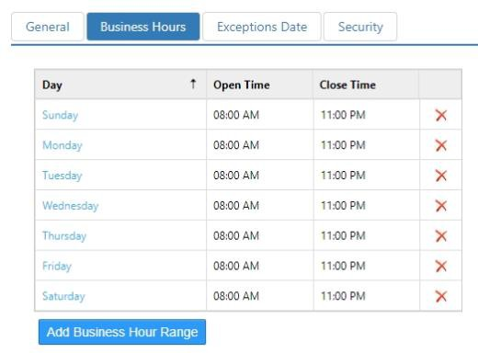

* **Day**: Day of the week.
* **Open**: Time of day the location opens for business.
* **Close**: Time of day the location closes for business.

*Exception Dates*

Dates that hours of operation that differ than what is defined on the Business Hours tab. Use for defining holiday hours or closures.

##### *Options > Location > Exception Dates tab*

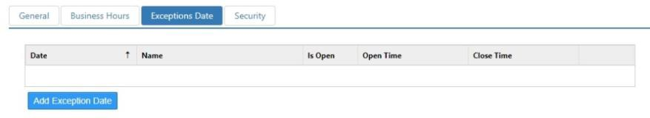

* **Date**: Date of the exception.
* **Name**: Name of the exception date.
* **Is Open**: Allows for open and close times.
* **Opens**: Time of day the location opens on the exception date.
* **Closes**: Time of day the location closes on the exception date.

*Security*

Settings that control security features for the location.

##### *Options > Location > Security tab*

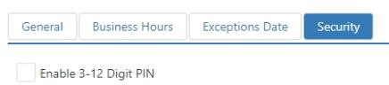

* **Enable 3–12 Digit PIN**: Sets the location to accept PINs of three to twelve digits in length for employee login instead of the standard four.

### Ordering

The Ordering tab contains sub-tabs that pertain to orders and how they are handles.

*General*

Settings that control how the system behaves during common ordering functions.

##### *Options > Ordering > General tab*

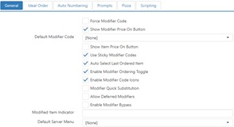

* **Force Modifier Code**: Register will require that a modifier code be selected prior to selecting a modifier.
* **Show Modifier Price On Button**: Modifier price will be displayed on the button on the ‘Modify’

screen when the modifier will carry a charge based on the **Modifier Groups** **> Free** setting.

* **Default Modifier Code**: Use the drop-down list to select a default modifier code (as configured on the Modifier Codes page).
* **Show Item Price On Button**: Buttons with a button behavior of ‘Order Item’ will display the item of the configured item.
* **Use Sticky Modifier Codes**: Selected modifier code remains selected after a modifier is ordered.
* **Auto Select Last Ordered Item**: When an item is ordered, it is automatically selected in the order list with the assumption that the employee will be selecting associated modifiers.
* **Enable Modifier Ordering Toggle**: Pressing a modifier button adds the modifier to the selected item, but pressing it a second time removes the modifier. (Normal behavior: Pressing a modifier button multiple times adds multiple copies of the modifier to the item.)
* **Enable Modifier Code Icons**: Displays icons on modifier buttons that show whether the modifier is included or excluded.
* **Modifier Quick Substitution**: Pressing a modifier button with a modifier selected in the ‘Order List’ panel replaces the selected modifier with the new one. When this box is checked, the **Modifier Code** drop-down list is displayed, allowing you to select a default modifier code (as configured on the Modifier Codes page) when using quick substitution.
* **Allowed Deferred Modifiers**: Allow cashiers to defer adding required modifiers to ordered items until the order is sent to the kitchen.
* **Enable Modifier ByPass**: Reduces the number of times “Done” is pressed on the System

Modifier Panel when all the modifier group requirements have already been fulfilled.

* + **Note**: Does not apply to Items > Modify Panels
  + A modifier group requirement is considered fulfilled when:  Flow is not required

 Modifier group has minimum number of modifiers

 Modifier group has maximum number of modifiers

* **Modified Item Indicator**: Symbol that will be printed on kitchen chits and displayed on kitchen displays for items that have been modified. Characters are limited to 8-bit ASCII (nos. 32–255). For a list of ASCII characters, see [http://www.asciitable.com/.](http://www.asciitable.com/)
* **Default Server Menu**: Default menu to display on the Register; can be overridden by **Jobs** **> Menus** and **Registers** **> Menu**.

*Ideal Order*

Configuration settings for defining an ideal order, which is used for suggestive selling in Customer Portal and reporting.

##### *Options > Ordering > Ideal Order tab*

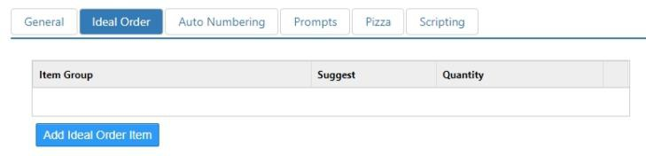

*Add Ideal Order Item Dialog*

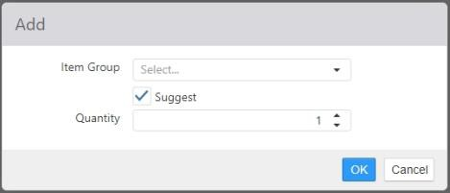

* **Item Group**: Item group containing the items that must be included for the order to qualify as an ideal order.
* **Suggest**: When item group requirement is not satisfied the associated menu items are to be displayed on Customer Portal prior to the customer completing their order.
* **Quantity**: Number of items from the selected group that must exist for the order to qualify as an ideal order.

*Auto Numbering*

Options controlling how a particular group of items are automatically numbered when added to an order.

**NOTE**: Auto Numbering overrides Consolidate Like Items. Any place where Auto Numbering is selected to display (i.e. receipts, order list…) will not consolidate like items, regardless of Consolidate Like Items settings.

##### *Options > Ordering > Auto Numbering tab*

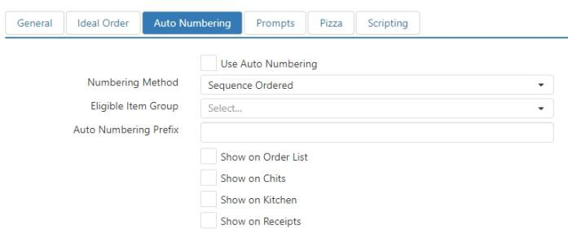

* **Use Auto Numbering**: Automatically number item of the selected item group.
* **Numbering Method**: In what order items will be numbered
  + **Sequence Ordered**: The order that items are placed in the order list.
  + **Kitchen Print Priority**: Based on an item’s Sort Priority settings (found in the **Printing** tab of the *Item* dialog).
* **Eligible Item Group**: Item group containing items that are to be numbered when ordered.
* **Auto Numbering Prefix**: Static text to appear before the automatically generated number.
* **Show on Order List**: Display the prefix and number on the register’s order list.
* **Show on Chits**: Print the prefix and number on kitchen chits.
* **Show on Kitchen**: Display the prefix and number on the kitchen display.
* **Show on Receipts**: Print the prefix and number on the order receipt.

*Prompts*

Defines message or confirmation dialogs that can be displayed when particular items are ordered.

##### *Options > Ordering > Prompts tab*

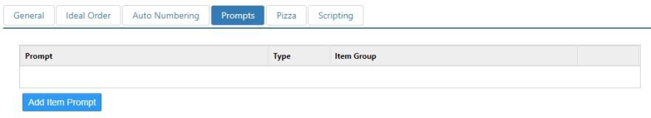

*Add Item Prompt Dialog*

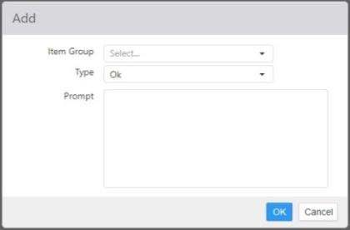

* **Item Group**: Item group containing the items that will result in the prompt being displayed.

#### Type:

* + **Ok**: Dialog that includes a single **OK** button for dismissing the dialog and ordering the item.
  + **Ok Cancel**: Dialog includes both an **OK** button, which dismisses the dialog and orders the item, and a **Cancel** button, which dismisses the dialog and does not order the item.
  + **Yes No**: Dialog includes both an **Yes** button, which dismisses the dialog and orders the item, and a **No** button, which dismisses the dialog and does not order the item.
* **Prompt**: Message to appear on the dialog when the prompt is displayed.

*Pizza*

NO LONGER USED.

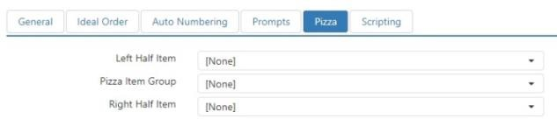

*Scripting*

Script that is to be executed any time an order is closed, either by the ‘Close Order’ button behavior or automatically via the lane when the order is tendered in full.

##### *Options > Ordering > Scripting tab*

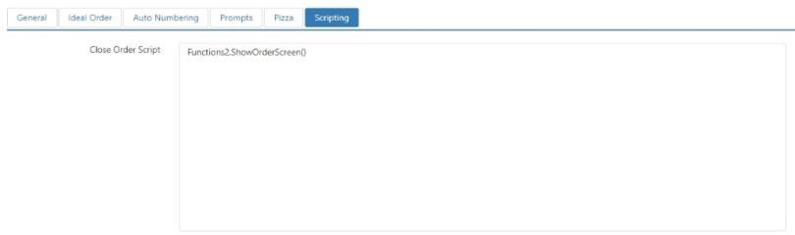

### Payment

The Payment tab contains sub-tabs with options pertaining to payment processing for credit cards, gift cards, and other non-cash payment types.

*Rounding*

Settings pertaining to how payments are rounded.

##### *Options > Payment > Rounding tab*

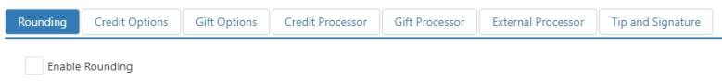

* **Enable Rounding**: Automatically rounds the order balance due when a cash payment is applied.

*Credit Options*

Configuration settings related to integrated credit card processing.

##### *Options > Payment > Credit Options tab*

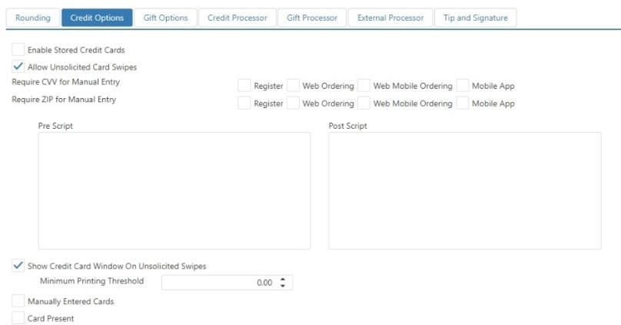

* **Enable Stored Credit Cards**: Credit cards can be stored on customer accounts, for the purpose of future date order deposits, and/or ‘Save Card to Party’ button behavior. Requires tokenization to be enabled.
* **Allow Unsolicited Card Swipes**: Credit cards can be swiped at any time in order to initiate the

‘Credit Card’ button behavior.

* **Require CVV for Manual Entry**: CVV is required for manually entered cards on the checked terminal types.
  + **Fail Transactions on CVV Mismatch**: If the CVV entered does not match the credit card’s

CVV, the transaction will fail.

**NOTE**: This control is only available when the **Credit Processor** is **First Data**.

* **Require ZIP for Manual Entry**: Billing zip code is required for manually entered cards on the checked terminal types.
  + **Fail Transactions on ZIP Mismatch**: If the zip code entered does not match the credit

card’s zip code, the transaction will fail.

**NOTE**: This control is only available when the **Credit Processor** is **First Data**.

* **Pre Script**: Script to execute after an unsolicited card swipe, but prior to displaying the credit card dialog or processing the card.
* **Post Script**: Script to be executed after processing an unsolicited card swipe.
* **Show Credit Card Window on Unsolicited Card Swipes**: Display the credit card dialog, allowing the employee to change the amount prior to processing. Requires selecting the **Done** button on the credit card dialog.
* **Minimum Printing Threshold**: Credit card transaction amount under which credit drafts will not be printed.
  + **Manually Entered Cards**: **Minimum Printing Threshold** applies to manually entered credit cards.
  + **Card Present**: **Minimum Printing Threshold** applies to swiped credit cards.

*Gift Options*

Configuration settings related to integrated gift card processing.

##### *Options > Payment > Gift Options tab*

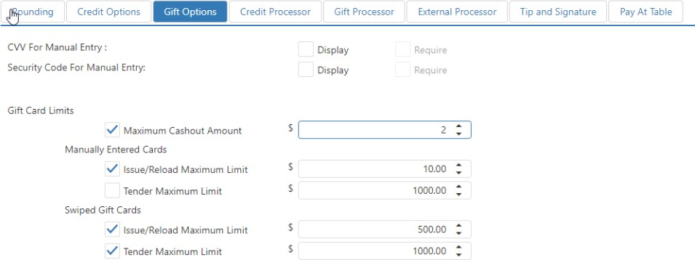

#### CVV For Manual Entry:

* + **Display**: Display the CVV field on the gift card dialog.

 **Required**: CVV value must be entered prior to processing manually entered gift cards.

#### Security Code For Manual Entry:

* + **Display**: Display the security code field on the gift card dialog.

 **Required**: security code value must be entered prior to processing manually entered gift cards.

* **Gift Card Limits**: Transaction maximums for gift card use, issuance, and reloading and cash out
  + **Maximum Cashout Amount**: If the **Enforce** checkbox is checked and an amount is entered, this value will be used to validate against the value of a gift card that can be cashed out.

 Note: Only applies when configured with Paytronix and Valutec gift card.

* + **Manually Entered Cards**: These limits apply to transactions for gift cards that are entered manually into the Register application.

 **Issue/Reload Maximum Limit**: If the **Enforce** check box is checked, the dollar amount in the **Limit** field is the most that can be added to a new or reloaded gift card in one transaction.

 **Tender Maximum Limit**: If the **Enforce** check box is checked, the dollar amount in the **Limit** field is the most that can be charged to a gift card in one transaction.

* + **Swiped Cards**: These limits apply to transactions for gift cards that are swiped on a card reader.

 **Issue/Reload Maximum Limit**: If the **Enforce** check box is checked, the dollar amount in the **Limit** field is the most that can be added to a new or reloaded gift card in one transaction.

 **Tender Maximum Limit**: If the **Enforce** check box is checked, the dollar amount in the **Limit** field is the most that can be charged to a gift card in one transaction.

**NOTE**: If the **Enforce** check box is checked, but the **Limit** is left at **$0.00**, then no transactions of that type will be allowed by the system.

*Credit Processor*

Payment processor configuration for integrated credit card processing. Each processor has a unique set of data fields that must be filled in.

***Options > Payment > Credit Processor*** *tab with no processor selected*

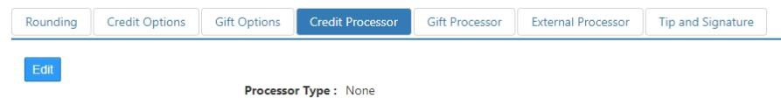

* **Processor Type**: When you select a processor in this drop-down list, an *Edit* dialog is displayed. The information that must go into the fields on this dialog is provided to you by the credit processor.

*Credit processor Edit dialog, Heartland (example)*

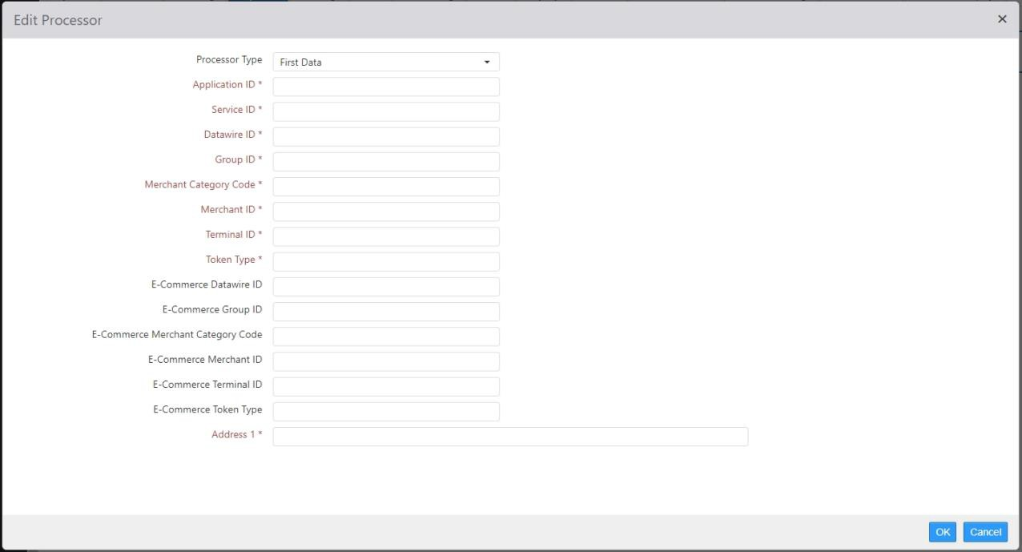

*Gift Processor*

Payment processor configuration for integrated stored value processing. Each processor has a unique set of data fields that must be filled in.

***Options > Payment > Gift Processor*** *tab with no processor selected*

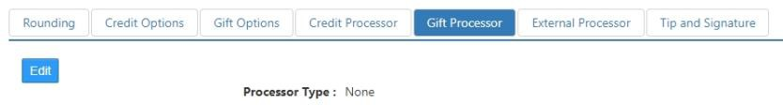

* **Processor Type**: When you select a processor in this drop-down list, an *Edit* dialog is displayed. Each gift processor will have a different dialog. The information that must go into the fields on this dialog is provided to you by the gift card processor.

*Gift processor Edit dialog, Givex (example)*

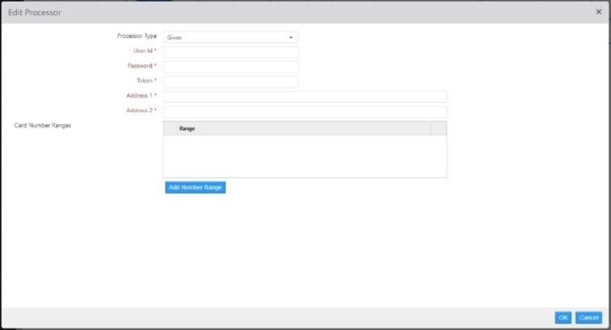

*External Processor*

Configuration of non-integrated payment processors. Currently, the only external processor supported by Brink POS is LevelUp.

***Options > Payment > External Processor*** *with* ***LevelUp*** *selected*

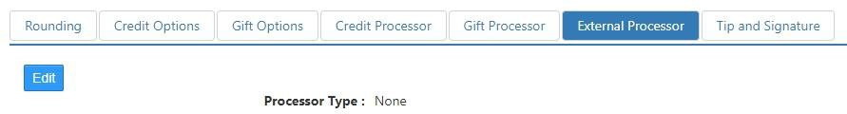

* **Processor Type**: Selecting **LevelUp** doesn’t automatically open the *Edit* dialog. Click **Edit** to open the dialog and enter the information provided to you by LevelUp.
* **URL**: Enter [***http://api.thelevelup.com/***](http://api.thelevelup.com/)
* **Get Token:** Select *Get Token* to request tokens from LevelUp with LevelUp provided Credentials
* **Token:** Requested token displayed.
* **Location ID:** Select corresponding *Location ID* from drop-down list.
* **Discount:** Select *LevelUp discount* from drop-down list. (This is mandatory)
* **Exempted Item Group:** Select *item group* from drop-down list. Default set to *None.*

*External processor Edit dialog, LevelUp (example)*

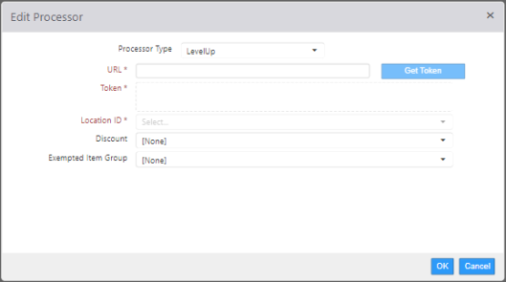

*Tip and Signature*

Settings to control the tip and signature prompt on the register main screen or customer display.

##### *Options > Payment > Tip and Signature tab*

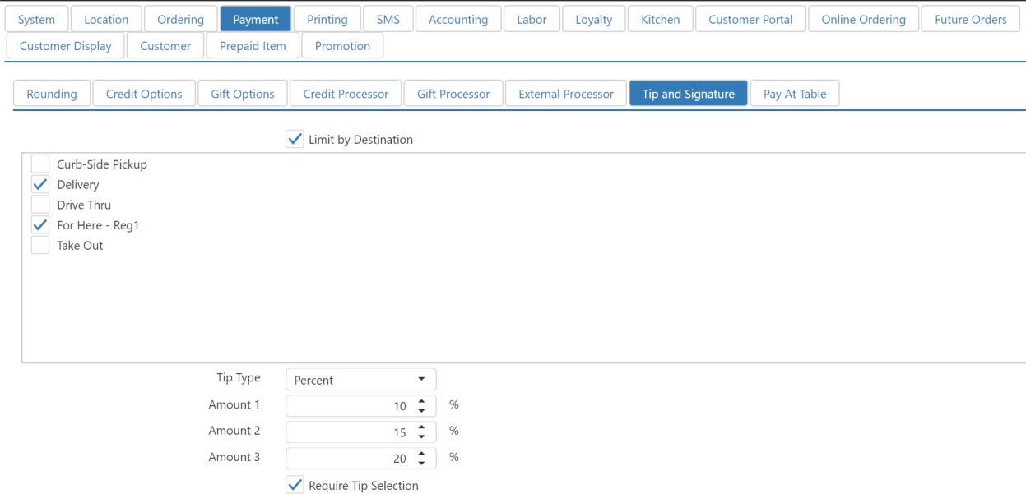

#### Dialog Placement:

* + **Customer Display**: The tip and signature prompt is displayed on the customer display.
  + **Main Screen**: The tip and signature prompt is displayed on the register main screen.
* **Limit by Destination**: Limit the display of the tip and signature prompt to orders for particular destinations (as configured on the Destinations page).

#### Tip Type:

* + **Percent:** The tip prompt displays tip amounts that are percentages of the order price.
  + **Fixed Amount:** The tip prompt displays fixed tip amounts.
* **Amount *N***: The amounts (in either percentage or dollar amount) to display on the tip prompt.
* **Require Tip Selection**: [*Placeholder in Admin Portal, implementation at Register in a later release*] Enable/disable the ability to require tip selection on the Tip and Signature screen to increase the likelihood of adding a tip to the order.

•

### Printing

The Printing tab contains sub-tabs with controls that pertain to how the system prints receipts, chits, credit drafts, and other related items.

*General*

Contains a printing control for the daily sales report.

##### *Options > Printing > General tab*

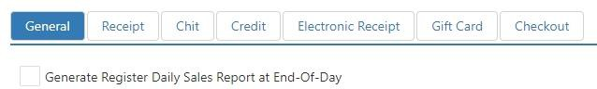

* **Generate Register Daily Sales Report at End-of-Day**: Print a copy of the daily sales summary report on the primary register when the end of day process runs.

*Receipt*

Contains printing controls for register receipts.

##### *Options > Printing > Receipt tab*

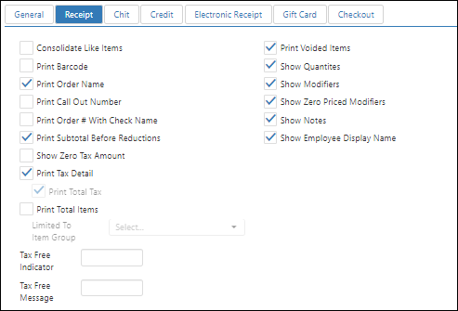

* **Consolidate Like Items**: Order items of the same item, with the same modifiers, are printed as a single item on the receipt with a quantity to the left.
* **Print Bar Code**: Bar code is printed in the receipt footer, to be used to recall the order.
* **Print Order Name**: Prints the order name in the receipt header.
* **Print Call Out Number**: Prints the call out number name in the receipt header, in large/bold font.
* **Print Order # with Check Name**: Prints the order number (as assigned by the Register application) along with the order name in the receipt header.
* **Print Subtotal Before Reductions**: Order sub-total is printed prior to printing any promotions or discounts.
* **Print Tax Detail**: Print total for each tax collected on the order.
  + **Print Tax Total**: When Print Tax Detail enabled, also print tax total.
* **Print Total Items**: Print the total number of items ordered at the bottom of the receipt.
  + **Limited To Item Group**: Limit the item total to a particular Item Group (see Item Groups).
* **Print Voided Items**: Print items that have been deleted after they were sent to the kitchen.
* **Show Quantities**: Print quantity to the left of all order items.
* **Show Zero Tax Amount**: Print tax line when total tax collected is equal to zero.
* **Show Modifiers**: Print modifiers indented under each order item.
* **Show Zero Priced Modifiers**: Include modifiers that do not carry a charge.
* **Show Notes**: Print order item note directly under the order item.
* **Show Employee Display Name**: Print employee’s name in the receipt header.
* **Tax Free Indicator**: Print the character or string entered in this field next to any item that is not subject to tax.
* **Tax Free Message**: Print the message entered in this field at the bottom of the receipt.

*Chit*

Contains printing controls for kitchen chits.

##### *Options > Printing > Chit tab*

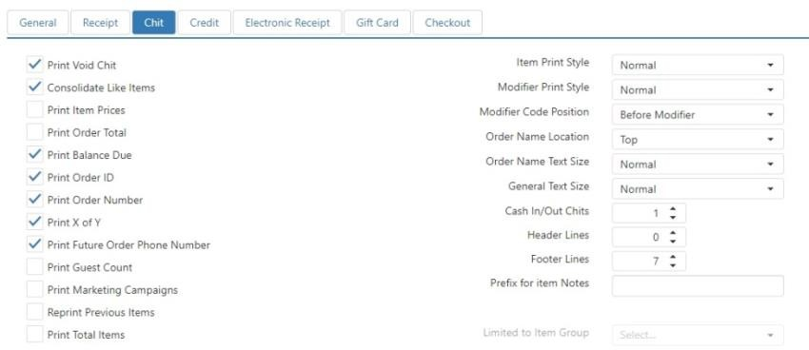

* **Print Void Chit**: Print kitchen chit showing voided items when items are deleted after being sent to the kitchen.
* **Consolidate Like Items**: Order items of the same item, with the same modifiers, are printed as a single item on the chit with a quantity to the left.
* **Print Item Prices**: Order item price is printed to the right of the item.
* **Print Order Total**: Order total is printed at the bottom of the chit.
* **Print Balance Due**: Order balance due is printed at the bottom of the chit.
* **Print Order Id**: Order ID is printed in the chit’s header.
* **Print Order Number**: Order number is printed below the chit’s header.
* **Print X of Y**: Prints the chit number (X) and the total number of chits printed (Y) at the bottom of each chit.
* **Print Future Order Phone Number**: Prints the guest’s phone number along with the other future

order details.

* **Print Guest Count**: Prints the order guest count at the time the order was sent.
* **Print Marketing Campaigns**: Prints all marketing campaigns associated with the order.
* **Reprint Previous Items**: Reprints items that were previously sent to the kitchen on chits for orders that items were later added to.
* **Print Total Items**: Print the total number of items ordered at the bottom of the chit.
  + **Limited To Item Group**: Limit the item total to a particular Item Group (see Item Groups).

#### Item Print Style:

* + **Normal**: Order items print in black font.
  + **Red**: Order items print in the color red, when the printer supports printing in red.
  + **Reverse**: Order items are printed with a black bar behind white text.

#### Modifier Print Style:

* + **Normal**: Order item modifiers print in black font.
  + **Red**: Order item modifiers print in the color red, when the printer supports printing in red.
  + **Reverse**: Order item modifiers are printed with a black bar behind white text.

#### Modifier Code Position:

* + **Before Modifier**: Modifier code abbreviation appears before the modifier.
  + **After Modifier**: Modifier code abbreviation appears after the modifier.

#### Order Name Location:

* + **Top**: Order name appears before list of order items.
  + **Bottom**: Order name appears after list of order items.
  + **Both**: Order name appears both before and after list of order items.
* **Order Name Text Size**: Font size of the order name.
* **Text Size**: Font size of order items and modifiers.
* **Cash In/Out Chits**: Number of detail chits to print when a Cash In/Out is performed via the

‘Manage Drawers’ screen.

* **Header Lines**: Number of blank lines at the top of the kitchen chit.
* **Footer Lines**: Number of blank lines at the end of the kitchen chit.
* **Prefix for Item Notes**: If item notes are used (via the ‘Note’ button in **Layout**), prefix to be printed on the chit.

*Credit*

Contains printing controls for credit card drafts.

##### *Options > Printing > Credit tab*

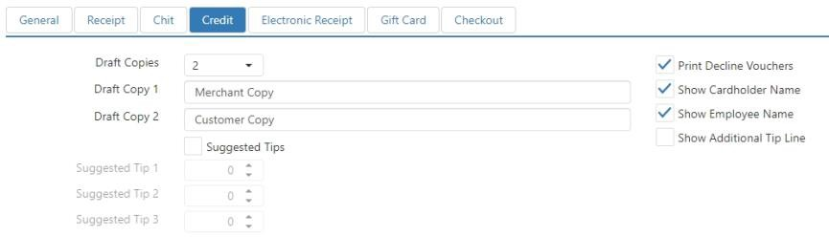

* **Draft Copies**: Number of credit drafts to print after a successful credit transaction.
* **Draft Copy 1**: Text to appear at the bottom of the first credit draft.
* **Draft Copy 2**: Text to appear at the bottom of the second credit draft. Only appears if **Draft Copies** is set to **2** or higher.
* **Draft Copy 3**: Text to appear at the bottom of the third credit draft. Only appears if **Draft Copies**

is set to **3** or higher.

* **Draft Copy 4**: Text to appear at the bottom of the fourth credit draft. Only appears if **Draft Copies** is set to **4**.
* **Suggested Tips**: Print sample tip calculations on the credit drafts as a percent of the order total.
* **Print Decline Vouchers**: Print a voucher when a credit transaction fails.
* **Show Cardholder Name**: Print the cardholder name read from the magnetic strip along with the transaction details on the receipt and credit drafts.
* **Show Employee Name**: Print the display name of the employee who processed the transaction in the header of the credit draft.
* **Show Additional Tip Line**: Prints a line to enter an additional tip amount when the credit draft’s

payment already has a tip entered.

*Electronic Receipt*

Contains controls for sending an electronic receipt to the customer.

##### *Options > Printing > Electronic Receipt tab*

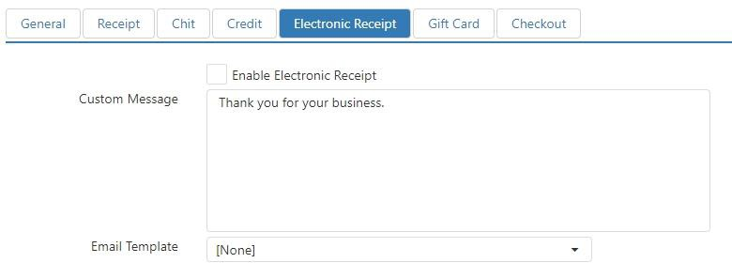

* **Enable Electronic Receipt**: ‘Electronic Receipt’ button behavior can be executed.
* **Custom Message**: Message to be included in the body of the email, before the order details.
* **Email Template**: Email template to be used for the electronic receipt.

*Gift Card*

Contains printing controls for gift card drafts.

##### *Options > Printing > Gift Card tab*

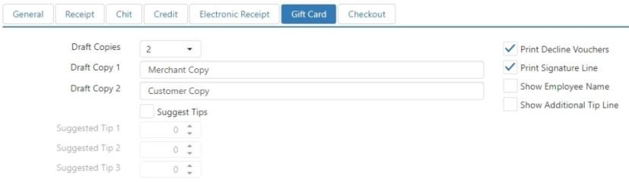

* **Draft Copies**: Number of gift card drafts to print after a successful gift card transaction.
* **Draft Copy 1**: Text to appear at the bottom of the first gift card draft.
* **Draft Copy 2**: Text to appear at the bottom of the second gift card draft. Only appears if **Draft Copies** is set to **2** or higher.
* **Draft Copy 3**: Text to appear at the bottom of the third gift card draft. Only appears if **Draft Copies** is set to **3** or higher.
* **Draft Copy 4**: Text to appear at the bottom of the fourth gift card draft. Only appears if **Draft Copies** is set to **4**.
* **Suggested Tips**: Print sample tip calculations on the gift card drafts as a percent of the order total.
* **Print Decline Vouchers**: Print a voucher when a gift card transaction fails.
* **Print Signature Line**: Print a place to sign on the gift card drafts.
* **Show Employee Name**: Print the display name of the employee who processed the transaction in the header of the gift card draft.
* **Show Additional Tip Line**: Prints a line to enter an additional tip amount when the gift card

draft’s payment already has a tip entered.

*Checkout*

Contains printing controls for drawer checkout.

##### *Options > Printing > Checkout tab*

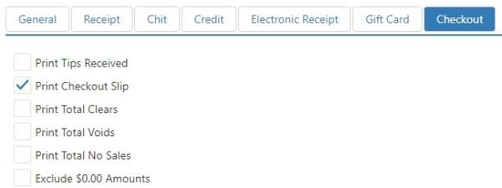

* **Print Tips Received**: Prints tip details on the bottom of the checkout slip, including tips received and tips owed.
* **Print Checkout Slip**: Prints checkout slip when cash drawer is checked out via ‘Manage Drawers’ screen or by the end of day process.
* **Print Total Clears**: Prints the total number of items that were deleted from orders before the order was sent to the kitchen. This includes items deleted using the ‘Clear’ button behavior and the ‘Delete’ button behavior.
* **Print Total Voids**: Prints the total number of items that were deleted from orders after the order was sent to the kitchen.
* **Print Total No Sales**: Prints the total number of times the cash drawer was opened without a sale being rung up.
* **Exclude $0.00 Amounts**: Excludes any categories with zero balances from being printed on the checkout report.

### SMS

The SMS tab allows you to enter settings for SMS messages. Currently, Brink POS supports two SMS providers: EZ Texting and Plivo.

***Options > SMS*** *tab with no provider selected*

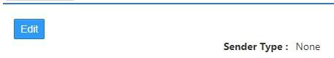

*SMS Edit dialog, EZ Texting (example)*

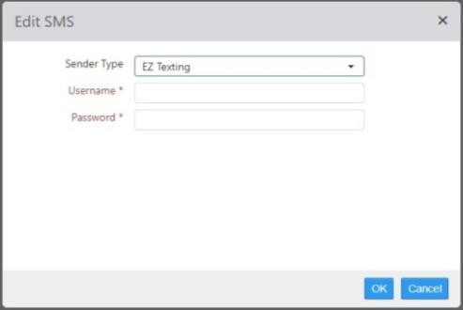

* **Sender Type**: Third-party SMS provider.

#### EZ Texting:

 **User**: EZ Texting username.



#### Plivo:



**Password**: EZ Texting password.

**Auth ID**: Auth ID provided by Plivo.

**Auth Token**: Auth Token provided by Plivo.

**Caller ID**: Telephone number that the text should appear to come from.

### Accounting

The Accounting tab contains sub-tabs with settings that pertain to how various accounting activities are recorded and calculated.

*General*

Contains the control to set the first day of the week.

##### *Options > Accounting > General tab*

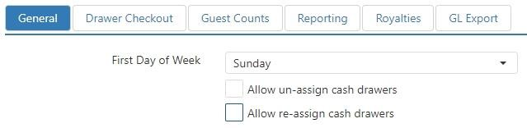

* **First Day of Week**: Determines the first day of the accounting week and the weekly/biweekly pay periods.
* **Move Cash Drawers**: Managers can move cash drawers between terminals without employees having to go through the checkout process. This can be useful if an employee needs to move from one terminal to another on the same shift.
* **Re-assign Cash Drawers**: Managers can re-assign cash drawers from terminals without employees having to go through the checkout process. This can be useful if an employee needs to go on break and have another employee fill in for them.

*Drawer Checkout*

Contains controls that pertain to drawer checkout and accounting for cash.

##### *Options > Accounting > Drawer Checkout tab*

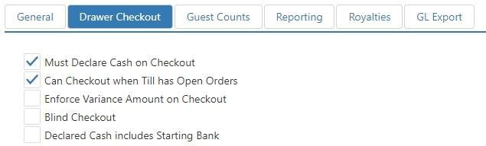

* **Must Declare Cash on Checkout**: Employee is prompted to enter declared cash when checkout is performed via either the ‘Checkout’ button behavior or the ‘Manage Drawers’ screen.
* **Can Checkout when Till has Open Orders**: Cash drawer can be checked out when open non- future orders exist that have payments associated with the till.
* **Enforce Variance Amount on Checkout**: Declared cash at checkout or via the ‘Edit Checkout’ button behavior must be within the valid variance cash amount of the calculated cash. Valid cash variance is defined in the *Edit Tender* dialog for the **Tender Type** of **Cash** with a **Default Amount** of **$0.00**. See
* Tenders.

**NOTE**: Only one tender with a **Tender Type** of **Cash** can have a **Default Amount** of **$0.00**. Any additional **Cash** tenders must be assigned a non-zero value for **Default Amount**.

* **Blind Checkout**: Do not pre-populate the declared cash prompt with the calculated cash amount.
* **Declared Cash includes Starting Bank**: System expects the declared cash amount to be all cash in the drawer, including the starting bank that was declared when the drawer was assigned.

*Guest Counts*

Contains settings pertaining to how the number of guests is counted.

##### *Options > Accounting > Guest Count tab*

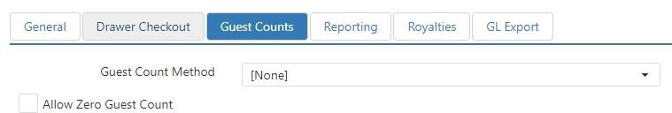

#### Guest Count Method:

* + **None**: Do not track guest count.
  + **Prompt on Create Party**: Prompt employee to enter guest count when table, tab, or order is opened.
  + **By Item Group**: Calculated based on the items ordered.

 **Item Group**: Item group that contains the items which count towards the guest count.

 **Factor**: Weight each item ordered from the selected item group carries towards

the order’s guest count.

* + **By Seat Count**: Equals the number of seats on the table.
* **Allow Zero Guest Count**: When Guest Count Method is set to Prompt on Create Party, guest count greater than zero must normally be entered in order to continue. Which this box is checked, a guest count of zero is considered valid.

*Reporting*

Contains settings pertaining to how certain accounting categories are calculated in reports (see Reports).

##### *Options > Accounting > Reporting tab*

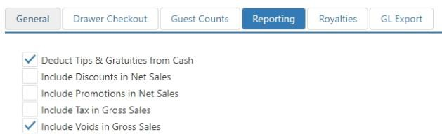

* **Deduct Tips & Gratuities from Cash**: It is expected that the employee will keep the cash equivalent of the tips and gratuities and these should be deducted from the calculated cash.
* **Include Discounts in Net Sales**: Include discounted amounts in the reported net sales.
* **Include Promotions in Net Sales**: Include promotion amounts in the reported net sales.
* **Include Tax in Gross Sales**: Include tax collected in the reported gross sales.
* **Include Voids in Gross Sales**: Include voided item amount in the reported gross sales.

*Royalties*

Contains fields for entering data pertaining to royalty payments. See Reports for more information.

##### *Options > Accounting > Royalties tab*

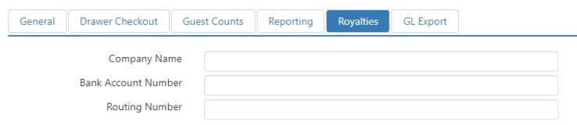

* **Company Name**: Company name that is to appear on the Royalties by Location report.
* **Bank Account Number**: Bank account number that is to appear on the Royalties by Location report.
* **Routing Number**: Bank routing number that is to appear on the Royalties by Location report.

*GL Export*

This section defines how sales data is to be mapped to general ledger account numbers in the various export formats.

##### *Options > Accounting > GL Export tab*

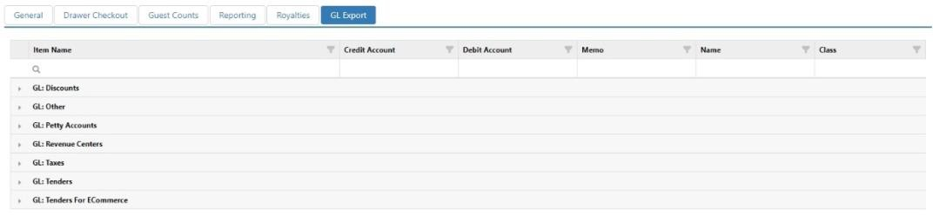

* **Credit Account**: GL account to be credited.
* **Debit Account**: GL account to be debited.
* **Memo**: Included in various sales export formats.
* **Name**: Included in various sales export formats.
* **Class**: Included in various sales export formats.

### Labor

The Labor tab contains sub-tabs with controls that pertain to employees.

*General*

Contains various time clock and timecard controls.

##### *Options > Labor > General tab*

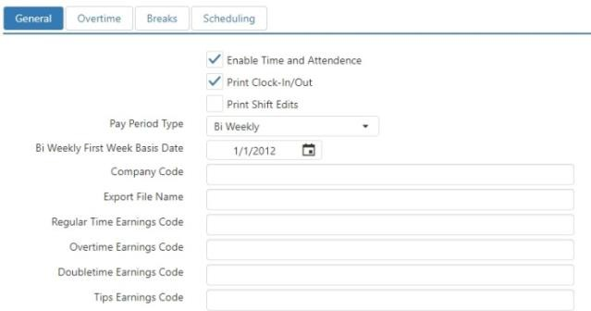

* **Enable Time And Attendance**: ‘Allow Clockout’ and ‘Start Break’ button behaviors.
* **Print Clock-In/Out**: Print a detail chit each time an employee clocks in or clocks out.
* **Print Shift Edits**: Print a detail chit each time a shift is edited.

#### Pay Period Type:

* + **Weekly**: Employees are paid one a week.
  + **Bi Weekly**: Employees are paid every other week.

 **Bi Weekly First Week Basis Date (required)**: Determines the pay period start when Pay Period Type is set to Bi Weekly.

* + **Semi Monthly**: Employees are paid twice per month.
  + **Monthly**: Employees are paid once per month.
* **Company Code**: Included in various labor export formats, issued by payroll provider.
* **Export File Name**: Name of the file to be produced by the labor export.
* **Regular Time Earnings Code**: Code included in labor export for time paid at the regular rate, code issued by payroll provider.
* **Overtime Earnings Code**: Code included in labor export for time paid at 1.5 times the regular rate, code issued by payroll provider.

#### Doubletime Earnings Code: Code included in labor export for time paid at 2 times the regular rate, code issued by payroll provider.

* **Tips Earnings Code**: Code included in labor export for tips declared, code issued by payroll provider.

*Overtime*

Contains controls allowing you to define overtime periods.

##### *Options > Labor > Overtime tab*

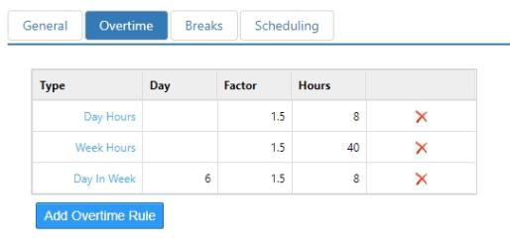

#### Overtime Rules:

#### Type:

 **Day Hours**: Overtime is paid when number of hours worked in a day exceeds a certain amount.

 **Week Hours**: Overtime is paid when number of hour worked in a week exceeds a certain amount.

 **Day In Week**: Overtime is paid when number of days worked in a week equals or exceeds a given count.

* + - **Day**: Number of days worked in a week when overtime is paid.

*Breaks*

 **Shift Hours**: Overtime is paid when the number of hours worked in one shift exceeds a certain amount.

* **Factor**: Pay rate multiplier when overtime rule is applied.
* **Hours**: Hours in day, week, or shift after which overtime rule is applied.
* **Remove**: Press to remove a line from the list.
* **Add**: Press to add a line to the list.

Contains settings that pertain to shift breaks.

##### *Options > Labor > Breaks tab*

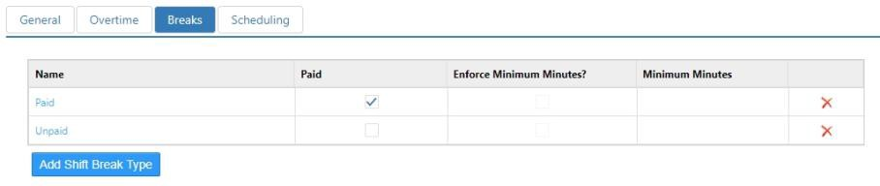

* + **Name**: Name of the break type.
  + **Paid**: Employee is paid for time on break.
  + **Enforce Minutes Minimum**: Employee is unable to clock back in until break has equaled or exceeded number of minutes.

*Scheduling*

Contains settings that pertain to shift scheduling.

##### *Options > Labor > Scheduling tab*

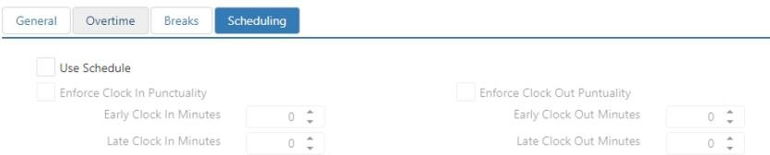

* + **Use Schedule**: Register will enforce selected punctuality rules for employee whose job does not have Exempt from Labor Schedule enabled.
    - **Enforce Clock In Punctuality**: Enforce clock in variance rules.

 **Early Clock In Minutes**: Maximum number of minutes an employee can clock in before their scheduled time without requiring approval.

 **Late Clock In Minutes**: Maximum number of minutes an employee can clock in after their scheduled time without requiring approval.

* + - **Enforce Clock Out Punctuality**: Enforce clock out variance rules.

 **Early Clock Out Minutes**: Maximum number of minutes an employee can clock out before their scheduled shift end time without requiring approval.

 **Late Clock Out Minutes**: Maximum number of minutes an employee can clock out after their scheduled shift end time without requiring approval.

### Loyalty

The Loyalty tab contains settings for various loyalty providers. The sub-tabs displayed depend on which loyalty provider is selected in the **Loyalty Provider** drop-down list, as does the contents of the sub-tabs.

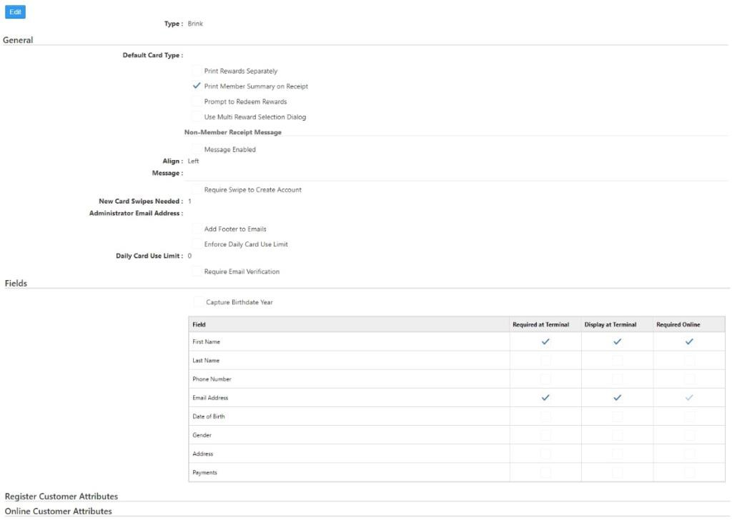

*Loyalty Provider: Beanstalk*

When **Beanstalk** is selected as the **Loyalty Provider**, only the **General** tab is displayed.

***Options > Loyalty > General*** *for Beanstalk*

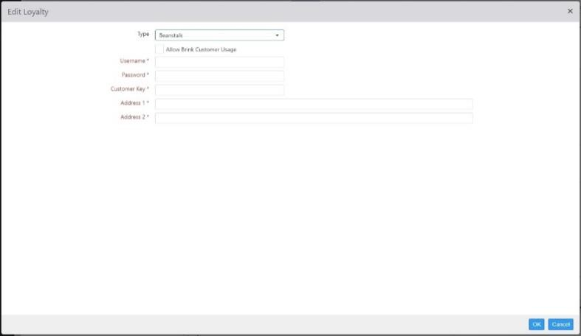

* + **Allow Brink Customer Usage**: Allows non-Brink loyalty providers to utilize the Brink customer database.

**NOTE**: In the majority of cases, this box should be checked. If you find this box unchecked, ask your Brink integration technician whether a) you are a special case and should leave it unchecked, or b) you should check the box.

* + **Username**: The username provided to you by Beanstalk.
  + **Password**: The password provided to you by Beanstalk.
  + **Customer Key**: The customer key provided to you by Beanstalk.
  + **Address 1**: The primary URL provided to you by Beanstalk.
  + **Address 2**: The secondary URL provided to you by Beanstalk.

*Loyalty Provider: Brink*

When **Brink** is selected as the **Loyalty Provider**, the **General**, **Fields**, **Register Customer Attributes**, and

**Online Customer Attributes** tabs are displayed.

***Options > Loyalty > General*** *tab for Brink*

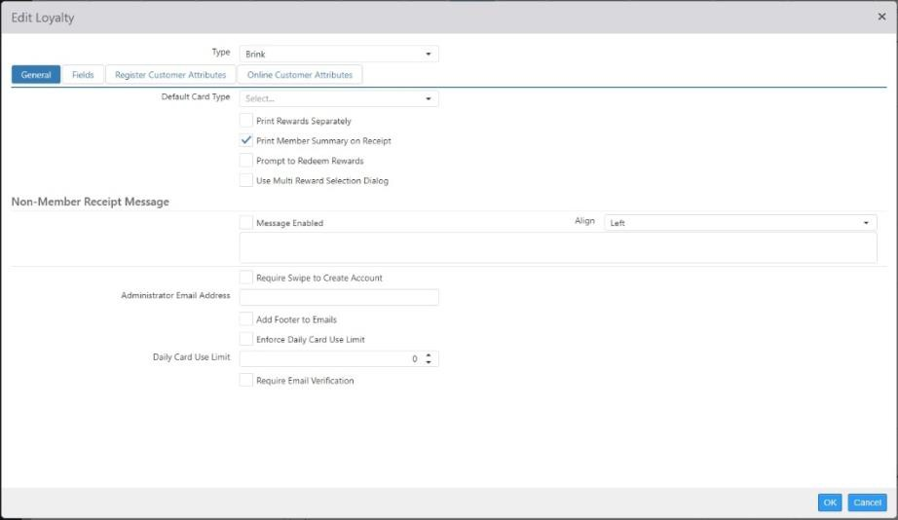

* + **Default Card Type**: Loyalty card to be associated with new customer records that are not assigned an account number.
  + **Print Rewards Separately**: When rewards are awarded that have a printed message defined, they are to be printed separately from the order receipt.
  + **Print Member Summary on Receipt**: Print a summary of all loyalty plans and redeemable rewards on the customer account, on the receipt.
  + **Prompt to Redeem Rewards**: When a customer with redeemable rewards is assigned to an order, prompt the employee to redeem each reward.
  + **Use Multi Reward Selection Dialog**: When prompting for rewards, use the register dialog that allows the cashier to select multiple rewards at once.
  + **Non-Member Receipt Message**: Message to be printed on the bottom of the receipt when a customer is not assigned to the order.
  + **Require Swipe to Create Account**: Magnetic card must be swiped prior to creating a new customer account to ensure the loyalty card is assigned based on the account number.
  + **Administrator Email Address**: Email address to appear in the From field of any system generated emails.
  + **Add Footer to Emails**: Automatically add a footer to all system generated email, which includes unsubscribe link and location contact information.
  + **Enforce Daily Card Use Limit**: Limit the number of orders a customer can be assigned to in a given business date without approval.
  + **Daily Card Use Limit**: Maximum number of orders that a single customer can be assigned to in a single business date without requiring approval.
  + **Require Email Verification**: Verification email sent to customer, who cannot redeem rewards until verified.

***Options > Loyalty > Fields*** *tab for Brink*

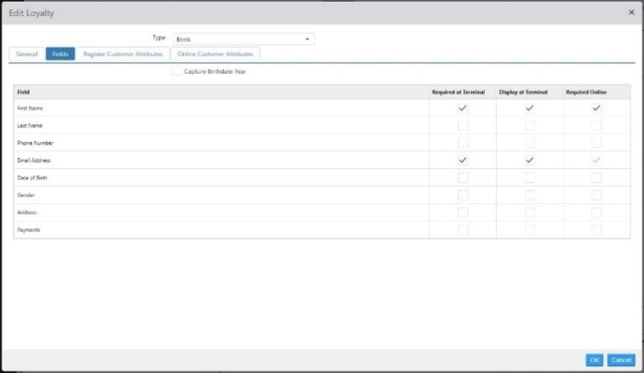

* + **Required at Terminal**: Field required at the register prior to saving the customer record.
  + **Display at Terminal**: Field displayed on the customer UI at the register.
  + **Required Online**: Field required when creating a customer account at customer portal or mobile.

***Options > Loyalty > Register Customer Attributes*** *tab for Brink*

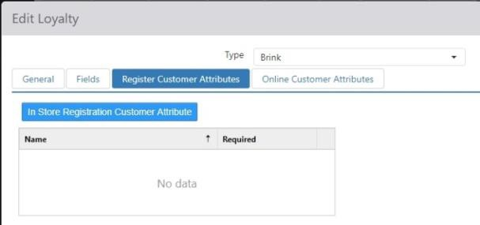

* + **Attribute**: Customer attribute to display.
  + **Required**: Attribute requires value input prior to saving the customer record.
* ***Options > Loyalty > Online Customer Attributes*** *tab for Brink*

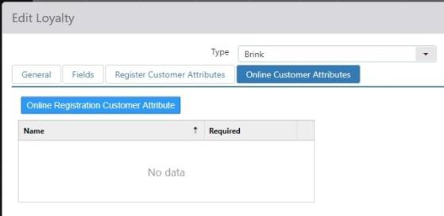

* + **Attribute**: Customer attribute to display.
  + **Required**: Attribute requires value input prior to saving the customer record.

*Loyalty Provider: Givex*

When **Givex** is selected as the **Loyalty Provider**, the **General** tab is displayed.

***Options > Loyalty > General*** *tab for Givex*

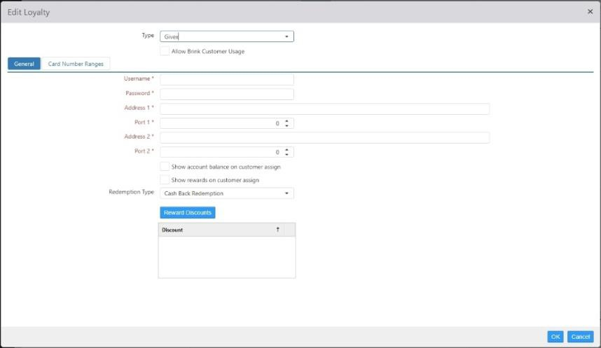

* + **Allow Brink Customer Usage**: Allows non-Brink loyalty providers to utilize the Brink customer database.

**NOTE**: In the majority of cases, this box should be checked. If you find this box unchecked, ask your Brink integration technician whether a) you are a special case and should leave it unchecked, or b) you should check the box.

* + **Username**: The username provided to you by Givex.
  + **Password**: The password provided to you by Givex.
  + **Address 1**: The primary URL provided to you by Givex.
  + **Port 1**: The port number for the primary URL.
  + **Address 2**: The secondary URL provided to you by GIvex.
  + **Port 2**: The port number for the secondary URL.
  + **Show account balance on customer assign**: When checked, the Register will display an account balance dialog when a customer is associated with an order.
  + **Show rewards on customer assign**: When checked, the Register will display an available rewards dialog when a customer is associated with an order.
  + **Rewards Discounts**: Discount associated with the Givex loyalty program. These must first be created on the Discounts page. See Discounts.
    - **Reward Discount**: The name of the discount.
    - **Point Value**: The number of points required to redeem the discount.

*Loyalty Provider: Heartland*

When **Heartland** is selected as the **Loyalty Provider**, the **General** tab is displayed.

***Options > Loyalty > General*** *tab for Heartland*

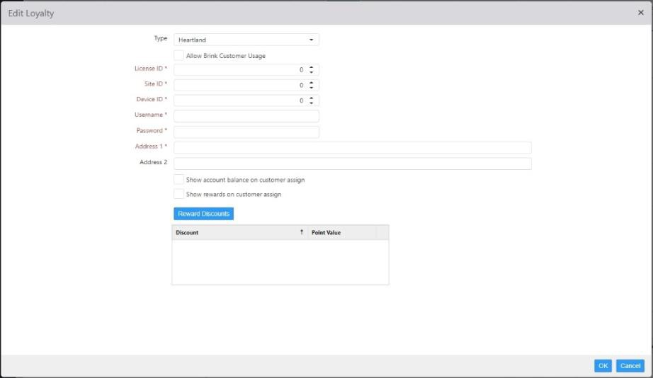

* + **Allow Brink Customer Usage**: Allows non-Brink loyalty providers to utilize the Brink customer database.

**NOTE**: In the majority of cases, this box should be checked. If you find this box unchecked, ask your Brink integration technician whether a) you are a special case and should leave it unchecked, or b) you should check the box.

* + **License ID**: Provided by Heartland.
  + **Site ID**: Provided by Heartland.
  + **Device ID**: Provided by Heartland.
  + **Username**: Provided by Heartland.
  + **Password**: Provided by Heartland.
  + **Address 1**: Provided by Heartland.
  + **Address 2**: Provided by Heartland.
  + **Show account balance on customer assign**: Display the Heartland stored value balance on the dialog that displays when a customer is assigned to an order.
  + **Show rewards on customer assign**: Show customer’s rewards available for redemption when a

customer is assigned to an order.

* + **Reward Discounts**: Discounts that are available for point redemption.
    - **Reward Discount**: Discount to be applied.
    - **Point Value**: Points to be redeemed.

*Loyalty Provider: Paytronix*

When **Paytronix** is selected as the **Loyalty Provider**, the **General** and **Fields** tabs are displayed.

***Options > Loyalty > General*** *tab for Paytronix*

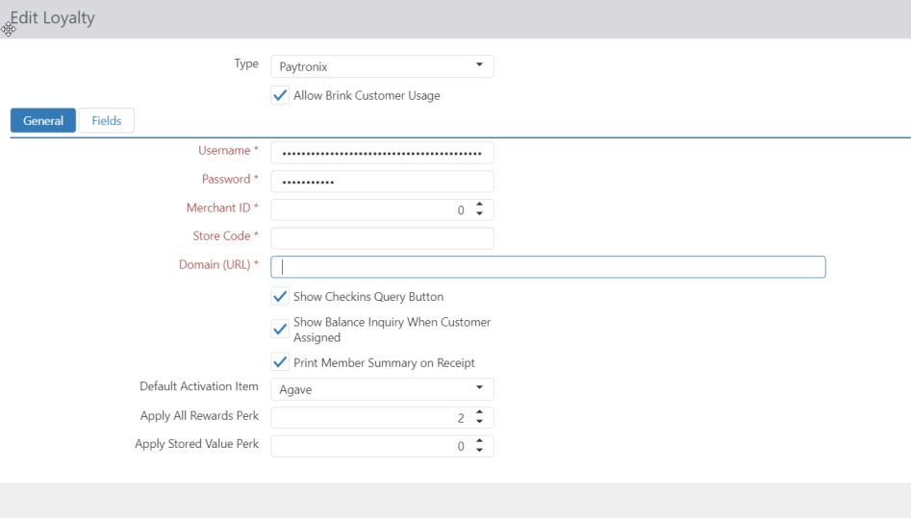

* + **Allow Brink Customer Usage**: Allows non-Brink loyalty providers to utilize the Brink customer database.

**NOTE**: In the majority of cases, this box should be checked. If you find this box unchecked, ask your Brink integration technician whether a) you are a special case and should leave it unchecked, or b) you should check the box.

* + **Ussername**: Provided by Paytronix.
  + **Password**: Provided by Paytronix.
  + **Merchant Id**: Provided by Paytronix.
  + **Store Code**: Provided by Paytronix.
  + **Domain**: Provided by Paytronix, but is typically https://api.pxsweb.com
  + **Show Checkins Query Button**: ‘Display Checkin’ Button on the customer lookup screen.
  + **Show Balance Inquiry When Customer Assigned**: Display stored value/gift card balance when a customer is assigned to an order.
  + **Print Member Summary on Receipt**: Print Paytronix loyalty summary on the customer’s receipt.
  + **Default Activation Item**: Item that triggers activation of the customer account in Paytronix, when ordered.
  + **Apply All Rewards**: If configured with Paytronix to apply all reward, POS will also need to be configured, value proved by Paytronix. When set up, all rewards applicable will be applied automatically to the order.
  + **Apply Stored Value**: f configured with Paytronix to apply stored value, POS will also need to be configured, value proved by Paytronix. When set up, available stored value will be applied automatically to the order.

***Options > Loyalty > Fields*** *tab for Paytronix*

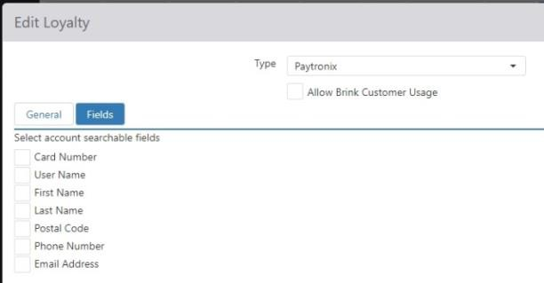

* + **Card Number**: Display card number input on lookup screen.
  + **Username**: Display username input on lookup screen.
  + **First Name**: Display first name input on lookup screen.
  + **Last Name**: Display last name input on lookup screen.
  + **Postal Code**: Display postal code input on lookup screen.
  + **Phone Number**: Display phone number input on lookup screen.
  + **Email Address**: Display email address input on lookup screen.

*Loyalty Provider: Punchh*

When **Punchh** is selected as the **Loyalty Provider**, the **General** tab is displayed.

***Options > Loyalty > General*** *tab for Punchh*

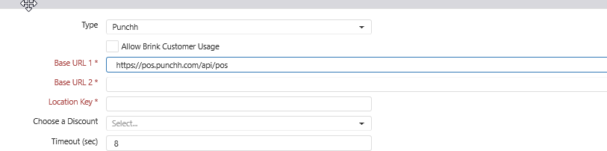

•

* + **Allow Brink Customer Usage**: Allows non-Brink loyalty providers to utilize the Brink customer database.

**NOTE**: In the majority of cases, this box should be checked. If you find this box unchecked, ask your Brink integration technician whether a) you are a special case and should leave it unchecked, or b) you should check the box.

* + **Base URL 1**: Provided by Punchh.
  + **Base URL 2**: Provided by Punchh.
  + **Location Key**: Provided by Punchh.
  + **Choose a Discount**: Select a discount in the drop-down list.
  + **Timeout (sec)**: Configurable timeout when Punchh can’t be reached, default is 8 seconds

**NOTE**: For a discount to appear in the drop-down list, it must be configured as **Type > Comp** and have the **Must Enter Amount** and **Loyalty Discount** boxes checked on the **Options** tab.

**NOTE:** The “Create Check In on order close” checkbox from previous versions has been removed in Brink POS 4.1f, due to a workflow update from Punchh Loyalty. Check-ins must now always be performed on order close if a customer is assigned to that order. This functionality now occurs automatically in the background, and no configuration is needed from the user.

*Loyalty Provider: Relevant*

When **Relevant** is selected as the **Loyalty Provider**, the **General** tab is displayed.

***Options > Loyalty > General*** *tab for Relevant*

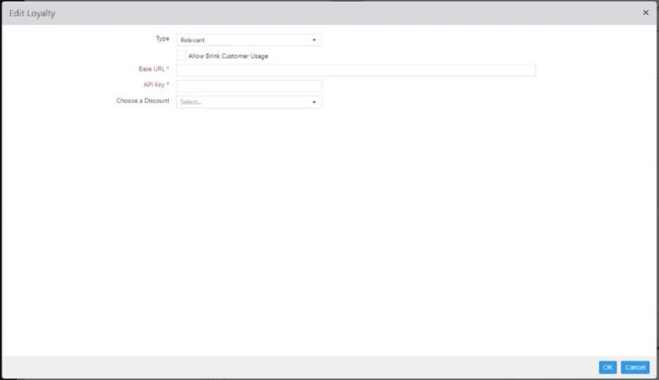

* + **Allow Brink Customer Usage**: Allows non-Brink loyalty providers to utilize the Brink customer database.

**NOTE**: In the majority of cases, this box should be checked. If you find this box unchecked, ask your Brink integration technician whether a) you are a special case and should leave it unchecked, or b) you should check the box.

* + **Base URL**: Provided by Relevant.
  + **API Key**: Provided by Relevant.
  + **Choose a Discount**: Select a discount on the drop-down list.

*Loyalty Provider: SessionM*

When **SessionM** is selected as the **Loyalty Provider**, the **General** tab is displayed.

***Options > Loyalty > General*** *tab for SessionM*

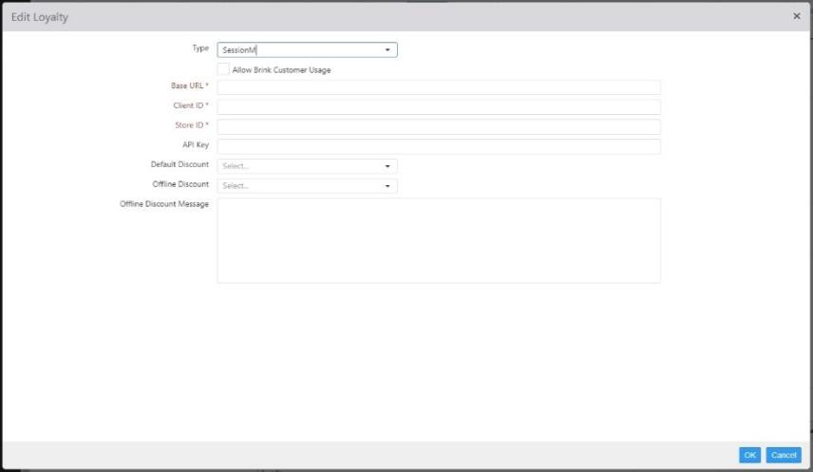

* + **Allow Brink Customer Usage**: Allows non-Brink loyalty providers to utilize the Brink customer database.

**NOTE**: In the majority of cases, this box should be checked. If you find this box unchecked, ask your Brink integration technician whether a) you are a special case and should leave it unchecked, or b) you should check the box.

* + **Base URL**: Provided by SessionM.
  + **Client ID**: Provided by SessionM.
  + **Store ID**: Provided by SessionM.
  + **API Key**: Provided by SessionM.
  + **Client Secret**: Leave this field blank.
  + **Default Discount**: Select the default discount for the SessionM loyalty program. This discount must be set up on the Discounts page of Settings Editor and must have the **Must Enter Amount** and **Loyalty Discount** boxes checked.

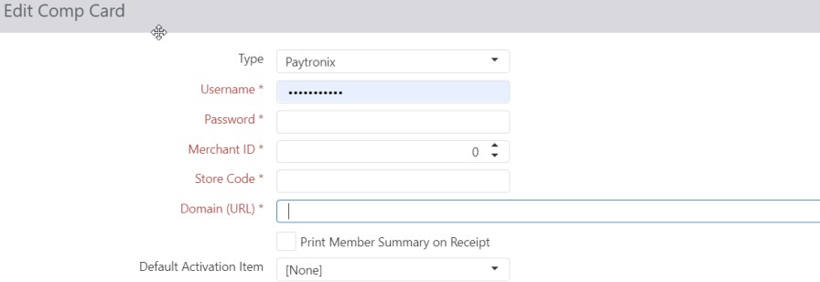*Comp Cards: Paytronix*

* + **Username**: Provided by Paytronix.
  + **Password**: Provided by Paytronix.
  + **Merchant Id**: Provided by Paytronix.
  + **Store Code**: Provided by Paytronix.
  + **Domain**: Provided by Paytronix, but is typically https://api.pxsweb.com
  + **Print Member Summary on Receipt**: Not part of phase one comp card feature
  + **Default Activation Item**: Item that triggers activation of the customer account in Paytronix, when ordered.

Note: Phase one of Comp Card for Paytronix is for configuration changes and allow customer to redeem a card.

### Kitchen

The **Kitchen** tab contains settings for kitchen displays.

*General*

##### *Options > Kitchen > General tab*

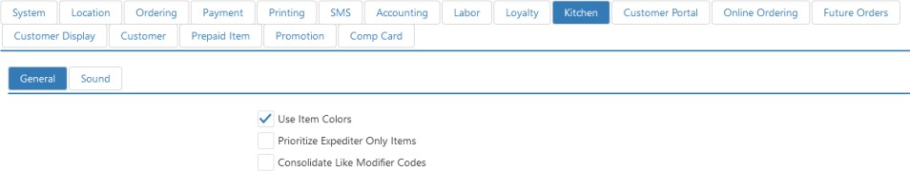

* + **Show Unsent Orders**: Moved to Kitchen Queue
    - **Can Bump Unsent Orders**: Moved to Kitchen Queue
  + **Consolidate Like Items**: Moved to Kitchen View
  + **Use Item Colors**: Order item is displayed in the Kitchen Color defined on the item, rather than the colors defined on the Kitchen View.
  + **Prioritize Expediter Only Orders**: Order items that only route to the kitchen queues with Is Expediter enabled are added to the beginning of the queue.
  + **Consolidate Like Modifier Codes**: Consolidate modifiers into groups based on the modifier code (ADD, NO, HALF, etc.) on both kitchen displays and printed kitchen chits.

*Sounds*

##### *Options > Kitchen > Sounds tab*

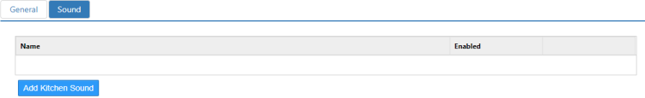

* + **Add Kitchen Sound**: Click this button to add a row to the list.

*Add Kitchen Sound dialog,* ***Destinations*** *tab*

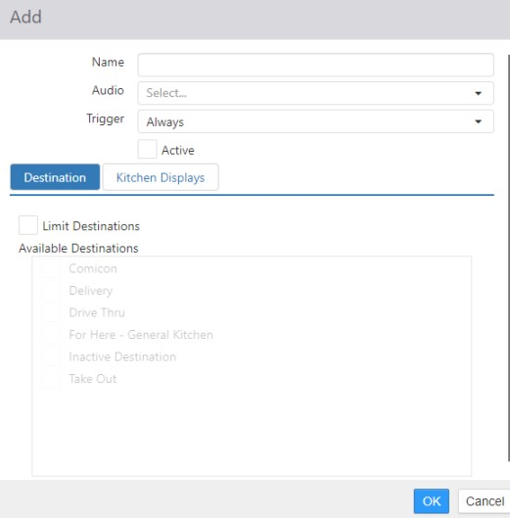

* + - **Name**: Name of the sound.
    - **Audio**: Select the sound file that is played.
    - **Trigger**: Select the event that triggers the sound.

 **Always**: Plays sound every time an order is sent to the kitchen.

 **Empty Displays Only:** Plays sound only when an order is sent to the kitchen and no other orders are currently on the kitchen display.

* + - **Active**: Check the box to activate the sound.
  + **Destination**: Select the order destination(s) that triggers the sound event.
  + **Kitchen Displays**: Select the kitchen display(s) that triggers the sound event.

**Important Note:** For the kitchen to play sounds, the items must be included in a video group and attached to a kitchen queue.

### Customer Portal

The Customer Portal tab contains sub-tabs with settings that pertain to the layout of the online ordering portal.

*General*

The General tab contains a control for the password reset email.

##### *Options > Customer Portal > General tab*

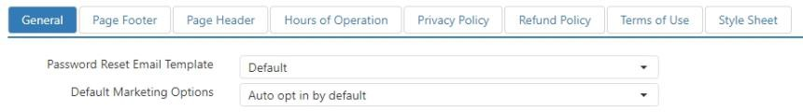

* + **Password Reset Email Template**: Select from the list of user-defined email templates (see Email Templates.)
  + **Default Marketing Options**: Controls the marketing email opt-in behavior of the Customer Portal.
    - **Auto opt in by default**: When a new customer uses the Customer Portal, they are automatically subscribed to the marketing email. This is the default setting.
    - **Auto opt in after registration**: When a new customer registers an account on the Customer Portal, they are automatically subscribed to the marketing email, but they are not automatically subscribed when they only place an order.
    - **Never auto opt in**: Customers are never automatically subscribed to the marketing email.

*Page Footer, Page Header, Hours of Operation, Privacy Policy, Refund Policy, Terms of Use, and Style Sheet* The following tabs contain text boxes into which you can enter text, HTML markup tags, and/or CSS style information. The text/markup/styles so entered populate the corresponding areas of the Customer Portal.

***Options > Customer Portal > Page Footer*** *tab (example)*

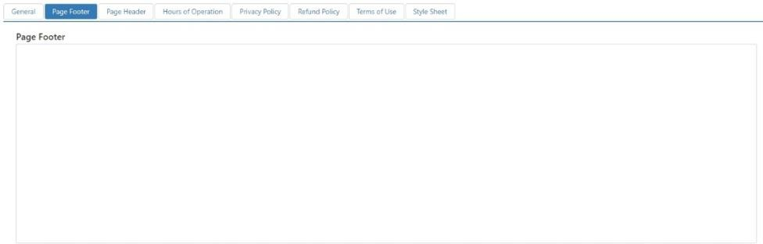

### Online Ordering

The Online Ordering tab contains sub-tabs with settings pertaining to ordering through the Customer Portal.

*General*

The General tab contains settings for basic functions of online ordering.

##### *Options > Online Ordering > General tab*

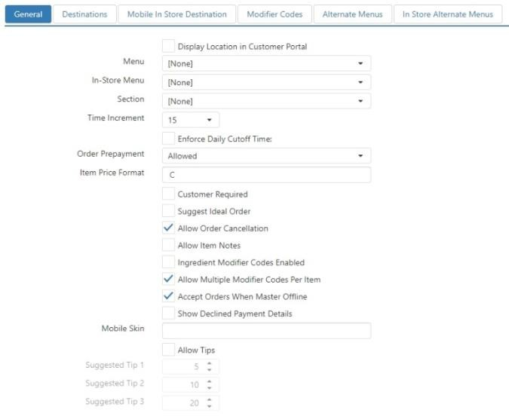

* + **Display Location in Customer Portal**: Location is visible on the locations page in the Customer Portal.
  + **Menu**: Menu to be displayed on the Customer Portal; online ordering is disabled when this is set to None.
  + **In-Store Menu**: Menu to be displayed on Customer Portal mobile when in in-store ordering mode.
  + **Section**: Section to be assigned to online orders.
  + **Time Increment**: Use the drop-down list to select a value of between **5** and **60** minutes. This sets the time increments presented when selecting a pickup time or delivery time. For example, selecting **5** presents 1:00, 1:05, 1:10; selecting **20** presents 1:00, 1:20, 1:40; etc.
  + **Enforce Daily Cutoff Time**: Do not allow online orders for the current date to be submitted after the specified time of day.
    - This time is the time after which you cannot SUBMIT an order

 You cannot hit the “Submit Order” button after the Daily Cutoff Time, if

configured

* + - You can place a future order with a Requested Time after the cutoff time (depending on

the location hours and prep time…)

#### Order Prepayment:

* + - **Allowed**: Orders can be submitted with or without payment.
    - **Not Allowed**: Orders can only be submitted without payment.
    - **Required**: Orders can only be submitted with payment.
  + **Item Price Format**: Formatting string for menu item prices (valid strings include **c**, **n0**, **n2**).
  + **Customer Required**: Customer is required to be signed in prior to submitting online order.
  + **Allow Order Cancellation**: Order cancelation page allows orders to be cancelled and link to the page is included in the footer of the confirmation email.
  + **Allow Item Notes**: Note field is displayed with each menu item for customer to enter custom notes.
  + **Ingredient Modifier Codes Enabled**: Modifiers listed for each modifier code is dependent on the

item’s list of ingredients and the modifier codes **Applies To** setting.

* + **Allow Multiple Modifier Codes Per Item**: The same modifier can be added to the same item with different modifier codes.
  + **Accept Orders when Primary is Offline**: Customer Portal and Ordering API accepts orders when the primary Register’s connection status is offline.
  + **Show Declined Payments Details**: Displays declined payment details to customers when a credit card transaction is declined.
  + **Mobile Skin**: Name of the skin to be applied to Customer Portal Mobile.
  + **Allow Tips**: Customers ordering online will be prompted to add a tip to their order.
  + **Suggested Tip *N***: Each field sets the percentage of the suggested tip link. The defaults are 5%, 10%, and 20%. When a customer clicks the associated link on the customer portal or mobile portal, the amount is automatically calculated and input into the tip field.

*Destinations*

The Destinations tab allows you to specify which destination or destinations an online order can be processed under (see Destinations).

##### *Options > Online Ordering > Destinations tab*

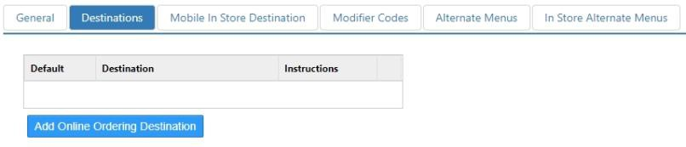

* + **Default**: Destination is selected by default.
  + **Destination**: Destination to display.
  + **Instructions**: Additional information to display along with the name of the destination, and included on the order confirmation email.

*Mobile In Store Destinations*

The Mobile In Store Destinations tab allows you to specify which destination or destinations a mobile in- store order can be processed under (see Destinations).

##### *Options > Online Ordering > Mobile In Store Destinations tab*

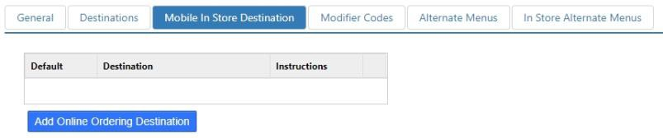

* + **Default**: Destination is selected by default.
  + **Destination**: Destination to display.
  + **Instructions**: Additional information to display along with the name of the destination, and included on the order confirmation email.

*Modifier Codes*

The Modifier Codes tab allows you specify which modifier codes are available on the Customer Portal.

##### *Options > Online Ordering > Modifier Codes tab*

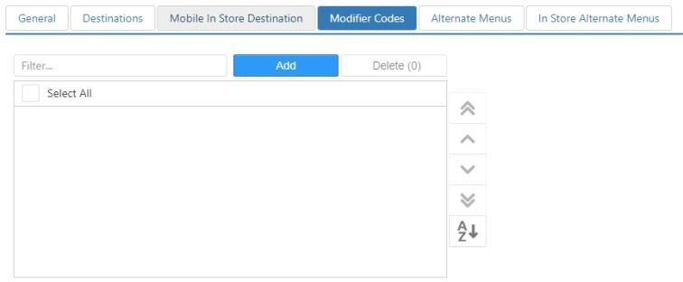

*Alternate Menus*

Menu that can override the default menu displayed in Customer Portal.

##### *Options > Online Ordering > Alternate Menus tab*

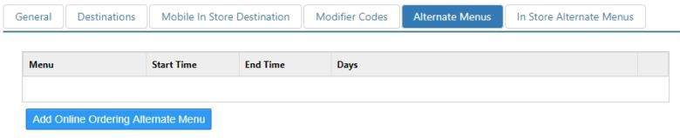

* + **Days**: Days of the week that the menu is valid.
  + **Menu**: Menu to display when
  + **Start Time**: Time of day the menu becomes valid.
  + **End Time**: Time of day the menu is no longer valid.

*In Store Alternate Menus*

Menu that can override the default menu displayed in the Mobile Customer Portal for in-store orders.

##### *Options > Online Ordering > In Store Alternate Menus tab*

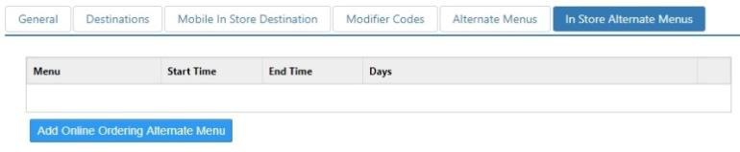

* + **Days**: Days of the week that the menu is valid.
  + **Menu**: Menu to display when
  + **Start Time**: Time of day the menu becomes valid.
  + **End Time**: Time of day the menu is no longer valid.

### Future Orders

The Future Orders tab contains sub-tabs with settings that control how future orders are handled.

*General*

The General tab contains basic tools for how future orders are handled.

##### *Options > Future Orders > General tab*

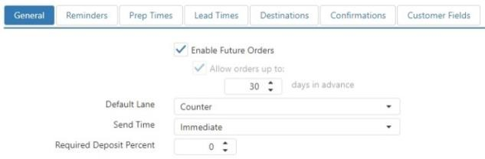

* + **Enable Future Orders**: Future orders can be entered on the Register and accepted via Customer Portal and the Ordering API.
  + **Allow orders up to X days in advance**: Number of days in the future that the request time can be set to.
  + **Default Lane**: Lane in which future orders are to be added when they are automatically sent.

**NOTE**: If this is set to **None**, you will not see online orders or future orders at the register.

#### Send Time:

* + - **Immediate**: Future orders are sent to the kitchen as soon as they are finished, or accepted via Customer Portal or the Ordering API.
    - **Sent Time**: Future orders automatically sent to the kitchen based on their calculated prep and lead time.
  + **Required Deposit Percent**: Percent of the order total that is required be paid on the order before it can be finished.

*Reminders*

The Reminders tab controls how and when reminder emails are sent to customers.

##### *Options > Future Orders > Reminders tab*

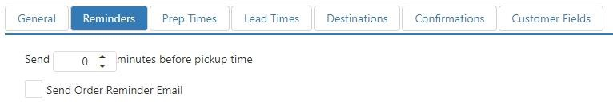

* + **Send Order Reminder Email**: Email is sent to remind the customer of their pending future order.
  + **Send *X* minutes before pickup time**: Number of minutes prior to the order’s request time to

send the email.

* + **Default Message**: Message included in the body of the email, before the order details.
  + **Email Template**: Email template to use for the email to be sent.

*Prep Times*

The Prep Times tab allows you to set a minimum preparation time for orders and set custom prep times for certain kinds of orders.

##### *Options > Future Orders > Prep Times tab*

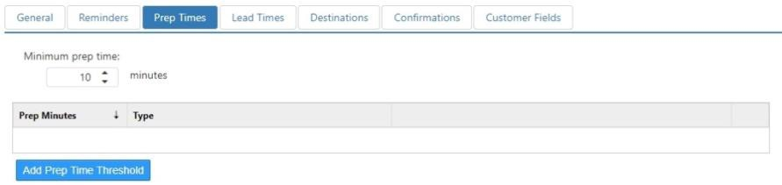

* + **Minimum Prep Time**: Default minimum prep minutes to be used for all future orders.

#### Prep Time Rules:

* + - **Prep Minutes**: Prep minutes to be used when order matches rule definition.

#### Type:

 **Item Count**: Order contains a minimum number of items.

* + - * **Count**: Minimum number of order items.

 **Order Amount**: Order total is equal to or exceeds a certain dollar amount.

* + - * **Amount**: Minimum order total.

 **Contains Item**: Order contains a particular item.

* + - * **Item**: Item that must exist on the order.

 **Contains Item In Group**: Order contains any items from a particular item group.

* + - * **Item Group**: Item group containing qualifying items.

*Lead Times*

Defines the rules for calculating the lead time minutes required for a future order. Prep time is calculated as the Minimum Lead Minutes, or the highest Lead Minutes on all matching rules.

##### *Options > Future Orders > Lead Times tab*

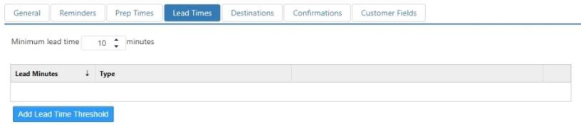

* + **Minimum Lead Time**: Default minimum lead time minutes to be used for all future orders.

#### Lead Time Rules:

* + - **Lead Minutes**: Lead time minutes to be used when order matches rule definition.

#### Type:

 **Item Count**: Order contains a minimum number of items.

* + - * **Count**: Minimum number of order items.

 **Order Amount**: Order total is equal to or exceeds a certain dollar amount.

* + - * **Amount**: Minimum order total.

 **Contains Item**: Order contains a particular item.

* + - * **Item**: Item that must exist on the order.

 **Contains Item In Group**: Order contains any items from a particular item group.

* + - * **Item Group**: Item group containing qualifying items.

*Destinations*

Defines the destinations that are available to choose from on the ‘Set Future Order’ screen on the Register.

##### *Options > Future Orders > Destinations tab*

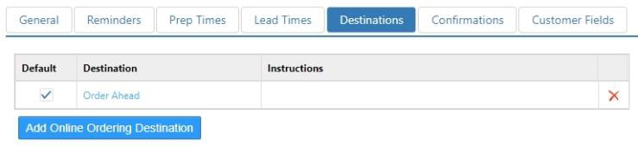

* + **Default**: Destination is selected by default when no destination is set on the future order.
  + **Destination**: Destination to display.
  + **Instructions**: Included on the order confirmation email.

*Confirmations*

The Confirmations tab controls how order confirmation emails are sent.

##### *Options > Future Orders > Confirmations tab*

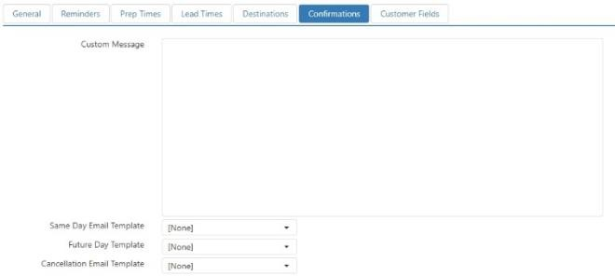

* + **Custom Message**: Message included in the body of the confirmation email, before the order details.
  + **Same Day Email Confirmation**: Email template to use for the email that is sent when a future order for the current business date is accepted via the Customer Portal or Ordering API.
  + **Future Date Email Template**: Email template to use for the email that is sent when a future order for a date later than the current business date is accepted via the Customer Portal or Ordering API.
  + **Cancellation Email Template**: Email template to use for the email that is sent when a future order is cancelled via the Customer Portal or Ordering API.

*Customer Fields*

Defines the customer fields that are visible and required when creating a new customer record on the Register via the ‘Set Future Order’ screen.

##### *Options > Future Orders > Customer Fields tab*

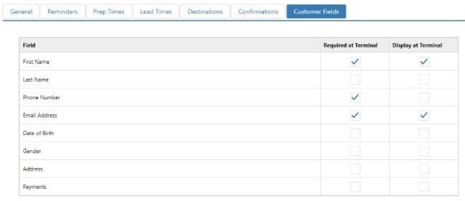

* + **Display at Terminal**: Field is visible on the ‘Customer Details’ screen on the Register.
  + **Required at Terminal**: Valid data must be entered into the field before the customer record can be saved.

### Customer Display

The Customer Display tab contains sub-tabs that control a customer-facing display.

*Line*

The Line tab is where you enter the scrolling message to be displayed on the customer display.

##### *Options > Customer Display > Line tab*

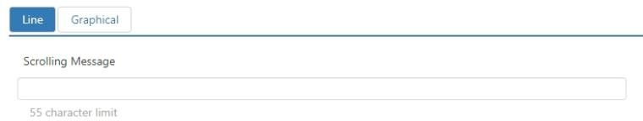

* + **Scrolling Message**: Text that is to scroll across the customer facing 2-line VFD on the terminal when the Register application is idle.

*Graphical*

The Graphical tab is where you set up the graphical components of the customer display.

##### *Options > Customer Display > Graphical tab*

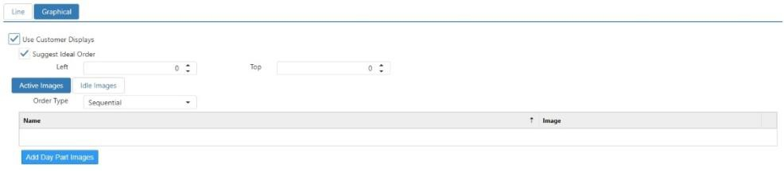

* + **Use Customer Displays**: Display the ‘Customer Display’ system panel on the Register application.
  + **Suggest Ideal Order**: NO LONGER USED.
  + **Left**: Number of pixels from the left edge of the screen to display the ‘Customer Display’ panel.
  + **Top**: Number of pixels from the top edge of the screen to display the ‘Customer Display’ panel.
  + **Active Images**: Images to display when an employee is logged into the Register, image changes each time the current order changes.

#### Order Type:

 **Sequential**: Display images in order sorted by the image name.

 **Random**: Randomly display images in no particular order.

* + **Idle Images**: Images to display when no employee is logged into the Register.
    - **Timer**: Number of seconds between the image changing.

#### Order Type:

 **Sequential**: Display images in order sorted by the image name.

 **Random**: Randomly display images in no particular order.

### Customer

The Customer tab contains controls for setting the default values for new customer signups.

##### *Options > Customers > Defaults tab*

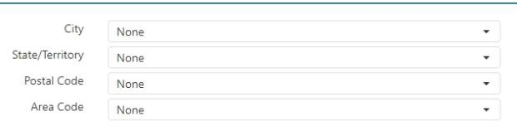

* + **City**: Default city for new addresses added to a customer record.
  + **State**: Default state/province for new addresses added to a customer record.
  + **Zip Code**: Default zip/postal code for new addresses added to a customer record.
  + **Area Code**: Default area code for new phone numbers added to a customer record.

### Prepaid Item

The Prepaid Item tab controls access information for prepaid item processors.

##### *Options > Prepaid Item tab*

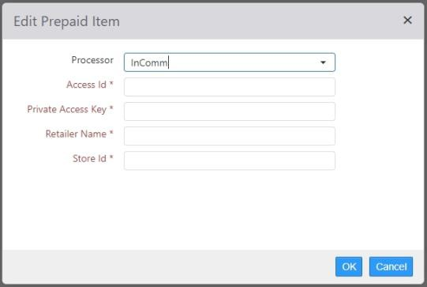

#### Processor Type:

* + - **None**: Prepaid items are not allowed.
    - **InComm**: Prepaid items are processed through InComm (<http://www.incomm.com/)>

 **Access ID**: Provided by InComm.

 **Private Access Key**: Provided by InComm.

 **Retailer Name**: Provided by InComm.

 **Store ID**: Provided by InComm.

### Promotion

The Promotion tab contains controls for Beanstalk promotions.

##### *Options > Promotion > Beanstalk tab*

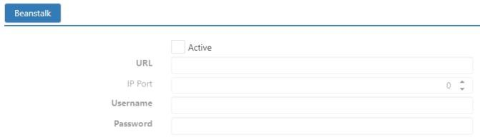

### Comp Card

The Comp Card tab contains controls for Paytonix Comp Card.

##### *Options > Comp Card tab*

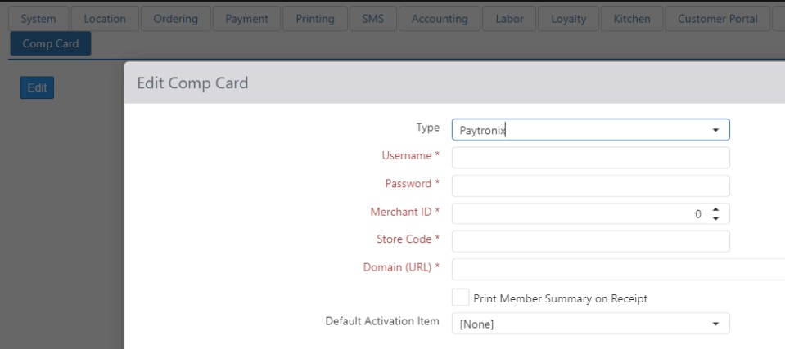

If configured with Paytronix to offer Comp Cards to guests, the POS will now support the ability to load/activate a card at the register. Comp Card Integration type must be configured first.

Then in Settings Editor, a new Item will be required for each Comp Card type you have configured with Paytronix (examples of Item Name: Guest Relations, Charitable Donations). See Item dialog > Options tab.

## Payment Devices

Payment device are peripheral devices that the Register application can request payment from. These devices often support Chip & PIN and NFC types of transactions.

Several settings are the same no matter what selection is chosen in the **Model** drop-down list:

*Edit Payment Device dialog*

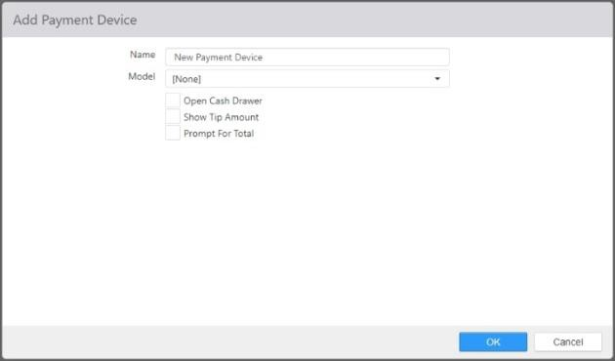

* + **Name**: Name of the payment device.
  + **Open cash drawer**: The cash drawer will open when a tip is applied at the payment device.
  + **Show tip amount**: When a tip is applied at the payment device, display the amount of the tip as a message on the register.
  + **Prompt for total**: When payments are made through the payment device, the register will display a dialog with the total amount of the order, allowing the employee to change the amount paid before conducting the transaction at the device.

Other settings depend on the selection in the **Model** drop-down list:

#### Datacap Canadian EMV:

*Edit Payment Device dialog, Datacap Canadian EMV*

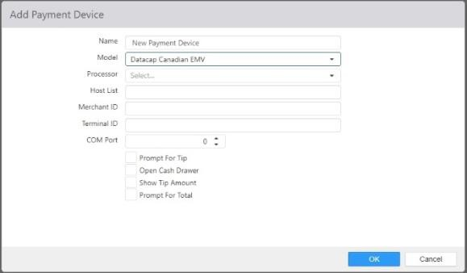

* + - **Processor**: Back end credit card processor.
    - **Host List**: Provided by processor.
    - **Merchant Id**: Provided by processor.
    - **Terminal Id**: ID unique per location, exposed for all Datacap payment devices.
    - **COM Port**: COM port the device is physically connected to.
    - **Prompt for Tip**: The device will prompt the customer to enter a tip amount.

#### Datacap PDCX:

*Edit Payment Device dialog, Datacap PDCX*

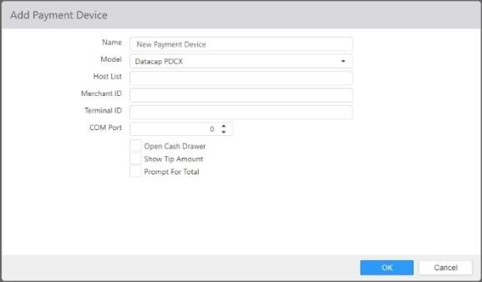

* + - **Host List**: Provided by processor.
    - **Merchant Id:** Provided by processor.
    - **Terminal Id**: ID unique per location, exposed for all Datacap payment devices.
    - **COM Port**: COM port the device is physically connected to.

#### Datacap US EMV:

*Edit Payment Device dialog, Datacap US EMV*

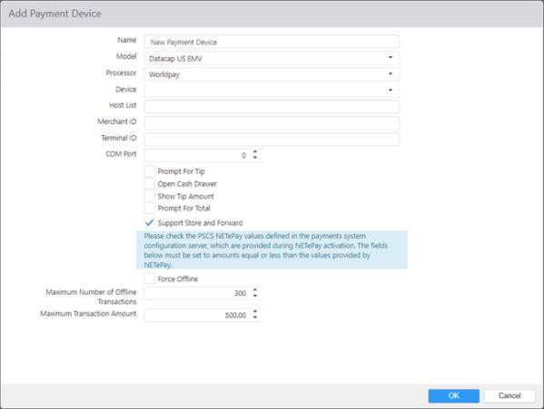

* + - **Processor**: Back end credit card processor.
    - **Device**: Choose SecureDevice.
    - **Host List**: Provided by processor.
    - **Merchant Id**: Provided by processor.
    - **Terminal Id**: ID unique per location, exposed for all Datacap payment devices.
    - **COM Port**: COM port the device is physically connected to.
    - **Prompt for Tip**: The device will prompt the customer to enter a tip amount.
    - **Support Store and Forward**: When credit card terminal is offline, allow customer to still pay on credit card terminal and transactions will be stored. Transactions will be forwarded for settlement when system comes back online.

 **Force Offline**: Immediately go into Store and Forward mode

 **Maximum Number of Offline Transactions:** Please put a value between 1 and 9999. Default value set to 300.

#### ParPay:

 **Maximum Transaction Amount:** Please put a value between 1 and 99,.00999; Default value set to 500.00.

*Edit Payment Device dialog, ParPay*

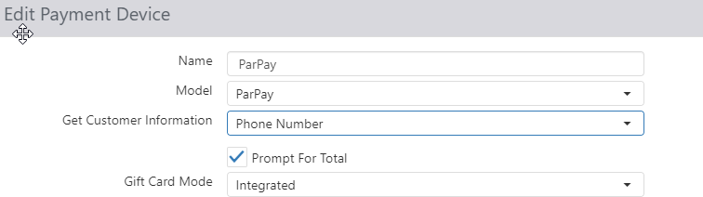

* + - **Gift Card Mode**: Select **Integrated** if you wish to use ParPay to process gift card transactions as well as credit and debit card transactions.
    - **Prompt for total**: When payments are made through the payment device, the register will display a dialog with the total amount of the order, allowing the employee to change the amount paid before conducting the transaction at the device.
    - **Get Customer Information**: Select Phone Number from dropdown, this will enable you to lookup Brink Loyalty using your ParPay Device

#### PAX POSLink:

*Edit Payment Device dialog, PAX POSLink*

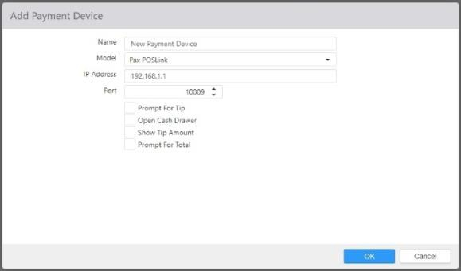

* + - **IP Address**: IP address of the payment device.
    - **Port**: TCP port that the device listens on for incoming connections from the Register.
    - **Prompt for Tip**: The device will prompt the customer to enter a tip amount.

#### Tender Retail:

*Edit Payment Device dialog, Tender Retail*

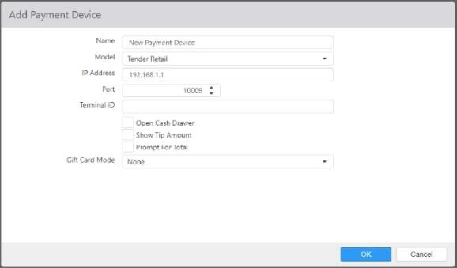

* + - **IP Address**: IP address of the payment device.
    - **Port**: TCP port that the device listens on for incoming connections from the Register.
    - **Terminal Id**: Provided by processor.
    - **Gift Card Mode**: When **Passthrough** is selected, the card reader will act as a magnetic stripe reader for gift card purchases. When **Integrated** is selected, the card reader sends gift card information to ValueLink for processing.

**NOTE**: For this feature to work, the payment device itself must be configured for it. Refer to the instructions that came with the payment device to configure it.

**NOTE**: The gift card **Passthrough** setting does not require ValueLink or any other specific gift card processor. The **Integrated** setting, however, only works with ValueLink (see Options> Payment > Gift Processor).

#### Verifone Point:

*Edit Payment Device dialog, Verifone Point*

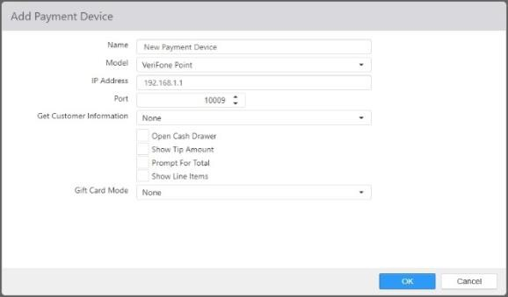

* + - **IP Address**: Static IP address of the payment device.
    - **Port**: TCP port that the device listens on for incoming connections from the Register.
    - **Get Customer Information**: Use the drop-down list to select **Email Address**, **Swipe Card or Phone Number**, or **Phone Number**.
    - **Show Line Items**: This check box is only exposed when the device can be configured to show line items. When this box is checked, items are displayed on the card reader’s screen as they are entered at the register.
    - **Allow payment entry at any time**: When this box is checked, the payment device can accept customer payment card input at any time during the order, not just after the customer is prompted to enter the information.
    - **Gift Card Mode**: When **Passthrough** is selected, the card reader will act as a magnetic stripe reader for gift card purchases.

**NOTE**: For this feature to work, the payment device itself must be configured for it. Refer to the instructions that came with the payment device to configure it for gift card passthrough.

#### Elavon

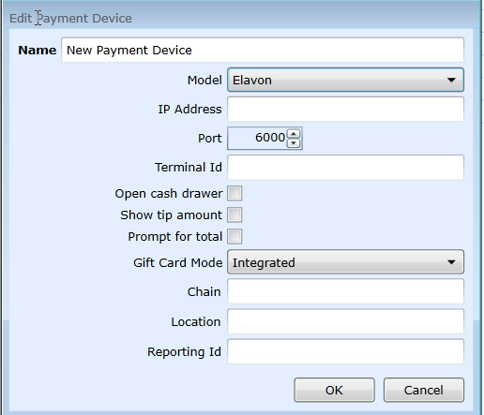

* + - **Name:** Name of the payment device
    - **Model:** Elavon
    - **IP Address:** Provided by processor
    - **Port:** Default 6000
    - **Terminal Id:** Unique per location, exposed for all Elavon payment devices
    - **Open cash drawer**: The cash drawer will open when a tip is applied at the payment device
    - **Show tip amount**: *Not Applicable for Elavon*
    - **Prompt for total**: When payments are made through the payment device, the register will display a dialog with the total amount of the order, allowing the employee to change the amount paid before conducting the transaction at the device.
    - **Gift Card** Mode**:** Integrated
    - **Chain:** Provided by processor
    - **Location:** Provided by processor
    - **Location:** Provided by processor
    - **Reporting ID:** Optional field for Customer to define, will be passed to Elavon (1-15 alpha numeric)

FreedomPay

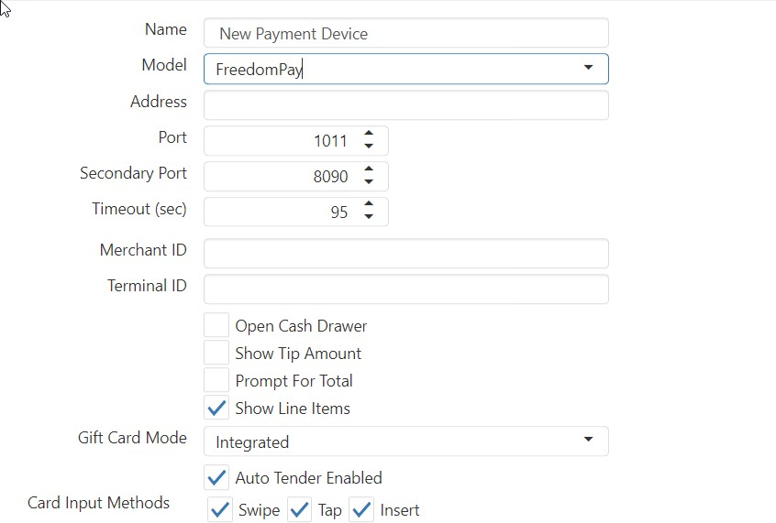

* + - **Name:** Name of the payment device
    - **Model:** FreedomPay
    - **Address:** Provided by processor
    - **Port:** Default :1011

#### Secondary Port:8090

#### Timeout: Configurable POS timeout, default is 95 sec

#### Merchant ID: Defined by FreedomPay

* + - **Terminal Id:** Unique per location,
    - **Open cash drawer**: The cash drawer will open when a tip is applied at the payment device
    - **Show tip amount**: *Not Applicable for FreedomPay*
    - **Prompt for total**: When payments are made through the payment device, the register will display a dialog with the total amount of the order, allowing the employee to change the amount paid before conducting the transaction at the device.
    - **Gift Card** Mode**:** Integrated or passthrough

## Permissions

Permissions are used to control access to particular buttons. In **Layout**, all buttons have a **Permission** option. This permission defaults to **None**, indicating that there are no limits on who can select the button. When a permission is assigned to a button in **Layout**, that’s when it uses the permission settings to determine who can access the button.

*Edit Permissions dialog,* ***Security Levels*** *tab*

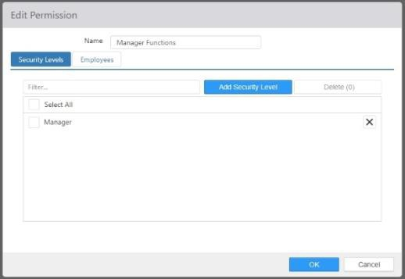

* + **Name**: Name of the permission.
  + **Security Levels**: Security levels granted access to the permission. You can assign the permissions to security levels either here or in **Security Levels > Permissions**. Changing it in one place automatically changes it in the other.

*Edit Permissions dialog,* ***Employees*** *tab*

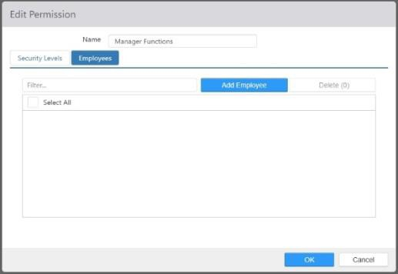

* + **Employees**: Employees granted access to the permission. You can assign the permissions to Employees either here or in **Employees > Permissions**. Changing it in one place automatically changes it in the other.

## Petty Accounts

Petty accounts are used to group paid in/out transactions and map those transactions to a particular general ledger account.

*Edit Petty Account dialog*

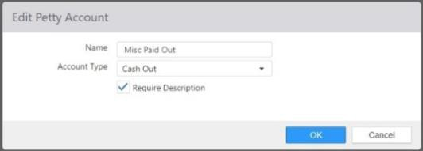

* + **Name**: Name of the petty account.

#### Account Type:

* + - **Cash In**: Displays as an option when paid in is performed, increases calculated cash in the drawer.
    - **Cash Out**: Displays as an option when paid out is performed, decreases calculated cash in the drawer.
  + **Require Description**: Prompts employee to enter a description when performing a paid in/out.

## Price Changes

The Price Changes function is used to set up automatic price changes for specific items. This can be used, for example, to create happy hour pricing for beverages and appetizers that only apply during specific times or on specific days.

*Edit Price Change dialog,* ***Items*** *tab*

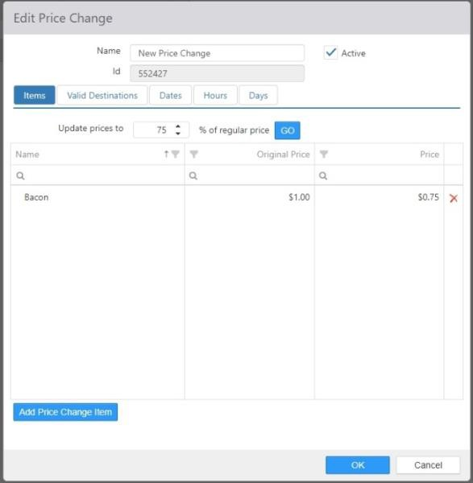

* + **Name**: Enter the name of the price change.
  + **Active**: When checked, the price change is active.
  + **Id**: The ID number is filled in by the system and cannot be changed.

#### Items tab:

* + - **Update prices to % of regular price**: Enter a percentage and press **GO** to

automatically update all of items’ **New Price** values to that percentage of the **Original Price**.

#### Items list:

 **Item**: The names of the items to which the price change applies.

 **Original Price**: The price of the item as set in the *Edit Item* dialog.

 **New Price**: The new price of the item. This can be set manually or calculated using the **Update prices to…** control.

**NOTE**: The Price Change function affects item prices directly. Menu pricing, price levels, and discounts and promotions that set a new price will continue to take priority over item prices on items that they are configured for.

#### Valid Destination tab:

*Edit Price Change dialog,* ***Valid Destinations*** *tab*

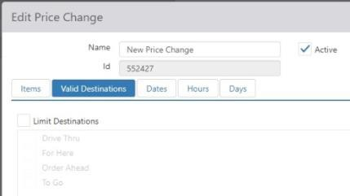

* + - **Limit Destinations**: Check this box to limit the price change to specific destinations.

 **Available Destinations**: The list of destinations as configured on the

**Destinations** page (see Destinations).

#### Dates tab:

*Edit Price Change dialog,* ***Dates*** *tab*

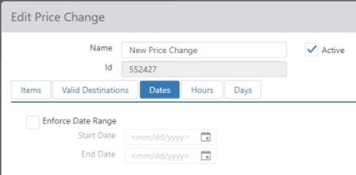

* + - **Enforce Date Range**: Check this box to limit the price change to a specific range of dates as set in the **Start Date** and **End Date** fields.

#### Hours tab:

*Edit Price Change dialog,* ***Hours*** *tab*

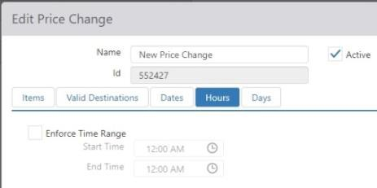

* + - **Enforce Time Range**: Check this box to limit the price change to a specific time period during the day, as set in the **Start Time** and **End Time** fields.

#### Days tab:

*Edit Price Change dialog,* ***Days*** *tab*

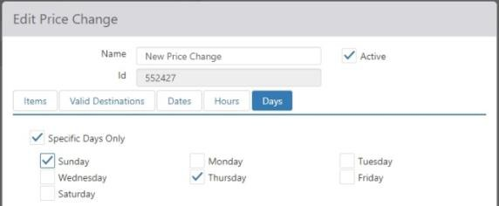

* + - **Enforce Days**: Check this box to limit the price change to specific days of the week using the check boxes below.

## Price Levels

Price levels are used to define the price of like items in a single place.

*Edit Price Level dialog*

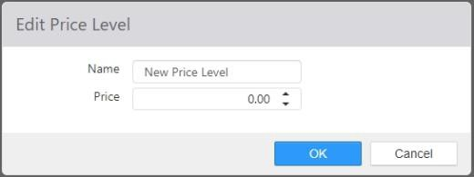

* + **Name**: Name of the price level.
  + **Price**: Price assigned to items of this price level.

## Printer Groups

Print groups control the routing of kitchen chits when order items are sent to the kitchen.

*Edit Printer Group dialog*

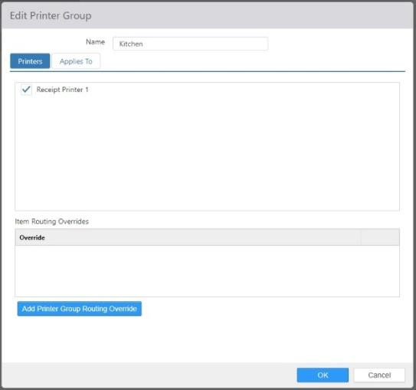

* + **Name**: Name of the printer group.
  + **Printers**: Printers that are to print kitchen chits for this group.
  + **Item Routing Overrides**: Defines an alternate set of printers to print to when the order meets

certain criteria. Use the ‘Add’ button to add overrides.

*Add item routing override dialog*

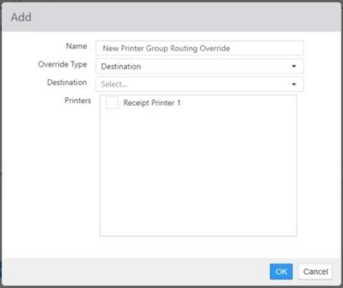

* + - **Name**: Name of the override

#### Override Type:

 **Destination**: Order items are for a specific destination.

 **Item**: Any of the selected items exist in the list of sent order items.

 **Item Group**: Any of the sent order items exist within a specific item group.

*Applies To Tab dialog*

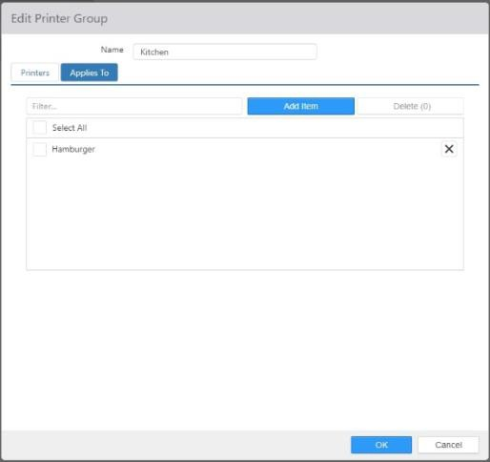

## Printer Messages

Printer Messages define text that is printed on receipts and chits.

*Edit Printer Message dialog,* ***Message*** *tab*

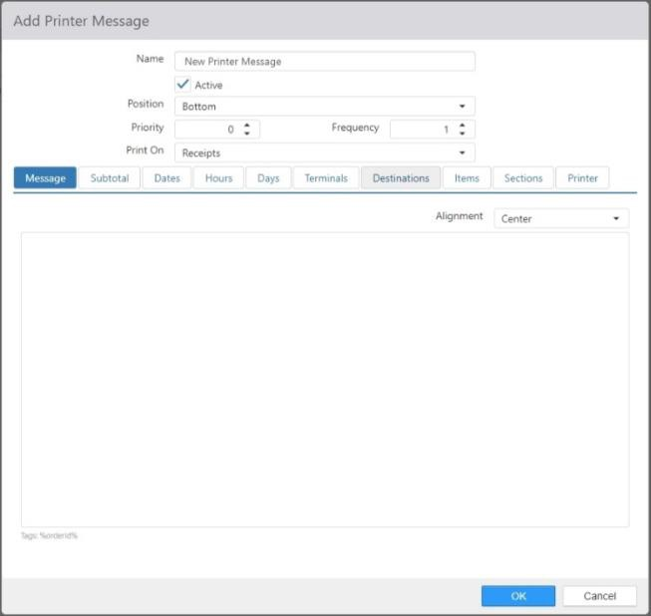

* + **Name**: The name of the printer message. It is suggested that the name be descriptive so that it is easily identified.
  + **Active**: The printer message is active.
  + **Position**: Whether the message is printed at the bottom or the top of the receipt or chit.
  + **Priority**: The priority of the message. Multiple messages are printed in priority order.
  + **Frequency**: How often the message prints. The default is **1**, which means the message is printed on every receipt or chit. The maximum is **999**, which means that the message is printed on every 999th receipt or chit.
  + **Print On**: What printouts the message is printed on: **Chits**, **Receipts**, or **Receipts and Chits**.
  + **Message** tab: The text of the message that is printed. Typing **%orderid%** tells the system to print the order ID in the message.
    - **Alignment**: The alignment of the printed text: **Center**, **Left**, or **Right**.

*Edit Printer Message dialog,* ***Subtotal*** *tab*

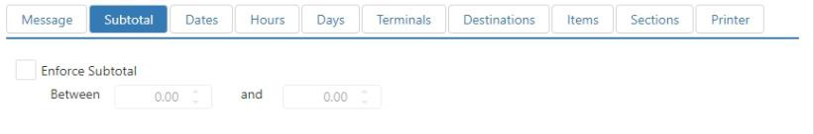

* + **Subtotal** tab:
    - **Enforce Subtotal**: Only print the message when the subtotal for the order is between the two listed values.

*Edit Printer Message dialog,* ***Dates*** *tab*

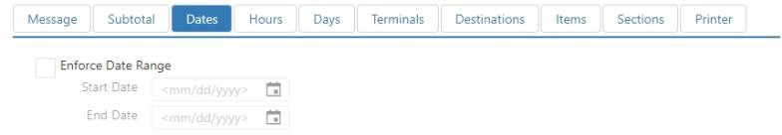

* + **Dates** tab:
    - **Enforce Date Ranges**: Only print the message when the date is between the listed

**StartDate** and **EndDate**.

*Edit Printer Message dialog,* ***Hours*** *tab*

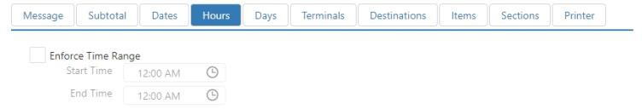

* + **Hours** tab:
    - **Enforce Time Range**: Only print the message when the time of day is between the listed

**StartTime** and **EndTime**.

*Edit Printer Message dialog,* ***Days*** *tab*

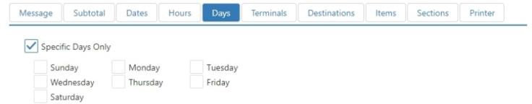

* + **Days** tab:
    - **Enforce Days**: Only print the message on the checked days of the week.

*Edit Printer Message dialog,* ***Terminals*** *tab*

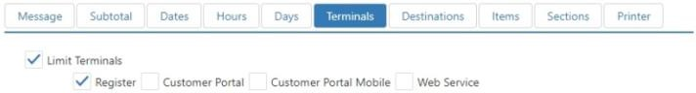

* + **Terminals** tab:
    - **Limit Terminals**: Only print the message when the order comes from the indicated terminals.

*Edit Printer Message dialog,* ***Destinations*** *tab*

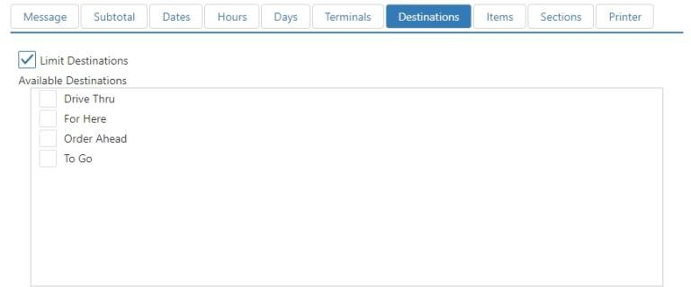

* + **Destinations** tab:
    - **Limit Destinations**: Only print the message when the order is for particular destinations.
    - **Available Destinations**: Check the boxes for the destinations for which you want the message printed. Destinations are configured on the Destinations page.

*Edit Printer Message dialog,* ***Items*** *tab*

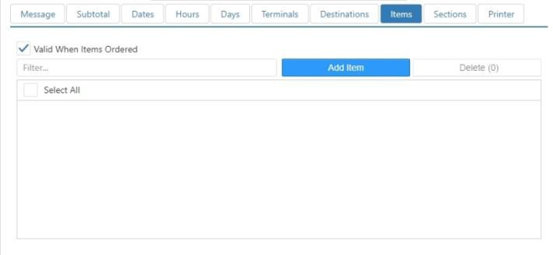

* + **Items** tab:
    - **Valid When Items Ordered**: Only print the message when the order contains items in the *Selected Items* list.

*Edit Printer Message dialog,* ***Sections*** *tab*

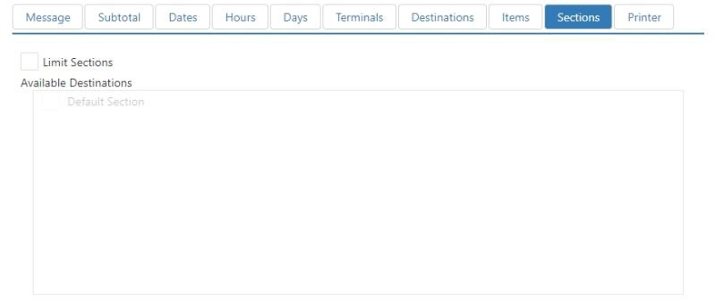

* + **Sections** tab:
    - **Limit Sections**: Only print the message when the order is for particular sections.
    - **Available Sections**: Check the boxes for the sections for which you want the message printed. Sections are configured on the Sections page.

*Edit Printer Message dialog,* ***Printers*** *tab*

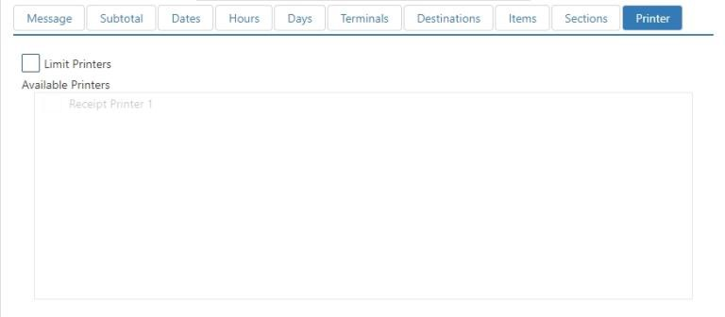

* + **Printers** tab:
    - **Limit Printers**: Only print the message when the receipt or chit is printed on selected printers.
    - **Available printers**: Check the boxes for the printers on which you want the message printed. Printers are configured on the **Error! Not a valid bookmark self-reference.** page.

## Printers

Printers define the physical printers that are part of the POS system.

*Edit Printer dialog,* ***General*** *tab*

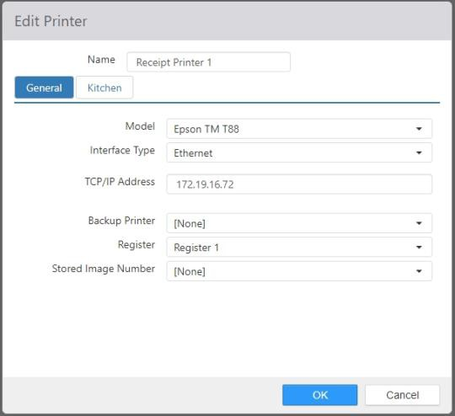

* + **Name**: Enter a name for the new printer.

#### General tab:

* + - **Model**: Select the printer model in the drop-down list.

 **Epson TM-L90**, **NCR 7197**, **PAR M3876**, **Partner RP-320**, **Star TSP100**, or **Zebra TTP 2000**: The following controls appear when any of these printers is selected:

* + - * **Parity**: Select **Odd** or **Even**.
      * **Handshake**: Select **DTR/DSR** or **XOnXOff**.
      * **COM Port**: Enter the com port number used by the printer.
      * **BaudRate**: Set the baud rate with the drop-down list.

 **Epson TM T88**, **Epson TM T88 ReStick**, or **Epson TM U200**: The following controls appear when either **Epson TM T88**, **Epson TM T88 ReStick**, or **Epson TM U200** is selected:

#### Interface Type:

#### Ethernet:

 **TCP/IP Address**: Enter the IP address of the printer.

#### Serial:

 **Parity**: Select **Odd** or **Even**.

 **Handshake**: Select **DTR/DSR** or **XOnXOff**.

 **COM Port**: Enter the com port number used by the printer.

 **BaudRate**: Set the baud rate with the drop-down list.

#### Windows:

 **Printer Name**: Enter the Windows printer name.

 **OPOS** or **Pos for .NET**: The following controls appear when **OPOS** is selected:

* + - * **OPOS Device Name**: Enter the name of the printer in the field.
      * **Printer Width**: Set the printer width in the field.
    - **Backup Printer**: Use the drop-down list to select a backup printer.
    - **Register**: Select the register that the printer is attached to.
    - **Stored Image Number**: Use the drop-down list to select the image number.

*Edit Printer dialog,* ***Kitchen*** *tab (most printers)*

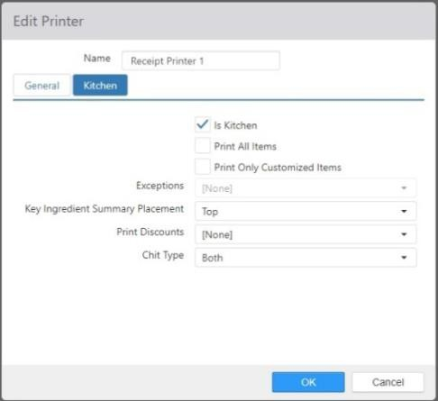

* + **Kitchen tab** (most printers): The **Kitchen** tab for most printers contains the following controls:
    - **Is Kitchen**: Can be included in printer groups.
    - **Print All Items**: All items sent are printed, including items routed to other printers.
    - **Print Only Customized Items**: Chits are printed only for items that have been customized (by adding or removing modifiers, upsizing or downsizing, etc.).

**NOTE**: This check box is only active when **Chit Type** (below) is set to **Single** or **Both**.

 **Exceptions**: When **Print Only Customized Items** is checked, this drop-down list can be used to select an item group for which all items will have chits printed, regardless of whether or not they have been customized.

* + - **Key Ingredient Summary Placement**: Prints a total count for each qualifying key ingredient summary for the sent order items.

**NOTE**: This will NOT print when **Chit Type** (see below) is set to **Single**.

* + - **Print Discounts**: Prints discount total each discount applied to the sent order items.

#### Chit Type:

 **None**: No chit is printed.

 **Summary**: One chit listing all sent order items is printed.

 **Single**: Individual chits are printed for each sent order item.

 **Both**: Both single chits and a summary chit is printed.

*Edit Printer dialog,* ***Kitchen*** *tab (Epson TM-L90)*

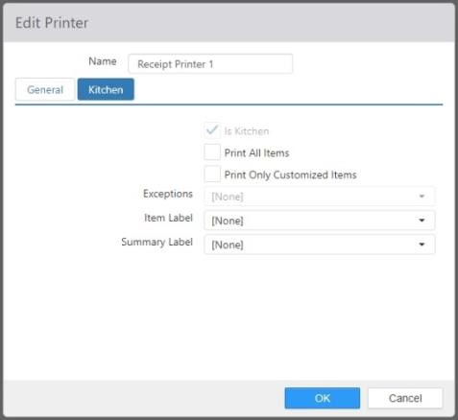

* + **Kitchen tab** (Epson TM-L90): The **Kitchen** tab for the Epson TM-L90 contains the following controls:
    - **Is Kitchen**: Can be included in printer groups.
    - **Print All Items**: All items sent are printed, including items routed to other printers.
    - **Print Only Customized Items**: Chits are printed only for items that have been customized (by adding or removing modifiers, upsizing or downsizing, etc.).

**NOTE**: This check box is only active when **Chit Type** (below) is set to **Single** or **Both**.

 **Exceptions**: When **Print Only Customized Items** is checked, this drop-down list can be used to select an item group for which all items will have chits printed, regardless of whether or not they have been customized.

* + - **Item Label**: Select an Item label from the drop-down list.
    - **Summary Label**: Select a Summary label from the drop-down list.

## Promotions

A promotion can be applied to an order to reduce, or alter, the price of order items. Promotions differ from discounts in that they can contain qualifiers, and can make use of codes.

*Edit Promotion dialog,* ***Bogo Options*** *tab*

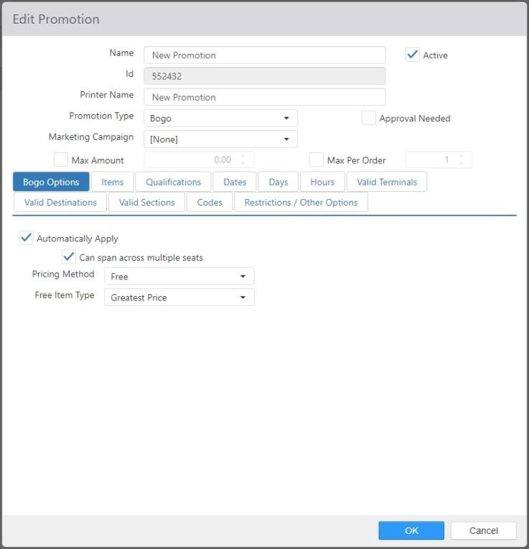

* + **Name**: Name of the promotion.
  + **Active**: Promotion can be applied to orders.
  + **Printed Name**: Name to be printed on the order receipt.

#### Promotion Type:

* + - **Bogo**: Requires one or more qualifying item be ordered along with the discounted item; order items need to be selected first. When this option is selected, the first tab is called **Bogo Options**.
    - **Combo**: This promotion type is no longer being used.
    - **Coupon**: One or more items are discounted; order items do not need to be selected first. When this option is selected, the first tab is called **Coupon Options**.
    - **Gift Card**: Reduces the price of items that are gift card issues or reloads. When this option is selected, the first tab is called **Gift Card**.
    - **Order Reduction**: One or more items are discounted; order items do not need to be selected first. When this option is selected, the first tab is called **Order Reductions Options**.
  + **Approval Needed**: Promotion can only be applied/authorized by an employee with **Security Level > Approve Promotion** enabled.
  + **Marketing Campaign**: Marketing campaign to assign to the order when the promotion is applied.
  + **Max Amount**: Maximum total dollar value of the promotion per order.
  + **Max Per Order**: Maximum number of times the promotion can be applied to a single order.
  + **Allow Prior Item Promotions**: Can be applied to order items that have already had another promotion applied.

#### Bogo Options tab:

* + - **Automatically Apply**: Automatically apply the promotion when qualifying items are ordered.

 **Can span across multiple seats**: Controls whether an automatically applied promotion should look at all items in an order (checked) or only items for a specific seat (unchecked) before being applied.

#### Pricing Method:

 **Discounted Price**: Reduce the discounted item to a specific price. Use the field below the drop-down list to enter the price.

 **Dollar Discount**: Reduce the price of the discounted item by a specific dollar amount. Use the field below the drop-down list to enter the discount amount.

 **Free**: Reduce the price of the discounted item to zero.

#### Free Item Type:

* + - * + **Greatest Price**: Highest priced item will be discounted.
        + **Lowest Price**: Lowered priced item will be discounted.

 **Percent Discount**: Reduce the price of the discounted item by a specific percentage. Use the field below the drop-down list to enter the percentage.

* + **Combo Options tab**: NO LONGER USED.

#### Coupon Options tab:

*Edit Promotion dialog,* ***Coupon Options*** *tab*

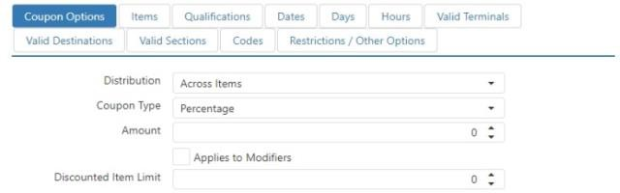

#### Distribution:

 **Across Items**: Discount amount is distributed equally across the qualifying items.

 **Each Item**: Discount amount is applied to each qualifying item.

#### Coupon Type:

 **Dollar Amount**: Order item is discounted by a specific dollar amount. Use the field below the drop-down list to enter the discount amount.

 **Percent**: Order item is discounted by a specific dollar amount. Use the field below the drop-down list to enter the percentage.

* + - **Applies to Modifiers**: Promotion applies to modifiers as well as base items.
    - **Discounted Item Limit**: Maximum number of items that can be reduced by the promotion.

#### Gift Card tab:

*Edit Promotion dialog,* ***Gift Card*** *tab*

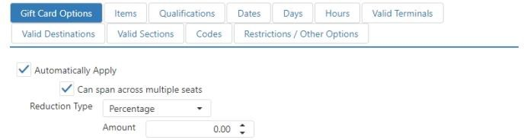

* + - **Automatically Apply**: Automatically apply the promotion when qualifying items are ordered.

 **Can span across multiple seats**: Controls whether an automatically-applied promotion should look at all items in an order (checked) or only items for a specific seat (unchecked) before being applied.

#### Reduction Type :

 **Amount**: Gift card item is discounted a specific dollar amount. Use the field below the drop-down list to enter the discount amount.

 **New Price**: Gift card item price is set to a specific amount. Use the field below the drop-down list to enter the price.

 **Percent**: Gift card item is discounted a specific percentage of its current price.

Use the field below the drop-down list to enter the percentage.

#### Order Reductions Options tab:

*Edit Promotion dialog,* ***Order Reductions Options*** *tab*

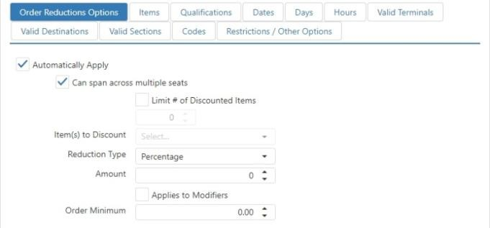

* + - **Automatically Apply**: Automatically apply the promotion when qualifying items are ordered.

 **Can span across multiple seats**: Controls whether an automatically applied promotion should look at all items in an order (checked) or only items for a specific seat (unchecked) before being applied.

* + - **Limit # of Discounted Items**: Maximum number of items that can be reduced by the promotion.

#### Item(s) to Discount:

* + - * **Greatest Price**: Highest priced item will be discounted.
      * **Lowest Price**: Lowered priced item will be discounted.

#### Reduction Type:

 **Amount**: Item is discounted a specific dollar amount. Use the field below the drop-down list to enter the discount amount.

 **New Individual Price**: Item price is set to a specific amount. Use the field below the drop-down list to enter the price.

**New Total Price**: Total order price is set to a specific amount. Use the field below the drop-down list to enter the price.

**NOTE**: This setting is best used along with promotion qualifications, as set on the **Qualifications** tab.

**Percentage**: Gift card item is discounted a specific percentage of its current price. Use the field below the drop-down list to enter the percentage.

* + - **Applies to Modifiers**: Promotion applies to modifiers as well as base items.
    - **Order Minimum**: Minimum order subtotal required before any items qualify.

#### Items Tab:

*Edit Promotion dialog,* ***Items*** *tab*

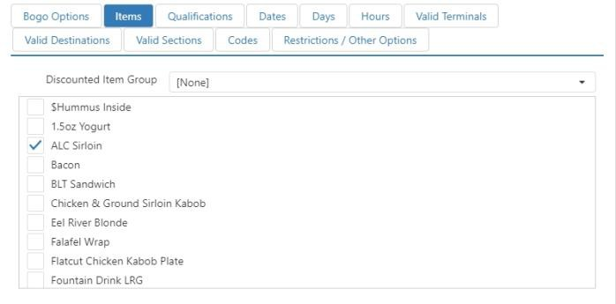

* + - **Discounted Item Group**: Item group containing the items that qualify. If left as **[None]**, then only the items selected in **Discounted Items** qualify for the promotion.
    - **Discounted Items**: Checked items qualify for the promotion.

#### Qualifications tab:

*Edit Promotion dialog,* ***Qualifications*** *tab*

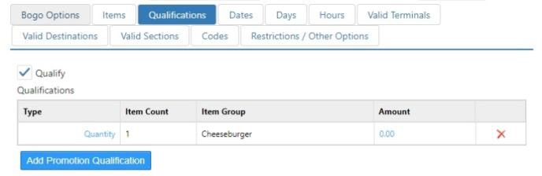

* + - **Qualify**: Additional items must be ordered before the qualifying item can be discounted.

#### Type:

 **Amount**: Additional qualifying items must exceed a specific dollar amount.

 **Quantity**: A specific number of additional qualifying items must be ordered.

* + - **Item Count**: The number of individual items that qualify for the promotion.
    - **Item Group**: Item group containing the additional qualifying items.
    - **Amount**: Dollar amount or count that must be satisfied.
    - **‘Add’ button**: Opens the *Add* dialog.

*Add dialog*

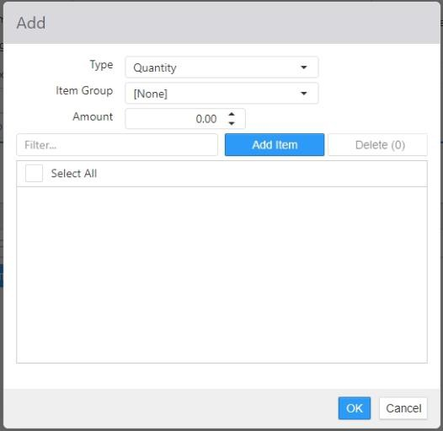

 **Type**:

* + - * **Amount**: Additional qualifying items must exceed a specific dollar amount.
      * **Quantity**: A specific number of additional qualifying items must be ordered.

 **Item Group**: Item group containing the additional qualifying items. If left at **[None]**, then only items in the right pane of the item list count as qualifying items.

 **Amount**: Dollar amount or count that must be satisfied.



#### Dates tab:

**Item list**: Items in the right pane count as qualifying items.

*Edit Promotion dialog,* ***Dates*** *tab*

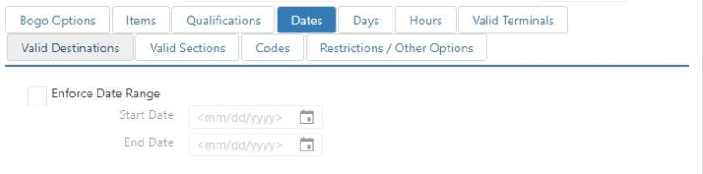

* + - **Enforce Date Range**: Promotion can only be applied within the specified date range, set using the **StartDate** and **EndDate** fields.

#### Days tab:

*Edit Promotion dialog,* ***Days*** *tab*

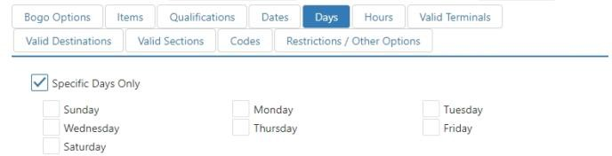

* + - **Enforce Days**: Promotion can only be applied on the checked days of the week.

#### Hours tab:

*Edit Promotion dialog,* ***Hours*** *tab*

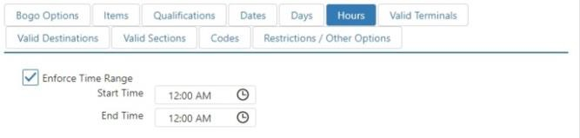

* + - **Enforce Time Range**: Promotion can only be applied within the specified time period, set using the **StartTime** and **EndTime** fields.

#### Valid Terminals tab:

*Edit Promotion dialog,* ***Valid Terminals*** *tab*

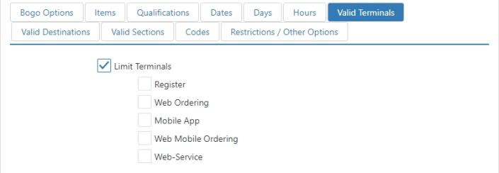

* + - **Limit Terminals**: Promotion can only be applied on the checked terminal types.

#### Valid Destinations tab:

*Edit Promotion dialog,* ***Valid Destinations*** *tab*

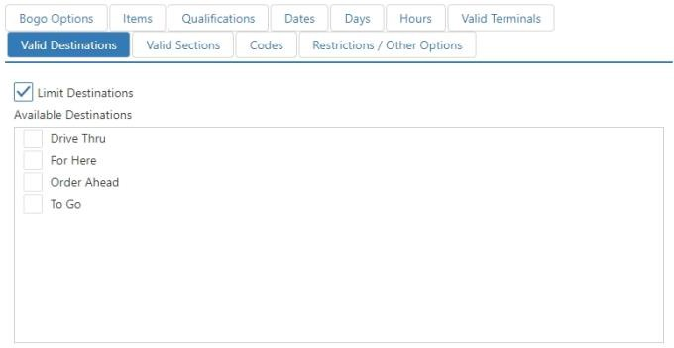

* + - **Limit Destinations**: Promotion can only be applied to orders of the selected destination.

#### Valid Sections tab:

*Edit Promotion dialog,* ***Valid Sections*** *tab*

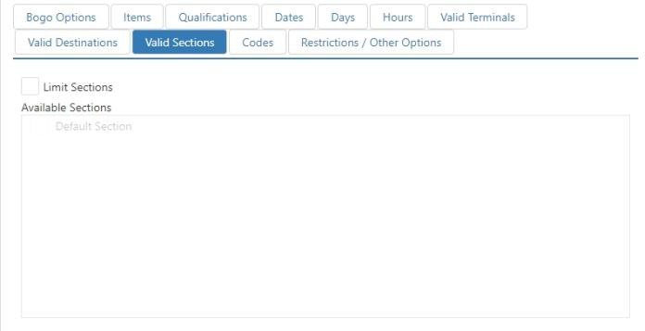

* + - **Limit Sections**: Promotion can only be applied when the order is in any of the checked sections.

#### Codes tab:

*Edit Promotion dialog,* ***Codes*** *tab*

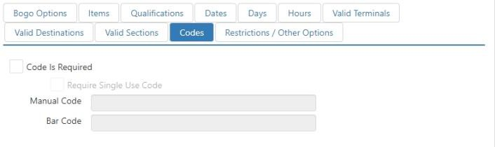

* + - **Code Is Required**: Promotion can only be applied be entering or scanning a code.
    - **Require Single Use Code**: Promotion can only be applied by using a single use promotion code. Single use promotion codes are to be sent to [support@brinksoftware.com](mailto:support@brinksoftware.com) to be loaded.

 **Manual Code**: Code that can be manually entered to apply the promotion when not using single use codes.

 **Bar Code**: Bar code value that can be scanned to apply the promotion when not using single use codes.

#### Restrictions / Other Options tab:

*Edit Promotion dialog,* ***Restrictions / Other Options*** *tab*

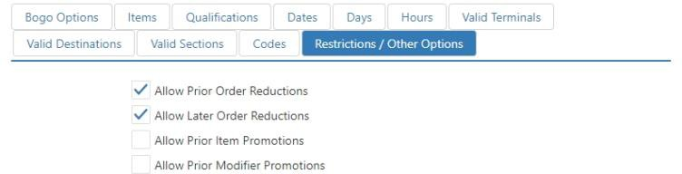

* + - **Allow Prior Order Reductions**: The promotion can be applied to orders that already have a promotion or discount applied to them.
    - **Allow Later Order Reductions**: Other promotions and discounts can be applied to orders that already have this promotion applied to them.
    - **Allow Prior Item Promotions**: This promotion can be applied to items that already have a promotion applied to them.
    - **Allow Prior Modifier Promotions**: This promotion can be applied to modifiers that already have a promotion applied to them.

## Refund Reasons

Refund reasons are listed for the employee to choose when the ‘Refund’ button behavior is executed.

*Refund Reasons list (example)*

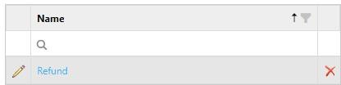

To add a new refund reason, click **Add**. To edit an existing refund reason, click its name in the list.

*Edit Refund Reason dialog*

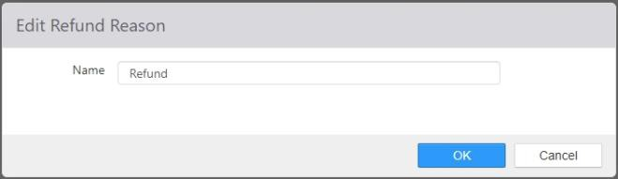

* + **Name**: Name of the refund reason.

## Registers

Registers are the physical terminals or tablets running the Register application.

*Edit Register dialog,* ***Options*** *tab*

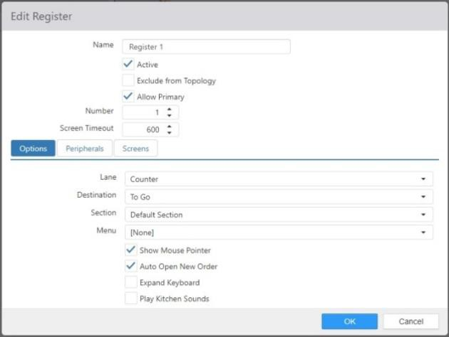

* + **Name**: Name of the register.
  + **Active**: Register application can run on terminal.
  + **Allow Primary**: If this register is configured as a secondary register, allow the system to make it the primary register if the configured primary register goes offline.
  + **Number**: Terminal number to be entered into the Register.cfg file.
  + **Screen Timeout**: Number of seconds with no activity before the Register application automatically logs out the current employee and returns to the login screen.

#### Options tab:

* + - **Lane**: Default lane to display, can be overridden by **Job > Lane**.
    - **Destination**: Destination of new orders created on register.
    - **Section**: Section of new orders created on register.
    - **Menu**: Default menu to display, can be overridden by **Job > Menus**.
    - **Show Mouse Pointer**: Displays the Windows mouse pointer within the Register application.
    - **Auto Open New Order**: Automatically created a new order in the current lane when employee logs in.
    - **Expand Keyboard**: Increases the size of the displayed keyboard for easier use.
    - **Play Kitchen Sounds**: Plays sounds on the register that are configured to play on kitchen displays. See Sounds and Kitchen Displays for more information.
    - **Screen Saver Image**: Image to display when the register is idle and no employee is logged in.

#### Peripherals tab:

*Edit Register dialog,* ***Peripherals*** *tab*

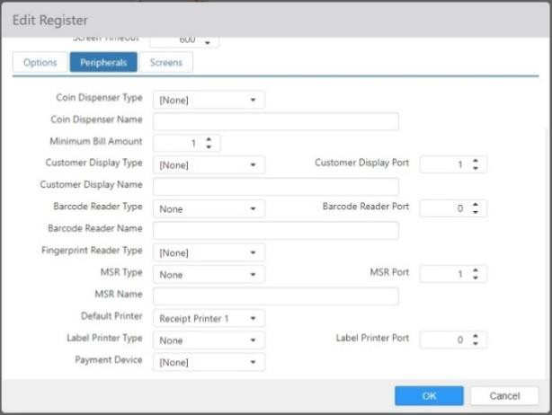

* + - **Coin Dispenser Type**: Interface type of the coin dispenser connected to the terminal.
    - **Coin Dispenser Name**: LDN of the coin dispenser defined in the device’s OPOS drivers.
    - **Minimum Bill Amount** (Canadian T-Flex only): Any change below the indicated denomination will not be given in bills, and therefore $1 and $2 coins will be dispensed for amounts lower than the setting. Maximum setting is **100**.
    - **Customer Display Type**: Interface type of the customer-facing VFD 2-line display connected to the terminal.
    - **Customer Display Port**: COM port the device is connected to.
    - **Customer Display Name**: LDN defined in the device’s OPOS drivers.
    - **Barcode Reader Type**: Interface of the barcode scanner connected to the terminal.
    - **Barcode Reader Port**: COM port the device is connected to.
    - **Barcode Reader Name**: LDN defined in the device’s OPOS drivers.
    - **Finger Scan Reader Type**: Brand and model of the biometric finger scanner connected to the terminal.
    - **MSR Type**: Interface type of the magnetic card reader connected to the terminal.
    - **MSR Port**: COM port the device is connected to.
    - **MSR Name**: LDN defined in the device’s OPOS drivers.
    - **Default Printer**: Printer to print all local print jobs to, such as order receipts and clock in/out chits.
    - **Label Printer Type**: Interface type of the label printer connected to the terminal for printing item SKU labels.
    - **Label Printer Port**: COM port the device is connected to.
    - **Payment Device**: Payment device to communicate with when the ‘Payment Device’ button behavior is executed.

#### Screens tab:

Edit Register dialog, Screens tab

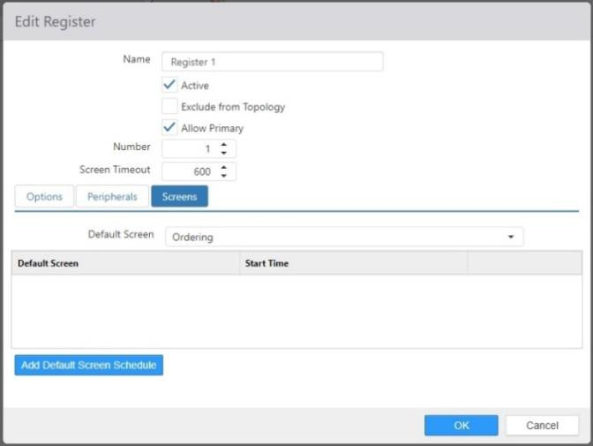

* + - **Default Screen**: Use the drop-down list to select the screen that displays when an employee logs in to the register. Can be overridden by **Jobs** **> Screens** settings.
    - **Default Screen list**: Displays screens that are configured to be displayed starting at certain times of day (for example, a breakfast screen starting at 6:00 a.m. or a dinner screen starting at 4:00 p.m.). Click the ‘Add’ button to add a screen override setting.

*Add default screen override dialog*

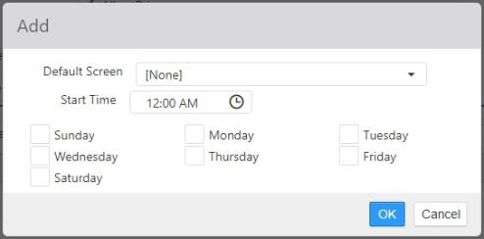

 **Default Screen:** Use the drop-down list to select the screen to be displayed.

Screens are configured on the Screens page.

 **Start Time:** The time of day to begin displaying the selected **Default Screen**.

 **Days:** The days of the week to display the selected **Default Screen** at the indicated **Start Time**.

## Revenue Centers

Revenue centers group items for reporting purposes and taxation; each item can only belong to a single revenue center.

*Edit Revenue Center dialog,* ***Taxes*** *tab*

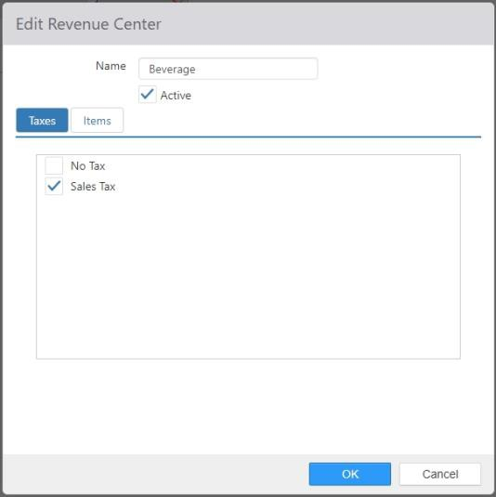

* + **Name**: Name of the revenue center.
  + **Active**: NO LONGER USED.
  + **Taxes tab**: Taxes to be applied to items contained within the revenue center.
  + **Items tab**: Items contained within the revenue center.

*Edit Revenue Center dialog,* ***Items*** *tab*

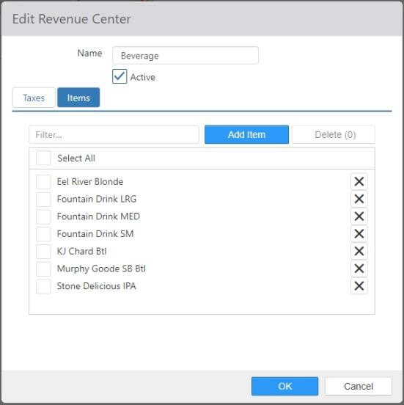

## Scales

Scales are the weigh scale peripherals connected to the POS system.

*Edit Scale dialog*

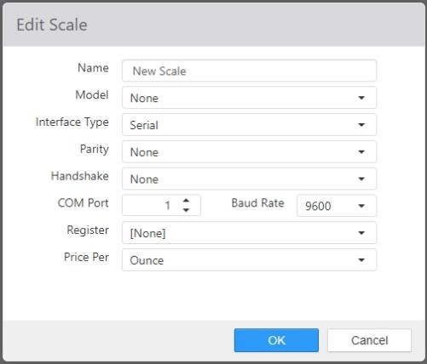

* + **Name**: Name of the scale.
  + **Model**: Brand and model of the scale.
  + **Interface Type**: Interface type of the scale.
  + **Parity**: Parity set on the scale.
  + **Handshake**: Handshake set on the scale.
  + **COM Port**: COM port number the scale is connected to.
  + **Baud Rate**: Baud rate set on the scale.
  + **Register**: The terminal the scale is physically connected to.

## Scheduled Events

Scheduled events are system processes that run at a given time of day.

*Edit Scheduled Event dialog*

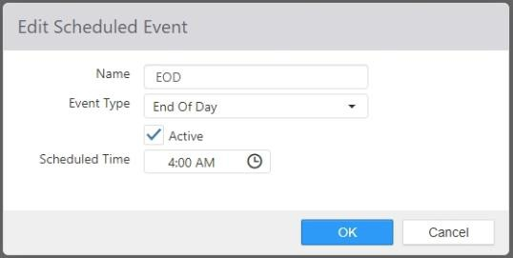

* + **Name**: Name of the scheduled event.

#### Event Type:

* + - **End of Day**: Run the end of day process.

**NOTE**: Currently, the only event type supported is **End of Day**.

* + **Active**: Scheduled event will be triggered.
  + **Scheduled Time**: Local time of day the event is to be fired.

## Screens

A screen is a collection of panels to be displayed when the screen is shown.

*Edit Screen dialog*

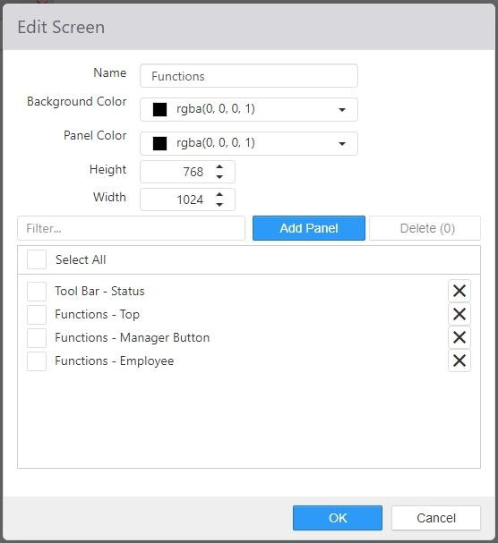

* + **Name**: Name of the screen.
  + **Background Color**: Background color of the screen.
  + **Panel Color**: Default background color for panels displayed within the screen.
  + **Width**: Width of the screen.
  + **Height**: Height of the screen.
  + **Selected Panels**: Panels to be displayed when the screen is shown.

## Script Functions

Script functions are VB Script functions that can be called via the ‘Execute Script’ button behavior. See

*Brink POS Register Scripting* for more details of the scripting environment on Brink POS.

*Edit Script Function dialog*

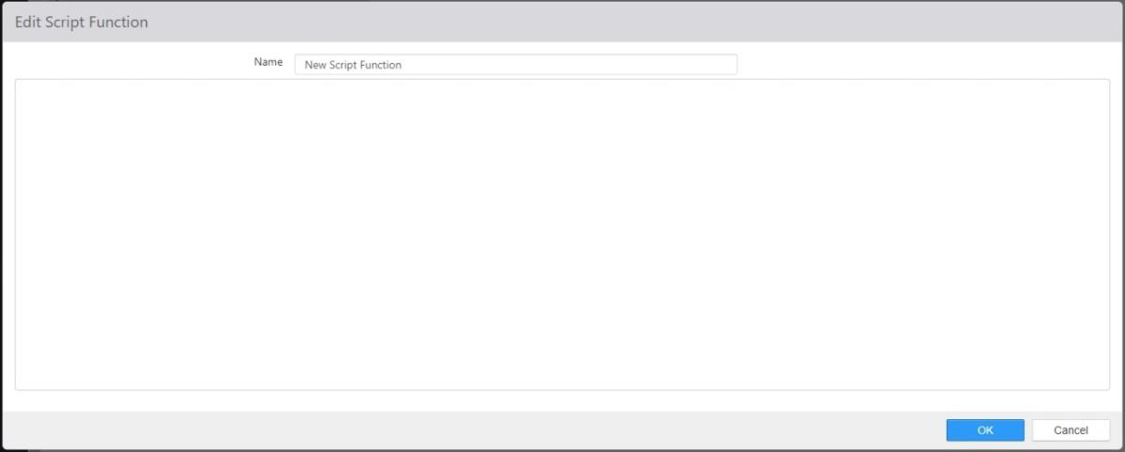

## Sections

Sections are used for groupings of tables.

*Edit Sections dialog,* ***Tables*** *tab*

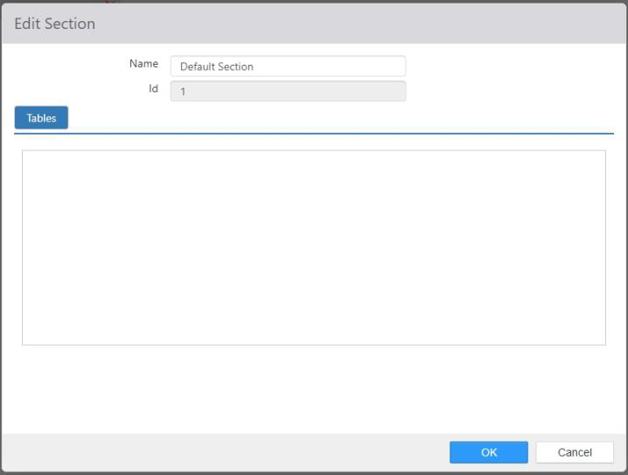

* + **Name**: Name of the section
  + **Tables**: Tables contained within the section.

## Security Levels

Security levels control the functions that an employee can perform on the Register.

*Edit Security Level,* ***Options*** *tab*

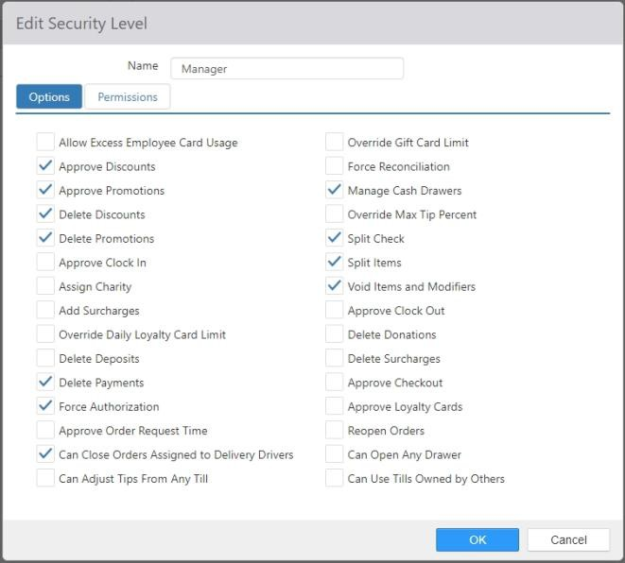

* + **Name**: Name of the security level.

#### Options tab:

* + - **Allow Excess Employee Card Usage**: Employee can authorize employee discounts amounts that exceed those defined for the receiving employee.
    - **Approve Discounts**: Employee can apply discounts via the ‘Discount’ button behavior

that have **Requires Approval** enabled.

* + - **Approve Promotions**: Employee can apply promotions via the ‘Promotion’ button

behavior that have **Requires Approval** enabled.

* + - **Assign Menu**: NO LONGER USED.
    - **Delete Discounts**: Employee can delete discounts from any order.
    - **Delete Promotions**: Employee can delete discounts from any order.
    - **Approve Clock In**: Employee can authorize employees to clock in who’s job has **Requires Approval to Clock In** enabled, or the current time is outside of the allowable time

variance for the employee’s scheduled shift or break.

* + - **Assign Charity**: Employee can execute the ‘Assign Charity’ button behavior.
    - **Add Surcharge**: Employee can execute the ‘Surcharge’ button behavior.
    - **Override Daily Loyalty Card Limit**: Employee can authorize assignment of customers to orders where the customer exceeds the **Daily Card Use Limit** defined at **Options > Loyalty**.
    - **Delete Deposits**: Employee can delete deposits on future date orders.
    - **Delete Payments**: Employee can delete payments applied to any order.
    - **Force Authorization**: Employee is able to select the **Voice** button on the ‘Credit Card’ payment dialog, used for offline credit authorizations.
    - **Approve Order Request Time**: Employee can authorize future order request times that are outside of business hours defined at **Options > Location**.
    - **Can Close Orders Assigned to Delivery Drivers**: Employee can close open orders that are assigned to employees clocked in under a job that has Delivery Driver enabled.
    - **Can Adjust Tips from Any Till**: Employee has access to all credit transactions via the

‘Adjust Tips’ screen, rather than just the transactions processed on the till they currently

have access to.

* + - **Force Reconciliation**: Employee can authorize checkout when the declared cash amount is outside of the allowable variance.
    - **Manage Cash Drawers**: Employee can execute the ‘Manage Cash Drawers’ button

behavior.

* + - **Override Max Tip Percent**: Employee can authorize tip adjustments that are greater than the allowable amount defined on the tender.
    - **Split Check**: Employee can execute the ‘Split Order’ button behavior.
    - **Split Items**: Employee can split items from the ‘Split Order’ screen.
    - **Void Items**: Employee can delete sent items from any order.
    - **Approve Clock Out**: Employee can authorize employees to clock in whose job has **Requires Approval to Clock Out** enabled, or the current time is outside of the allowable time variance for the employee’s scheduled shift or break.
    - **Delete Donations**: Employee can delete charities assigned to any order.
    - **Delete Surcharges**: Employee can delete surcharges from any order.
    - **Approve Checkout**: Employee can authorize employees, whose job has **Requires Approval to Checkout** enabled, to execute the ‘Checkout’ button behavior.
    - **Approve Loyalty Cards**: Employee can create new customers with a loyalty card that has

’Approval Needed’ enabled.

* + - **Reopen Orders**: Employee can reopen orders via the ‘Recall Order’ screen, or by executing the ‘Reopen Order’ button behavior.
    - **Can Open Any Drawer**: Employee can execute the ‘Open Cash Drawer’ button behavior

for any cash drawer that is not public and they are not assigned to.

* + - **Can Use Tills Owned by Others**: Employee can process transactions against tills assigned to other employees.

 **Can Process Payments**: The employee can process payments on tills assigned to other employees.

* + **Permissions tab**: Permissions granted to employees logged in under the security level. Permissions are defined on the **Permissions** page (see Permissions). You can assign the permissions to security levels either here or in the *Edit Permission* dialog. Changing it in one place automatically changes it in the other.

*Edit Security Level dialog,* ***Permissions*** *tab*

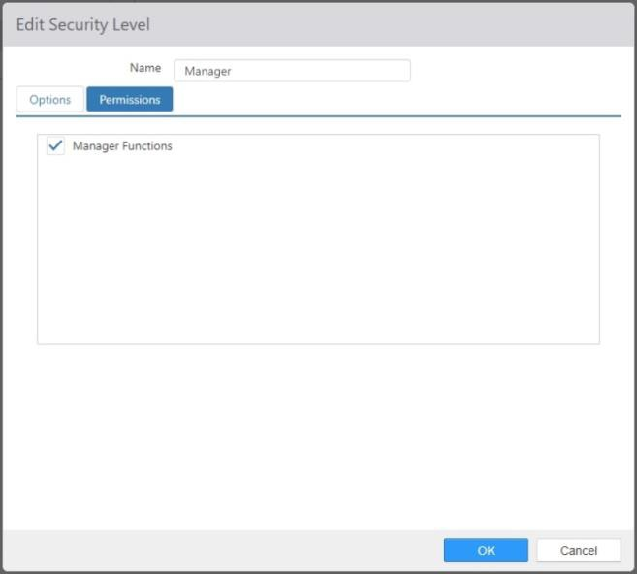

## Shift End Reasons

Shift edit reasons are presented when a shift is edited on either the Register or the Admin Portal.

*Edit Shift End Reason dialog*

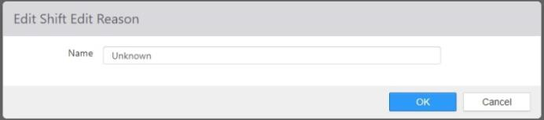

* + **Name**: Name of the shift edit reason.

## Smart Groups

Smart groups are used in conjunction with the ‘Smart Select’ and ‘Smart Item’ button behaviors, which allow for order items through a reduced number of buttons.

*Edit Smart Group dialog*

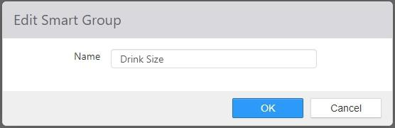

* + **Name**: Name of the smart group.
  + **Active**: NO LONGER USED.

## Sounds

Sound files can be uploaded to be played from kitchen displays when a new order is sent to an empty kitchen queue.

*Add Sound dialog*

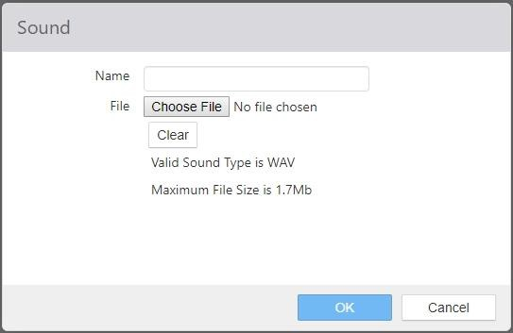

* + **Name**: The name of the sound file. This should be descriptive so that it is easy to find later.
  + **Clear** button to erase all text from this field.

## Surcharges

Surcharges are additional fees that can be applied to an order and are excluded from reported sales.

*Edit Surcharge dialog,* ***Party Size*** *tab*

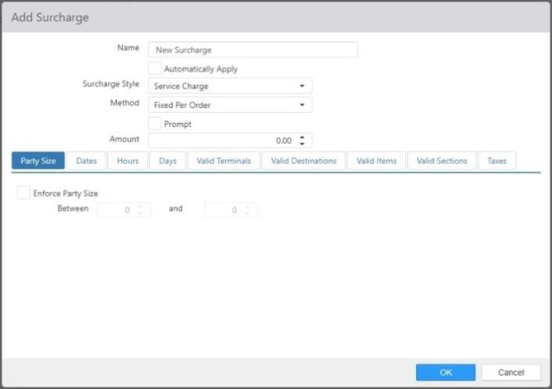

* + **Name**: Name of the surcharge.
  + **Automatically Apply**: Surcharge is automatically applied to qualifying orders.

#### Surcharge Style:

* + - **Gratuity**: Surcharge is considered to be paid in cash to the employee that owns that order, accounted for similar to tips.
    - **Service Charge**: Surcharge is considered to be retained by the restaurant.

#### Method:

* + - **Fixed Per Order**: Amount is a fixed dollar applied amount per order, regardless of the order items.
    - **Fixed Per Item**: Amount is a fixed dollar amount applied for each qualifying item.
    - **Percentage Per Order**: Amount is a fixed percentage of the sub-total per order, regardless of the order items.
    - **Percentage Per Item**: Amount is a fixed percentage of the item price applied for each qualifying item.
  + **Prompt**: Prompt employee to enter amount when surcharge is applied.
  + **Amount**: Dollar amount or percent of order sub-total to be applied. Percentage can be any rational number between .01 and 100, inclusive.
  + **Party Size tab**: When **Enforce Party Size** is checked, the surcharge can only be applied when the guest count is within the given range.
  + **Dates tab**: When **Enforce Date Ranges** is checked, the surcharge can only be applied when the date is within the given range, as defined by **StartDate** and **EndDate**.

*Edit Surcharge dialog,* ***Dates*** *tab*

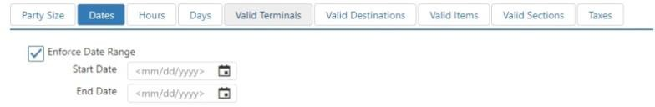

* + **Hours tab**: When **Enforce Time Range** is checked, the surcharge can only be applied during certain times of day, as defined by **StartTime** and **EndTime**.

*Edit Surcharge dialog,* ***Hours*** *tab*

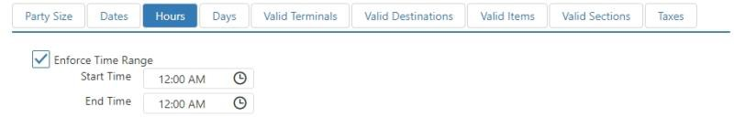

* + **Days tab**: When **Enforce Days** is checked, the surcharge can only be applied on the checked days of the week.

*Edit Surcharge dialog,* ***Days*** *tab*

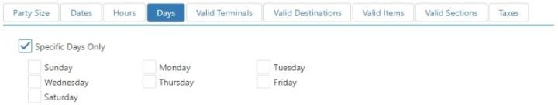

* + **Valid Terminals tab**: When **Limit Terminals** is checked, the surcharge can only be applied on the selected terminals.

*Edit Surcharge dialog,* ***Valid Terminals*** *tab*

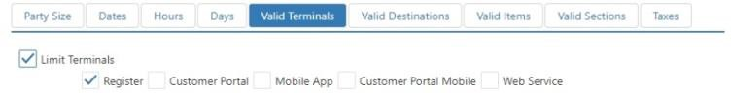

* + **Valid Destinations tab**: When **Limit Destinations** is checked, the surcharge can only be applied to the selected destinations.

*Edit Surcharge dialog,* ***Valid Destinations*** *tab*

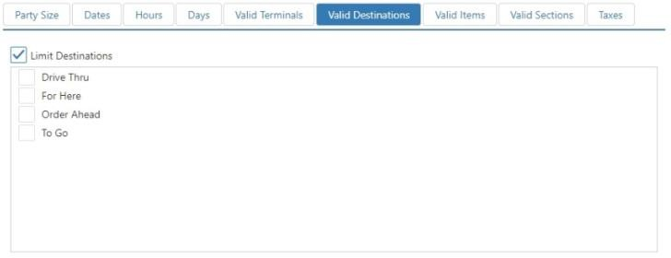

* + **Valid Items tab**: When **Valid When Items Ordered** is checked, the surcharge can only be applied to orders that contain one of the items listed in *Selected Items*. You can also choose to **Exclude Modifiers** and **Exclude Zero Priced Items**.

*Edit Surcharge dialog,* ***Valid Items*** *tab*

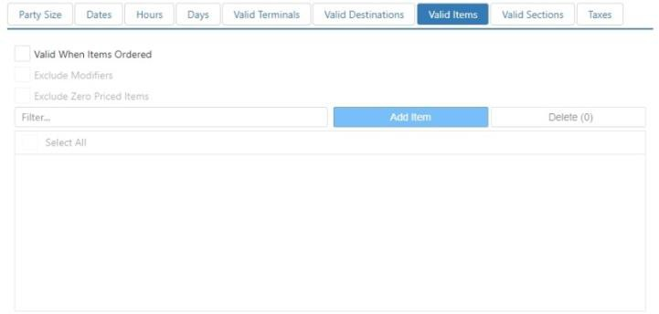

* + **Valid Section tab**: When **Limit Sections** is checked, the surcharge can only be applied to the selected sections.

*Edit Surcharge dialog,* ***Valid Sections*** *tab*

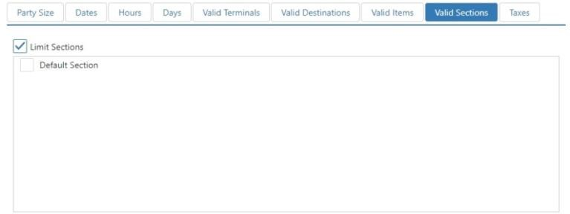

* + **Taxes**: Taxes to be applied to the surcharge.

*Edit Surcharge dialog,* ***Taxes*** *tab*

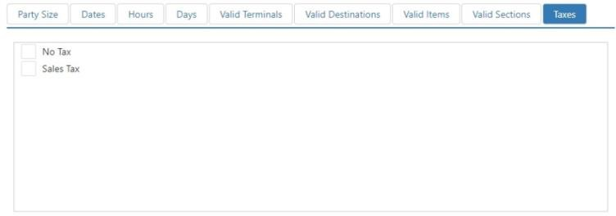

## Survey Question Groups

Survey question groups are used to group multiple survey questions into a single question to the respondent.

*Edit Survey Question Group dialog*

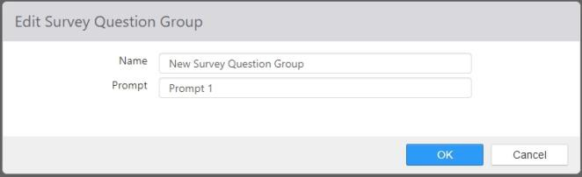

* + **Name**: Name of the survey question group.
  + **Prompt**: Text to be displayed for survey questions that are grouped together.

## Survey Questions

Survey questions define the question type and options presented to survey respondents.

*Edit Survey Question dialog with* ***Select Multiple*** *selected for* ***Input Type***

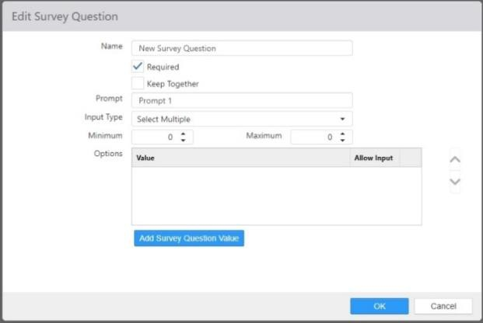

* + **Name**: Name of the survey question.
  + **Required**: Respondent is required to provide a response to the question.
  + **Keep Together**: Do not separate onto a new page this question from the previous question on the survey.
  + **Prompt**: Question text or prompt displayed on the survey.

#### Input Type:

* + - **Select Multiple**: The respondent can select multiple answers in a list.  **Minimum**: Minimum number of answers that can be selected.  **Maximum**: Maximum number of answers that can be selected.

*Edit Survey Question dialog with* ***Select Single*** *selected for* ***Input Type***

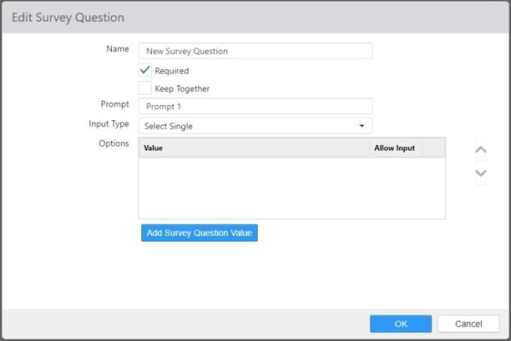

* + - **Select Single**: The respondent can only select one answer from a list.

*Edit Survey Question dialog with* ***Single-Line Text*** *selected for* ***Input Type***

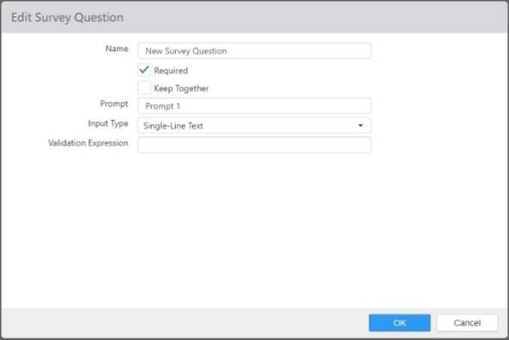

* + - **Single-Line Text**: The respondent can enter a line of text.

 **Validation Express**: Regular expression to be used to valid the response.

*Edit Survey Question dialog with* ***Multi-Line Text*** *selected for* ***Input Type***

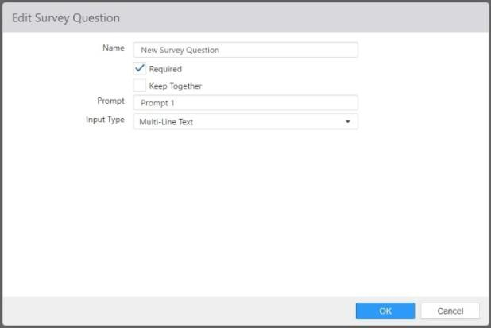

* + - **Multi-Line Text**: The respondent can enter a multi-line text response.

*Edit Survey Question dialog with* ***Rating*** *selected for* ***Input Type***

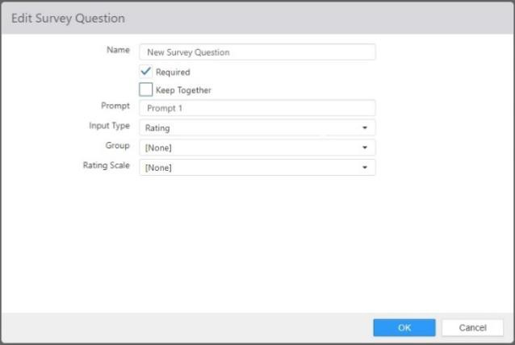

* + - **Rating**: The respondent can rate items using a scale.

 **Group**: Survey question group that identifies sequential questions that are to be presented as a single question.

 **Rate Scale**: Rating scale that defines the possible answers.

*Edit Survey Question dialog with* ***Drop Down List*** *selected for* ***Input Type***

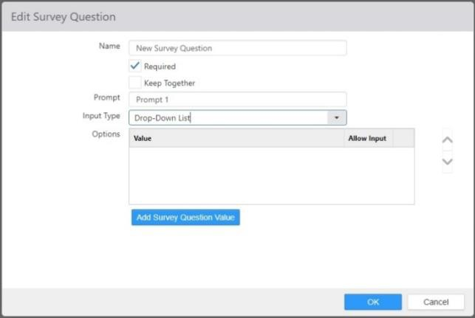

* + - **Drop Down List**: The respondent can select a response from a drop-down list.

*Edit Survey Question dialog with* ***Date*** *selected for* ***Input Type***

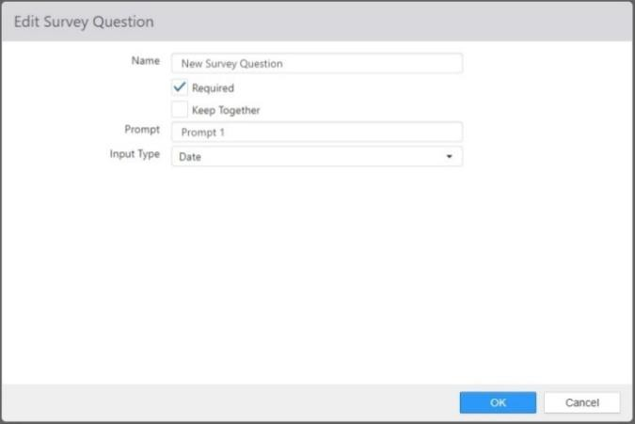

* + - **Date**: The respondent can enter a valid date expression.

## Survey Rating Scales

Survey rating scales define a predefined set of single answer options to assign to a survey question.

*Edit Survey Rating Scale dialog*

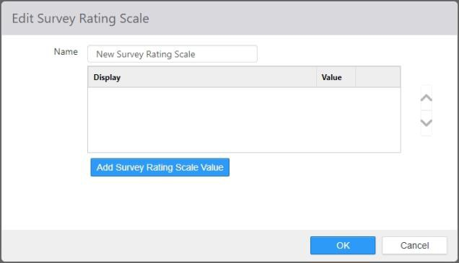

* + **Name**: Name of the survey rating scale

#### Options:

* + - **Display**: Text to display to the survey respondent.
    - **Value**: Numeric value assigned to the answer for the purpose of reporting averages.

## Surveys

Surveys are a mechanism for collecting customer feedback via the Customer Portal.

*Edit Survey dialog,* ***Instructions*** *tab*

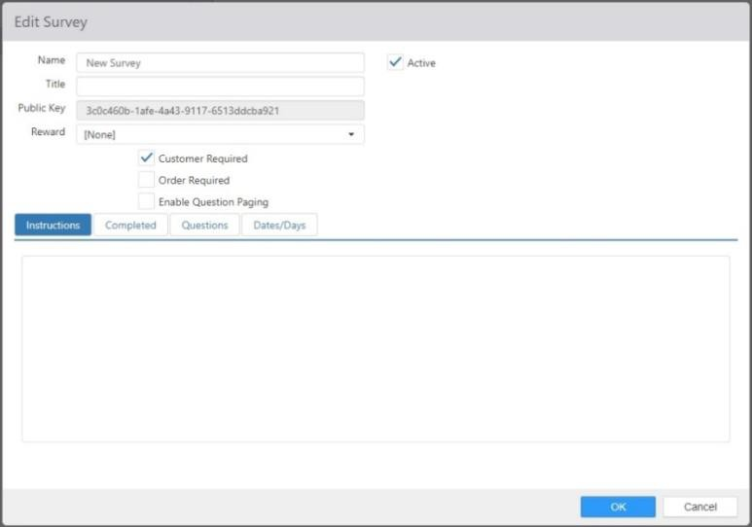

* + **Name**: Name of the survey.
  + **Active**: Survey respondents can submit survey responses.
  + **Title**: Title to be displayed at the top of the survey.
  + **Public Key**: Survey identifier to be passed to the survey via the query string parameter of key.
  + **Reward**: Reward to be issued to the customer after completing the survey.
  + **Customer Required**: Customer must be associated with the survey, either by the customer being logged into their account or by passing the Customer Id value in the query string as parameter cid.
  + **Order Required**: Survey must be associated with an order, either by the respondent enter Order Id and Order Total or by these values being passed as query string parameters of oid and ot.
  + **Enable Question Paging**: Displays paging button for the responded to advance to the next question.
  + **Instructions tab**: Message to be displayed at the top of the survey.
  + **Completed tab**: Message to be displayed after the survey has been completed.

*Edit Survey dialog,* ***Completed*** *tab*

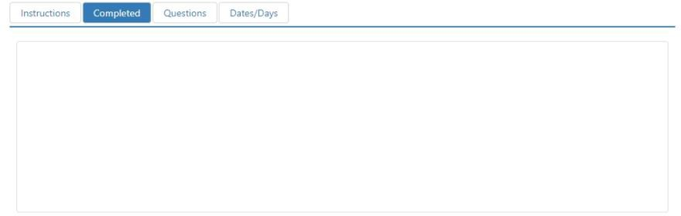

* + **Questions**: List of questions to be displayed on the survey.

*Edit Survey dialog,* ***Questions*** *tab*

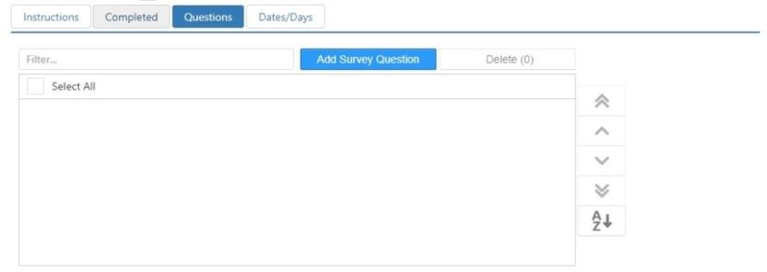

#### Dates/Days tab:

*Edit Survey dialog,* ***Dates/Days*** *tab*

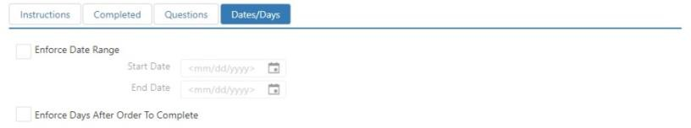

* + - **Date Range**: Date range during which the survey can be completed, as defined by **Start Date** and **End Date**.
    - **Days After Order to Complete**: When **Order Required** is enabled, the number of days

after the order’s business date that the survey can be completed.

## Tables

Tables define the properties of physical tables in the restaurant, which are represented by the Table control.

*Edit Table dialog*

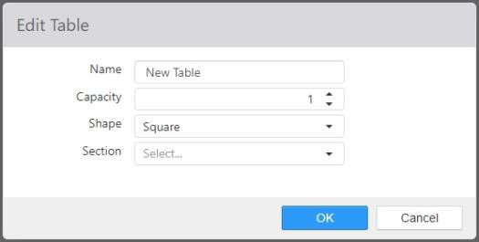

* + **Name**: Name of the table.
  + **Capacity**: The number of seats to display on the Table control, and the default guest count when the table is opened.
  + **Shape**: Shape of the Table control.
  + **Section**: Section assigned to new orders on parties assigned to the table.

## Tares

Tares are weight allowances for the packaging of weighed order items, such as a plate or cup.

*Edit Tare dialog*

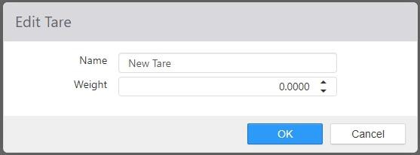

* + **Name**: Name of the tare.
  + **Weight**: Weight of the tare, measurement type is determined by the Price Per setting on the measured item.

## Taxes

Taxes are defined for calculating and collection of sales taxes.

*Edit Tax dialog,* ***Applies To*** *tab*

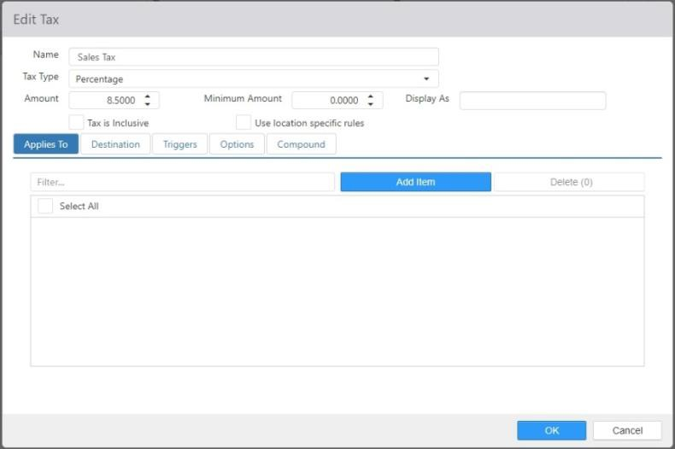

* + **Name**: Name of the tax.

#### Tax Type:

* + - **Percent**: Percent of the qualifying order item’s price.
    - **Flat Fee**: Fixed dollar amount per order.
  + **Amount**: Percent or dollar amount to be applied, depending on the Tax Type.
  + **Minimum Amount**: Minimum amount to be applied per qualifying order.
  + **Display As**: An alternative name that prints on the receipt.

**NOTE**: If multiple taxes are given the same Display As name, they will be combined on receipts.

* + **Tax is Inclusive**: When checked, tax is included in price of item.
  + **Use location specific rules**: Which checked, Brink POS uses embedded, location-specific tax tables.

**NOTE**: This feature is currently only for use in Florida locations.

* + **Applies To tab**: Items in the *Selected Items* list will have this tax applied to them.
  + **Destinations tab**: When **Limit Destinations** is checked, the tax only applies to the selected destinations.

*Edit Tax dialog,* ***Destination*** *tab*

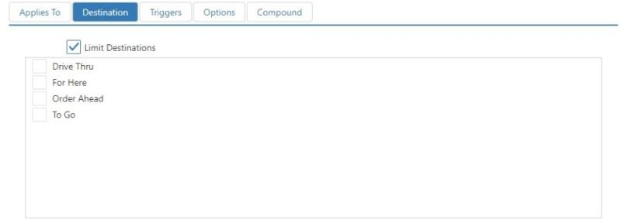

* + **Triggers tab**: Modifiers in the *Selected Items* list will result in the tax being applied to the root item.

*Edit Tax dialog,* ***Triggers*** *tab*

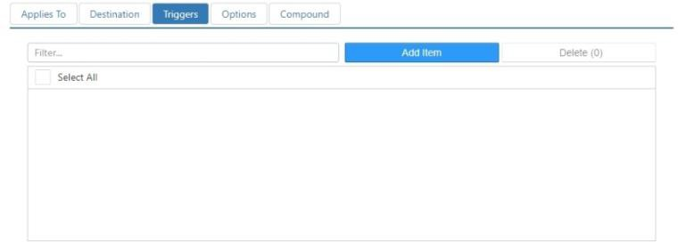

#### Options Tab:

*Edit Tax dialog,* ***Options*** *tab*

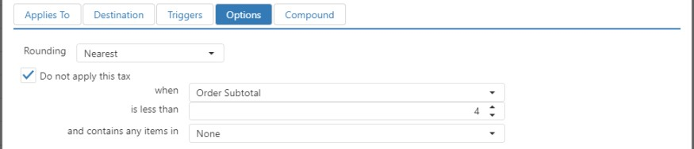

* + - **Rounding**: Select how taxes will be rounded when a calculation results in fractional cents.

 **Up**: Rounds up to the next higher cent.

 **Down**: Rounds down to the next lower cent.

 **Nearest**: Rounds to the nearest cent.

 **Bracket**: Selecting Bracket displays two lists: Non-Repeating and Repeating.

* + - **Do not apply this tax:** Check the check box if you want to exclude the tax based on an Order Total or Order Subtotal amount.

 **when:** Choose Order Total or Order Subtotal.

 **is less than:** Choose the [$ amount] value.

 **and only contains any items in**: Choose certain items up to a given price from having the tax applied.

*Edit Tax dialog,* ***Options*** *tab,* ***Rounding*** *method* ***Bracket***

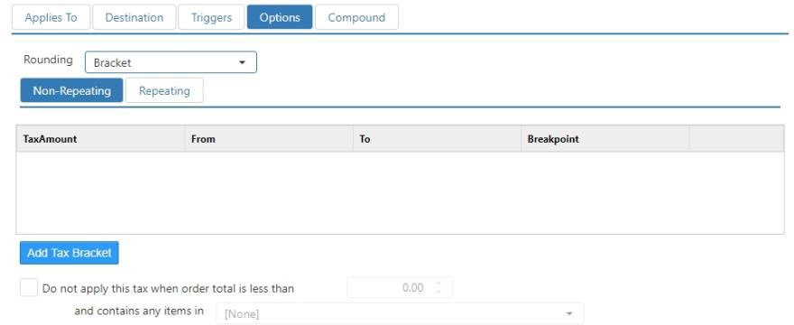

* + - * **Non-Repeating**: For rows where the intervals are not repeated, such as for the first dollar, where the taxation rate often includes a point below which no tax is charged.

**NOTE**: No matter how many rows are entered on the **Non-Repeating** sub-tab, the system does not use those values to extrapolate any additional taxable order totals. Therefore, if rows are only entered on the **Non-Repeating** sub-tab, then the maximum tax calculated will be the value in the lowest row.

* + - * **Repeating**: For establishing a pattern of tax brackets. When you enter a number of rows in the **Repeating** sub-tab to establish the pattern, the system extrapolates based on the established pattern for values above what is entered.

**NOTE**: It is recommended that ten or more rows be added on the **Repeating** sub-tab so that the system can accurately repeat the pattern for all order totals.

* + - * **‘Add’ button**: Inserts a row in either the **Non-Repeating** or **Repeating**

list.

* + - * + **Tax Amount**: The amount of tax charged.
        + **From**: The lowest order total for which the **Tax Amount** is charged.
        + **To**: The highest order total for which the **Tax Amount** is charged.
        + **Breakpoint**: The number of cents between **From** and **To**, inclusive.
    - **Do not apply this tax:** Check the check box if you want to exclude the tax based on an Order Total amount.

 **is less than:** Choose the [$ amount] value.



#### Compound tab:

**and only contains any items in**: Choose certain items up to a given price from having the tax applied.

*Edit Tax dialog,* ***Compound*** *tab*

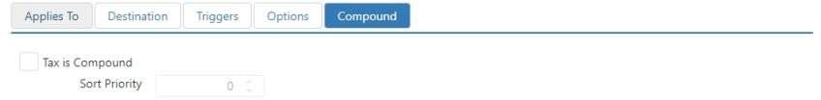

* **Tax is Compound**: When this box is checked, the tax is considered to be compound.
* **Sort Priority**: The order in which compound taxes are applied. The lowest priority is applied first.

## Tenders

**NOTE**: For compound taxes to work, two or more taxes must be created with the **Tax is Compound** check box checked and a **Sort Priority** set for each.

Tenders define the form of payment applied to an order.

*Edit Tender dialog*

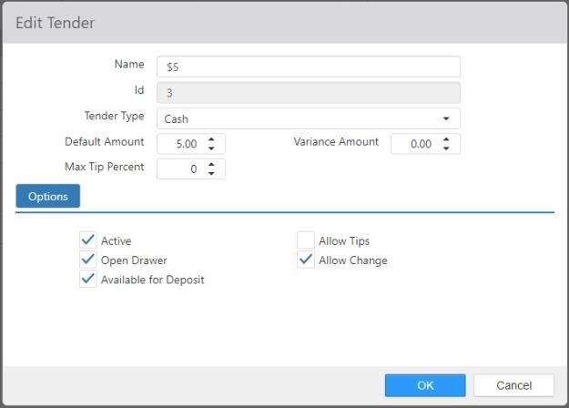

* + **Name**: Name of the tender.
  + **Id**: System generated identifier of the tender.

#### Tender Type:

#### Cash

#### Check

#### Credit Card:

 **Card Type**: Type of credit card.

 **Requires Authorization**: Payment must be authorized by a third-party processor.

#### Debit

#### External

#### Gift Card:

 **Card Type**: Type of credit card.

 **Requires Authorization**: Payment must be authorized by a third-party processor.

#### Gift Certificate

#### House Account

* + **Default Amount**: Amount that displays in the tender dialog. If default value is 0, the Amount defaults to the balance due.
  + **Variance Amount**: The amount of variance allowed on the tender.
  + **Max Tip Percent**: The maximum tip allowed on the tender.

#### Options:

* + - **Active**: Tender can be applied as payment or future date order deposit via the ‘Tender’

button behavior.

* + - **Open Drawer**: Open the cash drawer when ‘Tender’ button behavior executes.
    - **Available For Deposit**: Can be used for future date order deposits.
    - **Allow Tips**: Tip field is visible on the tender dialog; payments are available in the ‘Adjust Tips’ screen when tender **Type** is set to **Credit Card**.
    - **Allow Change**: Allow cash to be returned to the guest when payment amount exceeds the balance due.
    - **Allow Tip Adjust On Register**: When tender **Type** is set to **Credit Card** or **Gift Card** and **Requires Authorization** and **Allow Tips** option selected, allows the tip to be adjusted at the register via ‘Adjust Tips’ or ‘Adjust Payment’ buttons.

 If both Requires Authorization and Allow Tips options are selected, tips are automatically allowed at the register.

## Video Groups

Video groups control the routing of order items to kitchen queues.

*Edit Video Group dialog,* ***Options*** *tab*

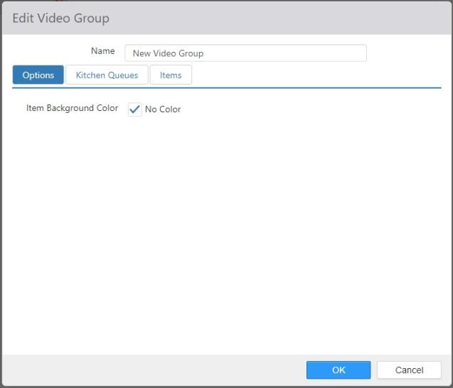

* + **Name**: Name of the video group.
  + **Item Background Color**: Defines the background color for all items and modifiers in the video group. It is overridden by any settings made in the *Edit Item* dialog. The default setting is None.

*Edit Video Group dialog,* ***Kitchen Queues*** *tab*

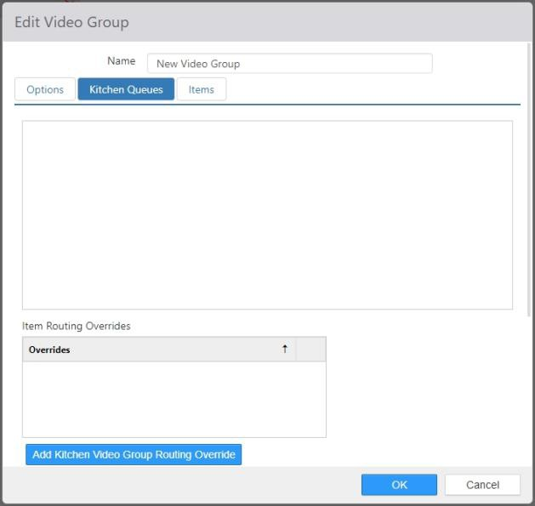

* + **Kitchen Queues tab**: Kitchen queues that contain the kitchen displays that are to display order items for this group.
    - **Item Routing Overrides**: Defines an alternate set of kitchen queues to route to when the order meets certain criteria.

*Add item routing override dialog*

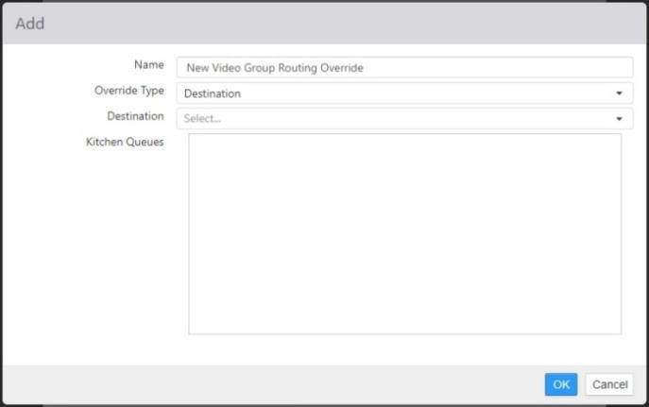

 **Name**: Name of the override

 **Override Type**:

* + - * **Destination**: Order items are for a specific destination.
      * **Item**: Any of the selected items exist in the list of sent order items.
      * **Item Group**: Any of the sent order items exist within a specific item group.

*Edit Video Group dialog,* ***Items*** *tab*

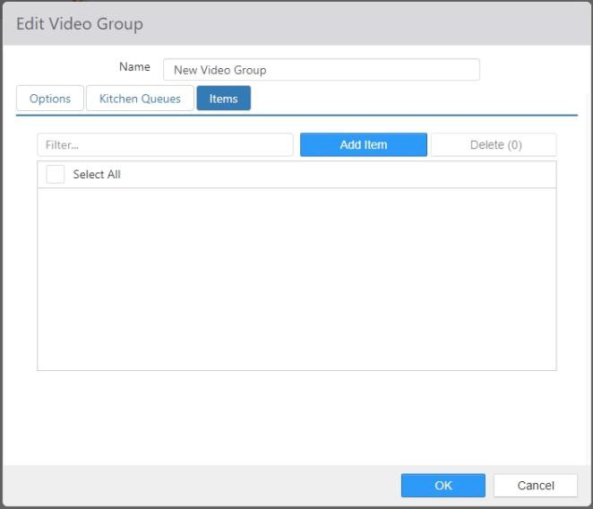

* + **Items tab**: Items set to route to this video group.

## Void Reasons

Refund reasons are listed for the employee to choose when the ‘Refund’ button behavior is executed.

*Void Reasons list (example)*

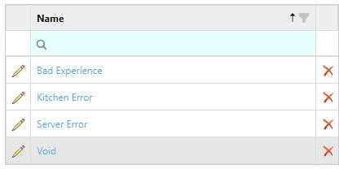

To add a new refund reason, click **Add**. To edit an existing refund reason, click its name in the list.

*Edit Void Reason dialog*

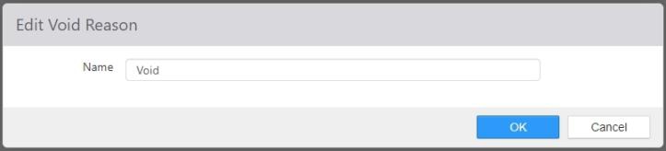

* + **Name**: Name of the void reason.